01 Low noise amplifier
Number | Frequency range  (GHz) | Noise factor  (dB) | Gain  (dB) | Standing wave | P1dB  (dBm) | Power consumption (V/mA) | Page number
CW-LN0108 | 1~8 | 1.4 | 23 | 2.3/2.2 | 16 | 5/73 | 6
CW-LN207305 | 2.7-3.5 | 0.55 | 29 | 1.3/1.3 | 11.5 | 5/31 | 9
CW-LN445 | 5-40 | 2.3 | 11 | 1.5/1.5 | 12 | 5/43 | 12
CW-LN369 | 24-40 | 2.5 | 20 | 2.5/2.0 | 1 | 5/35 | 16
CW-LN0711 | 8-9 | 0.8 | 25 | - | 14 | 5/32 | 19
CW-LN362 | 2~20 | 2.5 | 15 | - | 15 | 5/65 | 22

02 Drive/power amplifier
Number | Frequency range  (GHz) | Psat  (dBm) | P-1dB  (dBm) | Gain  (dB) | Standing wave | Power consumption  (V/mA) | Page number
CW-DA451 | 5-20 | 20 | 18.5 | 23 | 1.3/1.5 | 5/105 | 26
CW-DA5618 | 6-20 | 19.5 | 18.5 | 17 | 1.3/1.5 | 5/85 | 30

03 Switch
Number | Type | Frequency  Range  (GHz) | Insertion loss  (dB) | Degree of isolation  (dB) | P1dB  (dBm) | Open state  Standing wave | Off state  Standing wave | Control  Level  (V) | Page number
CW-SW10020 | SPST | DC-20 | 1.4 | 45 | 18 | 1.2 | 1.4 | 0/-5 | 35
CW-SW10040 | SPST | DC-40 | 1.4 | 33 | - | 1.2 | 1.2 | 0/-5 | 38
CW-SW20004 | SPDT | DC-4 | 0.5 | 48 | 27 | 1.4 | - | 0/-5 | 41
CW-SW20020 | SPDT | DC-20 | 1.7 | 46 | 18 | 1.5 | 1.3 | 0/-5 | 44
CW-SW30018 | SP3T | DC-18 | 1.7 | 40 | 20 | 1.3 | - | 0/-5 | 47
CW-SW200104 | SPDT | 0.1-4 | 0.7 | 40 | 25 | 1.5 | - | 0/+5 | 50
CW-SW0218A2 | - | 2-18 | 6.3 | 50 | 28 | 1.5 | - | 0/-5 | 53
CW-SW0218A4 | - | 2-18 | 6 | 45 | 18 | - | - | 0/-5 | 56
CW-SW30220 | SP3T | 2-20 | 3 | 38 | 16 | 1.8 | - | TTL /-5 | 60
CW-SW40220 | SP4T | 2-20 | 3.4 | 39 | - | 1.7 | - | TTL /-5 | 67
CW-SW60220-A011 | SP6T | 2-20 | 5 | 40 | - | 1.9 | - | TTL /-5 | 76
CW-SW206305 | SPDT | 2.6-3.5 | 0.7 | 47 | - | 1.4 | - | TTL/-5 | 80
CW-SW10020B | SPST | DC-20 | 1.5 | 50 | - | - | - | 0 /-5 | 83
CW-SW30020 | - | DC-20 | 2.1 | 50 | 25 | - | - | 0/-5 | 86

04 Drive circuit
Number | Function | Output level (V)  Low high level | Input current  (mA) | Switching time  (ns) | Page number
CW-FEN1 | 1 bit negative pressure output FET drive | -5.1 -0.3 | 0.2 | 15 | 90
CW-FEN4 | 4 bit negative pressure output FET drive | -5.1 -0.3 | 0.2 | 15 | 92
CW-FEN1A | 1 bit negative pressure output FET drive | -5 0 | 0.2 | 14 | 94
CW-FEN4A | 4 bit negative pressure output FET drive | -5 0 | 1 | 16-25 | 97
CW-FEN6A | 6 bit FET drive | -5 0 | - | 16 | 99
CW-FEN6B | 6 bit FET drive | -5 0 | 1 | 14-25 | 102
CW-FEN6 | 6 bit FET drive | -5 0 | 1 | 16-25 | 105

05 Mixer
Number | Frequency range RF&LO (GHz) | Intermediate frequency range  (GHz) | Frequency conversion loss  (dB) | LO-RF  Degree of isolation (dB) | LO-IF  Degree of isolation (dB) | RF-IF  Degree of isolation (dB) | Local vibration power  (dBm) | Page number
CW-MX787 | 3-10 | DC-4 | 7 | 45 | 35 | 18 | 17 | 109
CW-MX141 | 6-18 | DC-6 | 7 | 48 | 45 | 15 | 20 | 113
CW-MX142 | 6-18 | DC-6 | 7 | 48 | 45 | 15 | 20 | 117
CW-MX773 | 6-26 | DC-10 | 8 | 35 | 25 | 12 | 13 | 121
CW-MX553 | 7-14 | DC-5 | 7 | 45 | 40 | 23 | 13 | 125
CW-MX292 | 18-32 | DC-8 | 8 | 45 | 48 | 17 | 13 | 128
CW-MX560 | 21-40 | DC-18 | 8 | 45 | 45 | 25 | 13 | 132

06 Frequency doubler
Number | Input signal frequency range  (GHz) | Output signal frequency range  (GHz) | Conversion gain  (dB) | Fundamental isolation (dBc) | 3/4 harmonic isolation (dBc) | Input power  (dBm) | Page number
CW-MP0204 | 2-4 | 4-8 | -14 | 45 | 45/35 | 15 | 136
CW-MP204 | 4-8 | 8-16 | -14 | 45 | 45/35 | 15 | 138
CW-MP205 | 6-12 | 12-24 | -13.5 | 35 | 35/28 | 15 | 140

07 Attenuator
Number | Frequency range  (GHz) | Amount of attenuation  (dB) | Standing wave | Page number
CW-AT40 | DC-40 | 0/1/2/3……/30 | 1.3/1.3 | 143
CW-AT50 | DC-50 | 0/1/2/3/4/5/6/7/8/9/10 | 1.4/1.4 | 161
CW-DAT425 | 2.4-8 | 0.5-31.5 | 1.4/1.3 | 168
CW-AT105S_1_2 | DC~40 | 5 | - | 172
CW-DAT239NC | 0.5~18 | 0.5~15.5 | - | 174
CW-AT40A-15 | DC-40 | 15 | 1.2/1.2 | 177

08 Power divider
Number | Frequency range  (GHz) | Insertion loss  (dB) | Flatness of insertion loss  (dB) | Standing wave | isolation  (dB) | Page number
CW-PD0204V | 2-4 | 0.5 | ±0.2 | 1.3/1.3 | 20 | 180
CW-PD0204VA | 2-4 | 0.7 | ±0.2 | 1.2/1.2 | 25 | 183
CW-PD0218 | 2.0-18 | 0.7 | ±0.3 | 1.3/1.3 | 14 | 186
CW-PD0218V | 2.0-18 | 1 | ±0.3 | 1.5/1.5 | 15 | 189
CW-PD0618 | 6-18 | 0.6 | ±0.15 | 1.5/1.3 | 17 | 192
CW-PD0618V | 6-18 | 0.8 | ±0.4 | 1.3/1.4 | 20 | 195
CW-PD0812 | 8-12 | 0.4 | ±0.05 | 1.3/1.1 | 18 | 198
CW-PD1218V | 12-18 | 0.5 | ±0.2 | 1.3/1.3 | 20 | 201
CW-PD1840 | 18-40 | 0.5 | ±0.1 | 1.4/1.4 | 11 | 204
CW-PD1840V | 18-40 | 0.8 | ±0.2 | 1.2/1.4 | 22 | 207
CW-PD20P502 | 0.5-2 | 1.2 | ±0.3 | - | 20 | 210
CW-PD0118 | 1-18 | 1.4 | ±0.2 | 1.5/1.5 | 20 | 213
CW-PD0208 | 2-8 | 1 | ±0.2 | - | 18 | 215
CW-PD0218S | 2-18 | 0.7 | ±0.3 | - | 20 | 218
CW-PD1218VA | 12-18 | 0.4 | - | 1.3/1.3 | 20 | 220
CW-PD3040V | 30-40 | 0.5 | - | 1.3/1.3 | 25 | 223
CW-PD30618 | 6-18 | 1.0 | ±0.3 | 2.0/1.4 | 16 | 226
CW-PD31018 | 10-18 | 0.6 | ±0.3 | 1.3/1.2 | 22 | 229
CW-PD31418 | 14-18 | 0.5 | - | 1.5/1.4 | 16 | 232
CW-PD32040 | 20-40 | 0.8 | - | 1.9/1.5 | 15 | 235
CW-PD43040 | 33-37 | 1.1 | - | 1.37/1.2 | 20 | 238

09 Equalizer
Number | Frequency range  (GHz) | Insertion loss  (dB) | Equal measure  (dB) | Standing wave | Page number
CW-AE00506 | 0.5-6.0 | 0.5/0.6/0.8/0.8/0.9/1.0 | 2/3/4/5/6/7 | 1.2/1.2 | 242
CW-AE0218 | 2.0-18 | 1.0/1.0/1.0/1.0/1.2/1.2 | 2/3/4/5/6/7 | 1.2/1.2 | 248
CW-AE0218-8 | 2.0-18 | 1.3 | 8 | 1.3/1.3 | 254
CW-AE0218-16 | 2.0-18 | 2.5 | 16 | 1.3/1.3 | 256
CW-AE0612 | 6.0-12 | 0.9 | 3 | 1.2/1.2 | 258
CW-AE0618 | 6.0-18 | 0.6/0.6/1.0/1.1/1.1/1.1 | 2/3/4/5/6/7 | 1.2/1.2 | 260
CW-AE1840 | 18-40 | 1.2/1.2/1.2/1.1/1.1/1.6 | 2/3/4/5/6/7 | 1.4/1.4 | 266
CW-AE0618-357 | 6.0-18 | 0.8 | 3/5/7 | 1.3/1.3 | 270
CW-AE0118-4 | 1.0-18 | 0.5 | 4 | - | 272
CW-AE0118-6 | 1.0-18 | 0.6 | 6 | - | 274

10 Limiter
(The products in this catalog are customized multifunctional chips, welcome users to customize products according to their own needs)
Number | Frequency range  (GHz) | Insertion loss  (dB) | Limiting level  (dBm) | Input standing wave | Output standing wave | Page number
CW-LM0618 | 6-18 | 0.3 | 17 | 1.3 | 1.3 | 277
CW-LM1018 | 10-18 | 0.6 | 17 | 1.6 | 1.6 | 279

11 Field effect transistors
Numbering | Frequency range  (GHz) | Saturation leakage current  (mA) | transconductance  (mS) | Gain  dB | Noise factor  dB | Page number
CW-FET13 | 2-18 | 30-50 | 72 | 12@12GHz | 0.46 | 282
CW-FET45 | 2-18 | 40-60 | 90 | 13 | 0.5 | 284
(The products in this catalog are customized multifunctional chips. Users are welcome to customize products according to their own needs.)
- Low noise amplifier
Number | Frequency range  (GHz) | Noise factor  (dB) | Gain  (dB) | Standing wave | P1dB  (dBm) | Power consumption (V/mA) | Page number
CW-LN0108 | 1~8 | 1.4 | 23 | 2.3/2.2 | 16 | 5/73
CW-LN207305 | 2.7-3.5 | 0.55 | 29 | 1.3/1.3 | 11.5 | 5/31
CW-LN445 | 5-40 | 2.3 | 11 | 1.5/1.5 | 12 | 5/43
CW-LN369 | 24-40 | 2.5 | 20 | 2.5/2.0 | 1 | 5/35
CW-LN0711 | 8-9 | 0.8 | 25 | - | 14 | 5/32
CW-LN362 | 2~20 | 2.5 | 15 | - | 15 | 5/65

Performance Features:
- Frequency band: 1~8GHz
- Noise factor: 1.4dB
- Gain: 23dB
- Input/output return loss: >8.5dB/>8dB
- Output P1dB: 16dBm
- Single power supply: +5V@73mA
- Chip size: 2.4mm x 1.2mm x 0.1mm
Product Description:
CW-LN0108 is a GaAs MMIC broadband low noise amplifier chip, its frequency range covers 1~8GHz, the entire band noise factor typical value of 1.4dB.The CW-LN0108 is powered by +5V.
Electrical parameters: ( T_{A}=25℃，V_{d}=+5V)
Indicators | Minimum | Typical value | Maximum value | Units
Frequency range | 1~8 |  |  | GHz
Noise factor | 1.1 | 1.4 | 2.1 | dB
Gain | 22 | 23 | 26 | dB
Input return loss | 8.5 | - | - | dB
Output return loss | 8 | - | - | dB
Electrical parameters：(Exceeding any of the above maximum limits risks permanent damage.)
Input power | +18dBm
Control voltage | +5V
Storage temperature | -65℃~+150℃
Service temperature | -55℃~+125℃
Typical curve:
Small signal response（25℃） Gain（25℃）

Noise factor（25℃） Output 1dB compression point（25℃）
Size drawing: (unit mm)
Suggested assembly drawing:

Instructions:
Note: I/O has straight capacitance
Storage: The chip must be placed in a container with electrostatic protection and stored in a nitrogen environment.
Cleaning treatment: The bare chip must be operated and used in a purified environment. It is forbidden to use liquid cleaning agent to clean the chip.
Electrostatic protection: Strictly comply with the ESD protection requirements to avoid electrostatic damage to the components.
General operation: Use vacuum chuck or precision pointed tweezers to pick up the chip.Avoid touching the surface of the chip with tools or fingers during handling.
Mounting operation: The chip can be installed using AuSn solder eutectic welding or conductive adhesive bonding process.The mounting surface must be clean and flat.
Bonding operation: Input and output with 2 (recommended diameter of 25um gold wire) bonding wire, bonding wire length less than 250um is optimal.It is recommended to use the smallest possible ultrasonic energy.Bonding begins at the pressure point on the chip and ends at the package (or substrate).

Performance Characteristics:
- Band: 2.7-3.5GHz
- Noise factor: 0.55dB
- Gain: 29dB
- Output P-1dB: 11.5dBm
- Power supply: +5V@31mA
- Chip size: 1.8mm x 1.3mm x 0.1mm
Product Description:
The CW-LN207305 is a GaAs MMIC low noise amplifier with a frequency range covering 2.7-3.5GHz and an in-band noise factor of 0.55dB.The chip is powered by a +5V single power supply.
Electrical parameters: ( TA=25℃,VD=5V)
Index | Minimum | Typical value | Maximum value | Units
Frequency range | 2.7-3.5 |  |  | GHz
Noise factor | - | 0.55 | - | dB
Gain | - | 29 | - | dB
Input return loss | - | 20 | - | dB
Output return loss | - | 20 | - | dB
Output P1dB | - | 11.5 | - | dBm
Working current | - | 31 | - | mA
Use limit parameters：
Input power | 15dBm
Voltage | +7V
Storage temperature | -65℃-150℃
Service temperature | -55℃-85℃
Typical curve：
Gain input return loss
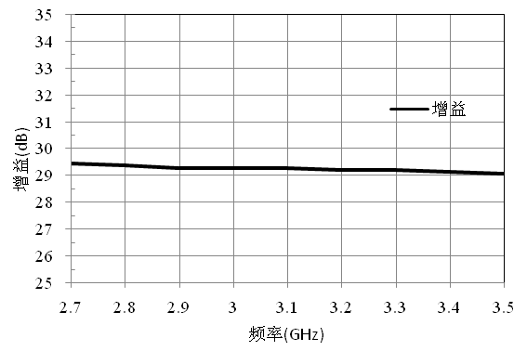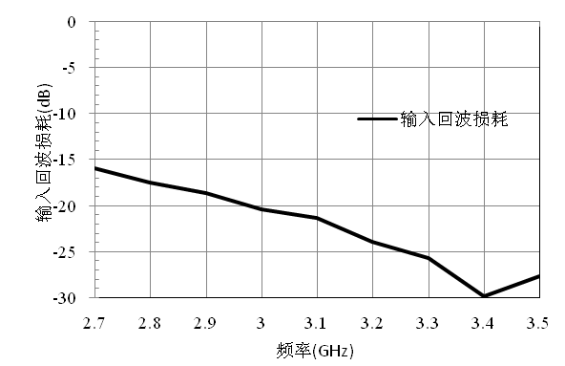
Output return loss Reverse isolation
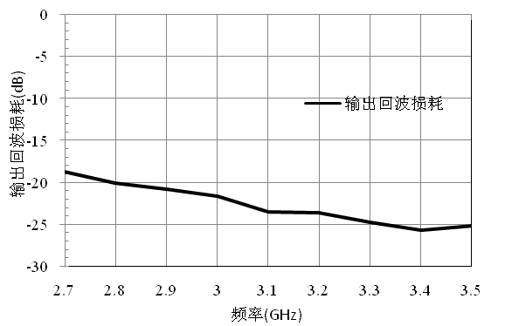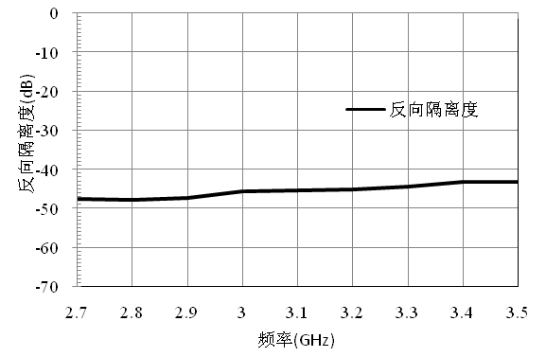
Noise coefficient output P1dB power
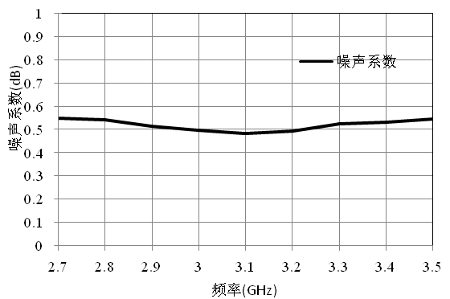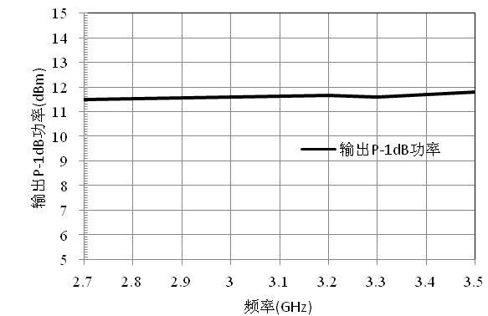
Size drawing：(Unit mm)

Suggested assembly drawing:
Instructions：
Storage: The chip must be placed in a container with electrostatic protection and stored in a nitrogen environment.
Cleaning treatment: The bare chip must be operated and used in a purified environment. It is forbidden to use liquid cleaning agent to clean the chip.
Electrostatic protection: Strictly comply with the ESD protection requirements to avoid electrostatic damage to the components.
General operation: Use vacuum chuck or precision pointed tweezers to pick up the chip.Avoid touching the surface of the chip with tools or fingers during handling.
Mounting operation: The chip can be installed using AuSn solder eutectic welding or conductive adhesive bonding process.The mounting surface must be clean and flat.
Bonding operation: Input and output with 2 (recommended diameter of 25um gold wire) bonding wire, bonding wire length less than 250um is optimal.It is recommended to use the smallest possible ultrasonic energy.Bonding begins at the pressure point on the chip and ends at the package (or substrate).

Performance Characteristics:
- Frequency band: 5~40GHz
- Noise factor: 2.3dB
- Gain: 11dB
- Input/output return loss: >14dB/>14dB
- Output P1dB: 12dBm
- Output IP3:26dBm
- Power Supply: +5V@43mA
- Chip size: 1.54mm x 1.38mm x 0.1mm
Product Description：
CW-LN445 is a GaAs MMIC ultra wideband low noise amplifier chip, its frequency range covers 5~40GHz, the whole band noise factor typical value is 2.3dB.The CW-LN445 is powered by +5V.
Electrical parameters：( T_{A}=25℃，VD=+5V)
Index | Minimum | Typical value | Maximum value | Units
Frequency range | 5~40 |  |  | GHz
Noise factor | 2 | 2.3 | 4.3 | dB
Gain | - | 11 | 12.8 | dB
Input return loss | 14 | - | - | dB
Output return loss | 14 | - | - | dB
Use limit parameters: (Exceeding any of the above maximum limits risks permanent damage.)
Input power | +23dBm
Control voltage | +9V
Storage temperature | -65℃~150℃
Service temperature | -55℃~125℃

Typical curve:
Small signal response（25℃） Gain Vs temperature

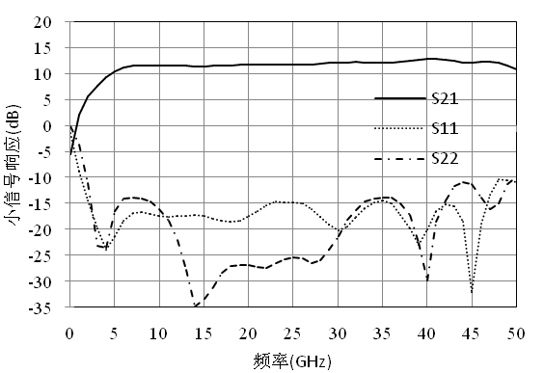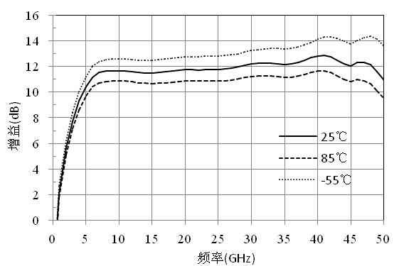

Noise factor Vs temperature Output 1dB compression point Vs temperature
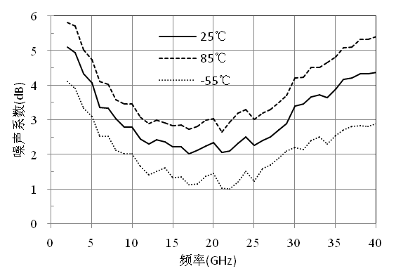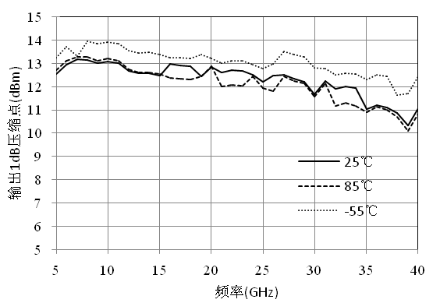

Output saturated power Vs temperature Output third order intermodulation point（25℃）
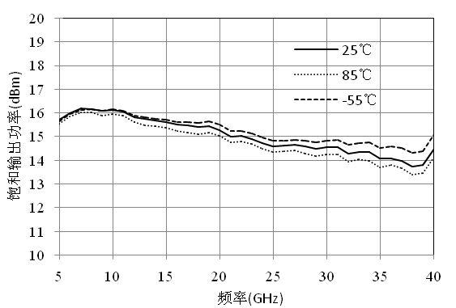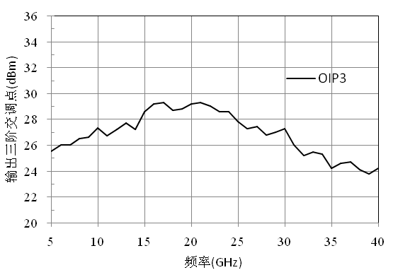

Size diagram：(unit mm)
Suggested assembly drawing：

Instructions：
Note: I/O has straight capacitance
Storage: The chip must be placed in a container with electrostatic protection and stored in a nitrogen environment.
Cleaning treatment: The bare chip must be operated and used in a purified environment. It is forbidden to use liquid cleaning agent to clean the chip.
Electrostatic protection: Strictly comply with the ESD protection requirements to avoid electrostatic damage to the components.
General operation: Use vacuum chuck or precision pointed tweezers to pick up the chip.Avoid touching the surface of the chip with tools or fingers during handling.
Mounting operation: The chip can be installed using AuSn solder eutectic welding or conductive adhesive bonding process.The mounting surface must be clean and flat.
Bonding operation: Input and output with 2 (recommended diameter of 25um gold wire) bonding wire, bonding wire length less than 250um is optimal.It is recommended to use the smallest possible ultrasonic energy.Bonding begins at the pressure point on the chip and ends at the package (or substrate).

Performance Characteristics:
- Frequency band: 24~40GHz
- Noise factor: 2.5dB
- Gain: 20dB
- I/O return loss: 10dB
- Output P1dB: >1dBm
- Power Supply: +5V@35mA
- Chip size: 2.00mm x 1.00mm x 0.1mm
Product Description:
CW-LN369 is a GaAs MMIC wideband low noise amplifier chip that covers the frequency range from 24GHz to 40GHz and provides a typical gain of 20dB with a noise factor of 2.5dB.The physical chip is powered by a +5V single power supply.
Electrical parameters : ( T_{A}=25℃，VD=+5V，Id=35mA)
Indicators | Minimum | Typical value | Maximum value | Minimum | Typical value | Maximum value | Minimum | Typical value | Maximum value | Units
Frequency range | 24-26 |  |  | 26-37 |  |  | 37-40 |  |  | GHz
Gain | 21 | 22 | - | 19.5 | 20 | - | 18 | 19 | - | dB
Noise factor | - | 2.5 | 2.9 | - | 2.3 | 2.5 | - | 3 | 4 | dB
Input echo | 8 | 10 | - |  | 10 | - | 7 | 8 | - | dB
Output echo | 12 | 15 | - | 10 | 15 | - | 12 | 12 | - | dB
Output P-1 | 1 | 2 | - | 3 | 8 | 11 | - | 10 | - | dBm
Working current | - | 35 | - | - | 35 | - | - | 35 | - | mA
Use limit parameters: (Exceeding any of the above maximum limits risks permanent damage.)
Maximum operating voltage | +5.5V
Maximum input power | 5 dBm
Channel temperature | 180℃
Storage temperature | -65℃-150℃
Service temperature | -55℃-125℃

Typical curve：
Gain/return loss（25℃） Gain Vs temperature
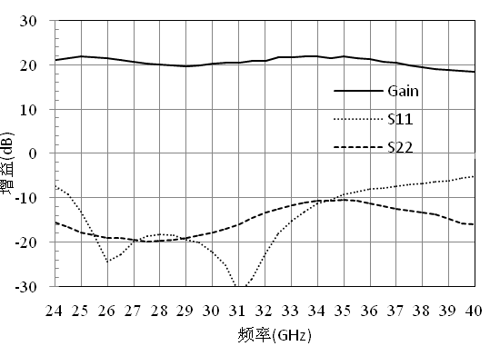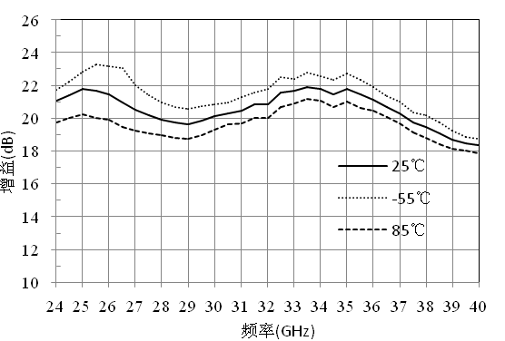

Noise factor Vs temperature Output P-1dB/Psat (25℃)
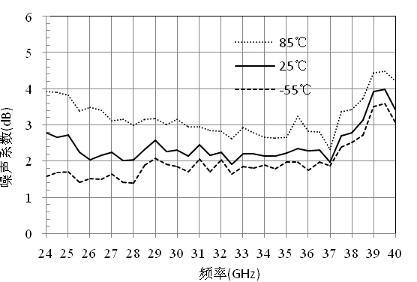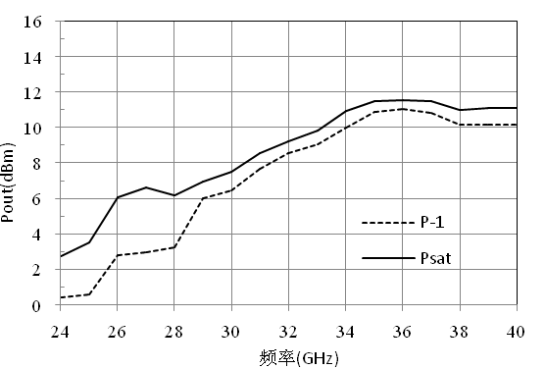

Input return loss Vs temperature Output return loss Vs temperature
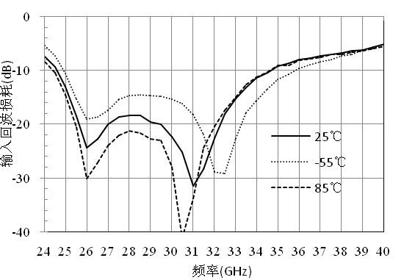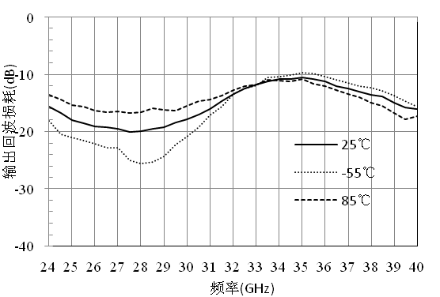

Size diagram：(unit mm)

Suggested assembly drawing:

Instructions:
Note: I/O has straight capacitance
Storage: The chip must be placed in a container with electrostatic protection and stored in a nitrogen environment.
Cleaning treatment: The bare chip must be operated and used in a purified environment. It is forbidden to use liquid cleaning agent to clean the chip.
Electrostatic protection: Strictly comply with the ESD protection requirements to avoid electrostatic damage to the components.
General operation: Use vacuum chuck or precision pointed tweezers to pick up the chip.Avoid touching the surface of the chip with tools or fingers during handling.
Mounting operation: The chip can be installed using AuSn solder eutectic welding or conductive adhesive bonding process.The mounting surface must be clean and flat.
Bonding operation: Input and output with 2 (recommended diameter of 25um gold wire) bonding wire, bonding wire length less than 250um is optimal.It is recommended to use the smallest possible ultrasonic energy.Bonding begins at the pressure point on the chip and ends at the package (or substrate).
Performance Characteristics:
- Frequency band: 8-9GHz
- Noise factor: 0.8dB
- Gain: 25dB
- Output P-1dB: 14dBm
- Power supply: +5V@32mA
- Chip size: 1.7mm x 0.82mm x 0.1mm
Product Description:
CW-LN0711 is a GaAs MMIC low noise amplifier with a frequency range covering 8-9 GHZ and an in-band noise factor of 0.8dB.The chip is powered by a +5V single power supply.
Electrical parameters:( TA=25℃,VD=5V)
Index | Minimum | Typical value | Maximum value | Units
Frequency range | 8-9 |  |  | GHz
Noise factor | - | 0.8 | - | dB
Gain | - | 25 | - | dB
Input return loss | - | 20 | - | dB
Output return loss | - | 18 | - | dB
Output P1dB | - | 14 | - | dBm
Working current | - | 33 | - | mA
Use limit parameters：
Input power | 15dBm
Voltage | +7V
Storage temperature | -65℃-150℃
Service temperature | -55℃-85℃
Typical curve：
Gain Input return loss
Frequency Frequency

Output return loss reverse isolation
Frequency Frequency

Noise factor 1dB compression point output power
Size diagram: (unit mm)

Suggested assembly drawing：
Instructions:
Storage: The chip must be placed in a container with electrostatic protection and stored in a nitrogen environment.
Cleaning treatment: The bare chip must be operated and used in a purified environment. It is forbidden to use liquid cleaning agent to clean the chip.
Electrostatic protection: Strictly comply with the ESD protection requirements to avoid electrostatic damage to the components.
General operation: Use vacuum chuck or precision pointed tweezers to pick up the chip.Avoid touching the surface of the chip with tools or fingers during handling.
Mounting operation: The chip can be installed using AuSn solder eutectic welding or conductive adhesive bonding process.The mounting surface must be clean and flat.
Bonding operation: Input and output with 2 (recommended diameter of 25um gold wire) bonding wire, bonding wire length less than 250um is optimal.It is recommended to use the smallest possible ultrasonic energy.Bonding begins at the pressure point on the chip and ends at the package (or substrate).
Performance Characteristics:
- Frequency band: 2~20GHz
- Noise factor: 2.5dB
- Gain: 15dB
- P1dB: +15dBm
- Self-biased power supply: +5V@65mA
- Input/Output :50ohm match
- Chip size: 3mm x 1.3mm x 0.1mm
Product Description：
CW-LN362 is a GaAs MMIC low noise amplifier chip with a frequency range covering 2 to 20 GHZ and a noise factor of 2.5dB.
Electrical parameters：( T_{A}=25℃，VD=+5V，IDD=65mA）
Indicators | Minimum | Typical value | Maximum value | Minimum | Typical value | Maximum value | Minimum | Typical value | Maximum value | Units
Frequency range | 2~6 |  |  | 6~12 |  |  | 12~20 |  |  | GHz
Gain | - | 14.8 | - | - | 14.9 | - | - | 15 | - | dB
Gain flatness | - | ±0.2 | - | - | ±0.2 | - | - | ±0.2 | - | dB
Input return loss | - | 25 | - | - | 18 | - | - | 15 | - | dB
Output return loss | - | 20 | - | - | 18 | - | - | 15 | - | dB
Output power 1dB compression point | - | 15 | - | - | 14.5 | - | - | 14 | - | dBm
Output IP3 | - | 25 | - | - | 24.5 | - | - | 24 | - | dBm
Saturated power | - | 17 | - | - | 16.5 | - | - | 16 | - | dBm
Noise factor | - | 2.5 | - | - | 2.0 | - | - | 2.5 | - | dB
Working current | - | 65 | - | - | 65 | - | - | 65 | - | mA
Use limiting parameters：
Input power | +15dBm
Storage temperature | -65℃~150℃
Service temperature | -55℃~85℃

Typical curve：
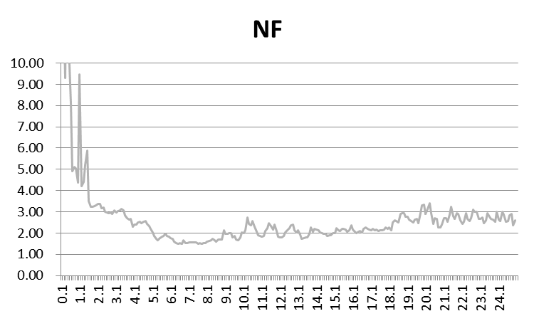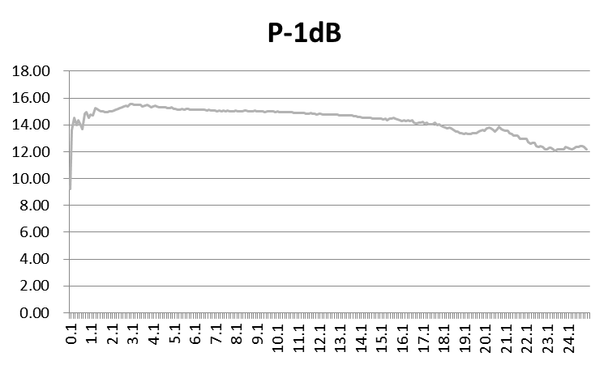

Dimensional drawing：（unit mm）

Suggested assembly drawing:

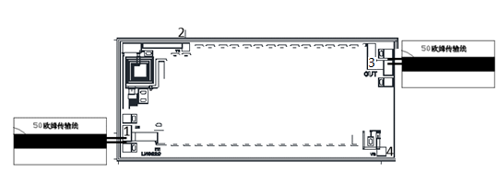

Pad Description: 3mil assembly clearance
Pad number | Function | Description
1 | IN | The pad is AC coupled with a matching value of 50ohm
2 | VD | The pad provides the amplifier's power supply voltage and requires an external 100pF and 0.01uF bypass capacitor with the pad to 100pF capacitor bonding wire controlled within 500um
3 | OUT | The pad is AC coupled and matches up to 50ohm
4 | VG | The pad can be adjusted chip gain, suspended during normal use, and can be connected to 0-0.5V voltage if you need to increase the gain, or -035-0V voltage if you need to decrease the gain
Back of the chip | GND | The back of the chip must be connected to the RF/DC ground

Instructions:
Storage: The chip must be placed in a container with electrostatic protection and stored in a nitrogen environment.
Cleaning treatment: The bare chip must be operated and used in a purified environment. It is forbidden to use liquid cleaning agent to clean the chip.
Electrostatic protection: Strictly comply with the ESD protection requirements to avoid electrostatic damage to the components.
General operation: Use vacuum chuck or precision pointed tweezers to pick up the chip.Avoid touching the surface of the chip with tools or fingers during handling.
Mounting operation: The chip can be installed using AuSn solder eutectic welding or conductive adhesive bonding process.The mounting surface must be clean and flat.
Bonding operation: Input and output with 2 (recommended diameter of 25um gold wire) bonding wire, bonding wire length less than 250um is optimal.It is recommended to use the smallest possible ultrasonic energy.Bonding begins at the pressure point on the chip and ends at the package (or substrate).

02 Drive/power amplifier
Number | Frequency range  (GHz) | Psat  (dBm) | P-1dB  (dBm) | Gain  (dB) | Standing wave | Power consumption  (V/mA) | Page number
CW-DA451 | 5-20 | 20 | 18.5 | 23 | 1.3/1.5 | 5/105
CW-DA5618 | 6-20 | 19.5 | 18.5 | 17 | 1.3/1.5 | 5/85

Performance Features:
- Frequency band: 5~20GHz
- Gain: 23dB
- Output P1dB: 18.5dBm
- Saturated output power: 20dBm
- Output IP3:32dBm
- Input/output return loss: 18dB/11dB
- Power supply: +5V@105mA
- Chip size: 1.5mm x 1.4mm x 0.1mm
Product Description:
CW-DA451 is a GaAs MMIC driver amplifier chip with a frequency range covering 5~20GHz and an output P1dB of 18.5dBm over the entire band.
Electrical parameters:( T_{A}=25℃，VD=+5V)
Index | Minimum | Typical value | Maximum value | Units
Frequency range | 5~20 |  |  | GHz
Gain | 22 | 23 | 25 | dB
Output P1dB | 18.5 | - | - | dBm
Saturated output power | 20 | - | - | dBm
Output IP3 | 32 | - | - | dBm
Input return loss | - | 18 | - | dB
Output return loss | - | 11 | - | dB
Use limit parameters: (Exceeding any of the above maximum limits risks permanent damage.)
Input power | +10dBm
Voltage | +6V
Storage temperature | -65℃~150℃
Service temperature | -55℃~125℃

Typical curve:
Gain Vs temperature input return loss Vs temperature
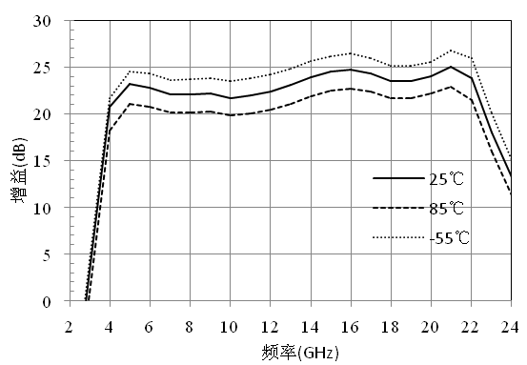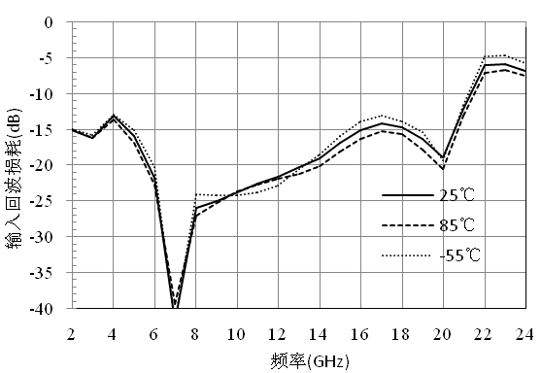
Output return loss Vs temperature reverse isolation Vs temperature

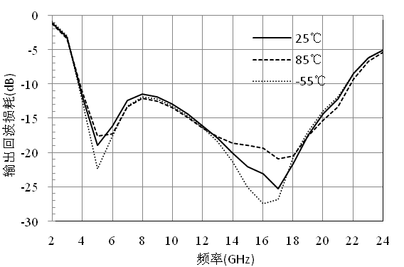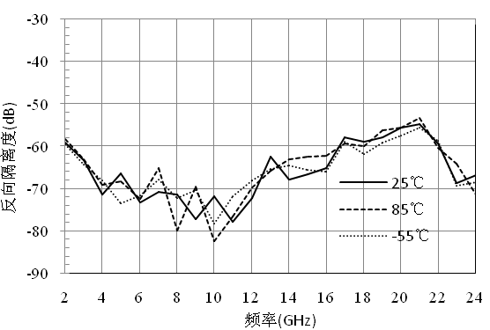
Noise factor Vs temperature Output P1dB Vs temperature
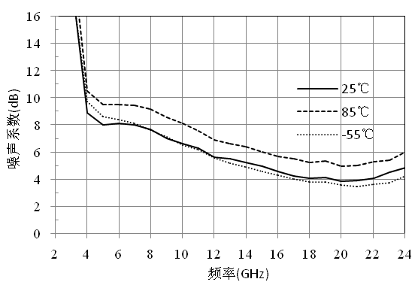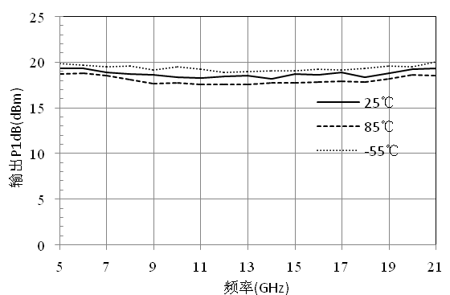

Saturated output power Vs temperature Output IP3（25℃）
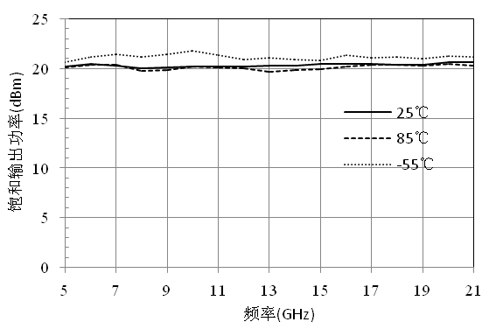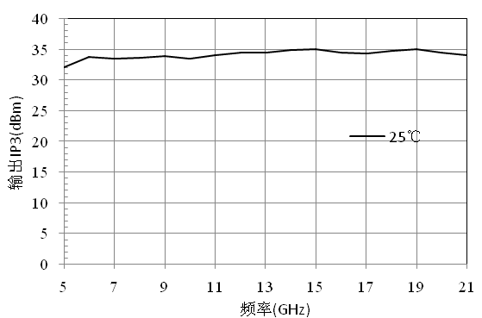
Size diagram：（unit mm）
Suggested assembly drawing：

Instructions:
Note: I/O has straight capacitance
Storage: The chip must be placed in a container with electrostatic protection and stored in a nitrogen environment.
Cleaning treatment: The bare chip must be operated and used in a purified environment. It is forbidden to use liquid cleaning agent to clean the chip.
Electrostatic protection: Strictly comply with the ESD protection requirements to avoid electrostatic damage to the components.
General operation: Use vacuum chuck or precision pointed tweezers to pick up the chip.Avoid touching the surface of the chip with tools or fingers during handling.
Mounting operation: The chip can be installed using AuSn solder eutectic welding or conductive adhesive bonding process.The mounting surface must be clean and flat.
Bonding operation: Input and output with 2 (recommended diameter of 25um gold wire) bonding wire, bonding wire length less than 250um is optimal.It is recommended to use the smallest possible ultrasonic energy.Bonding begins at the pressure point on the chip and ends at the package (or substrate).

Performance Characteristics:
- Frequency band: 6~20GHz
- Gain: 17dB
- Output P1dB: 18.5dBm
- Output saturation power: 19.5dBm
- Output IP3:32dBm
- Input/output return loss: 19dB/13dB
- Power supply: +5V@85mA
- Chip size: 1.25mm x 1.15mm x 0.1mm
Product Description:
CW-DA5618 is a GaAs MMIC driver amplifier chip with a frequency range covering 6 to 20GHz and an output P1dB of 18.5dBm over the entire band.
Electrical parameters：( T_{A}=25℃，VD=+5V)
Index | Minimum | Typical value | Maximum value | Units
Frequency range | 6~20 |  |  | GHz
Gain | 16.5 | 17 | 17.5 | dB
Output P1dB | 18.5 | - |  | dBm
Saturated output power | 19.5 | - | - | dBm
Output IP3 | 32 | - | - | dBm
Input return loss | - | 19 | - | dB
Output return loss | - | 13 | - | dB
Use limit parameters: (Exceeding any of the above maximum limits risks permanent damage.)
Input power | +12dBm
Voltage | +6V
Storage temperature | -65℃~150℃
Service temperature | -55℃~125℃

Typical curve:
Gain Vs temperature input return loss Vs temperature 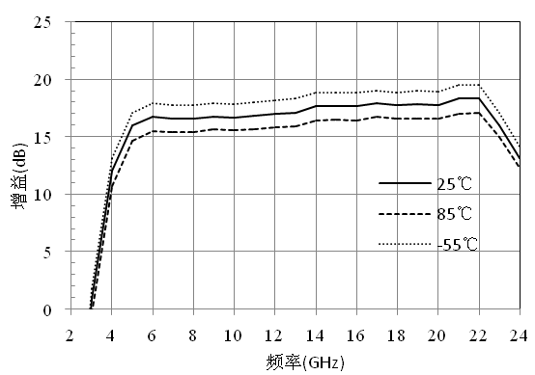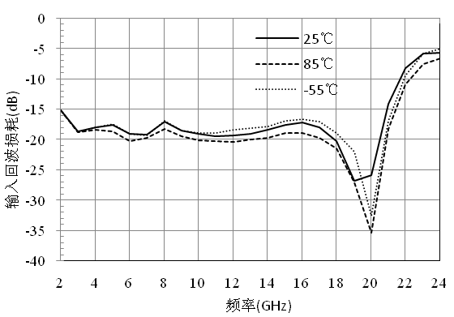
Output return loss Vs temperature reverse isolation Vs temperature
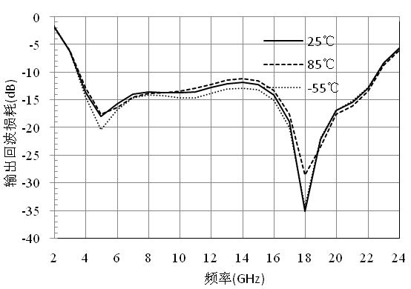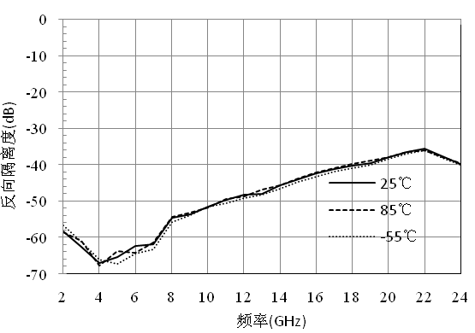
Noise factor Vs temperature Output P1dB Vs temperature
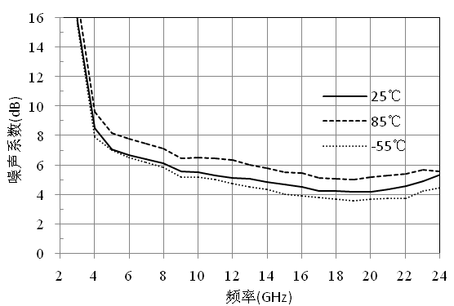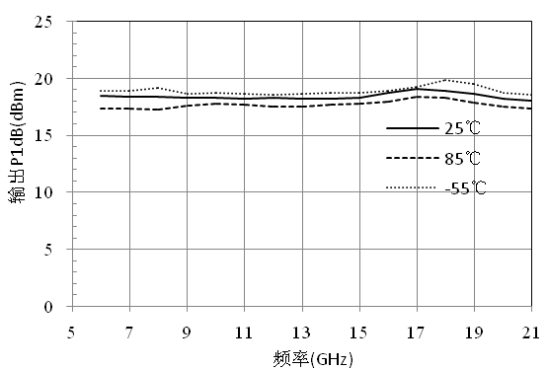

Output power Vs temperature output IP3（25℃）
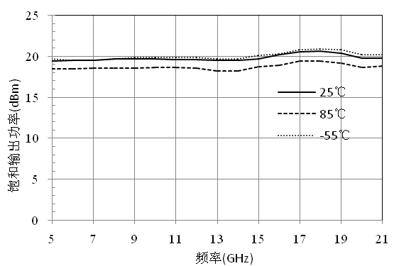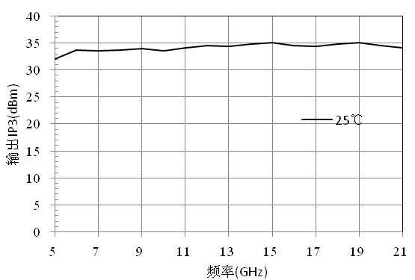
Size diagram：（unit mm）
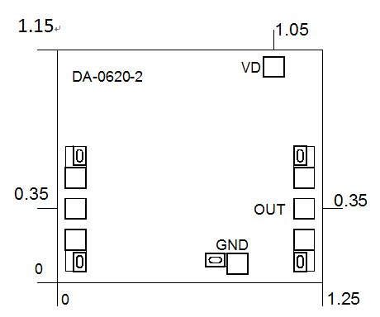
Suggested assembly drawing:
Instructions:
Note: I/O has straight capacitance
Storage: The chip must be placed in a container with electrostatic protection and stored in a nitrogen environment.
Cleaning treatment: The bare chip must be operated and used in a purified environment. It is forbidden to use liquid cleaning agent to clean the chip.
Electrostatic protection: Strictly comply with the ESD protection requirements to avoid electrostatic damage to the components.
General operation: Use vacuum chuck or precision pointed tweezers to pick up the chip.Avoid touching the surface of the chip with tools or fingers during handling.
Mounting operation: The chip can be installed using AuSn solder eutectic welding or conductive adhesive bonding process.The mounting surface must be clean and flat.
Bonding operation: Input and output with 2 (recommended diameter of 25um gold wire) bonding wire, bonding wire length less than 250um is optimal.It is recommended to use the smallest possible ultrasonic energy.Bonding begins at the pressure point on the chip and ends at the package (or substrate).

03 Switch
Number | Type | Frequency  Range  (GHz) | Insertion loss  (dB) | Degree of isolation  (dB) | P1dB  (dBm) | Open state  Standing wave | Off state  Standing wave | Control  Level  (V) | Page number
CW-SW10020 | SPST | DC-20 | 1.4 | 45 | 18 | 1.2 | 1.4 | 0/-5
CW-SW10040 | SPST | DC-40 | 1.4 | 33 | - | 1.2 | 1.2 | 0/-5
CW-SW20004 | SPDT | DC-4 | 0.5 | 48 | 27 | 1.4 | - | 0/-5
CW-SW20020 | SPDT | DC-20 | 1.7 | 46 | 18 | 1.5 | 1.3 | 0/-5
CW-SW30018 | SP3T | DC-18 | 1.7 | 40 | 20 | 1.3 | - | 0/-5
CW-SW200104 | SPDT | 0.1-4 | 0.7 | 40 | 25 | 1.5 | - | 0/+5
CW-SW0218A2 | - | 2-18 | 6.3 | 50 | 28 | 1.5 | - | 0/-5
CW-SW0218A4 | - | 2-18 | 6 | 45 | 18 | - | - | 0/-5
CW-SW30220 | SP3T | 2-20 | 3 | 38 | 16 | 1.8 | - | TTL /-5
CW-SW40220 | SP4T | 2-20 | 3.4 | 39 | - | 1.7 | - | TTL /-5
CW-SW60220-A011 | SP6T | 2-20 | 5 | 40 | - | 1.9 | - | TTL /-5
CW-SW206305 | SPDT | 2.6-3.5 | 0.7 | 47 | - | 1.4 | - | TTL/-5
CW-SW10020B | SPST | DC-20 | 1.5 | 50 | - | - | - | 0 /-5
CW-SW30020 | - | DC-20 | 2.1 | 50 | 25 | - | - | 0/-5

Performance Characteristics:
- Frequency range: DC-20GHz
- Insertion loss: 1.4dB@20GHz
- Isolation: 45dB@20GHz
- Open-state standing wave ratio: 1.2
- Off standing wave: 1.2
- Chip size: 1.5mm x 0.69mm x 0.1mm
Product Description:
The CW-SW10020 is a matching single-pole single-throw switch chip that provides less than 1.4dB of insertion loss and more than 45dB of isolation in the DC-20GHz frequency range.
Electrical parameters：( T_{A}=25℃)
Indicators | Minimum | Typical value | Maximum value | Units
Frequency range | DC-20 |  |  | GHz
Insertion loss | - | - | 1.4 | dB
isolation | 45 | 60 | - | dB
Open state standing wave (ON) | - | 1.2 | - | -
OFF standing wave (OFF) | - | 1.2 | - | -
Enter P-1 | - | 18 | - | dBm
Use limit parameters: (Exceeding any of the above maximum limits is likely to cause permanent damage.)
Maximum input power | 30dBm
Storage temperature | -65℃-150℃
Service temperature | -55℃-125℃
Truth table:
Control voltage (V) |  | On-off state
1 | 2 | IN-OUT
0 | -5 | OFF
-5 | 0 | ON

Typical curves:
Insertion loss isolation
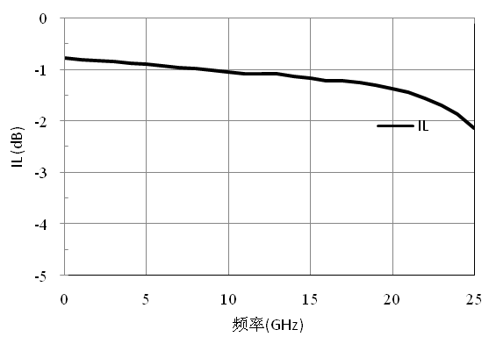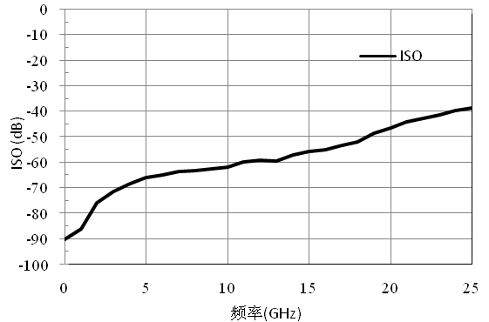
Open-state standing wave Off-state standing wave
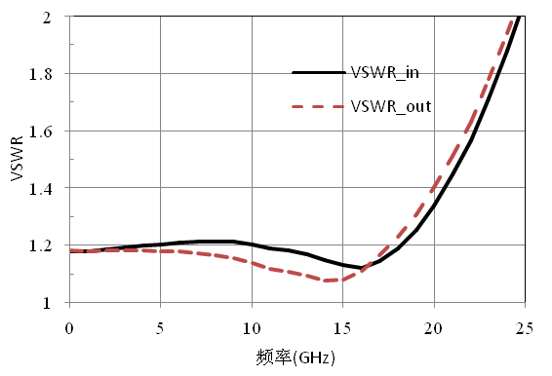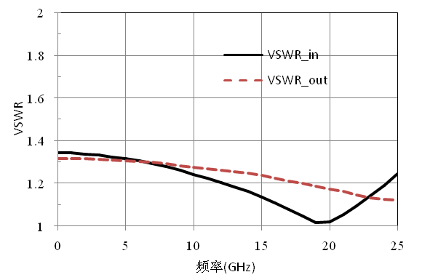
Size diagram：(unit mm)

Suggested assembly drawing:
Instructions:
Note: I/O no straight capacitance
Storage: The chip must be placed in a container with electrostatic protection and stored in a nitrogen environment.
Cleaning treatment: The bare chip must be operated and used in a purified environment. It is forbidden to use liquid cleaning agent to clean the chip.
Electrostatic protection: Strictly comply with the ESD protection requirements to avoid electrostatic damage to the components.
General operation: Use vacuum chuck or precision pointed tweezers to pick up the chip.Avoid touching the surface of the chip with tools or fingers during handling.
Mounting operation: The chip can be installed using AuSn solder eutectic welding or conductive adhesive bonding process.The mounting surface must be clean and flat.
Bonding operation: Input and output with 2 (recommended diameter of 25um gold wire) bonding wire, bonding wire length less than 250um is optimal.It is recommended to use the smallest possible ultrasonic energy.Bonding begins at the pressure point on the chip and ends at the package (or substrate).

Performance Characteristics:
- Frequency band: DC~40GHz
- Insertion loss: 1.4dB
- Isolation: 33dB
- Input/output voltage standing wave ratio: 1.2/1.2
- Control voltage: 0/-5V
- Chip size: 1.1mm×0.75mm×0.1mm
Product Description:
CW-SW10040 is a GaAs MMIC reflective single-pole single-throw switch chip with frequency range covering DC~40GHz, entire band insertion loss less than 1.4dB and isolation greater than 33dB.The CW-SW10040 is powered by 0/-5V.
Electrical parameters：( T_{A}=25℃，Vs=0/-5V)
Indicators | Minimum | Typical value | Maximum value | Units
Frequency range | DC~40 |  |  | GHz
Insertion loss | - | - | 1.4 | dB
isolation | 33 | - | - | dB
Input voltage standing wave ratio | - | - | 1.2 | -
Output voltage standing wave ratio | - | - | 1.2 | -
Use limit parameters: (Exceeding any of the above maximum limits risks permanent damage.)
Input power | +30dBm
Control voltage | -8~+1V
Storage temperature | -65℃~150℃
0Service temperature | -55℃~125℃
Switch truth table:
Control voltage (V) | On-off state
VS | IN-OUT
0 | OFF
-5 | ON

Typical curves:
Insertion loss Vs temperature isolation Vs temperature
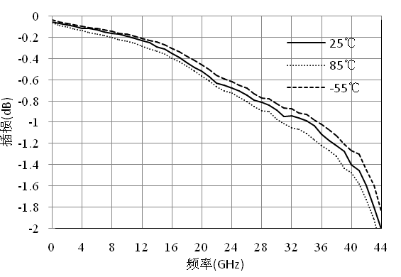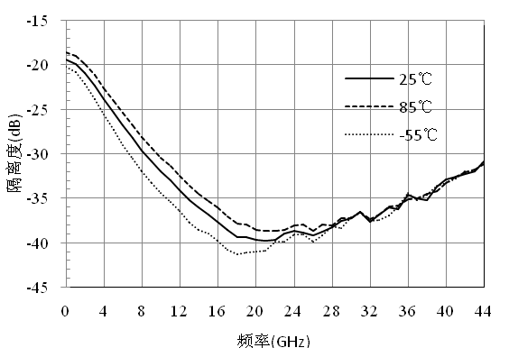

Open-state input voltage standing wave ratio Vs temperature output voltage standing wave ratio Vs temperature
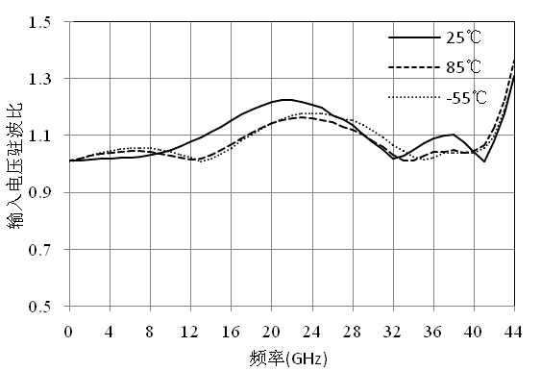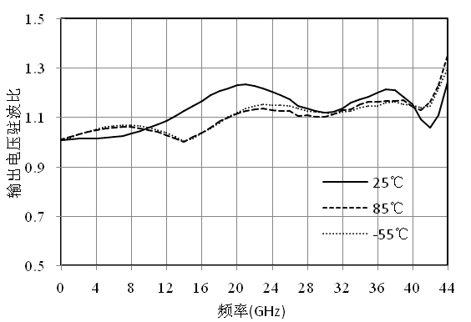

Size diagram:(unit mm)

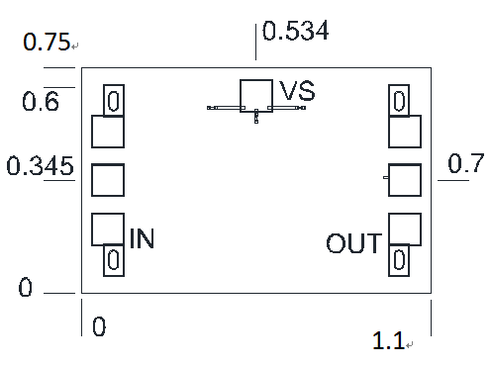

Suggested assembly drawing:

Instructions:
Note: I/O no straight capacitance
Storage: The chip must be placed in a container with electrostatic protection and stored in a nitrogen environment.
Cleaning treatment: The bare chip must be operated and used in a purified environment. It is forbidden to use liquid cleaning agent to clean the chip.
Electrostatic protection: Strictly comply with the ESD protection requirements to avoid electrostatic damage to the components.
General operation: Use vacuum chuck or precision pointed tweezers to pick up the chip.Avoid touching the surface of the chip with tools or fingers during handling.
Mounting operation: The chip can be installed using AuSn solder eutectic welding or conductive adhesive bonding process.The mounting surface must be clean and flat.
Bonding operation: Input and output with 2 (recommended diameter of 25um gold wire) bonding wire, bonding wire length less than 250um is optimal.It is recommended to use the smallest possible ultrasonic energy.Bonding begins at the pressure point on the chip and ends at the package (or substrate).

Performance Characteristics:
- Frequency band: DC~4GHz
- Insertion loss: 0.6dB
- Isolation: 48dB
- Control voltage: 0/-5V
- Chip size: 0.90mm×0.92mm×0.1mm
Product Description:
CW-SW20004 is a GaAs MMIC reflective single-pole double-throw switch chip, its frequency range covers DC~4GHz, the entire band insertion loss is less than 0.6dB, the isolation is greater than 48dB, CW-SW20004 uses 0/-5V power supply.
Electrical parameters：( T_{A}=25℃，Vs=0/-5V)
Indicators | Minimum | Typical value | Maximum value | Units
Frequency range | DC~4 |  |  | GHz
Insertion loss | - | 0.6 | - | dB
isolation | 48 | - | - | dB
Input voltage standing wave ratio | - | 1.5 | - | -
Output voltage standing wave ratio | - | 1.5 | - | -
Use limit parameters: (Exceeding any of the above maximum limits risks permanent damage.)
Input power | +30dBm
Control voltage | -8~+1V
Storage temperature | -65℃~150℃
Service temperature | -55℃~125℃
Switch truth table：
A | B | IN-1 | IN-2
-5 | 0 | ON | OFF
-0 | -5 | OFF | ON

Typical curves:
Insertion loss isolation
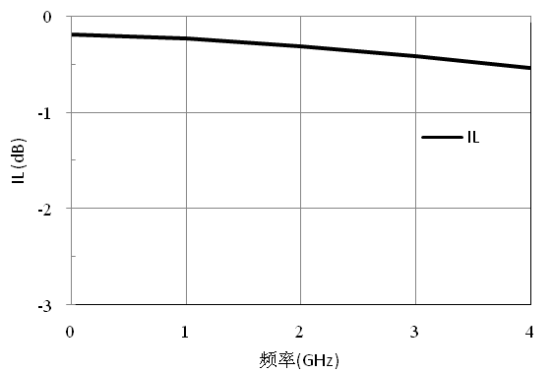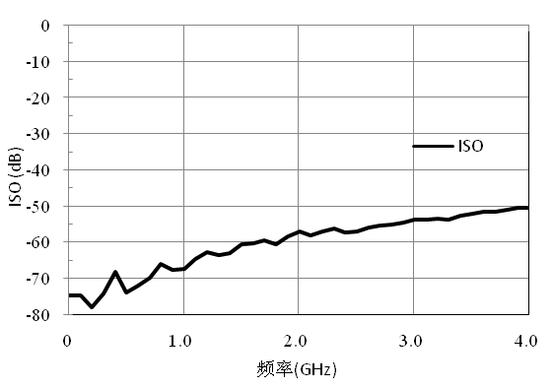
Input/output voltage standing wave ratio
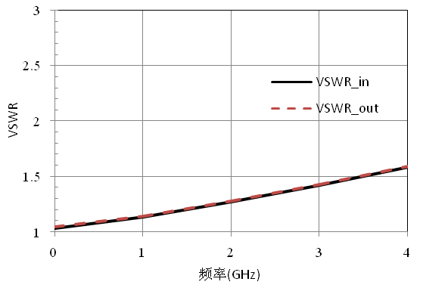
Size diagram : (unit mm)

Suggested assembly drawing:

Instructions:
Note: I/O no straight capacitance
Storage: The chip must be placed in a container with electrostatic protection and stored in a nitrogen environment.
Cleaning treatment: The bare chip must be operated and used in a purified environment. It is forbidden to use liquid cleaning agent to clean the chip.
Electrostatic protection: Strictly comply with the ESD protection requirements to avoid electrostatic damage to the components.
General operation: Use vacuum chuck or precision pointed tweezers to pick up the chip.Avoid touching the surface of the chip with tools or fingers during handling.
Mounting operation: The chip can be installed using AuSn solder eutectic welding or conductive adhesive bonding process.The mounting surface must be clean and flat.
Bonding operation: Input and output with 2 (recommended diameter of 25um gold wire) bonding wire, bonding wire length less than 250um is optimal.It is recommended to use the smallest possible ultrasonic energy.Bonding begins at the pressure point on the chip and ends at the package (or substrate).

Performance Characteristics:
- Frequency range: DC-20GHz
- Insertion loss: 1.7dB@20GHz
- Isolation: 42dB@20GHz
- Open state return loss: 17dB
- Off state return loss: 13dB
- Chip size: 1.5mm×1.5mm×0.1mm
Product Description：
The CW-SW20020 is a matching single-pole double-throw switch chip that provides less than 1.7dB of insertion loss and greater than 42dB of isolation in the DC-20GHz frequency range.
Electrical parameters：( TA=25℃)
Indicators | Minimum | Typical value | Maximum value | Units
Frequency range | DC-20 |  |  | GHz
Insertion loss | 1.2 | - | 1.7 | dB
isolation | 42 | 55 | - | dB
Return loss (ON) | 17 | - | - | dB
Return loss (OFF) | 13 | - | - | dB
Enter P-1 | - | 18 | - | dBm
Use limit parameters: (Exceeding any of the above maximum limits is likely to cause permanent damage.)
Maximum input power | 30dBm
Storage temperature | -65℃-150℃
Service temperature | -55℃-125℃
Truth table：
Control voltage (V) |  | On-off state
1 | 2 | IN-OUT1 | IN-OUT2
0 | -5 | ON | OFF
-5 | 0 | OFF | ON

Typical curves:
Insertion loss isolation

On-state return loss off-state return loss
Size diagram：(unit mm)
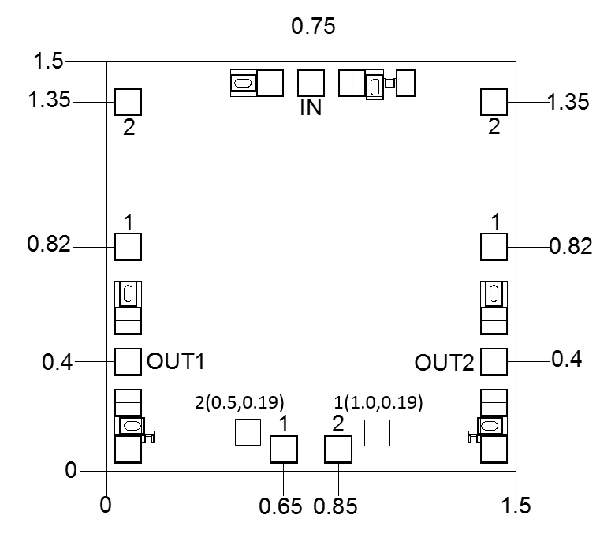

Suggested assembly drawing:
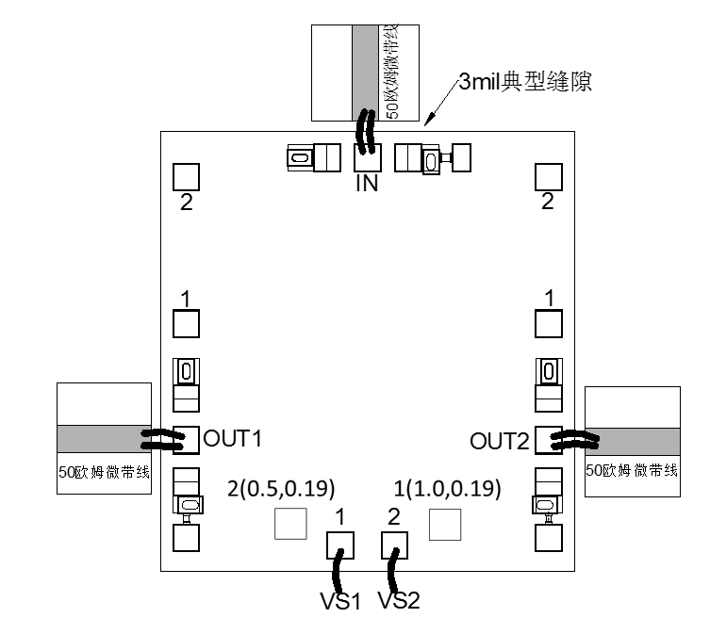
Instructions:
Note: I/O no straight capacitance
Storage: The chip must be placed in a container with electrostatic protection and stored in a nitrogen environment.
Cleaning treatment: The bare chip must be operated and used in a purified environment. It is forbidden to use liquid cleaning agent to clean the chip.
Electrostatic protection: Strictly comply with the ESD protection requirements to avoid electrostatic damage to the components.
General operation: Use vacuum chuck or precision pointed tweezers to pick up the chip.Avoid touching the surface of the chip with tools or fingers during handling.
Mounting operation: The chip can be installed using AuSn solder eutectic welding or conductive adhesive bonding process.The mounting surface must be clean and flat.
Bonding operation: Input and output with 2 (recommended diameter of 25um gold wire) bonding wire, bonding wire length less than 250um is optimal.It is recommended to use the smallest possible ultrasonic energy.Bonding begins at the pressure point on the chip and ends at the package (or substrate).

Performance Characteristics:
- Frequency band: DC~18GHz
- Insertion loss: 1.7dB
- Isolation: 40dB
- Input/output return loss: 17dB /17dB
- Control voltage: 0/-5V
- Chip size: 1.38mm×1.4mm×0.1mm
Product Description:
CW-SW30018 is a GaAs MMIC reflective single-pole three-throw switch chip with a frequency range covering DC~18GHz, the entire band insertion loss is less than 1.7dB, and the isolation is greater than 40dB.The CW-SW30018 is powered by 0/-5V.
Electrical parameters：( T_{A}=25℃)
Indicators | Minimum | Typical value | Maximum value | Units
Frequency range | DC~18 |  |  | GHz
Insertion loss | - | - | 1.7 | dB
isolation | 40 | - | - | dB
Input return loss | 17 | - | - | dB
Output return loss | 17 | - | - | dB
Use limit parameters: (Exceeding any of the above maximum limits risks permanent damage.)
Input power | +30dBm
Control voltage | -8~+1V
Storage temperature | -65℃~150℃
Service temperature | -55℃~125℃
Switch truth table：
V1 | V2 | V3 | V4 | V5 | V6 | IN-OUT1 | IN-OUT2 | IN-OUT3
0 | -5 | -5 | -5 | 0 | 0 | ON | OFF | OFF
-5 | 0 | 0 | -5 | -5 | 0 | OFF | ON | OFF
-5 | -5 | 0 | 0 | 0 | -5 | OFF | OFF | ON

Typical curves:
Insertion loss Vs temperature isolation Vs temperature
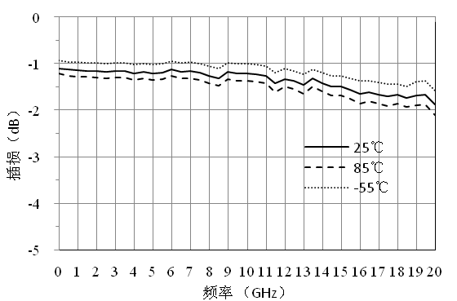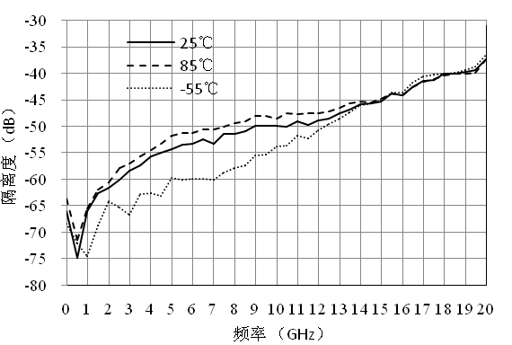

Input return loss Vs temperature output return loss Vs temperature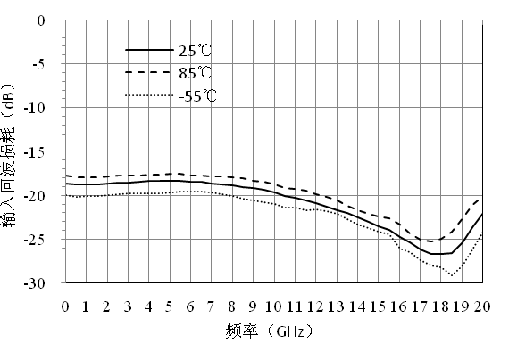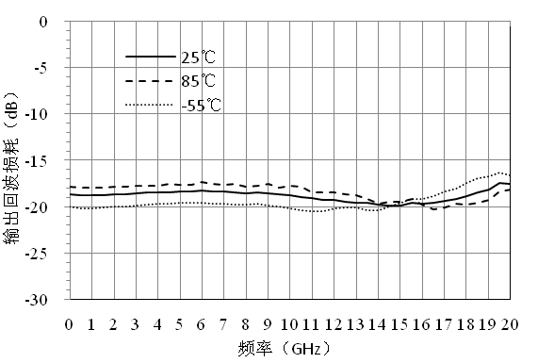
Size diagram：(unit mm)

Suggested assembly drawing：

Instructions:
Note: I/O no straight capacitance
Storage: The chip must be placed in a container with electrostatic protection and stored in a nitrogen environment.
Cleaning treatment: The bare chip must be operated and used in a purified environment. It is forbidden to use liquid cleaning agent to clean the chip.
Electrostatic protection: Strictly comply with the ESD protection requirements to avoid electrostatic damage to the components.
General operation: Use vacuum chuck or precision pointed tweezers to pick up the chip.Avoid touching the surface of the chip with tools or fingers during handling.
Mounting operation: The chip can be installed using AuSn solder eutectic welding or conductive adhesive bonding process.The mounting surface must be clean and flat.
Bonding operation: Input and output with 2 (recommended diameter of 25um gold wire) bonding wire, bonding wire length less than 250um is optimal.It is recommended to use the smallest possible ultrasonic energy.Bonding begins at the pressure point on the chip and ends at the package (or substrate).

Performance Characteristics:
- Frequency range: 100MHz~4GHz
- Insertion loss: 0.7dB
- Input return loss: 14dB
- Output return loss: 14dB
- Isolation degree: 40dB
- Chip size: 1.38mm×1.0mm×0.1mm
Product Description：
CW-SW200104 is a GaAs MMIC positive pressure absorption single-pole two-throw switch chip that provides less than 1dB of insertion loss and greater than 38dB of isolation in the frequency range of 100 MHZ to 4GHz.The CW-SW200104 uses +5V power supply.
Electrical parameters：( TA=25℃,VDD=+5V)
Index | Minimum | Typical value | Maximum value | Units
Radio frequency | 0.1~4 |  |  | GHz
Insertion loss | - | 0.7 | 1 | dB
Input return loss | - | 14 | - | dB
Output return loss | - | 14 | - | dB
isolation | 38 | 40 | - | dB
Enter P1dB | - | 25 | - | dBm
Use limiting parameters：
Maximum input power | 30dBm
Storage temperature | -65℃-150℃
Service temperature | -55℃-85℃
Switch truth table：
VDD | VCTL | RF1 | RF2
5 | 0 | OFF | ON
5 | 5 | ON | OFF

Typical curves:
RF1-ON RF2-OFF
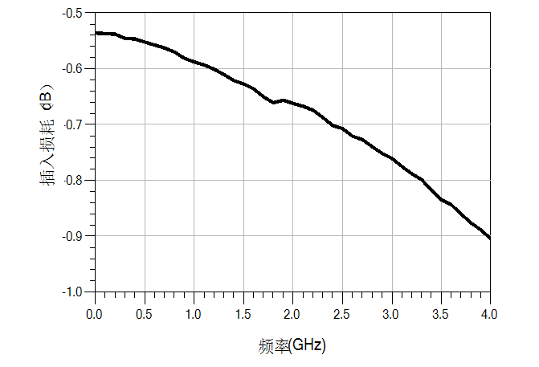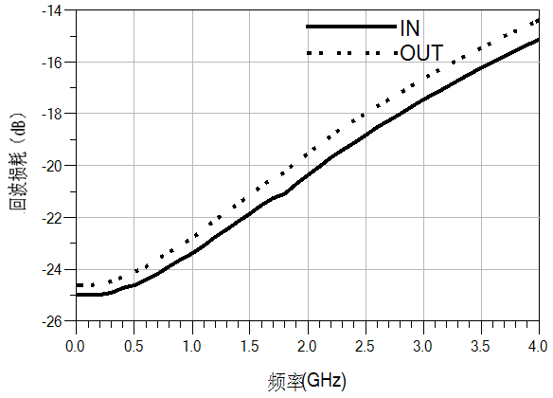
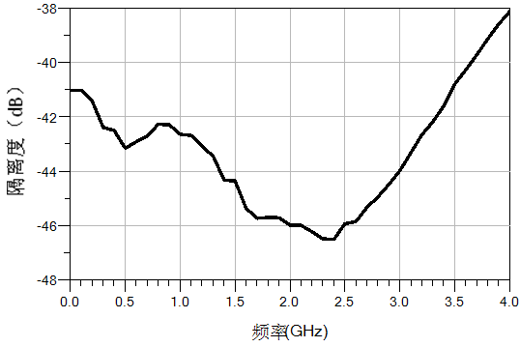
RF1-OFF RF2-ON
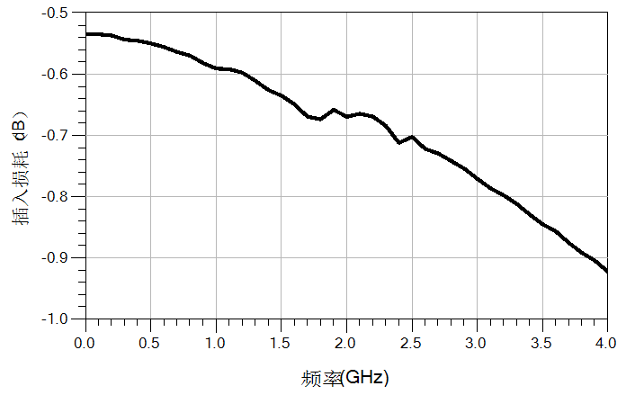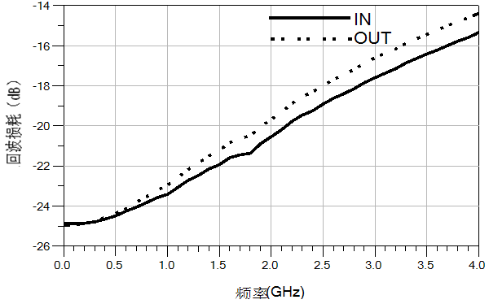

Size drawing: (unit mm)
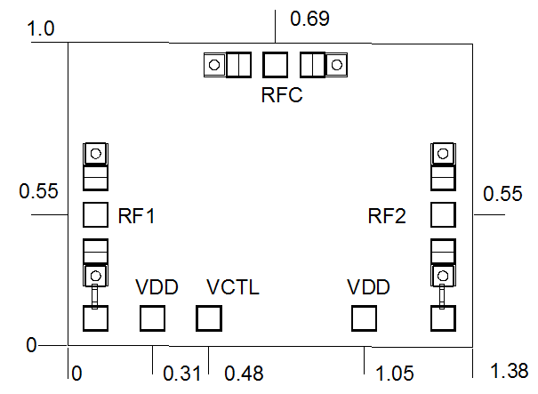

Suggested assembly drawing:
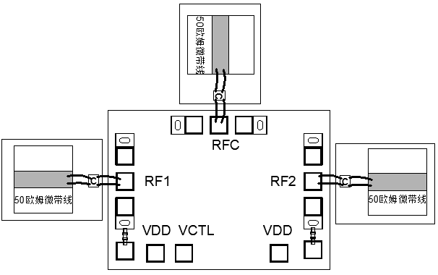
Instructions:
Note: I/O no straight capacitance, all C capacitance value size is 100PF.
Storage: The chip must be placed in a container with electrostatic protection and stored in a nitrogen environment.
Cleaning treatment: The bare chip must be operated and used in a purified environment. It is forbidden to use liquid cleaning agent to clean the chip.
Electrostatic protection: Strictly comply with the ESD protection requirements to avoid electrostatic damage to the components.
General operation: Use vacuum chuck or precision pointed tweezers to pick up the chip.Avoid touching the surface of the chip with tools or fingers during handling.
Mounting operation: The chip can be installed using AuSn solder eutectic welding or conductive adhesive bonding process.The mounting surface must be clean and flat.
Bonding operation: Input and output with 2 (recommended diameter of 25um gold wire) bonding wire, bonding wire length less than 250um is optimal.It is recommended to use the smallest possible ultrasonic energy.Bonding begins at the pressure point on the chip and ends at the package (or substrate).
Performance Characteristics：
- Frequency band: 2-18GHz
- Insertion loss: 6.3dB
- Open-state standing wave ratio: 1.5
- Off standing wave ratio: 1.5
- Enter P1dB: 28dBm
- Control mode: 0/-5V control
- Chip size: 2.3mm×2.0mm×0.1mm
Product Description:
CW-SW0218A2 is a GaAs MMIC switching matrix chip with frequency range covering 2-18GHz, overall insertion loss less than 6.3dB, 0/-5V control, mainly used in electronic warfare, radar and other fields of switching network components.
Electrical parameters：( TA=25℃，)
Index | Minimum | Typical value | Maximum value | Units
Frequency range | 2-18 |  |  | GHz
Insertion loss | - | - | 6.3 | dB
Open standing wave ratio | - | 1.5 | - | -
Off standing wave ratio | - | 1.5 | - | dB
Enter P1dB | - | 28 | - | dBm
Use limiting parameters：
Input power | 30dBm
Control voltage | -6V
Storage temperature | -65℃~150℃
Service temperature | -55℃~85℃

Typical curve:
Insertion loss open-state standing wave ratio
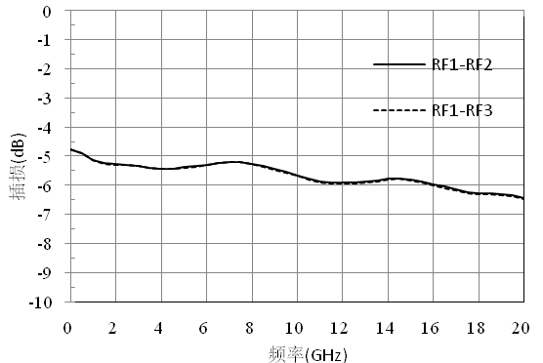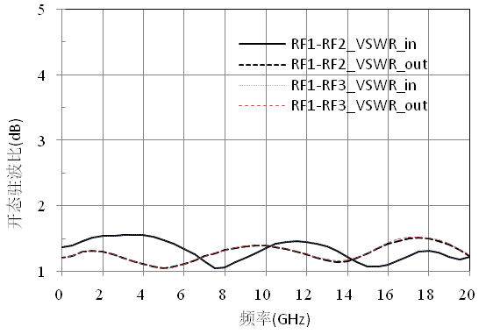

isolation off standing wave ratio
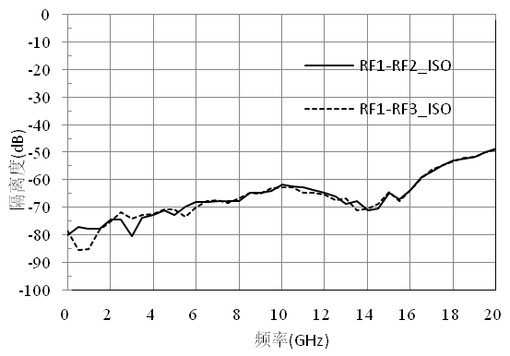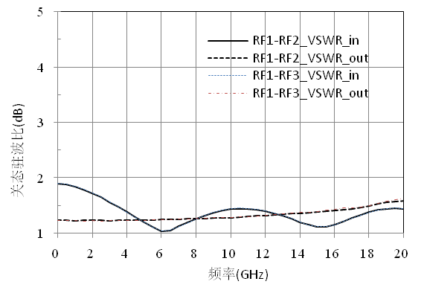
Truth table：
VA1 | VB1 | RF1-RF2 | VA2 | VB2 | RF1-RF3
0 | -5 | OFF | 0 | -5 | OFF
-5 | 0 | ON | -5 | 0 | ON
Note:
1, chip VA1, VB1 and VA2, VB2, respectively control their side switch off.
2, the two switches can be controlled separately, without interference.

Size diagram: (unit mm)
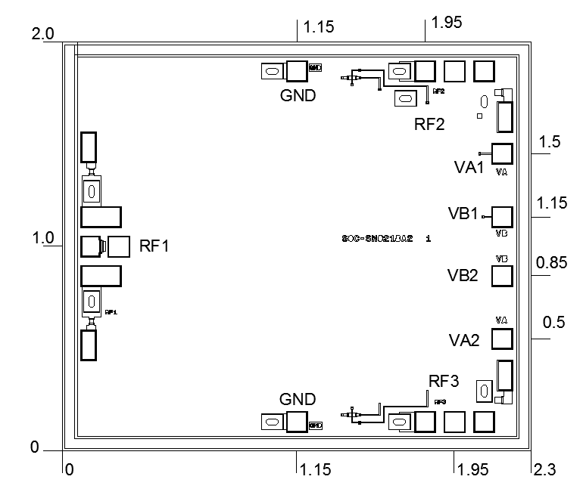
Suggested assembly drawing:
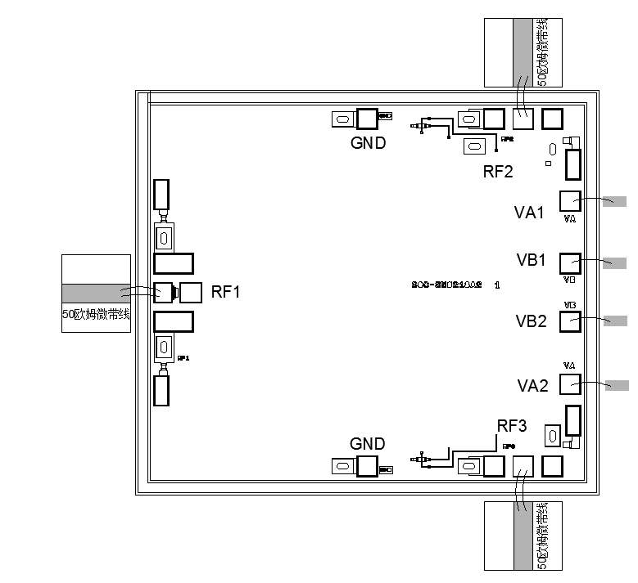
Instructions:
Storage: The chip must be placed in a container with electrostatic protection and stored in a nitrogen environment.
Cleaning treatment: The bare chip must be operated and used in a purified environment. It is forbidden to use liquid cleaning agent to clean the chip.
Electrostatic protection: Strictly comply with the ESD protection requirements to avoid electrostatic damage to the components.
General operation: Use vacuum chuck or precision pointed tweezers to pick up the chip.Avoid touching the surface of the chip with tools or fingers during handling.
Mounting operation: The chip can be installed using AuSn solder eutectic welding or conductive adhesive bonding process.The mounting surface must be clean and flat.
Bonding operation: Input and output with 2 (recommended diameter of 25um gold wire) bonding wire, bonding wire length less than 250um is optimal.It is recommended to use the smallest possible ultrasonic energy.Bonding begins at the pressure point on the chip and ends at the package (or substrate).

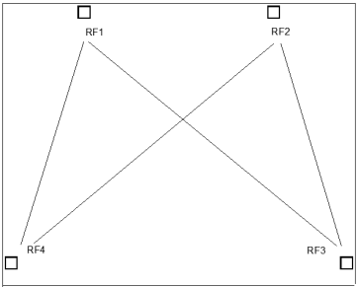
Performance Characteristics：
- Frequency band: 2~18GHz
- Insertion loss: 6.0dB
- Isolation: 45dB
- Enter P1dB: 18dBm
- V1, V2, V3, V4 at 0/-5V different power supply switch path
- Chip size: 3.1mm×2.5mm×0.1mm
Product Description:
CW-SW0218A4 is a GaAs MMIC single pole double throw matching switch chip with a frequency range of 2~18GHz and an entire in-band insertion loss of less than 6.0dB.V1, V2, V3, V4 switch switch paths at 0/-5V different power supply.
Electrical parameters：( TA=25℃)
Indicators | Minimum | Typical value | Maximum value | Units
Frequency range | 2~18 |  |  | GHz
Insertion loss | - | - | 6.0 | dB
isolation | 45 | - | - | dB
Use limiting parameters：
Input power | +27dBm
Storage temperature | -65℃~150℃
Service temperature | -55℃~125℃
Typical curve:
RF1-RF4 RF2-RF4—ON

RF1-RF4 RF2-RF3—ON
RF1-RF3 RF2-RF4—ON

RF1-RF3 RF2-RF3—ON

Size drawing：(unit mm)
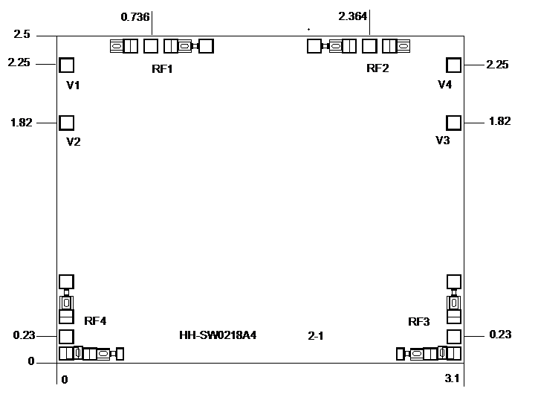
Suggested assembly drawing:
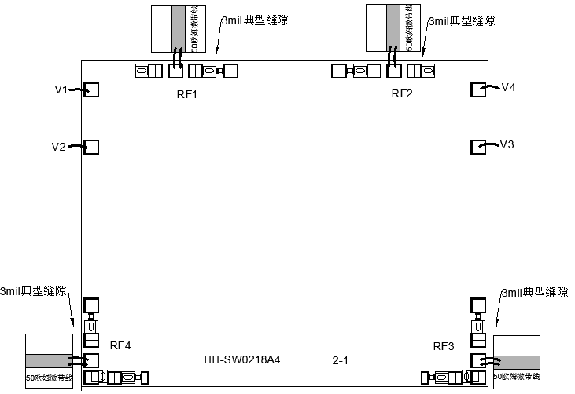

Truth table:
V1 | V2 | V3 | V4 | ON | OFF
0 | -5 | 0 | -5 | RF1→RF4  RF2→RF4 | RF1→RF3  RF2→RF3
0 | -5 | -5 | 0 | RF1→RF4  RF2→RF3 | RF1→RF3  RF2→RF4
-5 | 0 | 0 | -5 | RF1→RF3  RF2→RF4 | RF1→RF4  RF2→RF3
-5 | 0 | -5 | 0 | RF1→RF3  RF2→RF3 | RF1→RF4  RF2→RF4

Instructions:
Storage: The chip must be placed in a container with electrostatic protection and stored in a nitrogen environment.
Cleaning treatment: The bare chip must be operated and used in a purified environment. It is forbidden to use liquid cleaning agent to clean the chip.
Electrostatic protection: Strictly comply with the ESD protection requirements to avoid electrostatic damage to the components.
General operation: Use vacuum chuck or precision pointed tweezers to pick up the chip.Avoid touching the surface of the chip with tools or fingers during handling.
Mounting operation: The chip can be installed using AuSn solder eutectic welding or conductive adhesive bonding process.The mounting surface must be clean and flat.
Bonding operation: Input and output with 2 (recommended diameter of 25um gold wire) bonding wire, bonding wire length less than 250um is optimal.It is recommended to use the smallest possible ultrasonic energy.Bonding begins at the pressure point on the chip and ends at the package (or substrate).

Performance Characteristics:
- Frequency band: 2~20GHz
- Isolation: 38dB
- Insertion loss: 3.0dB
- Enter P1dB: 16dBm
- Input standing wave (open state) : 1.6
- Output standing wave (open state) : 1.8
- VEE=-5V, A1/A2, mirror B1/B2 different power supply switching switch path
- Chip size: 1.5mm x 1.55mm x 0.1mm
Product Description：
The CW-SW30220 is a GaAs MMIC band control single-pole three-throw switch chip with a frequency range covering 2 to 20 GHZ and an entire band insertion loss of less than 3.0dB.Adopt VEE=-5V, A1/A2, mirror B1/B2 different power supply switching switch path.
Electrical parameters :( TA=25℃，VEE=-5V)
Indicators | Minimum | Typical value | Maximum value | Units
Frequency range | 2~20 |  |  | GHz
Insertion loss | - | - | 3.0 | dB
isolation | 38 | - | - | dB
Input standing wave (open state) | - | - | 1.6 | -
Output standing wave (open state) | - | - | 1.8 | -
Enter P1dB | 16 | - | - | dBm
Use limiting parameters：
Input power | +20dBm
Storage temperature | -65℃~150℃
Service temperature | -55℃~85℃

Typical curves (not mirrored)：
OUT1-ON
Insert loss I/O standing wave
isolation
OUT2-ON
Insert loss I/O standing wave

isolation
OUT3-ON
Insertion loss I/O standing wave
isolation

Typical curve (mirror image)：
OUT1-ON
Insert loss I/O standing wave
isolation
OUT2-ON
Insert loss I/O standing wave

isolation
OUT3-ON
Insertion loss I/O standing wave
isolation

Size drawing：(unit mm)
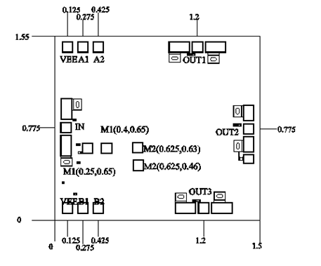
Suggested assembly drawing：
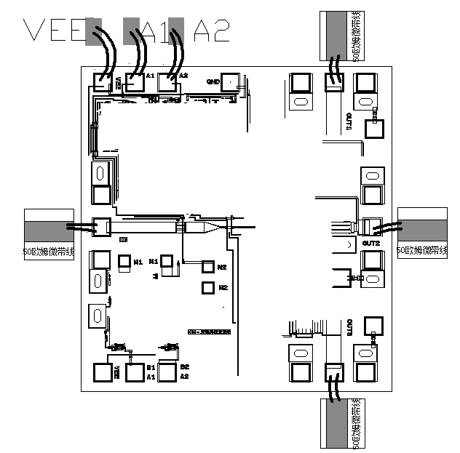
Truth table:
VEE | A1 | A2 | OUT1 | OUT2 | OUT3
-5 | 0 | 0 | ON | OFF | OFF
-5 | 0 | 5 | OFF | ON | OFF
-5 | 5 | 5 | OFF | OFF | ON
Note:
1.VEE with -5V voltage;A1/A2 different power supply switching channel;
2. Add -5V voltage when mirroring;B1/B2 different power supply switching switch paths, which need to connect M1 to M1, M2 to M2 with gold wire (note: red connection line in the assembly drawing).
Recommended assembly drawing of cascade chip：
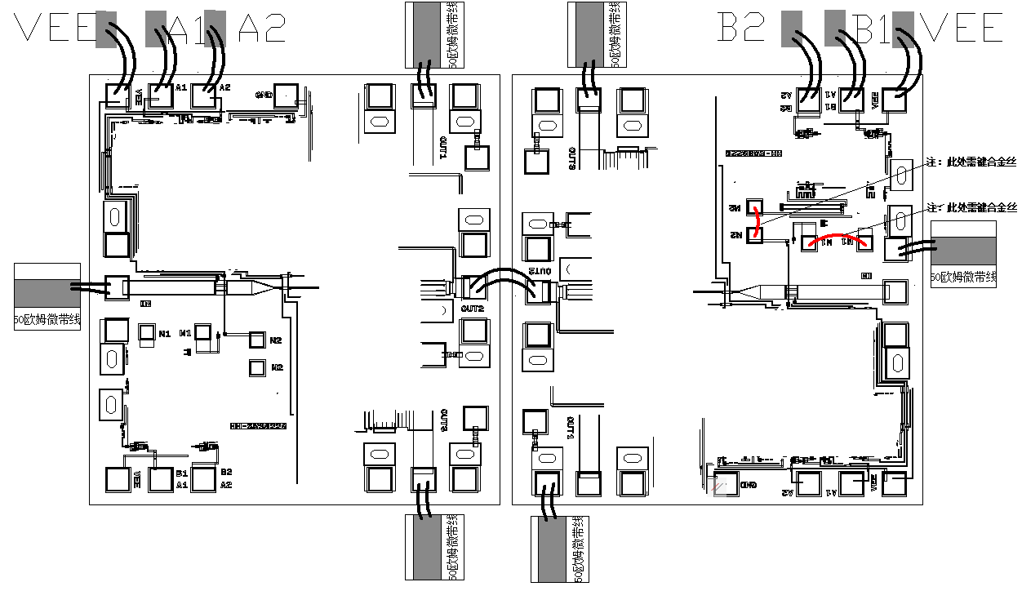
Truth table:
VEE | A1 | A2 | OUT1 | OUT2 | OUT3
-5 | 0 | 0 | ON | OFF | OFF
-5 | 0 | 5 | OFF | ON | OFF
-5 | 5 | 5 | OFF | OFF | ON
Mirrored truth table:
VEE | B1 | B2 | OUT1 | OUT2 | OUT3
-5 | 5 | 5 | ON | OFF | OFF
-5 | 5 | 0 | OFF | ON | OFF
-5 | 0 | 0 | OFF | OFF | ON
Instructions for use:
Storage: The chip must be placed in a container with electrostatic protection and stored in a nitrogen environment.
Cleaning treatment: The bare chip must be operated and used in a purified environment. It is forbidden to use liquid cleaning agent to clean the chip.
Electrostatic protection: Strictly comply with the ESD protection requirements to avoid electrostatic damage to the components.
General operation: Use vacuum chuck or precision pointed tweezers to pick up the chip.Avoid touching the surface of the chip with tools or fingers during handling.
Mounting operation: The chip can be installed using AuSn solder eutectic welding or conductive adhesive bonding process.The mounting surface must be clean and flat.
Bonding operation: Input and output with 2 (recommended diameter of 25um gold wire) bonding wire, bonding wire length less than 250um is optimal.It is recommended to use the smallest possible ultrasonic energy.Bonding begins at the pressure point on the chip and ends at the package (or substrate).
Performance Characteristics：

开
关

2
3

open
guan

2
3

- Frequency range: 2-20GHz
- Insertion loss: 3.4dB
- Isolation: 39dB
- Input/output standing wave: 1.7
- Chip size: 2.05mm x 2.0mm x 0.1mm
Product Description：
The CW-SW40220 is a single-pole four-throw switch chip that provides less than 3.4dB of insertion loss and greater than 39dB of isolation in the 2-20GHz frequency range.
Electrical parameters：( T_{A}=25℃)
Indicators | Minimum | Typical value | Maximum value | Units
Frequency range | 2-20 |  |  | GHz
Insertion loss | - | - | 3.4 | dB
isolation | 39 | - | - | dB
Input standing wave (open state) | - | - | 1.7 | dB
Output standing wave (open state) | - | - | 1.7 | dB
Use limiting parameters：
Maximum input power | 27dBm
Storage temperature | -65℃-150℃
Service temperature | -55℃-125℃
Truth table:
Non-mirrored version truth table：
VEE | A1 | A2 | RF2 | RF3 | RF4 | RF5
-5 | 0 | 0 | ON | OFF | OFF | OFF
-5 | 0 | 5 | OFF | ON | OFF | OFF
-5 | 5 | 0 | OFF | OFF | ON | OFF
-5 | 5 | 5 | OFF | OFF | OFF | ON

Mirrored version truth table:
VEE | B1 | B2 | RF2 | RF3 | RF4 | RF5
-5 | 5 | 5 | ON | OFF | OFF | OFF
-5 | 5 | 0 | OFF | ON | OFF | OFF
-5 | 0 | 5 | OFF | OFF | ON | OFF
-5 | 0 | 0 | OFF | OFF | OFF | ON
Typical curves:
Non-mirrored version curves:
First way
Insertion loss I/O standing wave
isolation

Second way
Insertion loss input-output standing wave
isolation
Third way
Insertion loss input-output standing wave

隔离度

Fourth way
Insertion loss input-output standing wave
isolation

Mirrored version curve:
First way
Insertion loss I/O standing wave
isolation

Second way
Insertion loss input-output standing wave

isolation

Third way
Insertion loss input-output standing wave
isolation

Fourth way
Insertion loss input-output standing wave
isolation

Size drawing：(unit mm)
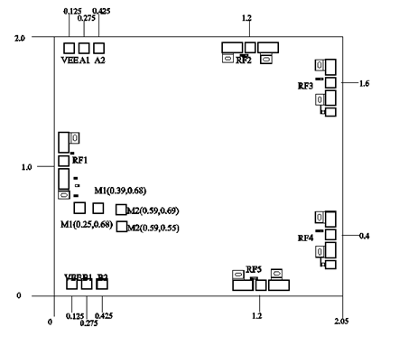

Suggested assembly drawing:
Non-mirrored version assembly drawing

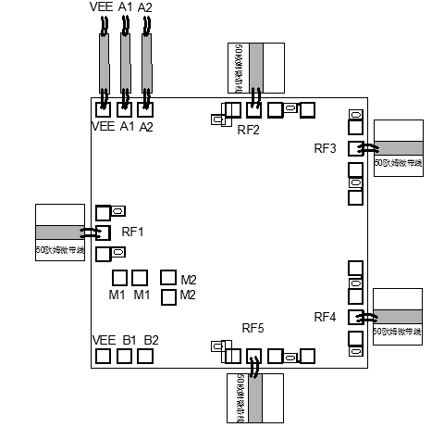
When not mirrored, the chip instructions:
1. IN and OUT port gold wire diameter 25um, the best length is 300μm;
2. VEE plus -5V voltage;A1/A2 different power supply switching channel;
3. Pay attention to ESD protection of all ports during use.

Mirror version assembly drawing
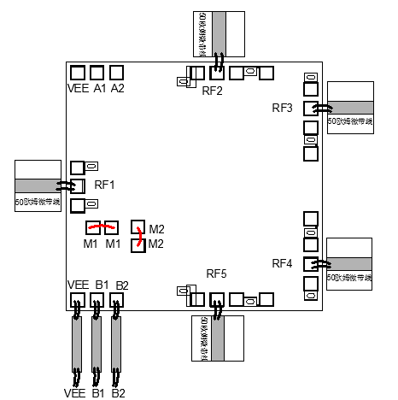

Mirrored version, chip instructions:
1. IN and OUT port gold wire diameter 25um, the best length is 300μm;
2. Add -5V voltage when mirroring;B1/B2 different power supply switching switches, which need to connect M1 to M1, M2 to M2 with gold wire connection.
Instructions for use:
Note: I/O no straight capacitance
Storage: The chip must be placed in a container with electrostatic protection and stored in a nitrogen environment.
Cleaning treatment: The bare chip must be operated and used in a purified environment. It is forbidden to use liquid cleaning agent to clean the chip.
Electrostatic protection: Strictly comply with the ESD protection requirements to avoid electrostatic damage to the components.
General operation: Use vacuum chuck or precision pointed tweezers to pick up the chip.Avoid touching the surface of the chip with tools or fingers during handling.
Mounting operation: The chip can be installed using AuSn solder eutectic welding or conductive adhesive bonding process.The mounting surface must be clean and flat.
Bonding operation: Input and output with 2 (recommended diameter of 25um gold wire) bonding wire, bonding wire length less than 250um is optimal.It is recommended to use the smallest possible ultrasonic energy.Bonding begins at the pressure point on the chip and ends at the package (or substrate).
Performance Characteristics：
- Frequency: 2~20GHz
- Insertion loss: 5 dB
- Isolation: 40dB
- I/O return loss: 10dB
- Chip size: 3.1mm×1.8mm×0.1mm
Product Description:
CW-SW60220-A01 is a GaAs MMIC reflex single-pole six-throw switch chip with frequency range covering 2~20GHz, insertion loss less than 5dB, isolation greater than 40dB, CW-SW60220-A01 adopts TTL logic control.
Electrical parameters：( TA=25℃，VEE=-5V)
Indicators | Minimum | Typical value | Maximum value | Units
Frequency range | 2~20 |  |  | GHz
Insertion loss |  | 3.5 | 5 | dB
isolation | 40 | 45 |  | dB
Input return loss |  | 14 |  | dB
Output return loss |  | 13 |  | dB
Use limiting parameters：
Input power | +30dBm
Storage temperature | -65℃~150℃
Service temperature | -55℃~125℃
Truth table：
VEE | A1 | A2 | A3 | OUT1 | OUT2 | OUT3 | OUT4 | OUT5 | OUT6
-5 | 0 | 0 | 0 | ON | OFF | OFF | OFF | OFF | OFF
-5 | 0 | 0 | 5 | OFF | ON | OFF | OFF | OFF | OFF
-5 | 0 | 5 | 0 | OFF | OFF | ON | OFF | OFF | OFF
-5 | 5 | 0 | 5 | OFF | OFF | OFF | ON | OFF | OFF
-5 | 5 | 5 | 0 | OFF | OFF | OFF | OFF | ON | OFF
-5 | 5 | 5 | 5 | OFF | OFF | OFF | OFF | OFF | ON

VEE | B1 | B2 | B3 | OUT1 | OUT2 | OUT3 | OUT4 | OUT5 | OUT6
-5 | 5 | 5 | 5 | ON | OFF | OFF | OFF | OFF | OFF
-5 | 0 | 5 | 5 | OFF | ON | OFF | OFF | OFF | OFF
-5 | 5 | 0 | 5 | OFF | OFF | ON | OFF | OFF | OFF
-5 | 0 | 5 | 0 | OFF | OFF | OFF | ON | OFF | OFF
-5 | 5 | 0 | 0 | OFF | OFF | OFF | OFF | ON | OFF
-5 | 0 | 0 | 0 | OFF | OFF | OFF | OFF | OFF | ON

Typical curves：
Insertion loss vs frequency OUT1 open isolation VS Frequency
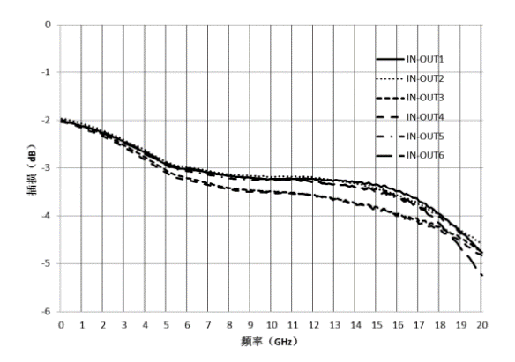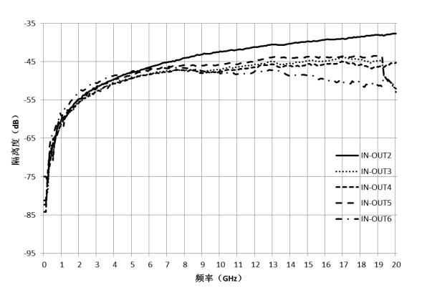
OUT2 on isolation vs Frequency OUT3 on isolation VS Frequency
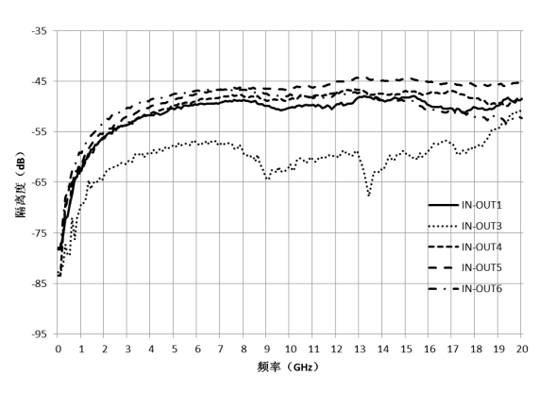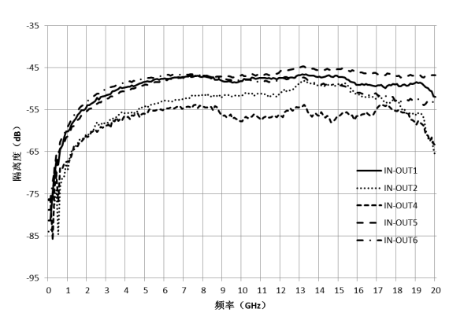
OUT4 open isolation vs Frequency OUT5 open isolation VS Frequency
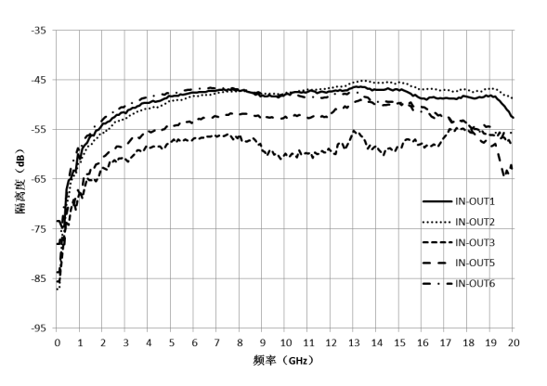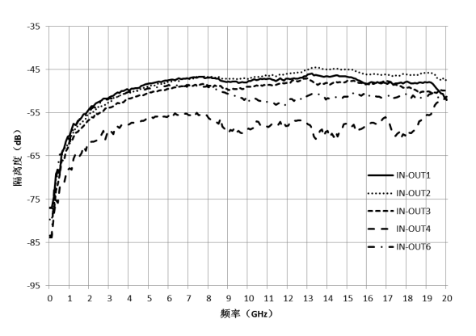

OUT6 open isolation vs frequency input return loss VS Frequency 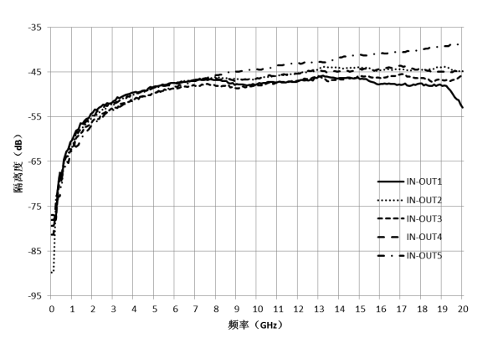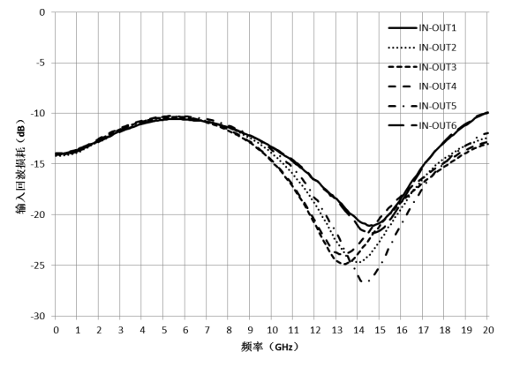
Output return loss VS frequency
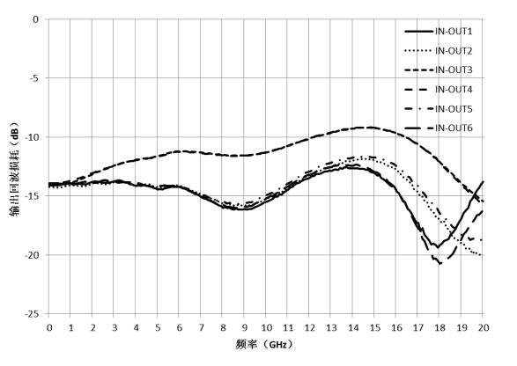
Size diagram：（unit mm）
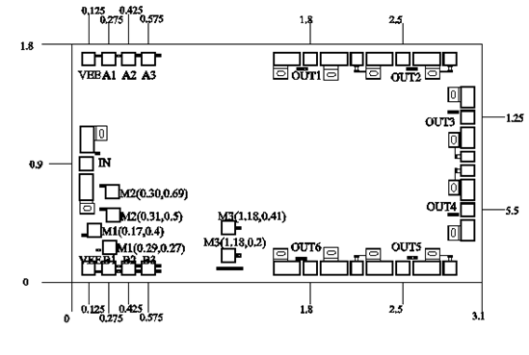

Suggested assembly drawing:
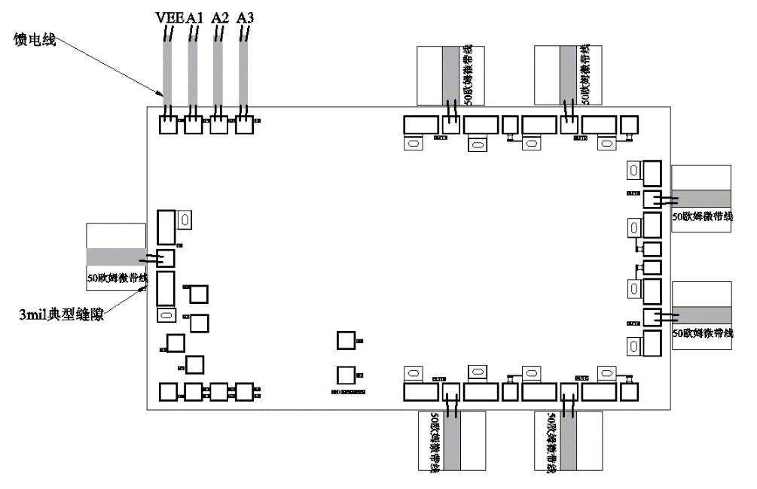
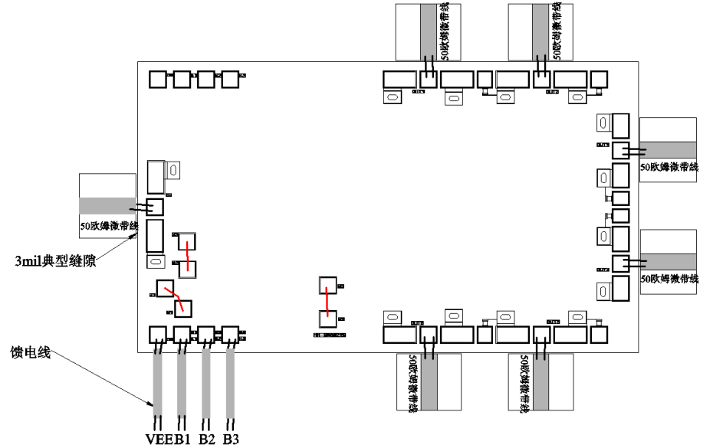
Instructions:
Note: I/O no straight capacitance
Storage: The chip must be placed in a container with electrostatic protection and stored in a nitrogen environment.
Cleaning treatment: The bare chip must be operated and used in a purified environment. It is forbidden to use liquid cleaning agent to clean the chip.
Electrostatic protection: Strictly comply with the ESD protection requirements to avoid electrostatic damage to the components.
General operation: Use vacuum chuck or precision pointed tweezers to pick up the chip.Avoid touching the surface of the chip with tools or fingers during handling.
Mounting operation: The chip can be installed using AuSn solder eutectic welding or conductive adhesive bonding process.The mounting surface must be clean and flat.
Bonding operation: Input and output with 2 (recommended diameter of 25um gold wire) bonding wire, bonding wire length less than 250um is optimal.It is recommended to use the smallest possible ultrasonic energy.Bonding begins at the pressure point on the chip and ends at the package (or substrate).
Performance Characteristics：
- Frequency: 2.6~3.5GHz
- Insertion loss: 0.7dB
- Isolation degree: 47dB
- I/O return loss: 15dB
- Chip size: 1.0mm×1.0mm×0.1mm
Product Description：
CW-SW206305 is a GaAs MMIC matching single-pole double-throw switch chip, the frequency range covers 2.6~3.5GHz, the insertion loss is less than 0.7dB, the isolation is greater than 45dB, the CW-SW206305 adopts TTL logic control.
Electrical parameters：( TA=25℃，VEE=-5V)
Indicators | Minimum | Typical value | Maximum value | Units
Frequency range | 2.6~3.5 |  |  | GHz
Insertion loss |  | 0.5 | 0.7 | dB
isolation |  | 47 |  | dB
Input return loss |  | 15 |  | dB
Output return loss |  | 15 |  | dB
Use limiting parameters：
Input power | +30dBm
Storage temperature | -65℃~150℃
Service temperature | -55℃~85℃
Truth table：
VEE | A1 | OUT1 | OUT2
-5 | 5 | ON | OFF
-5 | 0 | OFF | ON

Typical curves：
Insertion loss vs frequency isolation VS Frequency
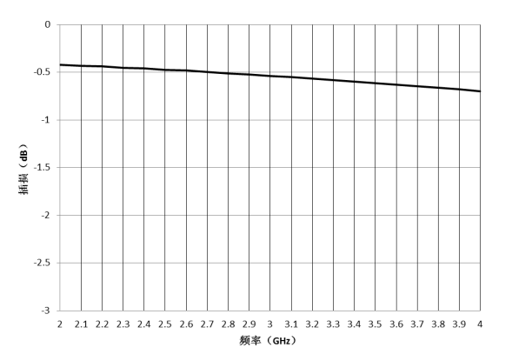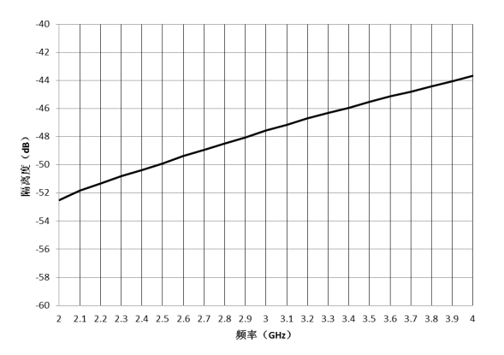
Input return loss vs frequency output return loss VS Frequency
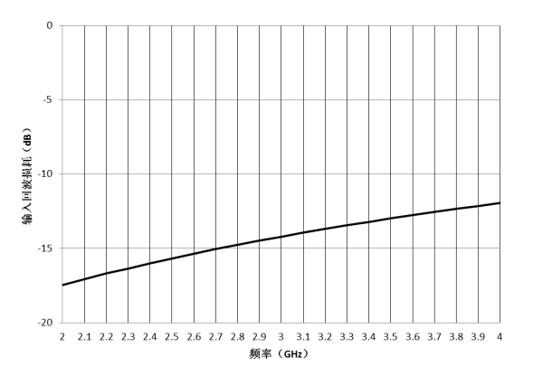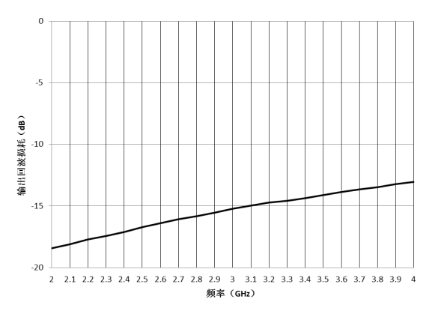
Size chart：（unit mm）
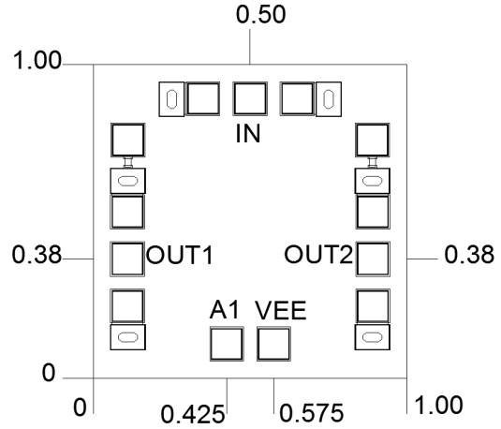

Suggested assembly drawing：
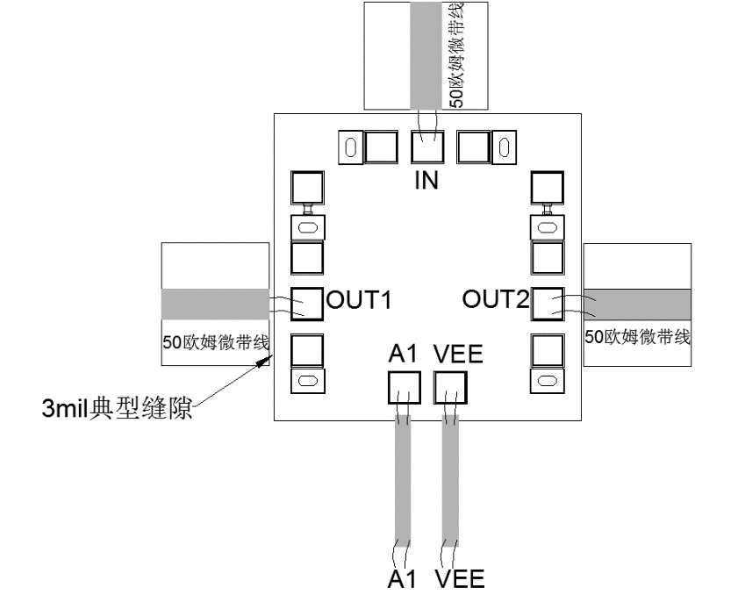
Instructions:
Note: I/O no straight capacitance
Storage: The chip must be placed in a container with electrostatic protection and stored in a nitrogen environment.
Cleaning treatment: The bare chip must be operated and used in a purified environment. It is forbidden to use liquid cleaning agent to clean the chip.
Electrostatic protection: Strictly comply with the ESD protection requirements to avoid electrostatic damage to the components.
General operation: Use vacuum chuck or precision pointed tweezers to pick up the chip.Avoid touching the surface of the chip with tools or fingers during handling.
Mounting operation: The chip can be installed using AuSn solder eutectic welding or conductive adhesive bonding process.The mounting surface must be clean and flat.
Bonding operation: Input and output with 2 (recommended diameter of 25um gold wire) bonding wire, bonding wire length less than 250um is optimal.It is recommended to use the smallest possible ultrasonic energy.Bonding begins at the pressure point on the chip and ends at the package (or substrate).
Performance Characteristics：
- Insertion loss: 1.5dB@20GHz
- Isolation: 50dB@20GHz
- Matching design
- Chip size: 1.5mm x 1.0mm x 0.1mm
Product Description：
The CW-SW10020B is a GaAs MMIC SPST matching switch with a frequency range of DC-20GHz and isolation 50dB@20GHz.
Electrical parameters：( TA=25℃,VCTL=0V/-5V)
Index | Minimum | Typical value | Maximum value | Units
Frequency range | DC-20 |  |  | GHz
Insertion loss |  | 1.5 |  | dB
isolation |  | 50 |  | dB
Return loss "on state" |  | 22 |  | dB
Return loss "off state" |  | 22 |  | dB
Input power 1dB compression point |  | 25 |  | dBm
Switching time |  | 15 |  | ns
Use limit parameters：
Input power | +30dBm
Storage temperature | -65℃-175℃
Service temperature | -55℃-85℃
Typical curve：
Insertion loss isolation
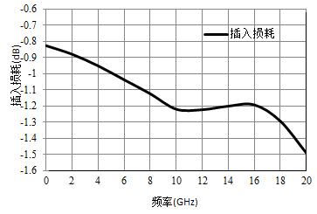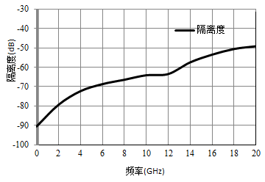

Return loss, "ON" state Return loss, "OFF" state
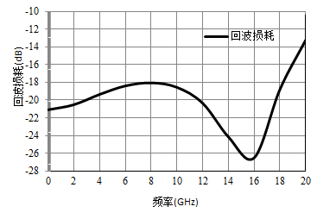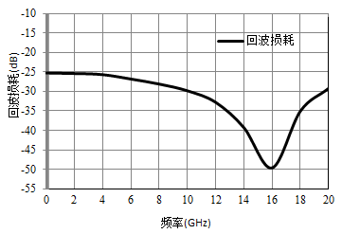
Size drawing：(unit mm)
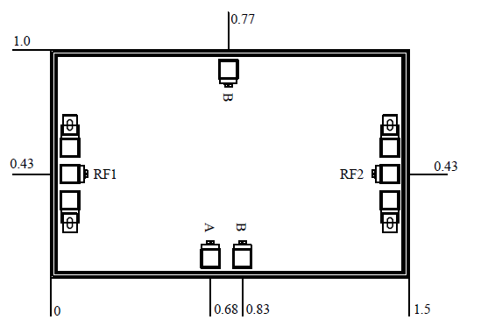

Truth table：

4

Functions | A | B
ON | 0V | -5V
OFF | -5V | 0V
Suggested assembly drawing：
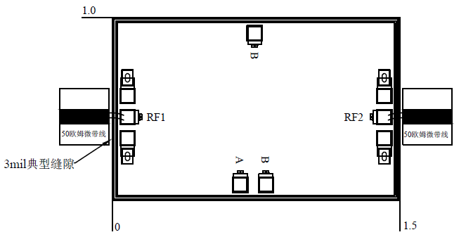

Instructions:
Storage: The chip must be placed in a container with electrostatic protection and stored in a nitrogen environment.
Cleaning treatment: The bare chip must be operated and used in a purified environment. It is forbidden to use liquid cleaning agent to clean the chip.
Electrostatic protection: Strictly comply with the ESD protection requirements to avoid electrostatic damage to the components.
General operation: Use vacuum chuck or precision pointed tweezers to pick up the chip.Avoid touching the surface of the chip with tools or fingers during handling.
Mounting operation: The chip can be installed using AuSn solder eutectic welding or conductive adhesive bonding process.The mounting surface must be clean and flat.
Bonding operation: Input and output with 2 (recommended diameter of 25um gold wire) bonding wire, bonding wire length less than 250um is optimal.It is recommended to use the smallest possible ultrasonic energy.Bonding begins at the pressure point on the chip and ends at the package (or substrate).
Performance Characteristics：
- Frequency band: DC~20GHz
- Insertion loss: ≤2.0dB@20 GHz
- Type: Absorption single pole triple throw
- Open input/output return loss: ≥13/≥17dB
- Chip size: 1.50mm×1.50mm×0.1mm
Product Description：
CW-SW30020 is a GaAs single-pole three-throw absorption switch chip. The chip has the characteristics of small strip insertion loss, small size and easy integration.Its frequency range covers DC~20GHz and the insertion loss is less than 2.3dB.
Electrical parameters：( TA=25℃）
Parameter name | Frequency (GHz) | Min | Typ | Max | Units
Insertion damage | DC~20 |  | 1.5 | 2.0 | dB
isolation | DC~20 |  | 50 |  | dB
Return loss (ON) | DC~20（RF_IN） | 13 | 20 |  | dB
Return loss (ON) | DC~20（RF1/RF2/RF3） | 17 | 22 |  | dB
Return loss (OFF) | DC~20 | - | 20 |  | dB
Enter the 1dB compression point | DC~20 | - | 25 |  | dBm
Switching time | - | - | 10 |  | ns
Use limiting parameters：
Input power | +27dBm
Storage temperature | -65℃~175℃
Service temperature | -55℃~+85℃
Truth table：
V1 | V2 | V3 | V4 | V5 | V6 | ON
0 | -5 | -5 | -5 | 0 | 0 | RF_in to RFOUT1
-5 | 0 | 0 | -5 | -5 | 0 | RF_in to RFOUT2
-5 | -5 | 0 | 0 | 0 | -5 | RF_in to RFOUT3

Typical curves：
Insertion loss isolation
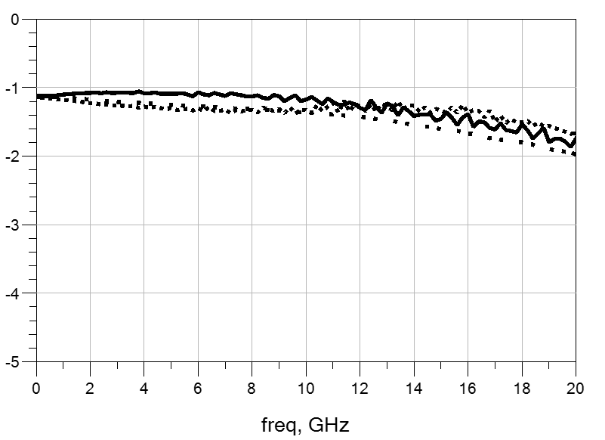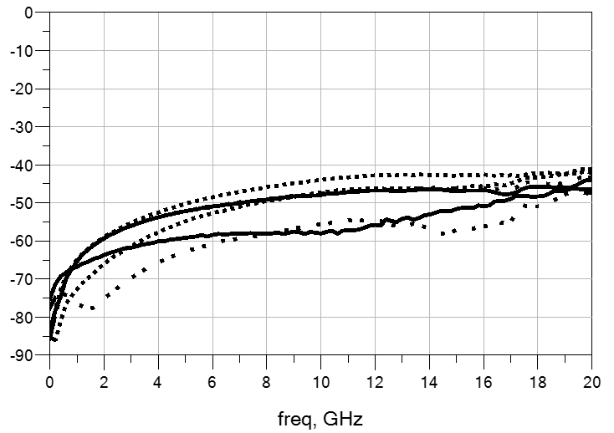
Open input return loss open output return loss
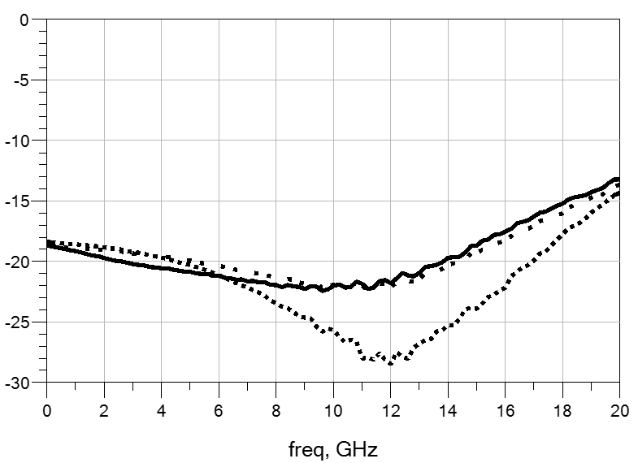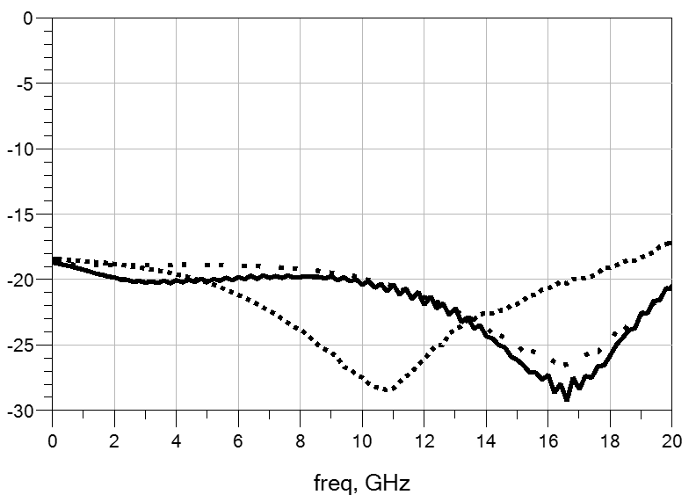
Off state output return loss
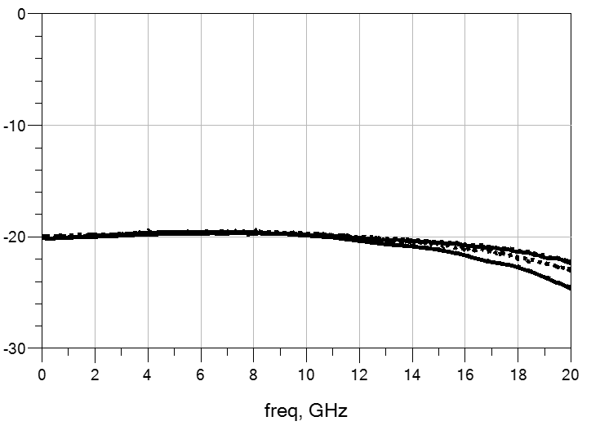

Size diagram：（unit mm）
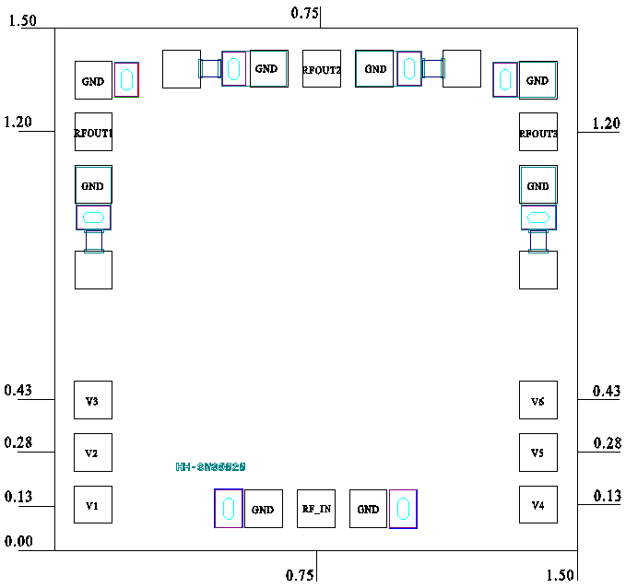

Suggested assembly drawing：

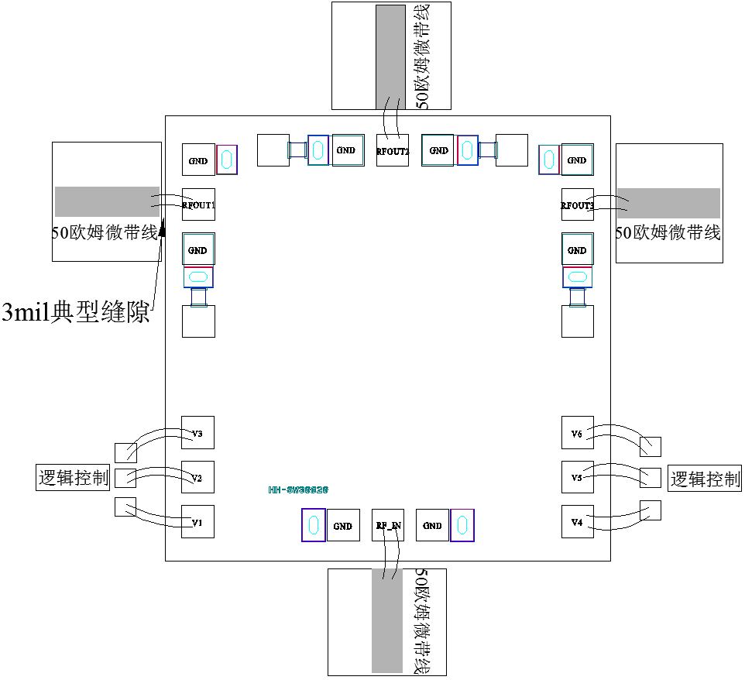

Instructions:
Storage: The chip must be placed in a container with electrostatic protection and stored in a nitrogen environment.
Cleaning treatment: The bare chip must be operated and used in a purified environment. It is forbidden to use liquid cleaning agent to clean the chip.
Electrostatic protection: Strictly comply with the ESD protection requirements to avoid electrostatic damage to the components.
General operation: Use vacuum chuck or precision pointed tweezers to pick up the chip.Avoid touching the surface of the chip with tools or fingers during handling.
Mounting operation: The chip can be installed using AuSn solder eutectic welding or conductive adhesive bonding process.The mounting surface must be clean and flat.
Bonding operation: Input and output each with 1 (recommended diameter of 25um gold wire) bonding wire, bonding wire length of 300um is optimal.It is recommended to use the smallest possible ultrasonic energy.Bonding begins at the pressure point on the chip and ends at the package (or substrate).

04 Drive Circuit
Number | Function | Output level (V)  Low high level | Input current  (mA) | Switching time  (ns) | Page number
CW-FEN1 | 1 bit negative pressure output FET drive | -5.1 -0.3 | 0.2 | 15
CW-FEN4 | 4 bit negative pressure output FET drive | -5.1 -0.3 | 0.2 | 15
CW-FEN1A | 1 bit negative pressure output FET drive | -5 0 | 0.2 | 14
CW-FEN4A | 4 bit negative pressure output FET drive | -5 0 | 1 | 16-25
CW-FEN6A | 6 bit FET drive | -5 0 | - | 16
CW-FEN6B | 6 bit FET drive | -5 0 | 1 | 14-25
CW-FEN6 | 6 bit FET drive | -5 0 | 1 | 16-25

Performance Characteristics:
- Output signal: -5V/0V
- Switching time: 20ns
- Chip size: 0.7mm×0.85mm×0.1mm
Product Description:
CW-FEN1 is a 1-bit negative pressure output FET driver chip, manufactured by GaAs process, which can generate the input TTL pulse signal to output the complementary pulse signal of -5.1V/-0.3V.The product can be widely used to control the FET switch, CNC attenuator, CNC phase shifter and other circuits.
Electrical parameters：( TA=25℃,VEE=-5V)
Indicators | Symbols | Minimum | Typical value | Maximum value | Units | Remarks
Static current | Iees | - | - | 1 | mA | -
Drive current | Io | - | 0.2 | - | mA | Related to load
Input current | Ii | - | 0.2 | - | mA | Single way
Output high level | Vh | -0.3 | - | - | V | Open circuit
Output low | Vl | -5.1 | - | - | V | Open circuit
Switching time | ts | - | 15 | - | ns | f=100KHz
Operating frequency | f | - | 10 | - | MHz | Load dependent
Truth table：
VEE=-5V
Model number | Enter (V) | Output (V)
Model number | A1 | 1A | 1B
CW-FEN1 | 0 | 0 | -5
CW-FEN1 | 5 | -5 | 0

Size drawing：(unit mm)
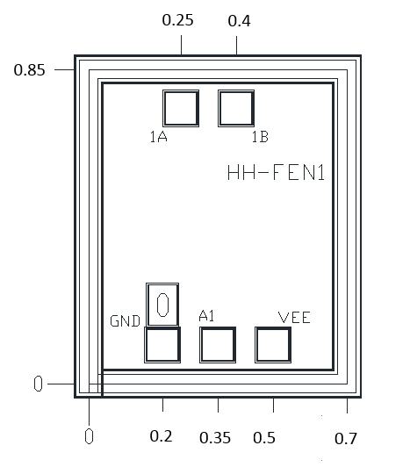

Suggested assembly drawing：

Instructions:
Storage: The chip must be placed in a container with electrostatic protection and stored in a nitrogen environment.
Cleaning treatment: The bare chip must be operated and used in a purified environment. It is forbidden to use liquid cleaning agent to clean the chip.
Electrostatic protection: Strictly comply with the ESD protection requirements to avoid electrostatic damage to the components.
General operation: Use vacuum chuck or precision pointed tweezers to pick up the chip.Avoid touching the surface of the chip with tools or fingers during handling.
Mounting operation: The chip can be installed using AuSn solder eutectic welding or conductive adhesive bonding process.The mounting surface must be clean and flat.
Bonding operation: Input and output with 2 (recommended diameter of 25um gold wire) bonding wire, bonding wire length less than 250um is optimal.It is recommended to use the smallest possible ultrasonic energy.Bonding begins at the pressure point on the chip and ends at the package (or substrate).

Performance Characteristics：
- Output signal: -5V-0V
- Switching time: 20ns
- Chip size: 1.36mm×0.9mm×0.1mm
Product Description：
CW-FEN4 is a 4-bit negative pressure output FET driver chip, manufactured by GaAs process, which can generate the input TTL pulse signal to output a complementary pulse signal of -5.1V/-0.3V.The product can be widely used to control the FET switch, CNC attenuator, CNC phase shifter and other circuits.
Electrical parameters：( TA=25℃,VEE=-5V)
Indicators | Symbols | Minimum | Typical value | Maximum value | Units | Remarks
Static current | Iees | - | - | 2 | mA | -
Drive current | Io | - | 0.2 | - | mA | Related to load
Input current | Ii | - | 0.2 | - | mA | Single way
Output high level | Vh | -0.3 | - | - | V | Open circuit
Output low | Vl | -5.1 | - | - | V | Open circuit
Switching time | ts | - | 15 | - | ns | f=100KHz
Operating frequency | f | - | 10 | - | MHz | Load dependent
Truth table：
VEE=-5V
Enter (V) | Output (V)
A1 | 1A | 1B
0 | -5 | 0
5 | 0 | -5
A2 | 2A | 2B
0 | -5 | 0
5 | 0 | -5
A3 | 3A | 3B
0 | -5 | 0
5 | 0 | -5
A4 | 4A | 4B
0 | -5 | 0
5 | 0 | -5

Size drawing：(unit mm)
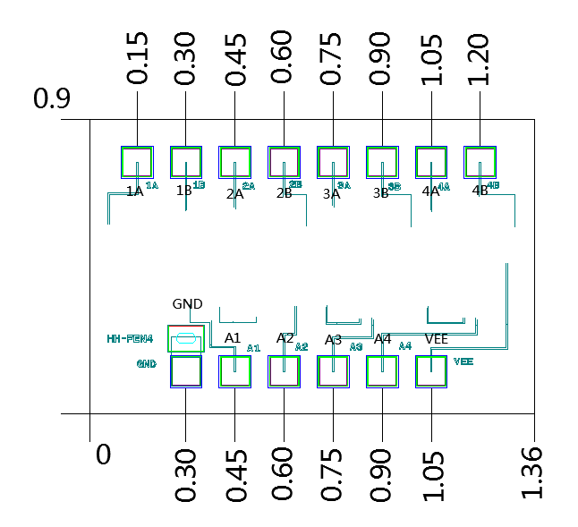

Suggested assembly drawing：
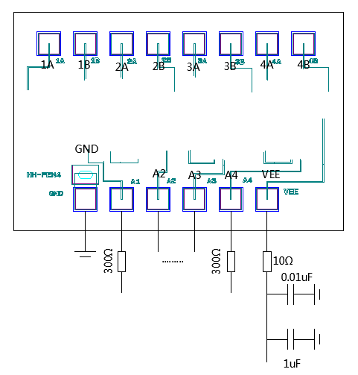
Instructions:
Storage: The chip must be placed in a container with electrostatic protection and stored in a nitrogen environment.
Cleaning treatment: The bare chip must be operated and used in a purified environment. It is forbidden to use liquid cleaning agent to clean the chip.
Electrostatic protection: Strictly comply with the ESD protection requirements to avoid electrostatic damage to the components.
General operation: Use vacuum chuck or precision pointed tweezers to pick up the chip.Avoid touching the surface of the chip with tools or fingers during handling.
Mounting operation: The chip can be installed using AuSn solder eutectic welding or conductive adhesive bonding process.The mounting surface must be clean and flat.
Bonding operation: Input and output with 2 (recommended diameter of 25um gold wire) bonding wire, bonding wire length less than 250um is optimal.It is recommended to use the smallest possible ultrasonic energy.Bonding begins at the pressure point on the chip and ends at the package (or substrate).
Performance Characteristics：
- Working mode: The input pulse signal is converted to the complementary signal output
- Operating voltage: -5V
- Input level: Compatible with TTL level
- Output level: 0/-5V
- Static current: 1mA
- Chip size: 0.6 x 1.13 x 0.1mm³
Product Description：
CW-FEN1A is a 1-bit negative pressure output FET driver chip, manufactured by GaAs technology, which can generate the input TTL pulse signal to output the complementary pulse signal of -5V/0V.The product can be widely used in the control of FET switch, CNC attenuator, CNC phase shifter and other circuits.
Electrical parameters：( TA=25℃, VEE=-5V)
Indicators | Symbols | Minimum | Typical value | Maximum value | Units | Remarks
Power supply voltage | V_{EE} | -5.5 | -5 | -4.5 | V | Normal operating voltage of the chip
Static current | I_{EE} | - | 1 | - | mA | The current of the chip after it is powered on -
Input high level | V_{IH} | 2.8 | 5 | 5 | V | Input voltage of the A1 pin, compatible with TTL levels
Input low level | V_{IL} | 0 | 0 | 0.4 | V | Input voltage of the A1 pin, compatible with TTL levels
Input current | I_{I} | - | 0.4 | - | mA | Related to load
Output high level | V_{OH} | - | 0 | - | V | Output voltage of the output port 1A and its reverse port 1B
Output low | V_{OL} | - | -5V | - | V | Output voltage of the output port 1A and its reverse port 1B
Output (drive) current | I_{O} | - | 2 | - | mA | Related to load
Operating frequency | f | 0 | 10 | 30 | MHz | Load dependent
Switching time | t | - | 14 | 25 | ns | -
Temperature | T_{A} | -55 | 25 | 86 | ℃ | -
Truth table：
Input | Output
A1 | 1A | 1B
Li | Lo | Ho
Hi | Ho | Lo
Note: Taking the input pulse level of 0/5V and the supply voltage of -5V as an example, Li means 0V, Hi means 5V, Lo means -5V, and Ho means 0V.
Use limit parameters：
Power supply voltage | -6V
Input high level | 5.5V
Input low | -0.5V
Storage temperature | -65℃~150℃

Typical usage：
Physical size drawing：(unit µm)

1
位
FET
驱
动
芯
片

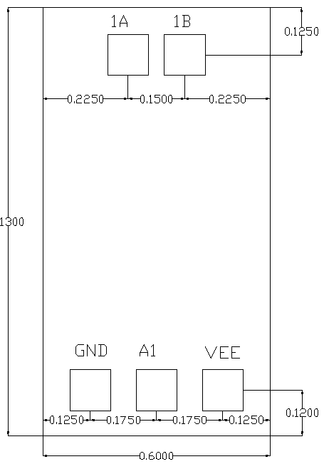
1

Pad description：
4

4

Pad number | Function | Description
1 | 1A | The pad is the pulse level output, in phase with the input pulse level
2 | 1B | The pad is the output end of the pulse level, inverting the input pulse
3 | VEE | The pad is the supply voltage input end, connected to -5V
4 | A1 | The pad is the pulse level input, and the highest pulse frequency supported is load dependent
5 | GND | The pad is the ground end
Instructions for use:
Storage: The chip must be placed in a container with electrostatic protection and stored in a nitrogen environment.
Cleaning treatment: The bare chip must be operated and used in a purified environment. It is forbidden to use liquid cleaning agent to clean the chip.
Electrostatic protection: Strictly comply with the ESD protection requirements to avoid electrostatic damage to the components.
General operation: Use vacuum chuck or precision pointed tweezers to pick up the chip.Avoid touching the surface of the chip with tools or fingers during handling.
Mounting operation: The chip can be installed using AuSn solder eutectic welding or conductive adhesive bonding process.The mounting surface must be clean and flat.
Bonding operation: Input and output with 2 (recommended diameter of 25um gold wire) bonding wire, bonding wire length less than 250um is optimal.It is recommended to use the smallest possible ultrasonic energy.Bonding begins at the pressure point on the chip and ends at the package (or substrate).

Things to watch for:
1. When in use, 1uF filter capacitor should be added within the nearest 1cm range of power supply voltage input pin VEE;Pay attention to anti-static when the chip is used;
2. not use the output end should be suspended, not use the input end should be connected to 0V;
3. in order to ensure the speed, it is required to input TTL signal: rise time tr≤20ns, fall time tf≤20ns, VIH≥4V;
4. the back of the chip should be suspended, it is recommended to use insulation adhesive bonding;
5. the input signal needs to be in common with the chip when in use;
6. Before powering up, the input terminal should be connected to low level 0V;
7. the input end should be connected in series with 300Ω ~ 3ω protection resistance, under the premise of meeting the switching speed, the larger the protection resistance, the better;
Performance characteristics：
- Working mode: The input pulse signal is converted to the complementary signal output
- Operating voltage: -5V
- Input level: Compatible with TTL level
- Output level: 0/-5V
- Static current: 3mA
- Chip size: 1.48mm x 1.13mm x 0.1mm
Product Description：
CW-FEN4A is a 4-bit negative pressure output FET driver chip, manufactured by GaAs process, which can generate the input TTL pulse signal to output the complementary pulse signal of -5.1V/-0.3V.The product can be widely used in the control of FET switch, CNC attenuator, CNC phase shifter and other circuits.
Electrical parameters：( TA=25℃,VEE=-5V)
Parameter name | Symbols | Minimum | Typical value | Maximum value | Units | Instructions
Power supply voltage | V_{EE} | -5.5 | -5 | -4.5 | V | Normal operating voltage of the chip
Static current | I_{EE} | - | 3 | - | mA | Current after the chip is powered on
Input high level | V_{IH} | 2.8 | 5 | 5 | V | Input voltage of pin A1-A6, compatible with TTL levels  Capacity TTL level
Input low level | V_{IL} | 0 | 0 | 0.4 | V
Input current | I_{i} | - | 0.4 | - | mA | -
Output high level | V_{OH} | - | 0 | - | V | In-phase and antiphase ends (1A, 1B  Pin, etc.) output voltage
Output low | V_{OL} | - | -5 | - | V
Output (drive) current in each channel | Io | - | 2 | - | mA | Related to load
Operating frequency | f | 0 | 10 | 30 | MHz | Load dependent
Switching time | t | - | 16 | 25 | ns | -
Temperature | T_{A} | -55 | 25 | 85 | ℃ | -
Truth table：
Input |  |  |  | Output
A1 | A2 | A3 | A4 | 1A | 1B | 2A | 2B | 3A | 3B | 4A | 4B
Li | Li | Li | Li | Lo | Ho | Lo | Ho | Lo | Ho | Lo | Ho
Hi | Li | Li | Li | Ho | Lo | Lo | Ho | Lo | Ho | Lo | Ho
Li | Hi | Li | Li | Lo | Ho | Ho | Lo | Lo | Ho | Lo | Ho
Li | Li | Hi | Li | Lo | Ho | Lo | Ho | Ho | Lo | Lo | Ho
Li | Li | Li | Hi | Lo | Ho | Lo | Ho | Lo | Ho | Ho | Lo
Hi | Hi | Hi | Hi | Ho | Lo | Ho | Lo | Ho | Lo | Ho | Lo

Dimensional drawing：(unit mm)
Suggested assembly drawing：
Instructions:
Storage: The chip must be placed in a container with electrostatic protection and stored in a nitrogen environment.
Cleaning treatment: The bare chip must be operated and used in a purified environment. It is forbidden to use liquid cleaning agent to clean the chip.
Electrostatic protection: Strictly comply with the ESD protection requirements to avoid electrostatic damage to the components.
General operation: Use vacuum chuck or precision pointed tweezers to pick up the chip.Avoid touching the surface of the chip with tools or fingers during handling.
Mounting operation: The chip can be installed using AuSn solder eutectic welding or conductive adhesive bonding process.The mounting surface must be clean and flat.
Bonding operation: Input and output with 2 (recommended diameter of 25um gold wire) bonding wire, bonding wire length less than 250um is optimal.It is recommended to use the smallest possible ultrasonic energy.Bonding begins at the pressure point on the chip and ends at the package (or substrate).
Performance Characteristics：
- Working mode: The input pulse signal is converted to the complementary signal output
- Operating voltage: -5V
- Input level: Compatible with TTL level
- Output level: 0/-5V
- Static current: 4mA
- Chip size: 2.1mm x 1.13mm x 0.1mm
Product Description：
CW-FEN6A is a 6-bit FET driver chip, manufactured by GaAs process, which can generate 0V/-5V complementary pulse output from the input TTL pulse signal.The chip size is 2.1mm×1.13mm×0.1mm.
Electrical parameters：( T_{A}=+25℃,VEE=-5V）
Parameter name | Symbols | Minimum | Typical value | Maximum value | Units | Instructions
Power supply voltage | V_{EE} | -5.5 | -5 | -4.5 | V | Normal operating voltage of the chip
Static current | I_{EE} | - | 4 | - | mA | Current after the chip is powered on
Input high level | V_{IH} | 2.8 | 5 | 5 | V | Input voltage of pin A1-A6, compatible with TTL levels  Capacity TTL level
Input low level | V_{IL} | 0 | 0 | 0.4 | V
Input current | I_{i} | - | 0.4 | - | mA | -
Output high level | V_{OH} | - | 0 | - | V | In-phase and antiphase ends (1A, 1B  Pin, etc.) output voltage
Output low | V_{OL} | - | -5 | - | V
Output (drive) current in each channel | Io | - | 2 | - | mA | Related to load
Operating frequency | f | 0 | 10 | 30 | MHz | Load dependent
Switching time | t | - | 16 | 25 | ns | -
Temperature | T_{A} | -55 | 25 | 85 | ℃ | -
Use limit parameters: (Exceeding any of the following maximum limits risks permanent damage)
Power supply voltage | -6V
Input high level | 5.5V
Input low | -0.5V
Storage temperature | -65℃~+150℃

Truth table：
Input |  |  |  |  |  | Output
A1 | A2 | A3 | A4 | A5 | A6 | 1A | 1B | 2A | 2B | 3A | 3B | 4A | 4B | 5A | 5B | 6A | 6B
Li | Li | Li | Li | Li | Li | Lo | Ho | Lo | Ho | Lo | Ho | Lo | Ho | Lo | Ho | Lo | Ho
Hi | Li | Li | Li | Li | Li | Ho | Lo | Lo | Ho | Lo | Ho | Lo | Ho | Lo | Ho | Lo | Ho
Li | Hi | Li | Li | Li | Li | Lo | Ho | Ho | Lo | Lo | Ho | Lo | Ho | Lo | Ho | Lo | Ho
Li | Li | Hi | Li | Li | Li | Lo | Ho | Lo | Ho | Ho | Lo | Lo | Ho | Lo | Ho | Lo | Ho
Li | Li | Li | Hi | Li | Li | Lo | Ho | Lo | Ho | Lo | Ho | Ho | Lo | Lo | Ho | Lo | Ho
Li | Li | Li | Li | Hi | Li | Lo | Ho | Lo | Ho | Lo | Ho | Lo | Ho | Ho | Lo | Lo | Ho
Li | Li | Li | Li | Li | Hi | Lo | Ho | Lo | Ho | Lo | Ho | Lo | Ho | Lo | Ho | Ho | Lo
Hi | Hi | Hi | Hi | Hi | Hi | Ho | Lo | Ho | Lo | Ho | Lo | Ho | Lo | Ho | Lo | Ho | Lo
Note: Take the input pulse level of 0/5V and the supply voltage of -5V, L_{i}Represents 0V, H_{i}Represents 5V, L_{o}It means -5V, H_{o}Represents 0V.
Size drawing：(unit mm)
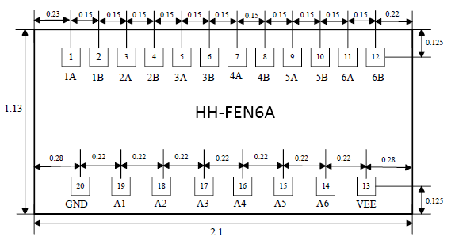
Suggested assembly drawing:
4

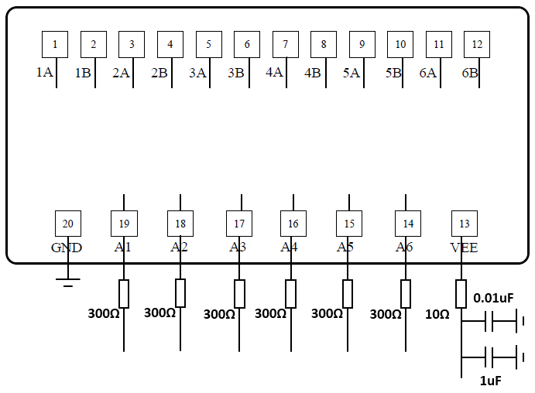

Instructions:
Working conditions: The input end should be connected in series with 300Ω ~ 3ω protection resistance, under the premise of meeting the switching speed, the larger the protection resistance, the better.
Storage: The chip must be placed in a container with electrostatic protection function, and stored in a nitrogen environment.
Cleaning treatment: The bare chip must be operated and used in a purified environment. It is forbidden to use liquid cleaning agent to clean the chip.
Electrostatic protection: Strictly comply with the ESD protection requirements to avoid electrostatic damage to the components.
General operation: Use vacuum chuck or precision pointed tweezers to pick up the chip.Avoid touching the surface of the chip with tools or fingers during handling.
Mounting operation: The chip can be installed using AuSn solder eutectic welding or conductive adhesive bonding process.The mounting surface must be clean and flat.
Bonding operation: Input and output with 2 (recommended diameter of 25um gold wire) bonding wire, bonding wire length less than 250um is optimal.It is recommended to use the smallest possible ultrasonic energy.Bonding begins at the pressure point on the chip and ends at the package (or substrate).
Performance Characteristics：
- Working mode: The input pulse signal is converted to the complementary signal output
- Operating voltage: -5V
- Input level: Compatible with TTL level
- Output level: 0/-5V
- Static current: 2mA
- Chip size: 2.1mm x 1.13mm x 0.1mm
Product Description：
CW-FEN6B is a 6-bit FET driver chip, manufactured by GaAs process, which can generate 0V/-5V complementary pulse output from the input TTL pulse signal.
Electrical parameters：( T_{A}=25℃）
Parameter name | Symbols | Minimum | Typical value | Maximum value | Units | Instructions
Power supply voltage | V_{EE} | -5.5 | -5 | -4.5 | V | Chip operating voltage
Static current | I_{EE} | - | 2 | - | mA | Current after power-on
Input high level | V_{IH} | 2.8 | 5 | 5 | V | A1-A6 input voltage is compatible with TTL levels
Input low level | V_{IL} | 0 | 0 | 0.4 | V | A1-A6 input voltage is compatible with TTL levels
Input current | I_{i} | - | 0.4 | - | mA | -
Output high level | V_{OH} | - | 0 | - | V | The output voltage of the in-phase end and the antiphase end
Output low | V_{OL} | - | -5 | - | V | The output voltage of the in-phase end and the antiphase end
Output current | Io | - | 2 | - | mA | Load dependent
Operating frequency | F | 0 | 10 | 30 | MHz | Load dependent
Switching time | t | - | 14 | 25 | ns | -
Temperature | Ta | -55 | 25 | 85 | ℃ | -
Use limit parameters: (Exceeding any of the following maximum limits risks permanent damage)
Power supply voltage | -6V
Input high level | 5.5V
Input low | -0.5V
Storage temperature | -65℃~+150℃

Truth table：(unit：V)
Input |  |  |  |  |  | Output
A1 | A2 | A3 | A4 | A5 | A6 | 1A | 1B | 2A | 2B | 3A | 3B | 4A | 4B | 5A | 5B | 6A | 6B
0 | 0 | 0 | 0 | 0 | 0 | -5 | 0 | -5 | 0 | -5 | 0 | -5 | 0 | -5 | 0 | -5 | 0
5 | 0 | 0 | 0 | 0 | 0 | 0 | -5 | -5 | 0 | -5 | 0 | -5 | 0 | -5 | 0 | -5 | 0
0 | 5 | 0 | 0 | 0 | 0 | -5 | 0 | 0 | -5 | -5 | 0 | -5 | 0 | -5 | 0 | -5 | 0
0 | 0 | 5 | 0 | 0 | 0 | -5 | 0 | -5 | 0 | 0 | -5 | -5 | 0 | -5 | 0 | -5 | 0
0 | 0 | 0 | 5 | 0 | 0 | -5 | 0 | -5 | 0 | -5 | 0 | 0 | -5 | -5 | 0 | -5 | 0
0 | 0 | 0 | 0 | 5 | 0 | -5 | 0 | -5 | 0 | -5 | 0 | -5 | 0 | 0 | -5 | -5 | 0
0 | 0 | 0 | 0 | 0 | 5 | -5 | 0 | -5 | 0 | -5 | 0 | -5 | 0 | -5 | 0 | 0 | -5
5 | 5 | 5 | 5 | 5 | 5 | 0 | -5 | 0 | -5 | 0 | -5 | 0 | -5 | 0 | -5 | 0 | -5
Size drawing：(unit mm)
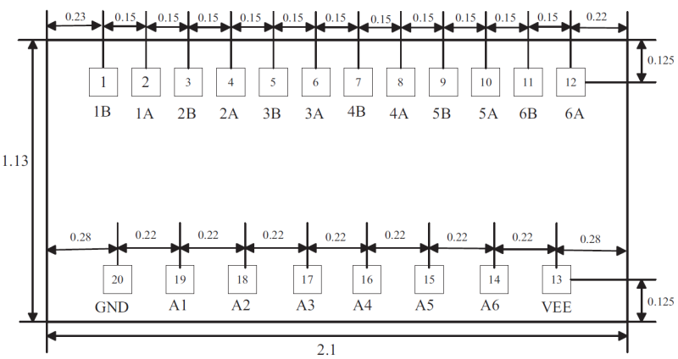
CW-FEN6B
Suggested assembly drawing：
4

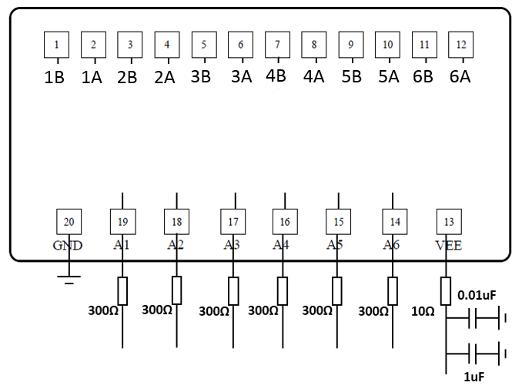

Instructions:
Working conditions: The input end should be connected in series with 300Ω ~ 3ω protection resistance, under the premise of meeting the switching speed, the larger the protection resistance, the better.
Storage: The chip must be placed in a container with electrostatic protection function, and stored in a nitrogen environment.
Cleaning treatment: The bare chip must be operated and used in a purified environment. It is forbidden to use liquid cleaning agent to clean the chip.
Electrostatic protection: Strictly comply with the ESD protection requirements to avoid electrostatic damage to the components.
General operation: Use vacuum chuck or precision pointed tweezers to pick up the chip.Avoid touching the surface of the chip with tools or fingers during handling.
Mounting operation: The chip can be installed using AuSn solder eutectic welding or conductive adhesive bonding process.The mounting surface must be clean and flat.
Bonding operation: Input and output with 2 (recommended diameter of 25um gold wire) bonding wire, bonding wire length less than 250um is optimal.It is recommended to use the smallest possible ultrasonic energy.Bonding begins at the pressure point on the chip and ends at the package (or substrate).
Performance Characteristics：
- Working mode: The input pulse signal is converted to the complementary signal output
- Operating voltage: -5V
- Input level: Compatible with TTL level
- Output level: 0/-5V
- Static current: 2mA
- Chip size: 2.1mm x 1.13mm x 0.1mm
Product Description：
CW-FEN6 is a 6-bit FET driver chip, manufactured by GaAs process, which can generate 0V/-5V complementary pulse output from the input TTL pulse signal.The chip size is 2.1mm×1.13mm×0.1mm.
Electrical parameters：( T_{A}=+25℃,VEE=-5V）
Parameter name | Symbols | Minimum | Typical value | Maximum value | Units | Instructions
Power supply voltage | V_{EE} | -5.5 | -5 | -4.5 | V | Normal operating voltage of the chip
Static current | I_{EE} | - | 2 | - | mA | Current after the chip is powered on
Input high level | V_{IH} | 2.8 | 5 | 5 | V | Input voltage of pin A1-A6, compatible with TTL levels  Capacity TTL level
Input low level | V_{IL} | 0 | 0 | 0.4 | V
Input current | I_{i} | - | 0.4 | - | mA | -
Output high level | V_{OH} | - | 0 | - | V | In-phase and antiphase ends (1A, 1B  Pin, etc.) output voltage
Output low | V_{OL} | - | -5 | - | V
Output (drive) current in each channel | Io | - | 2 | - | mA | Related to load
Operating frequency | f | 0 | 10 | 30 | MHz | Load dependent
Switching time | t | - | 16 | 25 | ns | -
Temperature | T_{A} | -55 | 25 | 85 | ℃ | -
Use limit parameters：(Exceeding any of the following maximum limits risks permanent damage)
Power supply voltage | -6V
Input high level | 5.5V
Input low | -0.5V
Storage temperature | -65℃~+150℃

Truth table:
Input |  |  |  |  |  | Output
A1 | A2 | A3 | A4 | A5 | A6 | 1A | 1B | 2A | 2B | 3A | 4B | 4A | 5B | 5A | 6A
Li | Li | Li | Li | Li | Li | Lo | Ho | Lo | Ho | Lo | Ho | Lo | Ho | Lo | Lo
Hi | Li | Li | Li | Li | Li | Ho | Lo | Lo | Ho | Lo | Ho | Lo | Ho | Lo | Lo
Li | Hi | Li | Li | Li | Li | Lo | Ho | Ho | Lo | Lo | Ho | Lo | Ho | Lo | Lo
Li | Li | Hi | Li | Li | Li | Lo | Ho | Lo | Ho | Ho | Ho | Lo | Ho | Lo | Lo
Li | Li | Li | Hi | Li | Li | Lo | Ho | Lo | Ho | Lo | Lo | Ho | Ho | Lo | Lo
Li | Li | Li | Li | Hi | Li | Lo | Ho | Lo | Ho | Lo | Ho | Lo | Lo | Ho | Lo
Li | Li | Li | Li | Li | Hi | Lo | Ho | Lo | Ho | Lo | Ho | Lo | Ho | Lo | Ho
Hi | Hi | Hi | Hi | Hi | Hi | Ho | Lo | Ho | Lo | Ho | Lo | Ho | Lo | Ho | Ho
Note: Take the input pulse level of 0/5V and the supply voltage of -5V, L_{i}Represents 0V, H_{i}Represents 5V, L_{o}It means -5V, H_{o}Represents 0V.
Size drawing：(unit mm)
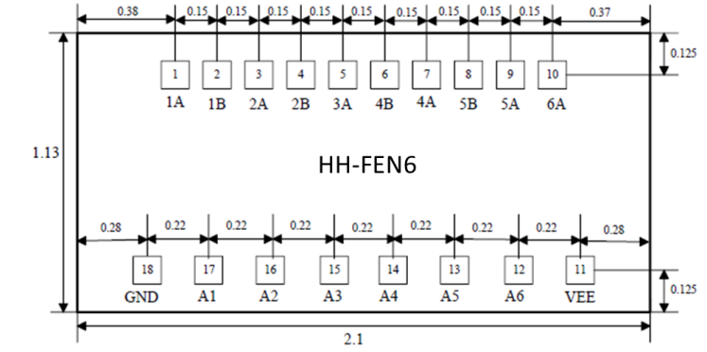
Suggested assembly drawing：
4

4

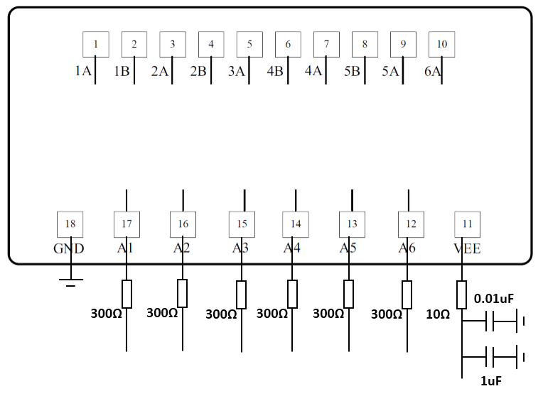

Instructions:
Working conditions: The input end should be connected in series with 300Ω ~ 3ω protection resistance, under the premise of meeting the switching speed, the larger the protection resistance, the better.
Storage: The chip must be placed in a container with electrostatic protection function, and stored in a nitrogen environment.
Cleaning treatment: The bare chip must be operated and used in a purified environment. It is forbidden to use liquid cleaning agent to clean the chip.
Electrostatic protection: Strictly comply with the ESD protection requirements to avoid electrostatic damage to the components.
General operation: Use vacuum chuck or precision pointed tweezers to pick up the chip.Avoid touching the surface of the chip with tools or fingers during handling.
Mounting operation: The chip can be installed using AuSn solder eutectic welding or conductive adhesive bonding process.The mounting surface must be clean and flat.
Bonding operation: Input and output with 2 (recommended diameter of 25um gold wire) bonding wire, bonding wire length less than 250um is optimal.It is recommended to use the smallest possible ultrasonic energy.Bonding begins at the pressure point on the chip and ends at the package (or substrate).

05 Mixer
Number | Frequency range RF&LO (GHz) | Intermediate frequency range  (GHz) | Frequency conversion loss  (dB) | LO-RF  Degree of isolation (dB) | LO-IF  Degree of isolation (dB) | RF-IF  Degree of isolation (dB) | Local vibration power  (dBm) | Page number
CW-MX787 | 3-10 | DC-4 | 7 | 45 | 35 | 18 | 17
CW-MX141 | 6-18 | DC-6 | 7 | 48 | 45 | 15 | 20
CW-MX142 | 6-18 | DC-6 | 7 | 48 | 45 | 15 | 20
CW-MX773 | 6-26 | DC-10 | 8 | 35 | 25 | 12 | 13
CW-MX553 | 7-14 | DC-5 | 7 | 45 | 40 | 23 | 13
CW-MX292 | 18-32 | DC-8 | 8 | 45 | 48 | 17 | 13
CW-MX560 | 21-40 | DC-18 | 8 | 45 | 45 | 25 | 13

Performance Features：
- RF/LO frequency band: 3GHz~10GHz
- IF band: DC to 4GHz
- Frequency conversion loss: 7dB
- RF-IF isolation: 18dB
- LO-IF isolation: 35dB
- LO-RF isolation degree: 45dB
- Local vibration power: 17dBm
- Chip size: 1.23mm×0.78mm×0.1mm
Product Description：
CW-MX787 is a GaAs MMIC passive double balanced mixer chip with RF/local frequency covering 3~10GHz, IF frequency covering DC~4GHz, conversion loss less than 8.5dB, Rf to intermediate frequency isolation greater than 16dB, local vibration to intermediate frequency isolation greater than 32dB, local vibration to radio frequency isolation greater than 42dB, typical local vibration input power is 17dBm.
Electrical parameters：( TA=25℃,IF=0.1GHz,LO=17dBm)
Indicators | Minimum | Typical value | Maximum value | Units
Radio frequency | 3~10 |  |  | GHz
Local frequency | 3~10 |  |  | GHz
If frequency | DC~4 |  |  | GHz
Frequency conversion loss | 6 | 7 | 8.5 | dB
RF-IF isolation | 16 | 18 | 25 | dB
LO-IF isolation | 32 | 35 | 37 | dB
LO-RF isolation | 42 | 45 | 55 | dB
P1dB(input) | 9 | 12 | 15 | dBm
Use limit parameters: (Exceeding any of the above maximum limits is likely to cause permanent damage.)
Rf/IF power | 26dBm
Local vibration power | 26dBm
Storage temperature | -65℃~150℃
Service temperature | -55℃~125℃

Typical curve：
Conversion loss @LO=17dBm, IF frequency 0.1GHz isolation @LO=17dBm, if frequency 0.1GHz 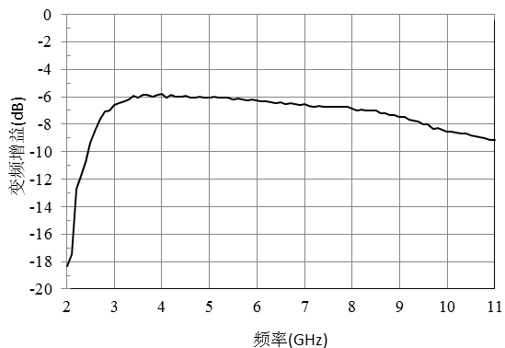 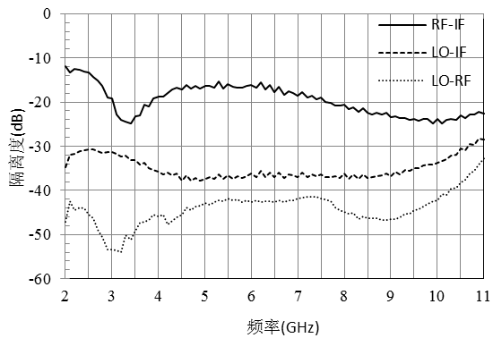

Frequency conversion loss @IF frequency 0.1GHz IF bandwidth @LO=10GHz,LO=17dBm
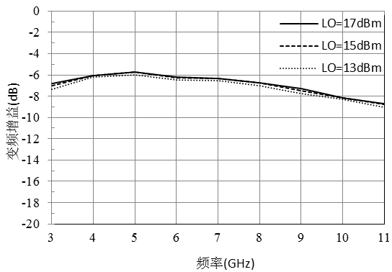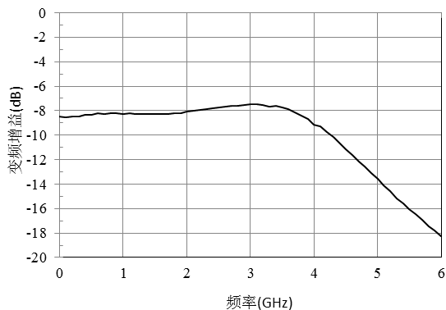

Rf return loss IF return loss
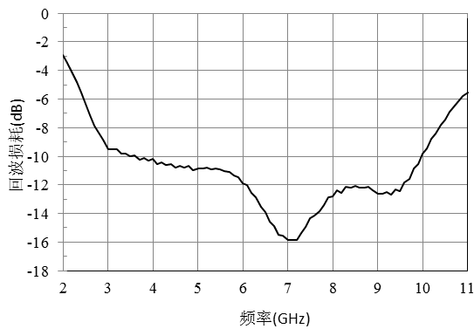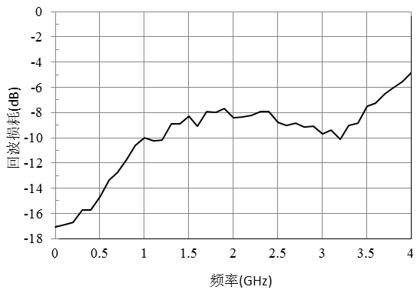

Enter P-1@LO=17dBm Enter IP3@LO=17dBm
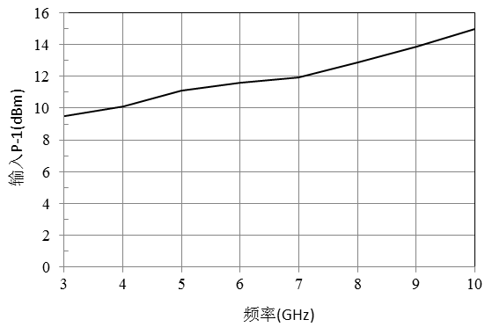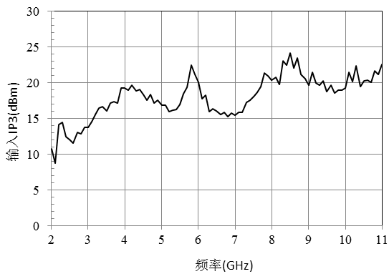
Dimensional drawing：(unit mm)
Suggested assembly drawing：

Instructions:
Storage: The chip must be placed in a container with electrostatic protection and stored in a nitrogen environment.
Cleaning treatment: The bare chip must be operated and used in a purified environment. It is forbidden to use liquid cleaning agent to clean the chip.
Electrostatic protection: Strictly comply with the ESD protection requirements to avoid electrostatic damage to the components.
General operation: Use vacuum chuck or precision pointed tweezers to pick up the chip.Avoid touching the surface of the chip with tools or fingers during handling.
Mounting operation: The chip can be installed using AuSn solder eutectic welding or conductive adhesive bonding process.The mounting surface must be clean and flat.
Bonding operation: Input and output with 2 (recommended diameter of 25um gold wire) bonding wire, bonding wire length less than 250um is optimal.It is recommended to use the smallest possible ultrasonic energy.Bonding begins at the pressure point on the chip and ends at the package (or substrate).

Performance Characteristics：
- RF/LO frequency band: 6GHz-18GHz
- IF band: DC-6GHz
- Frequency conversion loss: 7dB
- RF-IF isolation: 15dB
- LO-IF isolation degree: 45dB
- LO-RF isolation degree: 48dB
- Local vibration power: 20dBm
- Chip size: 1.274mm×0.822mm×0.1mm
Product profile：
CW-MX141 is a GaAs MMIC passive double balanced mixer with RF/local frequency covering 6-18GHz, IF frequency covering DC-6GHz, conversion loss less than 8dB, Rf to if isolation greater than 11dB, local vibration to if isolation greater than 41dB, local vibration to radio frequency isolation greater than 45dB, typical local input power is 20dBm.
Electrical parameters：( TA=25℃,IF=0.1GHz,LO=20dBm)
Indicators | Minimum | Typical value | Maximum value | Units
Radio frequency | 6-18 |  |  | GHz
Local frequency | 6-18 |  |  | GHz
If frequency | DC-6 |  |  | GHz
Frequency conversion loss | 6.5 | 7 | 8 | dB
RF-IF isolation | 11 | 15 | 22 | dB
LO-IF isolation | 41 | 45 | 51 | dB
LO-RF isolation | 45 | 48 | 50 | dB
P1dB(input) | 11 | 12 | 13 | dBm
Use limit parameters: (Exceeding any of the above maximum limits is likely to cause permanent damage.)
Rf/IF power | 20 dBm
Local oscillator power | 27 dBm
Storage temperature | -65℃~150℃
Service temperature | -55℃~125℃

Typical curve：
Frequency conversion loss curve @LO=20dBm, IF frequency 0.1GHz isolation @LO=20dBm, if frequency 0.1GHz
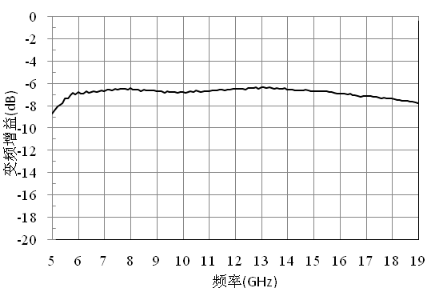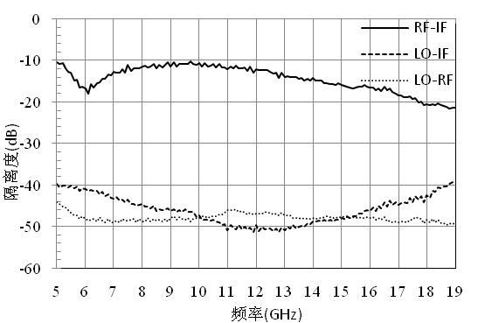
Frequency conversion loss @IF frequency 0.1GHz IF bandwidth @LO=18GHz,LO=20dBm 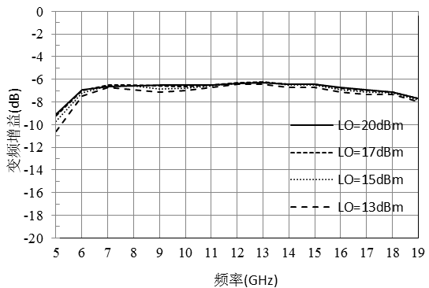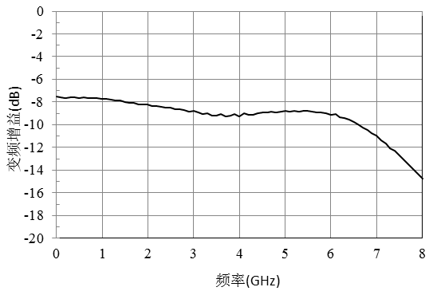

RF return loss Intermediate frequency return loss 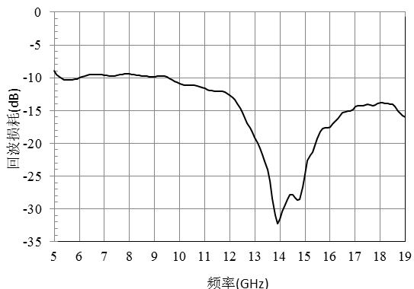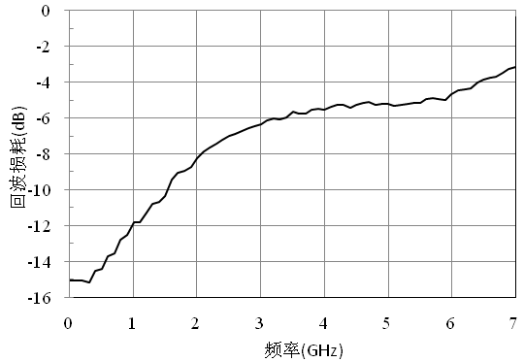

InputP-1@LO=17dBm OutputIP3@LO=17dBm 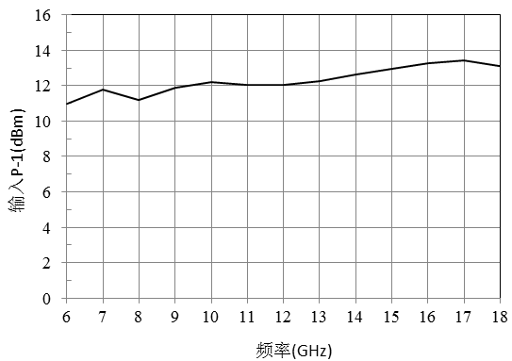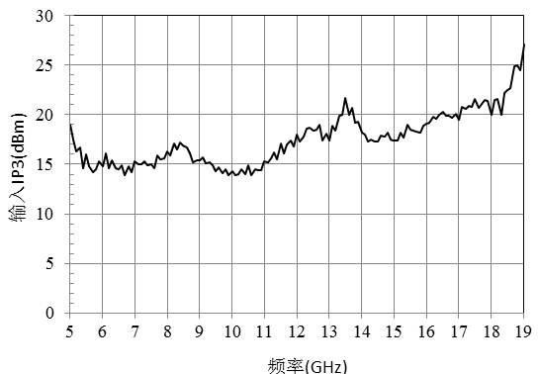

Dimensional drawing：(unit mm)
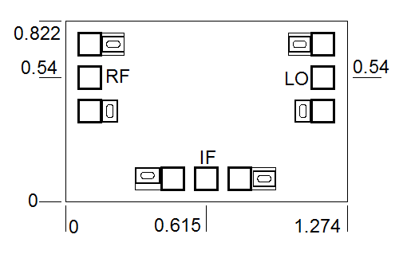
Suggested assembly drawing：

Instructions:
Note: I/O has straight capacitance.
Storage: The chip must be placed in a container with electrostatic protection and stored in a nitrogen environment.
Cleaning treatment: The bare chip must be operated and used in a purified environment. It is forbidden to use liquid cleaning agent to clean the chip.
Electrostatic protection: Strictly comply with the ESD protection requirements to avoid electrostatic damage to the components.
General operation: Use vacuum chuck or precision pointed tweezers to remove the chip.Avoid touching the surface of the chip with tools or fingers during handling.
Mounting operation: The chip can be installed using AuSn solder eutectic welding or conductive adhesive bonding process.The mounting surface must be clean and flat.
Bonding operation: Input and output with 2 (recommended diameter of 25um gold wire) bonding wire, bonding wire length less than 250um is optimal.It is recommended to use the smallest possible ultrasonic energy.Bonding begins at the pressure point on the chip and ends at the package (or substrate).

Performance Characteristics：
- RF/LO frequency band: 6GHz-18GHz
- IF band: DC-6GHz
- Frequency conversion loss: 7dB
- RF-IF isolation: 15dB
- LO-IF isolation degree: 45dB
- LO-RF isolation degree: 48dB
- Local vibration power: 20dBm
- Chip size: 1.274mm×0.822mm×0.1mm
Product profile：
CW-MX142 is a GaAs MMIC passive double balanced mixer with RF/local frequency covering 6-18GHz, IF frequency covering DC-6GHz, conversion loss less than 8dB, Rf to if isolation greater than 11dB, local vibration to if isolation greater than 41dB, local vibration to radio frequency isolation greater than 45dB, typical local input power is 20dBm.
Electrical parameters：( TA=25℃,IF=0.1GHz,LO=20dBm)
Indicators | Minimum | Typical value | Maximum value | Units
Radio frequency | 6-18 |  |  | GHz
Local frequency | 6-18 |  |  | GHz
If frequency | DC-6 |  |  | GHz
Frequency conversion loss | 6.5 | 7 | 8 | dB
RF-IF isolation | 11 | 15 | 22 | dB
LO-IF isolation | 41 | 45 | 51 | dB
LO-RF isolation | 45 | 48 | 50 | dB
P1dB(input) | 11 | 12 | 13 | dBm
Use limit parameters: (Exceeding any of the above maximum limits is likely to cause permanent damage.)
Rf/IF power | 20 dBm
Local oscillator power | 27 dBm
Storage temperature | -65℃~150℃
Service temperature | -55℃~125℃

Typical curve：
Frequency conversion loss curve @LO=20dBm, IF frequency 0.1GHz isolation @LO=20dBm, if frequency 0.1GHz

Frequency conversion loss @IF frequency 0.1GHz IF bandwidth @LO=18GHz,LO=20dBm

Rf return loss IF return loss

Enter P-1@LO=17dBm Enter IP3@LO=17dBm

Dimensional drawing：(unit mm)
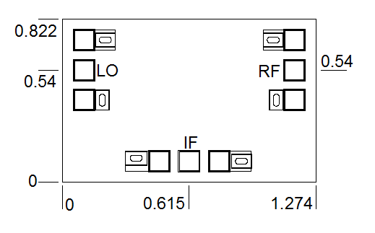

Suggested assembly drawing：

Instructions:
Note: I/O has straight capacitance
Storage: The chip must be placed in a container with electrostatic protection and stored in a nitrogen environment.
Cleaning treatment: The bare chip must be operated and used in a purified environment. It is forbidden to use liquid cleaning agent to clean the chip.
Electrostatic protection: Strictly comply with the ESD protection requirements to avoid electrostatic damage to the components.
General operation: Use vacuum chuck or precision pointed tweezers to pick up the chip.Avoid touching the surface of the chip with tools or fingers during handling.
Mounting operation: The chip can be installed using AuSn solder eutectic welding or conductive adhesive bonding process.The mounting surface must be clean and flat.
Bonding operation: Input and output with 2 (recommended diameter of 25um gold wire) bonding wire, bonding wire length less than 250um is optimal.It is recommended to use the smallest possible ultrasonic energy.Bonding begins at the pressure point on the chip and ends at the package (or substrate).

Performance Characteristics：
- RF/LO frequency band: 6GHz-26GHz
- IF band: DC-10GHz
- Frequency conversion loss: 8dB
- RF-IF isolation: 12dB
- LO-IF isolation: 25dB
- LO-RF isolation degree: 35dB
- Local vibration power: 13dBm
- Chip size: 1.38mm×0.9mm×0.1mm
Product Description：
CW-MX773 is a GaAs MMIC passive double balanced mixer with RF/local frequency covering 6-26GHz, IF frequency covering DC-10GHz, conversion loss less than 10dB, Rf to if isolation greater than 7dB, local vibration to if isolation greater than 20dB, local vibration to radio frequency isolation greater than 29dB, typical local input power is 13dBm.
Electrical parameters：( TA=25℃,IF=0.5GHz,LO=13dBm)
Indicators | Minimum | Typical value | Maximum value | Units
Radio frequency | 6-26 |  |  | GHz
Local frequency | 6-26 |  |  | GHz
If frequency | DC-10 |  |  | GHz
Frequency conversion loss | 7 | 8 | 10 | dB
RF-IF isolation | 7 | 12 | 23 | dB
LO-IF isolation | 20 | 25 | 33 | dB
LO-RF isolation | 29 | 35 | 55 | dB
P1dB(input) | 9.5 | 12 | 13.5 | dBm
Use limit parameters: (Exceeding any of the above maximum limits is likely to cause permanent damage.)
Rf/IF power | 21dBm
Local vibration power | 21dBm
Storage temperature | -65℃-150℃
Service temperature | -55℃-125℃

Typical curve：
Frequency conversion loss curve @LO=13dBm, IF frequency 0.5GHz isolation @LO=13dBm, if frequency 0.5GHz 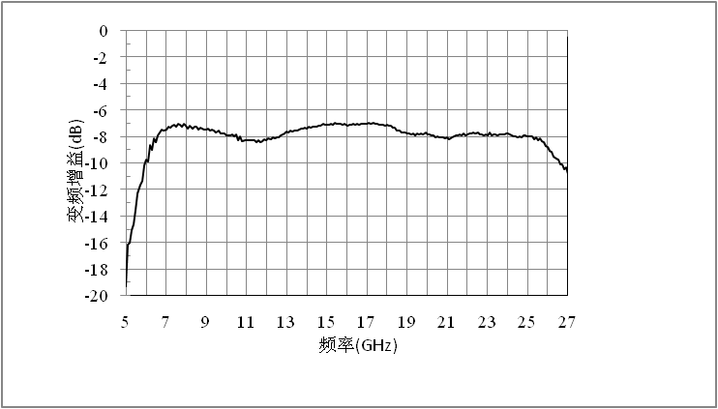 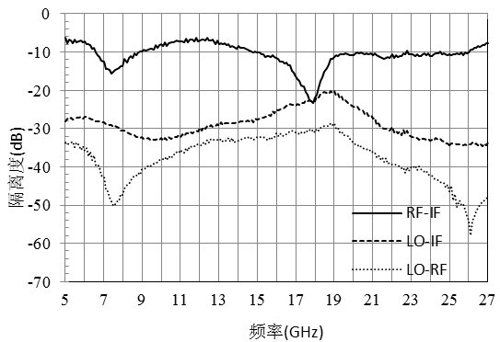

Frequency conversion loss curve @ IF frequency 0.5GHz IF bandwidth @LO=26GHz,LO=13dBm
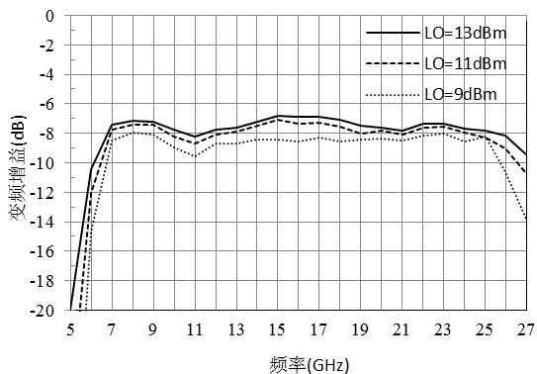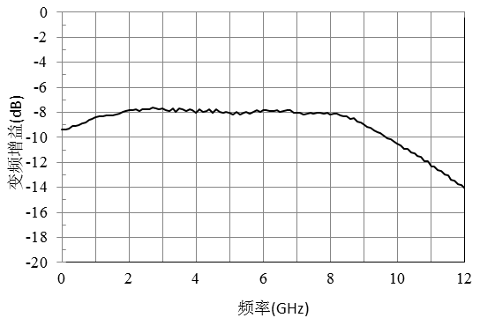

Rf return loss IF return loss 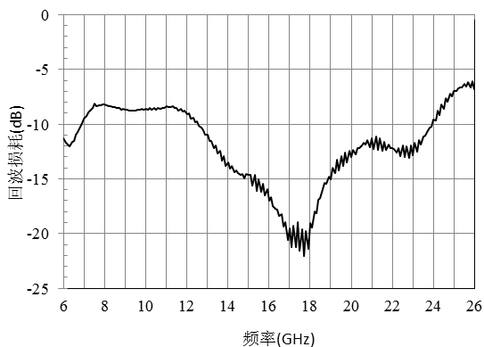 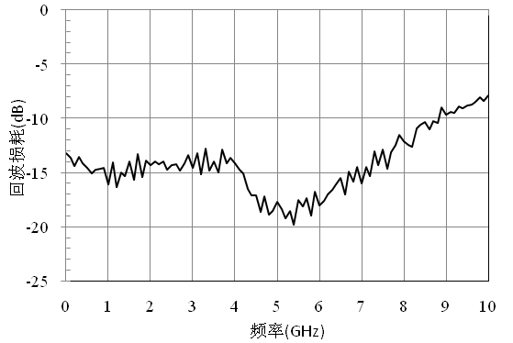

Enter P-1@LO=13dBm Enter IP3@LO=13dBm
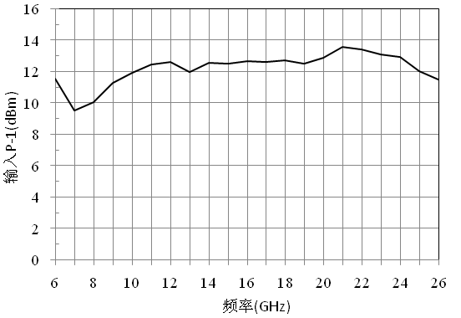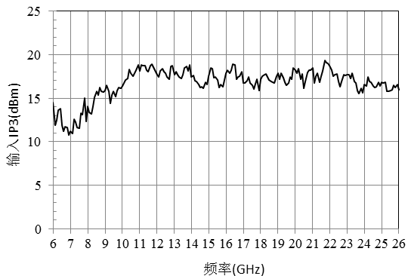

Dimensional drawing：(unit mm)
Suggested assembly drawing：
Instructions:
Storage: The chip must be placed in a container with electrostatic protection and stored in a nitrogen environment.
Cleaning treatment: The bare chip must be operated and used in a purified environment. It is forbidden to use liquid cleaning agent to clean the chip.
Electrostatic protection: Strictly comply with the ESD protection requirements to avoid electrostatic damage to the components.
General operation: Use vacuum chuck or precision pointed tweezers to pick up the chip.Avoid touching the surface of the chip with tools or fingers during handling.
Mounting operation: The chip can be installed using AuSn solder eutectic welding or conductive adhesive bonding process.The mounting surface must be clean and flat.
Bonding operation: Input and output with 2 (recommended diameter of 25um gold wire) bonding wire, bonding wire length less than 250um is optimal.It is recommended to use the smallest possible ultrasonic energy.Bonding begins at the pressure point on the chip and ends at the package (or substrate).

Performance Characteristics：
- RF/LO frequency band: 7GHz-14GHz
- IF band: DC-5GHz
- Frequency conversion loss: 7dB
- RF-IF isolation: 23dB
- LO-IF isolation: 40dB
- LO-RF isolation degree: 45dB
- Local vibration power: 13dBm
- Chip size: 1.192mm×0.822mm×0.1mm
Product profile：
CW-MX553 is a GaAs MMIC passive double balanced mixer with RF/local frequency covering 7-14GHz, IF frequency covering DC-5GHz, conversion loss less than 9dB, Rf to if isolation greater than 20dB, local vibration to if isolation greater than 38dB, local vibration to radio frequency isolation greater than 40dB, typical local input power is 13dBm.
Electrical parameters：( TA=25℃,IF=0.1GHz,LO=13dBm)
Indicators | Minimum | Typical value | Maximum value | Units
Radio frequency | 7-14 |  |  | GHz
Local frequency | 7-14 |  |  | GHz
If frequency | DC-5 |  |  | GHz
Frequency conversion loss | 6.5 | 7 | 9 | dB
RF-IF isolation | 20 | 23 | 25 | dB
LO-IF isolation | 38 | 40 | 44 | dB
LO-RF isolation | 40 | 45 | 48 | dB
P1dB(input) | 10 | 12 | 14.5 | dBm
Use limit parameters: (Exceeding any of the above maximum limits is likely to cause permanent damage.)
Rf/IF power | 25dBm
Local oscillator power | 25dBm
Storage temperature | -65℃-150℃
Service temperature | -55℃-125℃

-+

Typical curve:
Frequency conversion loss curve @LO=13dBm, IF frequency 0.1GHz isolation @LO=13dBm, if frequency 0.1GHz
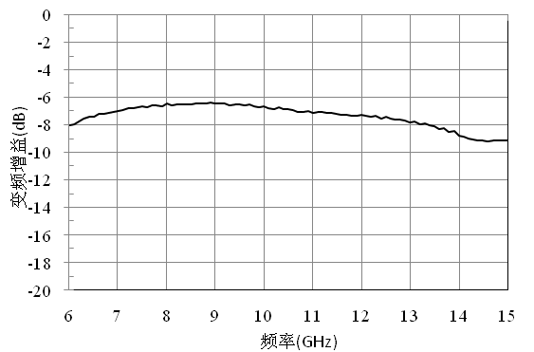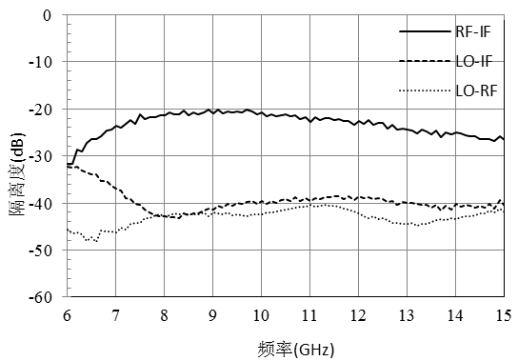
Frequency conversion loss curve @IF frequency 0.1GHz IF bandwidth @LO=14GHz,LO=13dB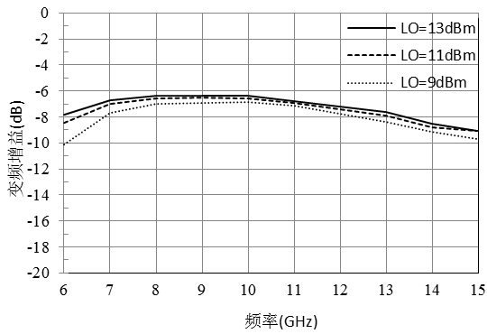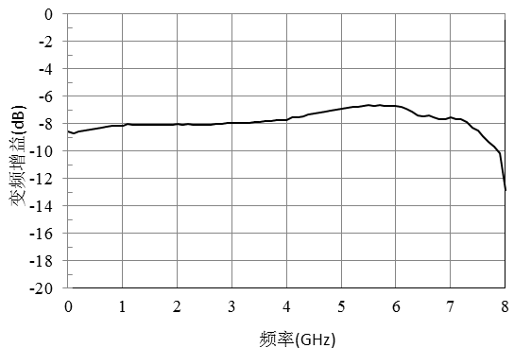
Rf return loss IF return loss
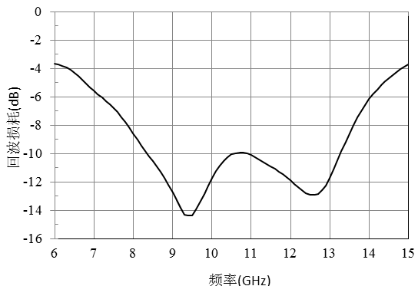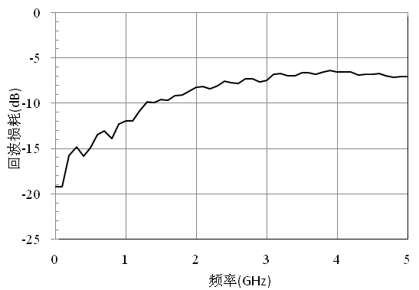

Enter P-1@LO=13dBm Enter IP3@LO=13dBm
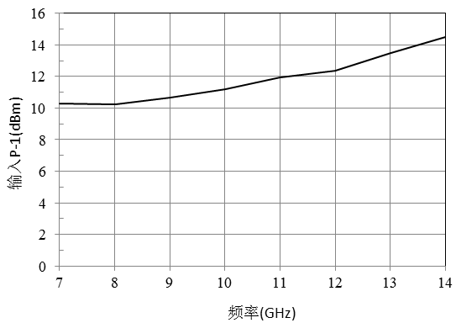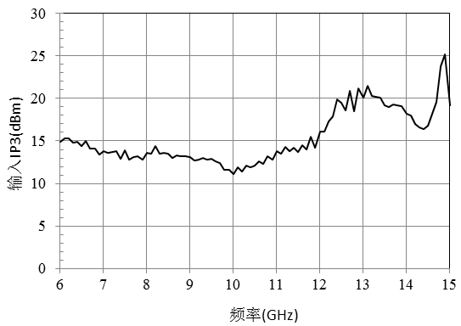
Dimensional drawing：(unit mm)
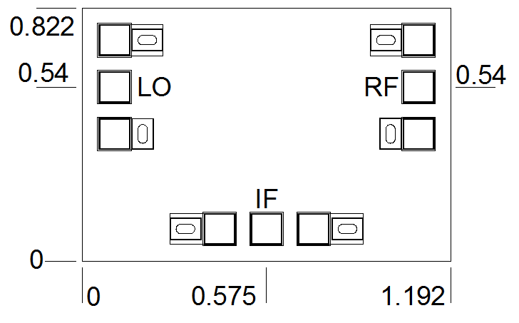
Suggested assembly drawing:

Instructions:
Storage: The chip must be placed in a container with electrostatic protection and stored in a nitrogen environment.
Cleaning treatment: The bare chip must be operated and used in a purified environment. It is forbidden to use liquid cleaning agent to clean the chip.
Electrostatic protection: Strictly comply with the ESD protection requirements to avoid electrostatic damage to the components.
General operation: Use vacuum chuck or precision pointed tweezers to pick up the chip.Avoid touching the surface of the chip with tools or fingers during handling.
Mounting operation: The chip can be installed using AuSn solder eutectic welding or conductive adhesive bonding process.The mounting surface must be clean and flat.
Bonding operation: Input and output with 2 (recommended diameter of 25um gold wire) bonding wire, bonding wire length less than 250um is optimal.It is recommended to use the smallest possible ultrasonic energy.Bonding begins at the pressure point on the chip and ends at the package (or substrate).

Performance Characteristics：
- RF/LO frequency band: 18GHz-32GHz
- IF band: DC-8GHz
- Frequency conversion loss: 8dB
- RF-IF isolation: 17dB
- LO-IF isolation: 48dB
- LO-RF isolation degree: 45dB
- Local vibration power: 13dBm
- Chip size: 1.192mm×0.822mm×0.1mm
Product profile：
CW-MX292 is a GaAs MMIC passive double balanced mixer with RF/local frequency covering 18-32GHz, IF frequency covering DC-8GHz, conversion loss less than 8.5dB, Rf to IF isolation greater than 13dB, local vibration to if isolation greater than 40dB, local vibration to RF isolation greater than 43dB, typical local input power is 13dBm.
Electrical parameters：( TA=25℃,IF=0.1GHz,LO=13dBm)
Indicators | Minimum | Typical value | Maximum value | Units
Radio frequency | 18-32 |  |  | GHz
Local frequency | 18-32 |  |  | GHz
If frequency | DC-8 |  |  | GHz
Frequency conversion loss | 7.5 | 8 | 8.5 | dB
RF-IF isolation | 13 | 17 | 24 | dB
LO-IF isolation | 40 | 48 | 55 | dB
LO-RF isolation | 43 | 45 | 48 | dB
P1dB(input) | 11 | 12 | 13 | dBm
Use limit parameters: (Exceeding any of the above maximum limits is likely to cause permanent damage.)
Rf/IF power | 24dBm
Local vibration power | 24dBm
Storage temperature | -65℃-150℃
Service temperature | -55℃-125℃

Typical curve：

Frequency conversion loss curve @LO=13dBm, IF frequency 0.1GHz isolation @LO=13dBm, if frequency 0.1G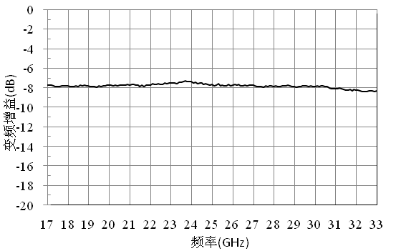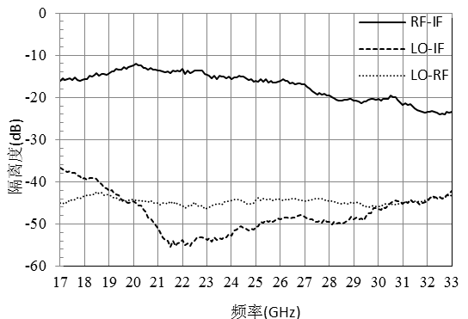

Frequency conversion loss @IF frequency 0.1GHz IF bandwidth @LO=26GHz,LO=13dBm
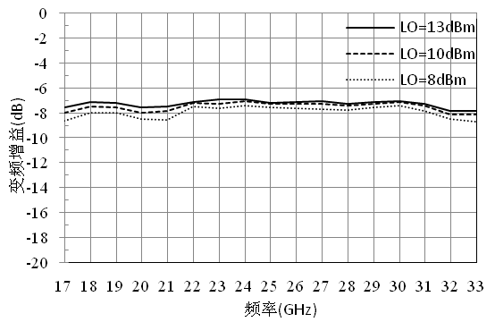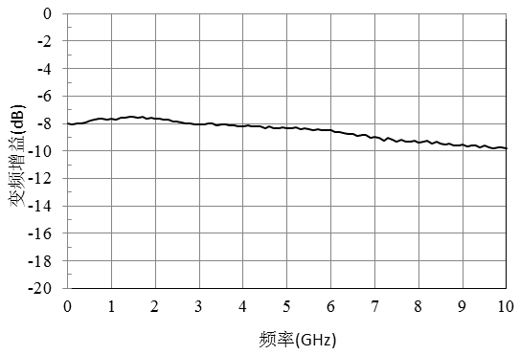

Rf return loss IF return loss
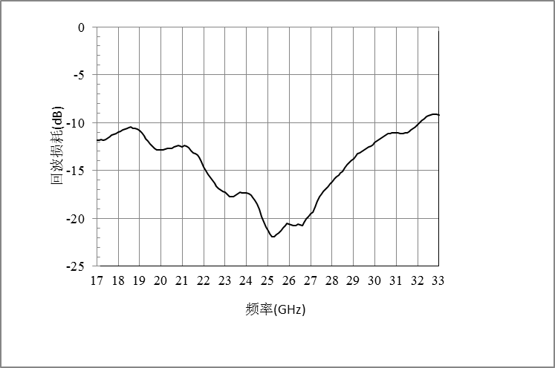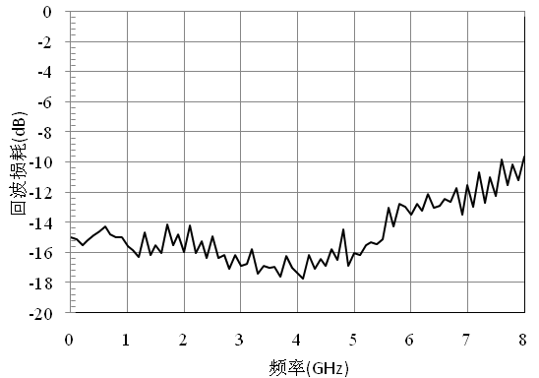

Enter P-1@LO=13dBm Enter IP3@ LO=13dBm
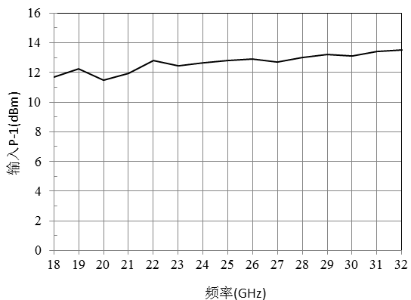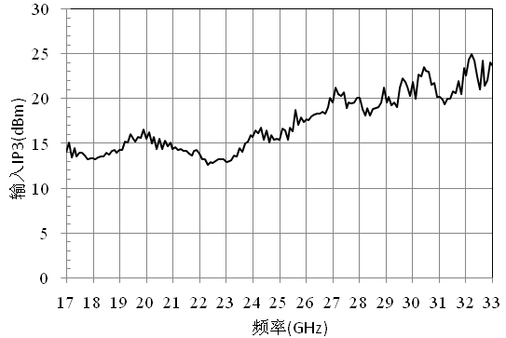
Dimensional drawing：(unit mm)
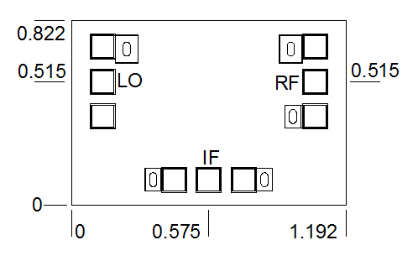

Suggested assembly drawing：
Instructions:
Storage: The chip must be placed in a container with electrostatic protection and stored in a nitrogen environment.
Cleaning treatment: The bare chip must be operated and used in a purified environment. It is forbidden to use liquid cleaning agent to clean the chip.
Electrostatic protection: Strictly comply with the ESD protection requirements to avoid electrostatic damage to the components.
General operation: Use vacuum chuck or precision pointed tweezers to remove the chip.Avoid touching the surface of the chip with tools or fingers during handling.
Mounting operation: The chip can be installed using AuSn solder eutectic welding or conductive adhesive bonding process.The mounting surface must be clean and flat.
Bonding operation: Input and output with 2 (recommended diameter of 25um gold wire) bonding wire, bonding wire length less than 250um is optimal.It is recommended to use the smallest possible ultrasonic energy.Bonding begins at the pressure point on the chip and ends at the package (or substrate).

Performance Characteristics：
- RF/LO frequency band: 21GHz~40GHz
- IF band: DC-18GHz
- Frequency conversion loss: 8dB
- RF-IF isolation: 25dB
- LO-IF isolation degree: 45dB
- LO-RF isolation degree: 45dB
- Local vibration power: 13dBm
- Chip size: 1.192mm×0.822mm×0.1mm
Product profile：
CW-MX560 is a GaAs MMIC passive double balanced mixer with RF/local frequency covering 21-40GHz, IF frequency covering DC-18GHz, conversion loss less than 9dB, Rf to if isolation degree greater than 18dB, local vibration to if isolation degree greater than 40dB, local vibration to RF isolation degree greater than 35dB, typical local input power is 13dBm.
Electrical parameters：( TA=25℃,IF=1GHz,LO=13dBm)
Indicators | Minimum | Typical value | Maximum value | Units
Radio frequency | 21-40 |  |  | GHz
Local frequency | 21-40 |  |  | GHz
If frequency | DC-18 |  |  | GHz
Frequency conversion loss | 7.5 | 8 | 9 | dB
RF-IF isolation | 18 | 25 | 31 | dB
LO-IF isolation | 40 | 45 | 58 | dB
LO-RF isolation | 35 | 45 | 70 | dB
P1dB(input) | 10 | 12 | 13 | dBm
Use limit parameters: (Exceeding any of the above maximum limits is likely to cause permanent damage.)
Rf/IF power | 25dBm
Local oscillator power | 23dBm
Storage temperature | -65℃-150℃
Service temperature | -55℃-125℃

Typical curve：

Frequency conversion loss curve @LO=13dBm, IF frequency 1GHz isolation @LO=13dBm, if frequency 1GHz
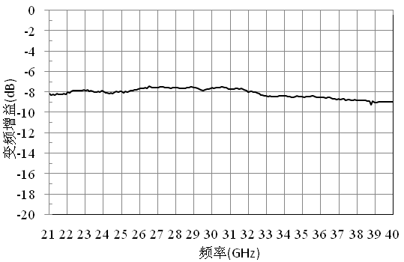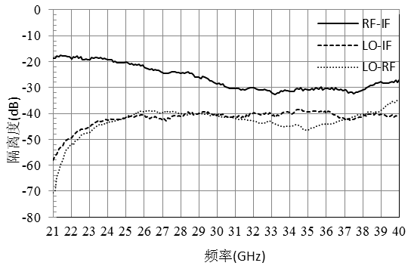

Frequency conversion loss curve @IF frequency 1GHz IF bandwidth @LO=40GHz,LO=13dBm
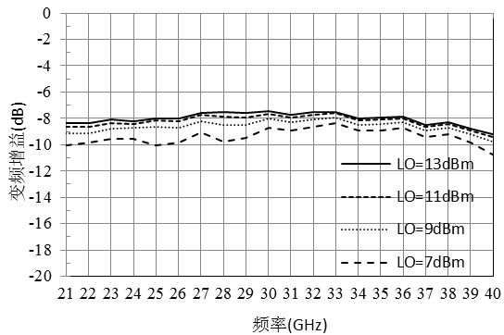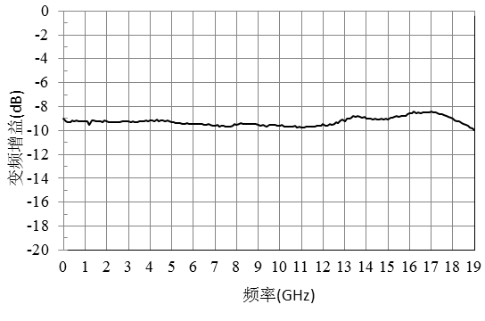

Rf return loss IF return loss
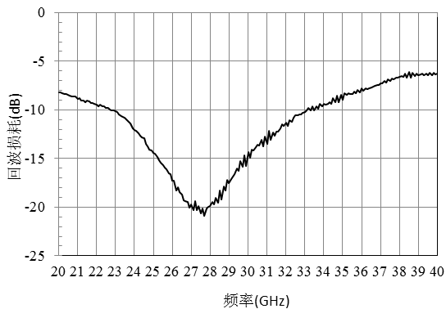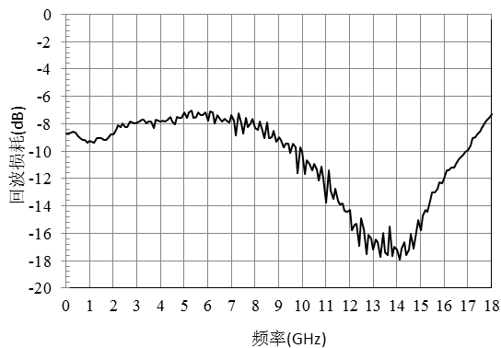

Enter P-1@LO=13dBm Enter IP3@LO=13dBm
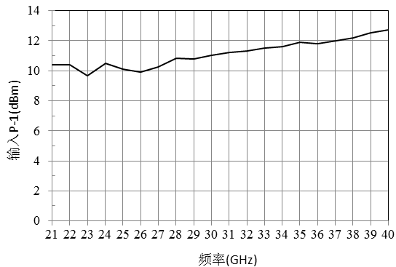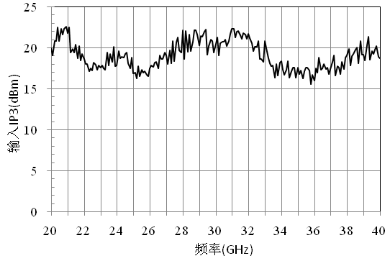
Dimensional drawing：(unit mm)
Suggested assembly drawing：
Instructions:
Storage: The chip must be placed in a container with electrostatic protection and stored in a nitrogen environment.
Cleaning treatment: The bare chip must be operated and used in a purified environment. It is forbidden to use liquid cleaning agent to clean the chip.
Electrostatic protection: Strictly comply with the ESD protection requirements to avoid electrostatic damage to the components.
General operation: Use vacuum chuck or precision pointed tweezers to pick up the chip.Avoid touching the surface of the chip with tools or fingers during handling.
Mounting operation: The chip can be installed using AuSn solder eutectic welding or conductive adhesive bonding process.The mounting surface must be clean and flat.
Bonding operation: Input and output with 2 (recommended diameter of 25um gold wire) bonding wire, bonding wire length less than 250um is optimal.It is recommended to use the smallest possible ultrasonic energy.Bonding begins at the pressure point on the chip and ends at the package (or substrate).
06 Frequency doubler
Numbering | Input signal frequency range  (GHz) | Output signal frequency range  (GHz) | Conversion gain  (dB) | Fundamental isolation (dBc) | 3/4 harmonic isolation (dBc) | Input power  (dBm) | Page number
CW-MP0204 | 2-4 | 4-8 | -14 | 45 | 45/35 | 15
CW-MP204 | 4-8 | 8-16 | -14 | 45 | 45/35 | 15
CW-MP205 | 6-12 | 12-24 | -13.5 | 35 | 35/28 | 15

Performance Features：
- Frequency range: 2GHz-4GHz
- Conversion gain: -14dB
- F0 isolation: 45dBc
- 3F0 Isolation: 45dBc
- 4F0 Isolation: 35dBc
- Input signal power: 15dBm
- Chip size: 1.4mm×0.9mm×0.1mm
Product description：
CW-MP0204 is a GaAs MMIC passive frequency doubler, this type of frequency doubler chip in the input power of 15dBm, conversion gain typical value of -14dB, the fundamental wave suppression to 45dBc, the third harmonic suppression to 45dBc, the fourth harmonic suppression to 35dBc, the typical input power of 15dBm.
Electrical parameters：( TA=25℃,Pin=15dBm)
Indicators | Minimum | Typical value | Maximum value | Units
Input frequency | 2-4 |  |  | GHz
Output frequency | 4-8 |  |  | GHz
Conversion gain | -13 | -14 | -15.5 | dB
Fundamental wave suppression | 45 | - | - | dBc
Third harmonic suppression | 45 | - | - | dBc
Fourth harmonic suppression | 35 | - | - | dBc
Use limit parameters: (Exceeding any of the above maximum limits risks permanent damage.)
Maximum input power | 27 dBm
Storage temperature | -65℃-150℃
Service temperature | -55℃-125℃
Typical curve:
Conversion gain curve @Pin=15dBm Isolation @Pin=15dBm
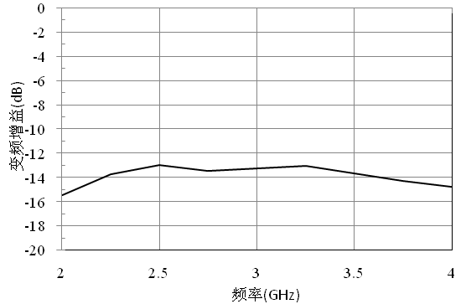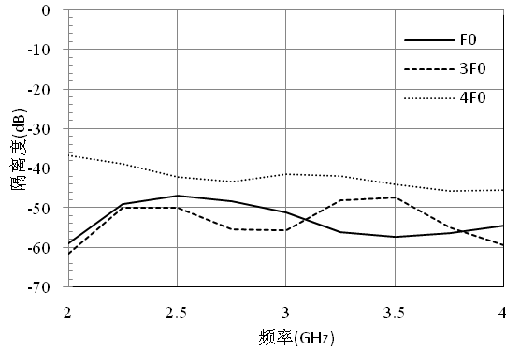

Size diagram：(unit mm)
Suggested assembly drawing：
Instructions:
Note: I/O has straight capacitance
Storage: The chip must be placed in a container with electrostatic protection and stored in a nitrogen environment.
Cleaning treatment: The bare chip must be operated and used in a purified environment. It is forbidden to use liquid cleaning agent to clean the chip.
Electrostatic protection: Strictly comply with the ESD protection requirements to avoid electrostatic damage to the components.
General operation: Use vacuum chuck or precision pointed tweezers to pick up the chip.Avoid touching the surface of the chip with tools or fingers during handling.
Mounting operation: The chip can be installed using AuSn solder eutectic welding or conductive adhesive bonding process.The mounting surface must be clean and flat.
Bonding operation: Input and output with 2 (recommended diameter of 25um gold wire) bonding wire, bonding wire length less than 250um is optimal.It is recommended to use the smallest possible ultrasonic energy.Bonding begins at the pressure point on the chip and ends at the package (or substrate).

Performance Characteristics：
- Frequency range: 4GHz-8GHz
- Conversion gain: -14dB
- F0 isolation: 45dBc
- 3F0 Isolation: 45dBc
- 4F0 Isolation: 35dBc
- Input signal power: 15dBm
- Chip size: 1.5mm×0.69mm×0.1mm
Product Description：
CW-MP204 is a GaAs MMIC passive frequency multiplier, this type of frequency multiplier chip in the input power of 15dBm, conversion gain typical value of -14dB, the fundamental wave suppression to 45dBc, the third harmonic suppression to 45dBc, the fourth harmonic suppression to 35dBc, the typical input power of 15dBm.
Electrical parameters：( T_{A}=25℃,Pin=15dBm)
Indicators | Minimum | Typical value | Maximum value | Units
Input frequency | 4-8 |  |  | GHz
Output frequency | 8-16 |  |  | GHz
Conversion gain | -13 | -14 | -16 | dB
Fundamental wave suppression | 45 | - | - | dBc
Third harmonic suppression | 45 | - | - | dBc
Fourth harmonic suppression | 35 | - | - | dBc
Use limiting parameters：
Maximum input power | 27 dBm
Storage temperature | -65℃-150℃
Service temperature | -55℃-125℃

Typical curve：
Conversion gain curve @Pin=15dBm Isolation @Pin=15dBm
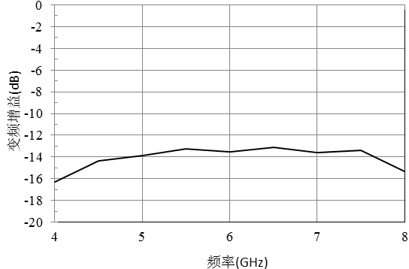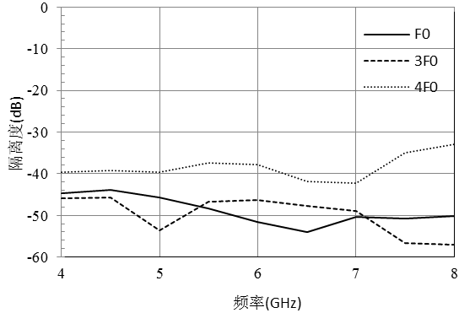

Size diagram：(unit mm)
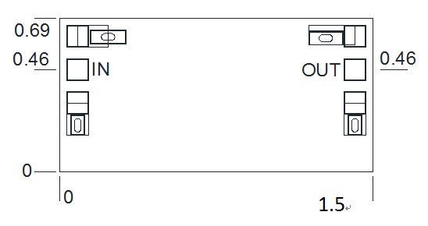
Suggested assembly drawing:
Instructions:
Note: I/O has straight capacitance
Storage: The chip must be placed in a container with electrostatic protection and stored in a nitrogen environment.
Cleaning treatment: The bare chip must be operated and used in a purified environment. It is forbidden to use liquid cleaning agent to clean the chip.
Electrostatic protection: Strictly comply with the ESD protection requirements to avoid electrostatic damage to the components.
General operation: Use vacuum chuck or precision pointed tweezers to pick up the chip.Avoid touching the surface of the chip with tools or fingers during handling.
Mounting operation: The chip can be installed using AuSn solder eutectic welding or conductive adhesive bonding process.The mounting surface must be clean and flat.
Bonding operation: Input and output with 2 (recommended diameter of 25um gold wire) bonding wire, bonding wire length less than 250um is optimal.It is recommended to use the smallest possible ultrasonic energy.Bonding begins at the pressure point on the chip and ends at the package (or substrate).

Performance Characteristics：
- Frequency range: 6GHz-12GHz
- Conversion gain: -13.5dB
- F0 isolation: 35dBc
- 3F0 Isolation: 35dBc
- 4F0 Isolation: 28dBc
- Input signal power: 15dBm
- Chip size: 1.4mm×0.69mm×0.1mm
Product Description：
CW-MP205 is a GaAs MMIC passive frequency doubler, this type of frequency doubler chip in the input power of 15dBm, conversion gain typical value of -14dB, the fundamental wave suppression to 35dBc, the suppression of the third harmonic to 35dBc, the suppression of the fourth harmonic to 30dBc, the typical input power of 15dBm.
Electrical parameters：( TA=25℃,Pin=15dBm)
Indicators | Minimum | Typical value | Maximum value | Units
Input frequency | 6-12 |  |  | GHz
Output frequency | 12-24 |  |  | GHz
Conversion gain | -13 | -13.5 | -14 | dB
Fundamental wave suppression | 35 | - | - | dBc
Third harmonic suppression | 35 | - | - | dBc
Fourth harmonic suppression | 28 | - | - | dBc
Use limit parameters: (Exceeding any of the above maximum limits risks permanent damage.)
Maximum input power | 27 dBm
Storage temperature | -65℃-150℃
Service temperature | -55℃-125℃
Typical curve：
Conversion gain curve @Pin=15dBm Isolation @Pin=15dBm
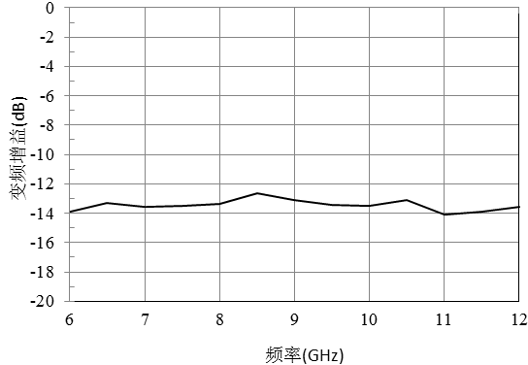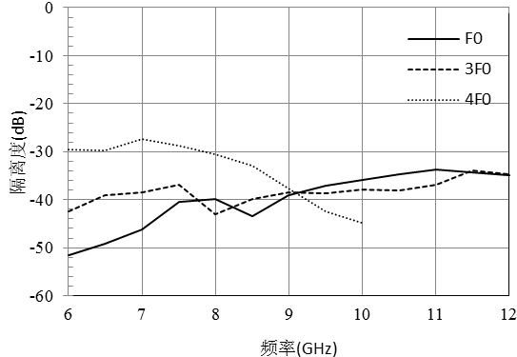

Size diagram：(unit mm)
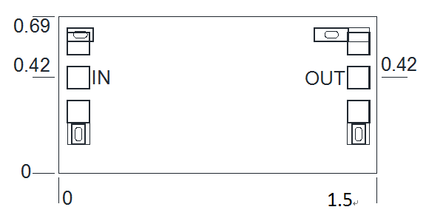
Suggested assembly drawing：

Instructions:
Note: I/O has straight capacitance
Storage: The chip must be placed in a container with electrostatic protection and stored in a nitrogen environment.
Cleaning treatment: The bare chip must be operated and used in a purified environment. It is forbidden to use liquid cleaning agent to clean the chip.
Electrostatic protection: Strictly comply with the ESD protection requirements to avoid electrostatic damage to the components.
General operation: Use vacuum chuck or precision pointed tweezers to pick up the chip.Avoid touching the surface of the chip with tools or fingers during handling.
Mounting operation: The chip can be installed using AuSn solder eutectic welding or conductive adhesive bonding process.The mounting surface must be clean and flat.
Bonding operation: Input and output with 2 (recommended diameter of 25um gold wire) bonding wire, bonding wire length less than 250um is optimal.It is recommended to use the smallest possible ultrasonic energy.Bonding begins at the pressure point on the chip and ends at the package (or substrate).

07 Attenuator
Number | Frequency range  (GHz) | Amount of attenuation  (dB) | Standing wave | Page number
CW-AT40 | DC-40 | 0/1/2/3……/30 | 1.3/1.3
CW-AT50 | DC-50 | 0/1/2/3/4/5/6/7/8/9/10 | 1.4/1.4
CW-DAT425 | 2.4-8 | 0.5-31.5 | 1.4/1.3
CW-AT105S_1_2 | DC~40 | 5 | -
CW-DAT239NC | 0.5~18 | 0.5~15.5 | -
CW-AT40A-15 | DC-40 | 15 | 1.2/1.2

Performance Features：
4

4

Frequency range: DC-40GHz
Attenuation range: 0/1/2/3......28/29/30dB
Insert loss fluctuation: 0.4dB
Input/output voltage standing wave ratio: 1.3/1.3
Chip size: 0.762mm×0.762mm×0.1mm
Product profile：
The CW-AT40 is a GaAs MMIC fixed attenuator with excellent performance.The chip covers the DC-40GHz band range, attenuation range is optional, plug-in loss fluctuation is less than 0.4dB, input-output voltage standing wave ratio is less than 1.3.
Electrical parameters：( T_{A}=25℃)
Indicators |  | Minimum | Typical value | Maximum value | Units
Frequency range |  | DC-40 |  |  | GHz
Amount of attenuation | 0dB | 0 | 0 | 0.5 | dB
Amount of attenuation | 1dB | 0.9 | 1 | 1.2 | dB
Amount of attenuation | 2dB | 2 | 2 | 2.4 | dB
Amount of attenuation | 3dB | 2.9 | 3 | 3.4 | dB
Amount of attenuation | 4dB | 3.8 | 4 | 4.3 | dB
Amount of attenuation | 5dB | 4.9 | 5 | 5.4 | dB
Amount of attenuation | 6dB | 5.8 | 6 | 6.4 | dB
Amount of attenuation | 7dB | 6.8 | 7 | 7.3 | dB
Amount of attenuation | 8dB | 7.9 | 8 | 8.4 | dB
Amount of attenuation | 9dB | 8.9 | 9 | 9.3 | dB
Amount of attenuation | 10dB | 10 | 10 | 10.3 | dB
Amount of attenuation | 11dB | 11 | 11 | 11.4 | dB
Amount of attenuation | 12dB | 11.8 | 12 | 12.3 | dB
Amount of attenuation | 13dB | 12.8 | 13 | 13.3 | dB
Amount of attenuation | 14dB | 14 | 14 | 14.3 | dB
Amount of attenuation | 15dB | 15 | 15 | 15.4 | dB
Amount of attenuation | 16dB | 15.9 | 16 | 16.4 | dB
Amount of attenuation | 17dB | 16.8 | 17 | 17.4 | dB
Amount of attenuation | 18dB | 17.8 | 18 | 18.3 | dB
Amount of attenuation | 19dB | 18.8 | 19 | 19.3 | dB
Amount of attenuation | 20dB | 19.9 | 20 | 20.3 | dB
Amount of attenuation | 21dB | 20.9 | 21 | 21.3 | dB
Amount of attenuation | 22dB | 21.9 | 22 | 22.3 | dB
Amount of attenuation | 23dB | 23 | 23 | 23.3 | dB
Amount of attenuation | 24dB | 23.8 | 24 | 24.4 | dB
Amount of attenuation | 25dB | 24.9 | 25 | 25.3 | dB
Amount of attenuation | 26dB | 26 | 26 | 26.3 | dB
Amount of attenuation | 27dB | 26.8 | 27 | 27.4 | dB
Amount of attenuation | 28dB | 27.9 | 28 | 28.4 | dB
Amount of attenuation | 29dB | 28.8 | 29 | 29.3 | dB
Amount of attenuation | 30dB | 29.8 | 30 | 30.2 | dB
Enter the standing wave ratio |  | - | 1.2 | 1.3 | -
Output standing wave ratio |  | - | 1.2 | 1.3 | -
Use limit parameters: (Exceeding any of the above maximum limits risks permanent damage.)
Maximum input power | 27 dBm
Storage temperature | -65℃-150℃
Service temperature | -55℃-125℃
Typical curve：
Input-output standing wave ratio insertion loss
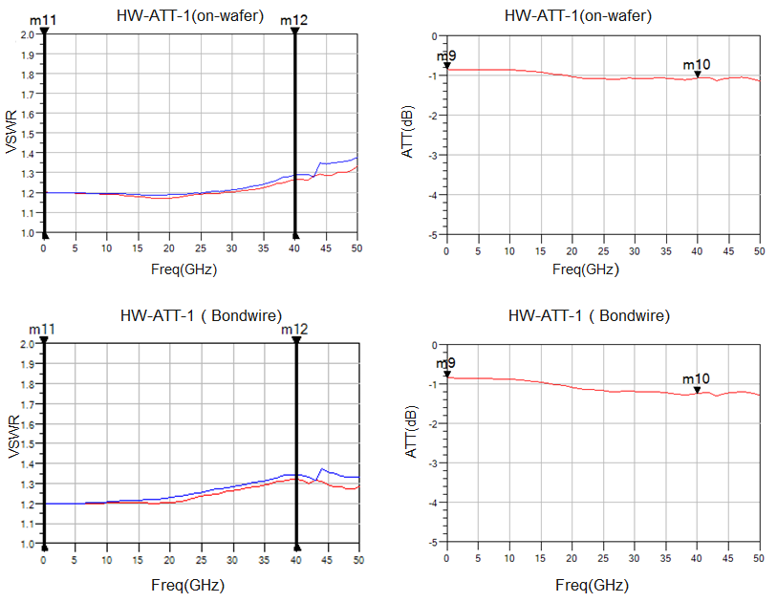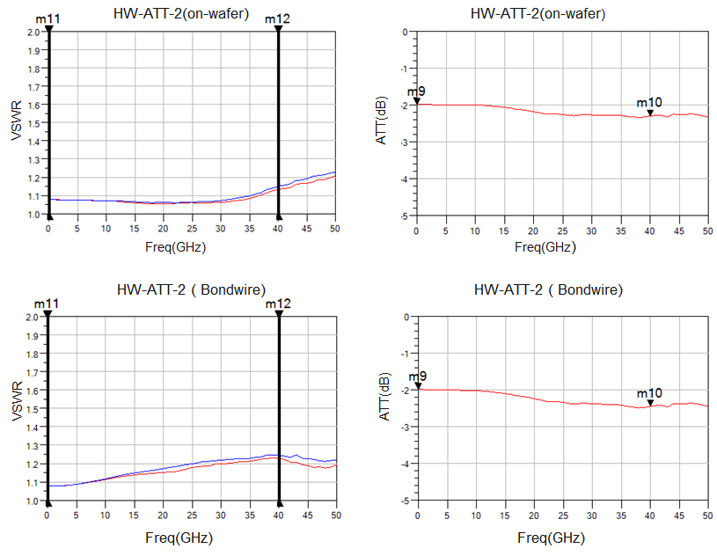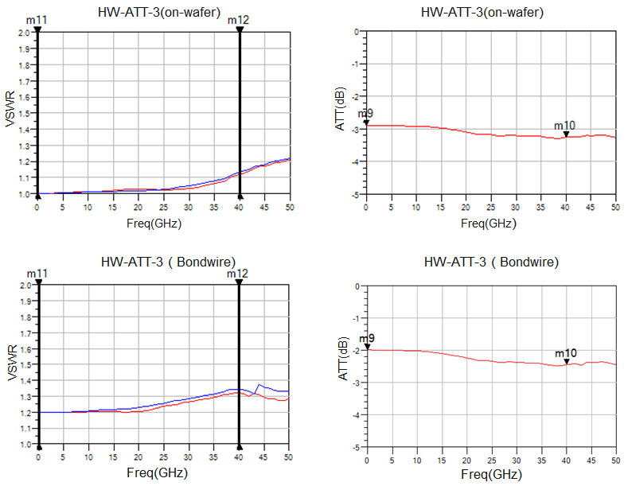
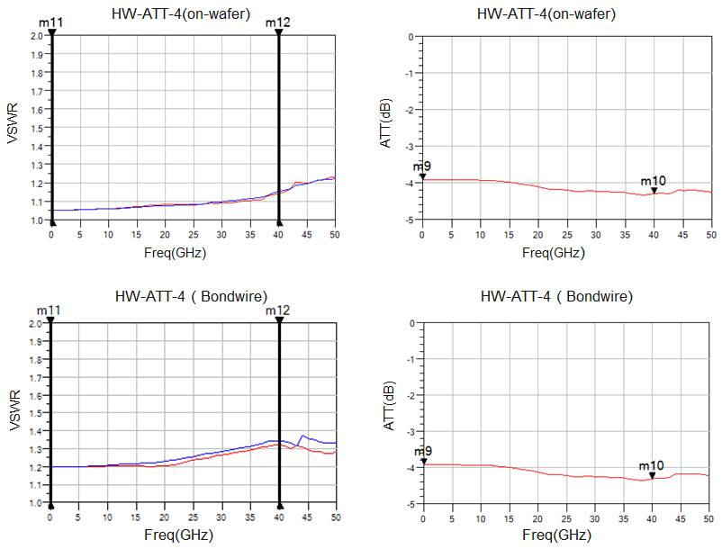
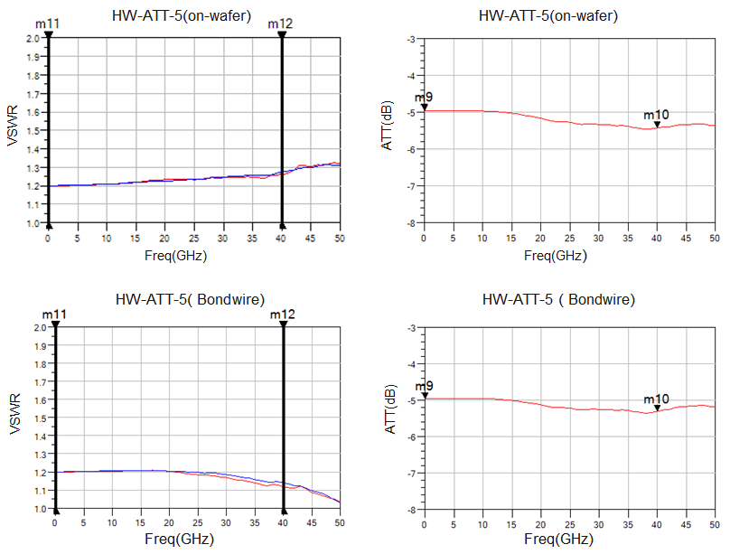
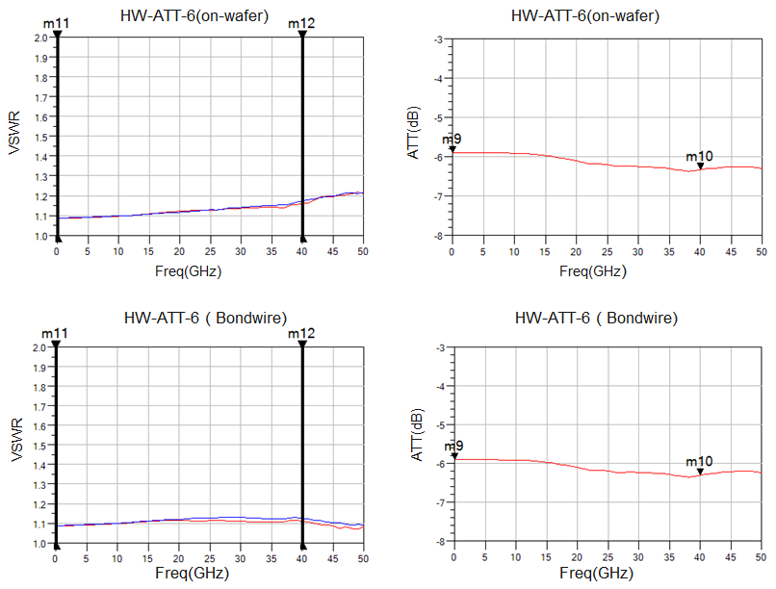
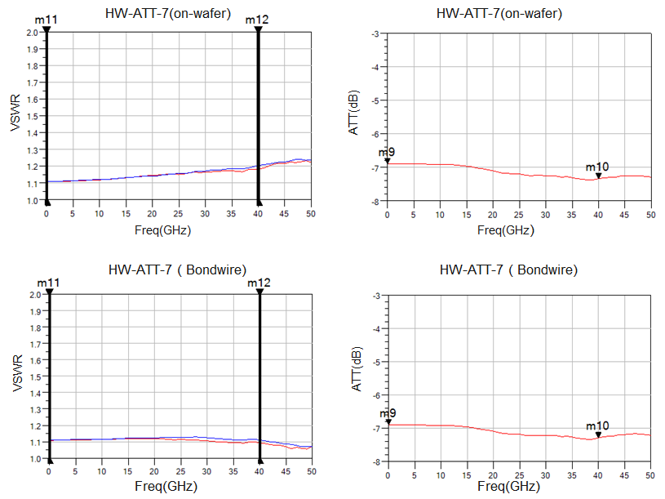
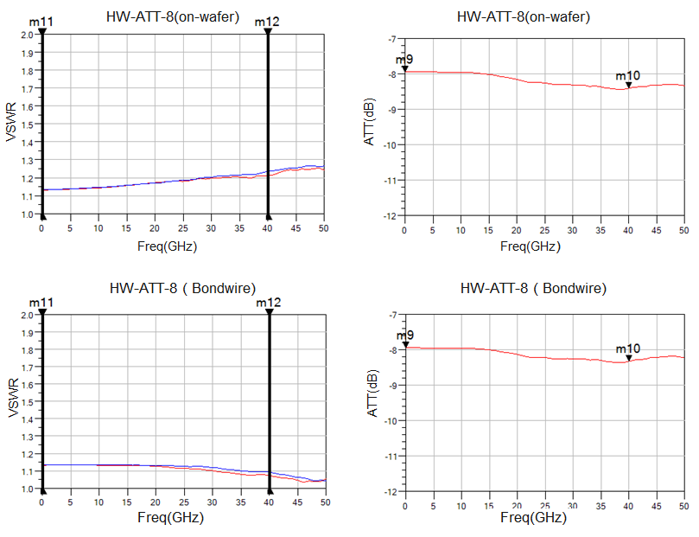
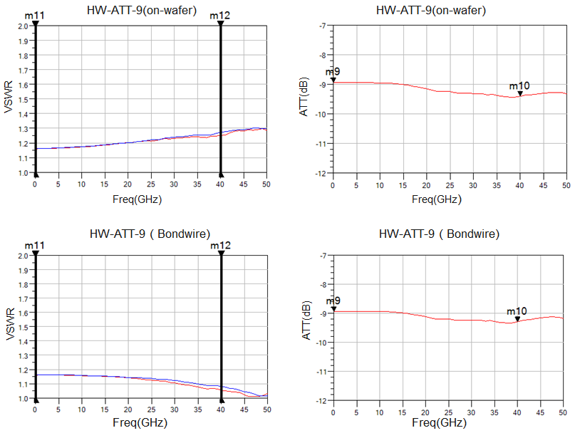
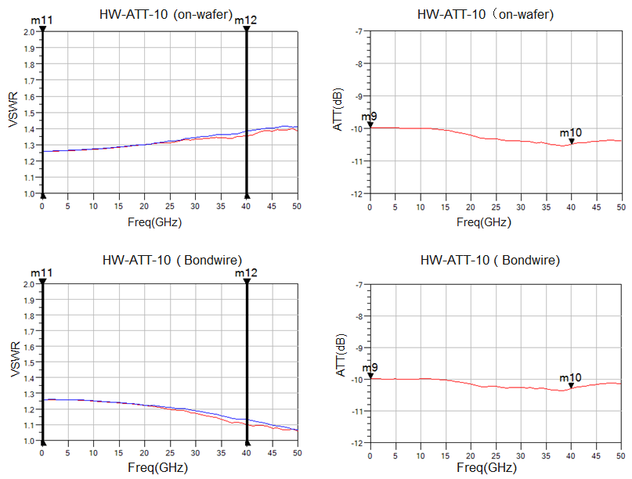
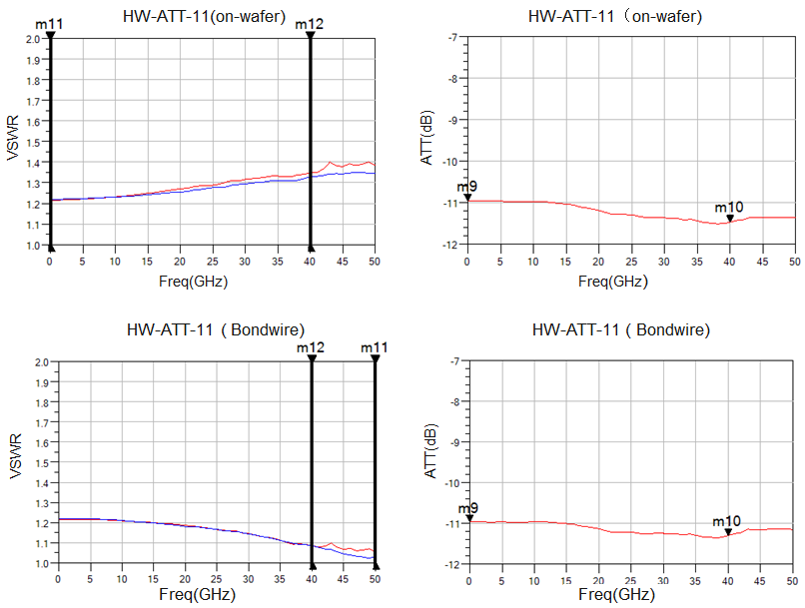
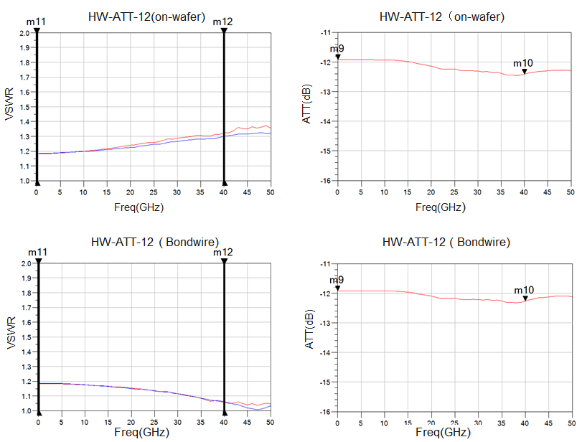
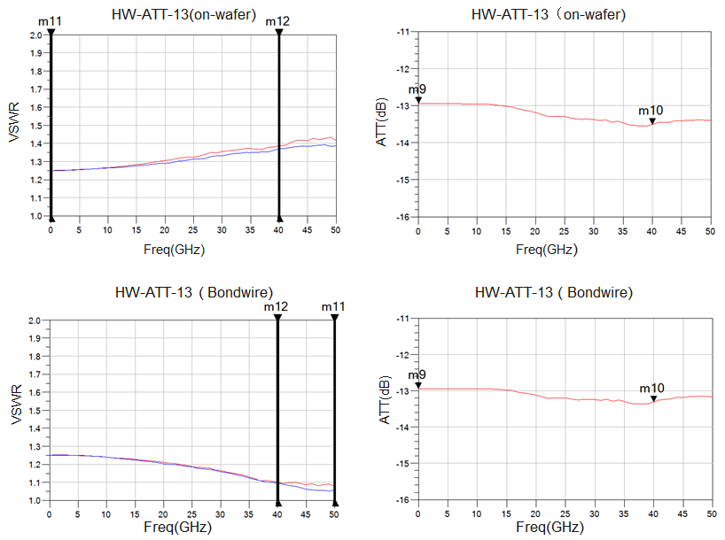
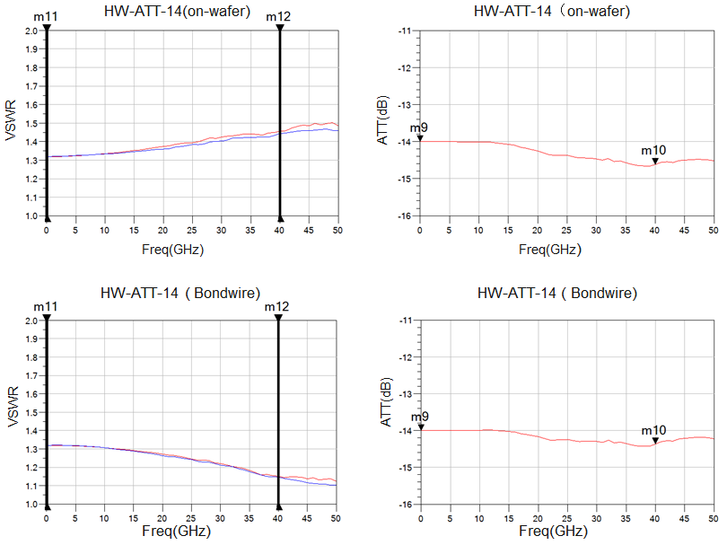
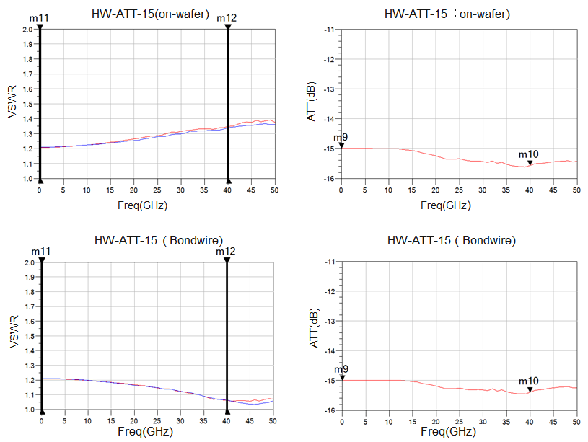
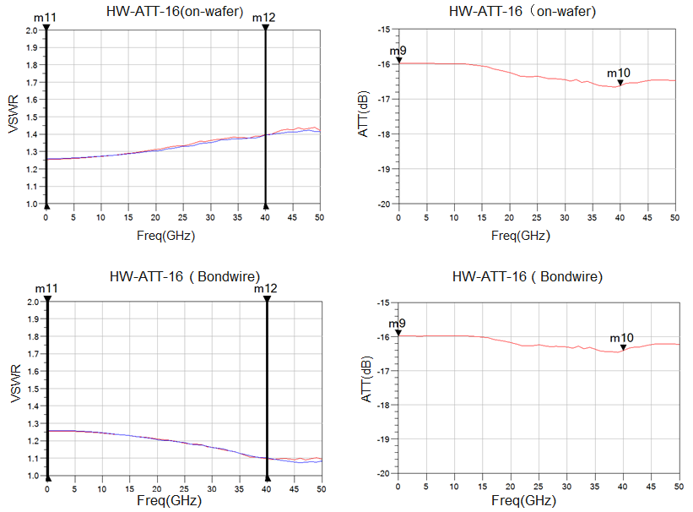
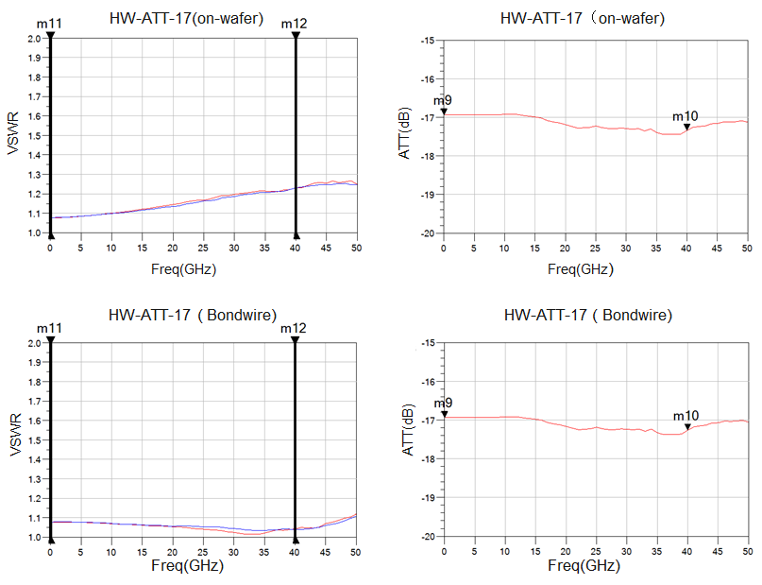
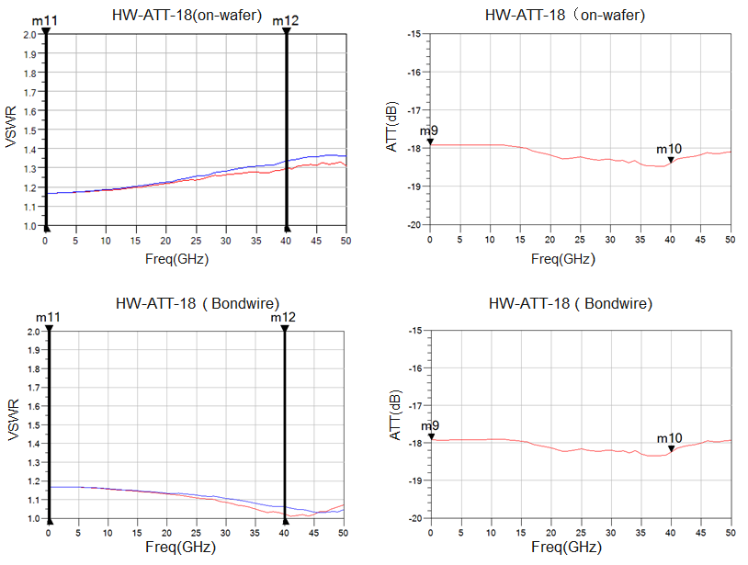
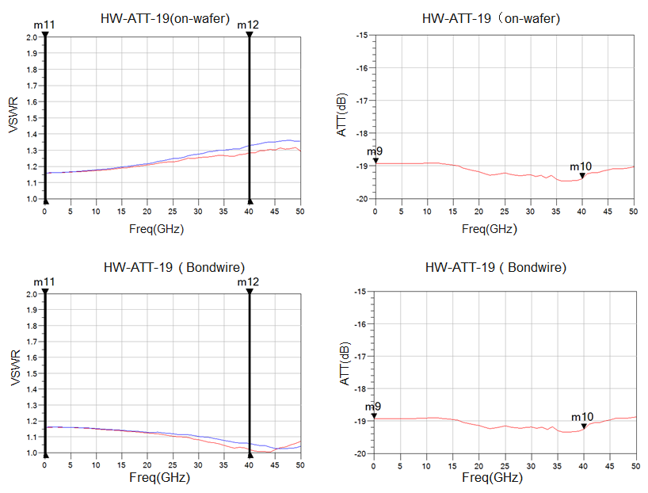
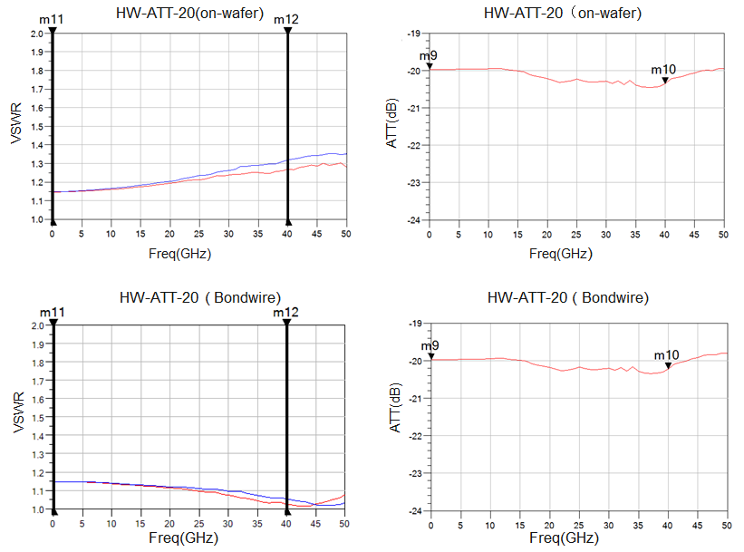
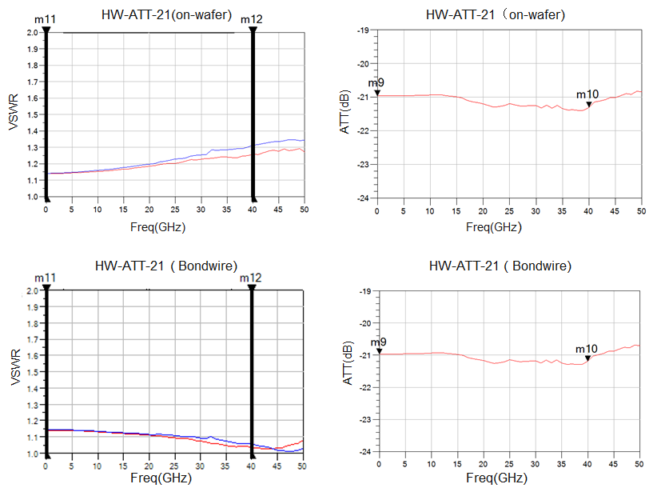
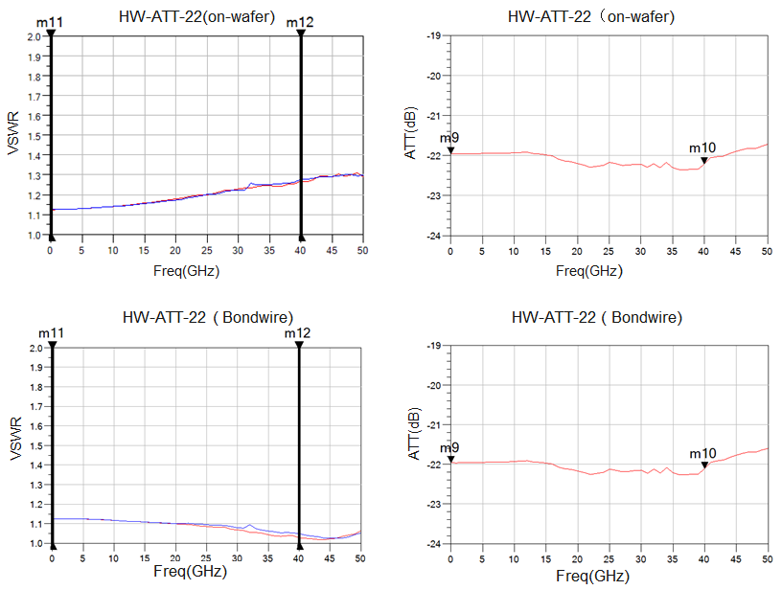
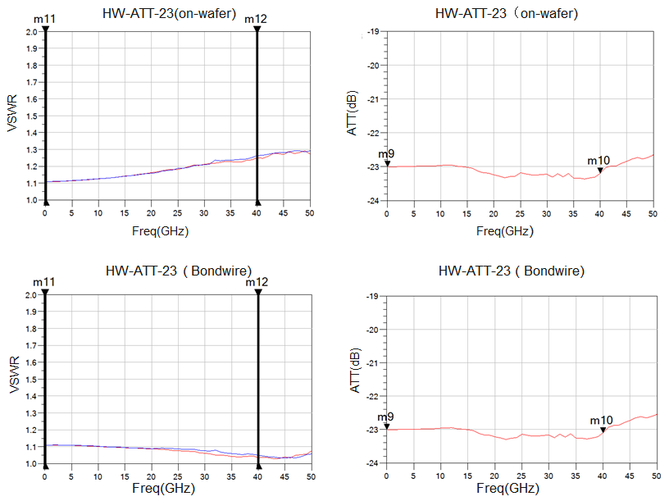
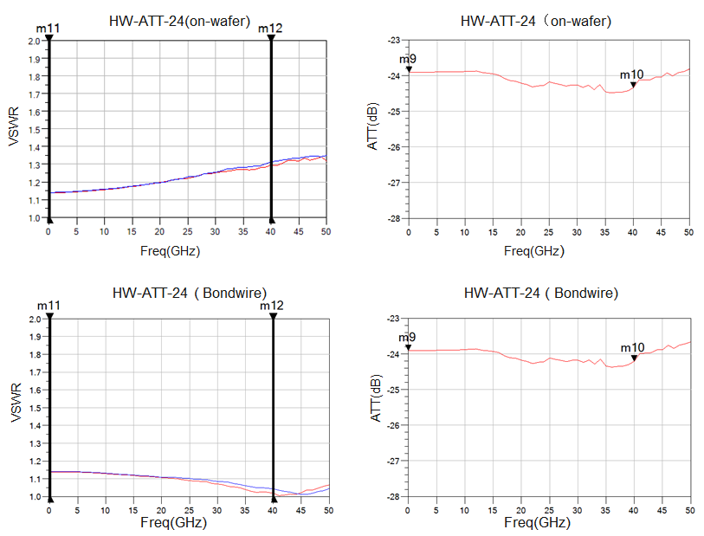
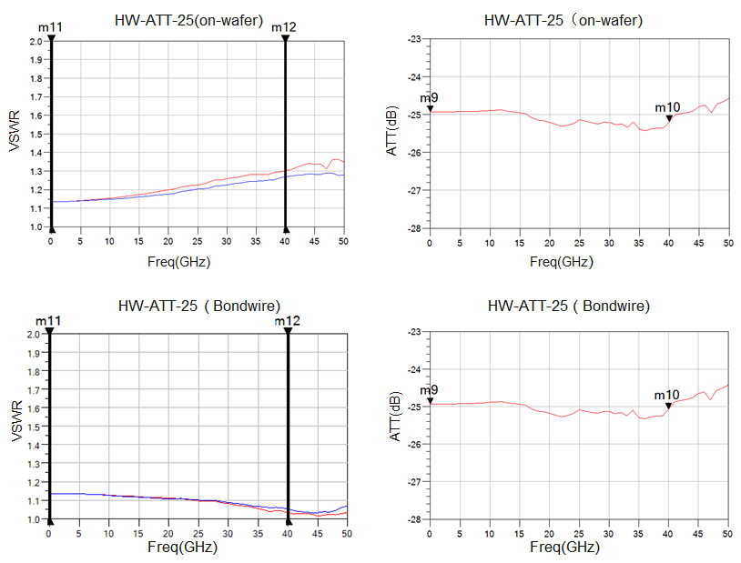
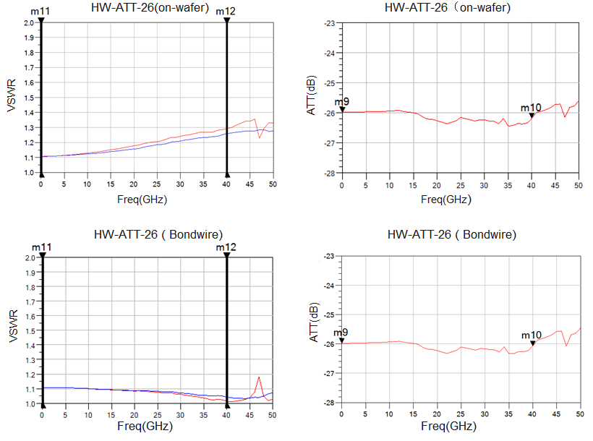
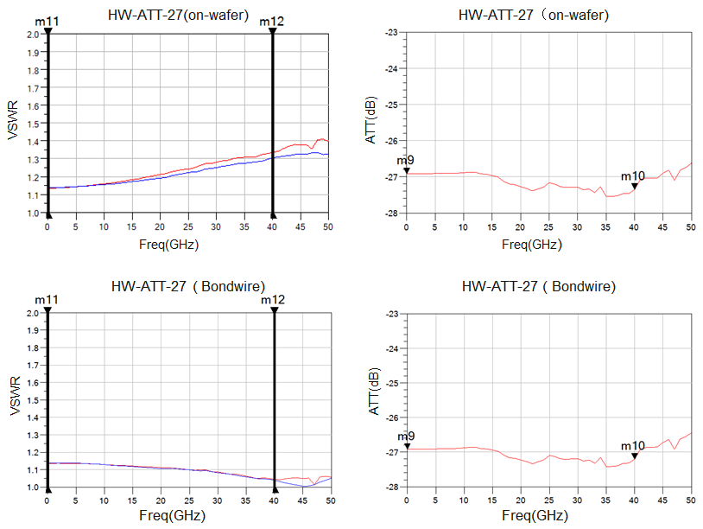
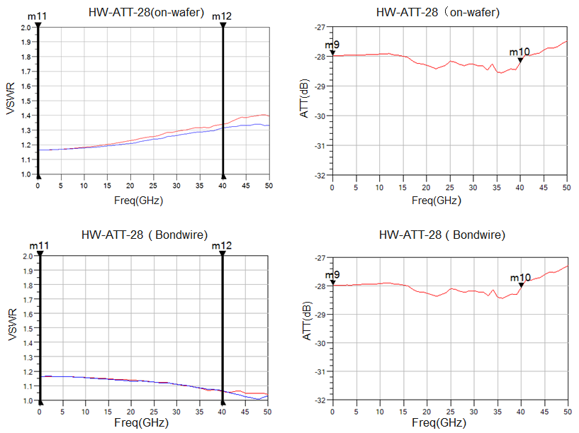
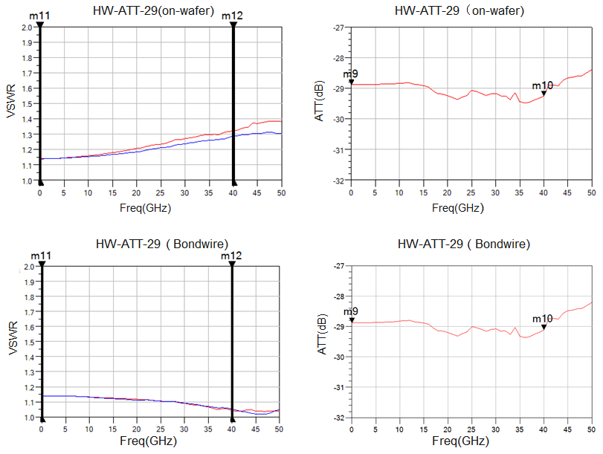
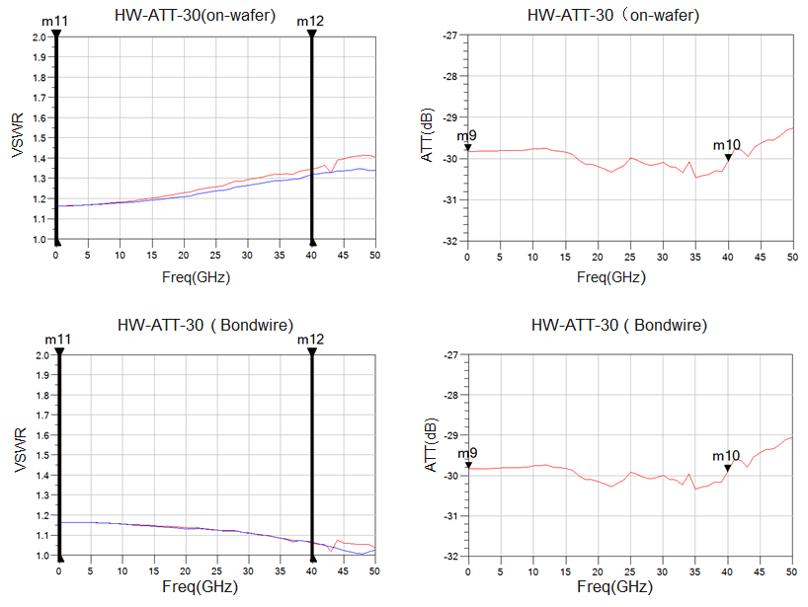
Physical size drawing：(unit mm)

Physical proposed assembly drawing：
Instructions:
Storage: The chip must be placed in a container with electrostatic protection and stored in a nitrogen environment.
Cleaning treatment: The bare chip must be operated and used in a purified environment. It is forbidden to use liquid cleaning agent to clean the chip.
Electrostatic protection: Strictly comply with the ESD protection requirements to avoid electrostatic damage to the components.
General operation: Use vacuum chuck or precision pointed tweezers to pick up the chip.Avoid touching the surface of the chip with tools or fingers during handling.
Mounting operation: The chip can be installed using AuSn solder eutectic welding or conductive adhesive bonding process.The mounting surface must be clean and flat.
Bonding operation: Input and output with 2 (recommended diameter of 25um gold wire) bonding wire, bonding wire length less than 250um is optimal.It is recommended to use the smallest possible ultrasonic energy.Bonding begins at the pressure point on the chip and ends at the package (or substrate).

Performance Features：
6

6

- Frequency range: DC-50GHz
- Attenuation range: 0/1/2/3/4/5/6/7/8/9/10dB
- Fluctuation of insertion loss: 0.4dB
- Input/output voltage standing wave ratio: 1.4/1.4
- Chip size: 0.60mm×0.60mm×0.1mm
Product Description：
The CW-AT50 is a GaAs MMIC fixed attenuator with excellent performance.The chip covers the DC-50GHz band range, attenuation range is optional, plug-in loss fluctuation is less than 0.4dB, input-output voltage standing wave ratio is less than 1.4.
Electrical parameters：( T_{A}=25℃)
Indicators |  | Minimum | Typical value | Maximum value | Units
Frequency range |  | DC-50 |  |  | GHz
Amount of attenuation | 0dB | 0 | 0 | 0.5 | dB
Amount of attenuation | 1dB | 0.8 | 1 | 1.3 | dB
Amount of attenuation | 2dB | 2 | 2 | 2.4 | dB
Amount of attenuation | 3dB | 3 | 3 | 3.4 | dB
Amount of attenuation | 4dB | 4 | 4 | 4.4 | dB
Amount of attenuation | 5dB | 5 | 5 | 5.4 | dB
Amount of attenuation | 6dB | 6 | 6 | 6.4 | dB
Amount of attenuation | 7dB | 7 | 7 | 7.4 | dB
Amount of attenuation | 8dB | 8 | 8 | 8.4 | dB
Amount of attenuation | 9dB | 9 | 9 | 9.4 | dB
Amount of attenuation | 10dB | 10 | 10 | 10.3 | dB
Enter the standing wave ratio |  | - | 1.2 | 1.4 | -
Output standing wave ratio |  | - | 1.2 | 1.4 | -
Use limit parameters: (Exceeding any of the above maximum limits risks permanent damage.)
Maximum input power | 27 dBm
Storage temperature | -65℃-150℃
Service temperature | -55℃-125℃

Typical curve：
Input-output standing wave ratio insertion loss
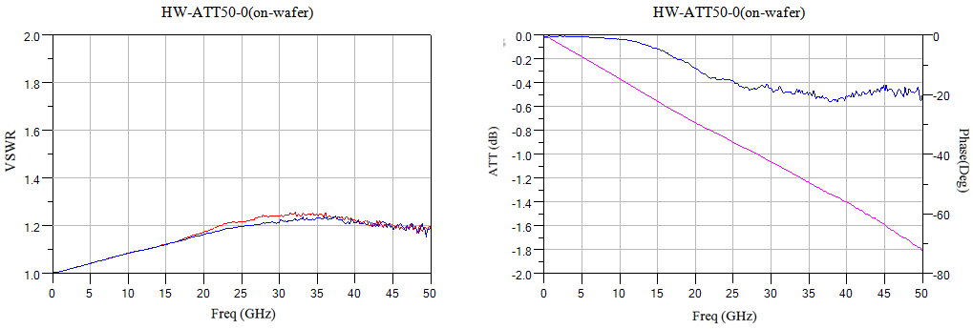
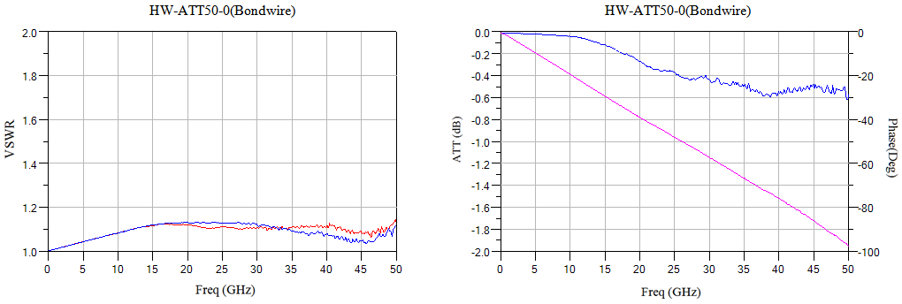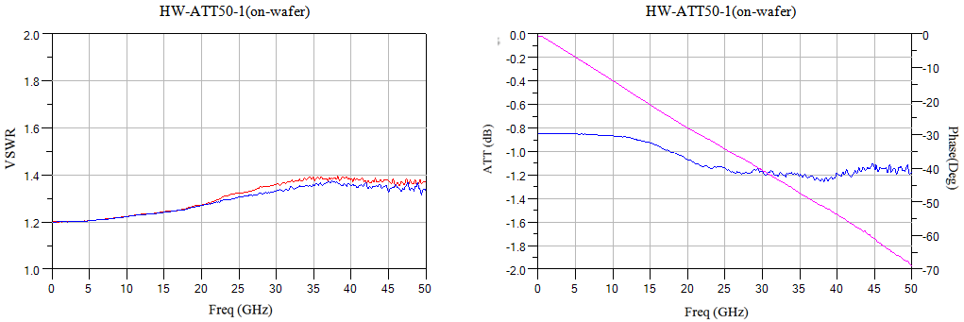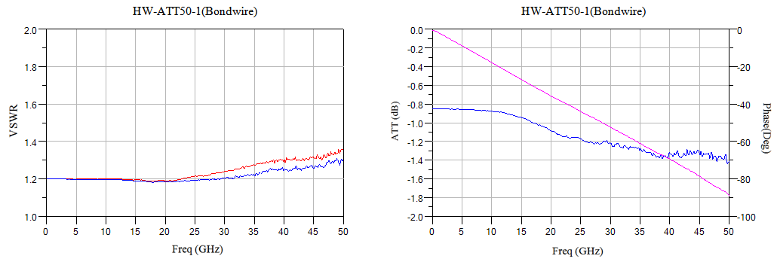
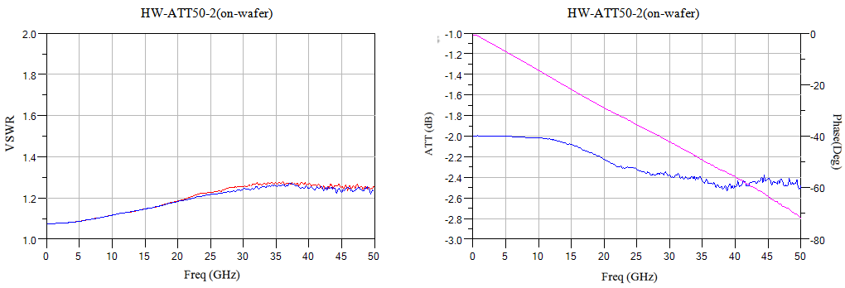
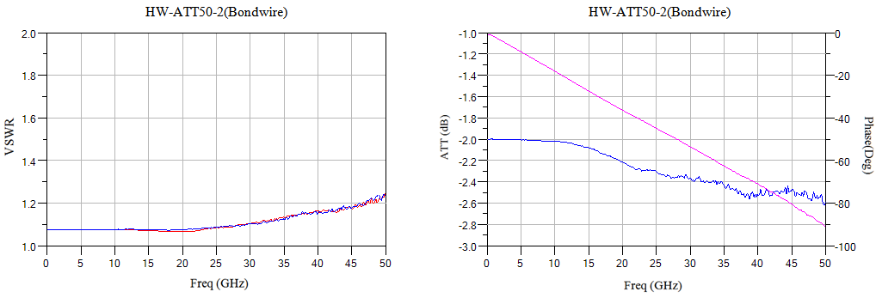
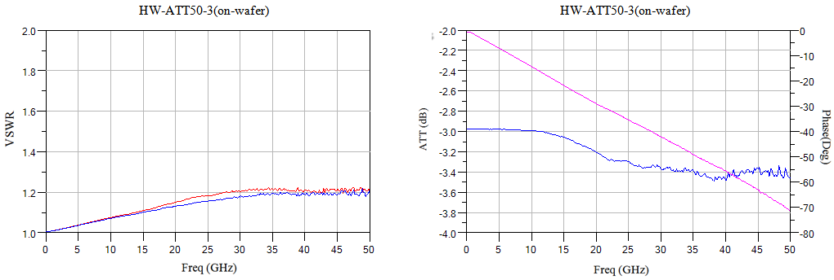
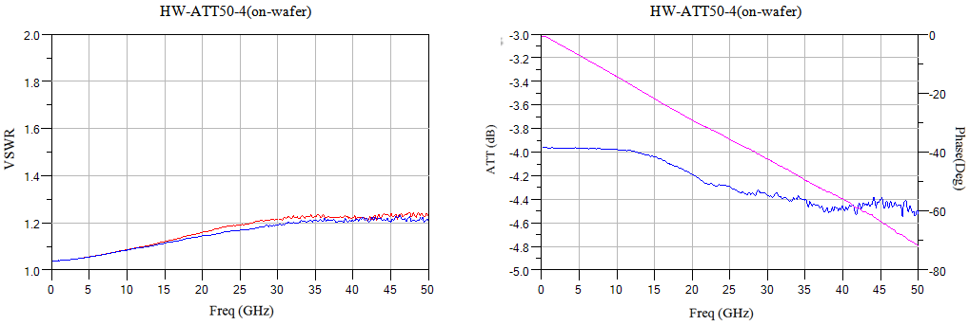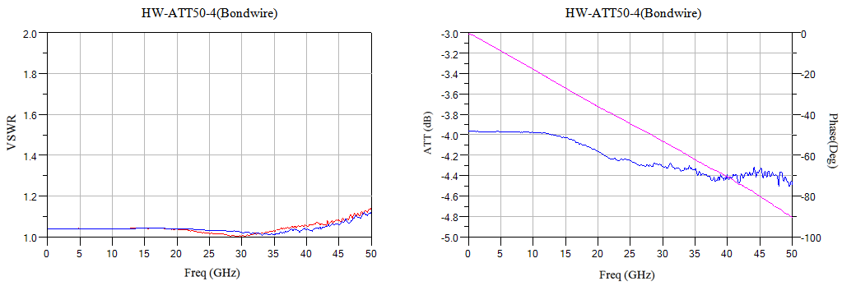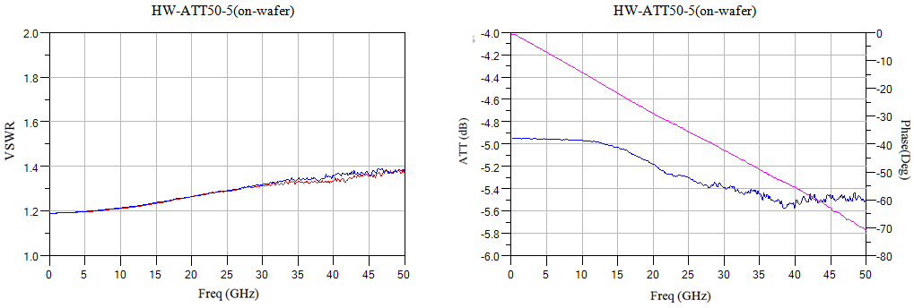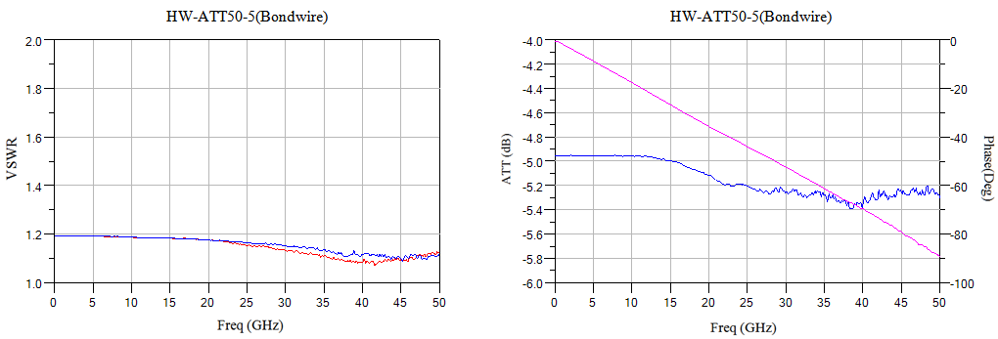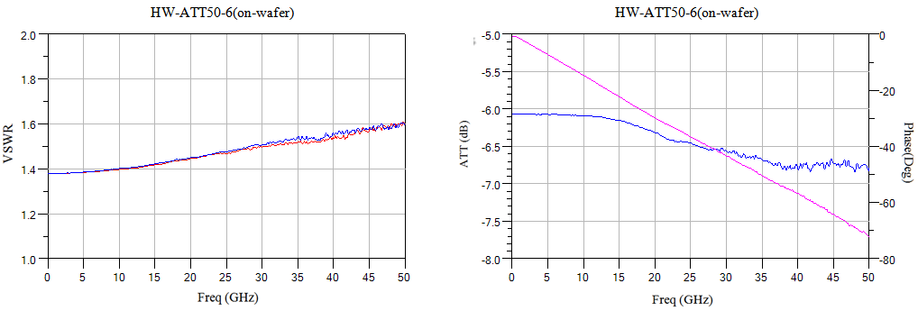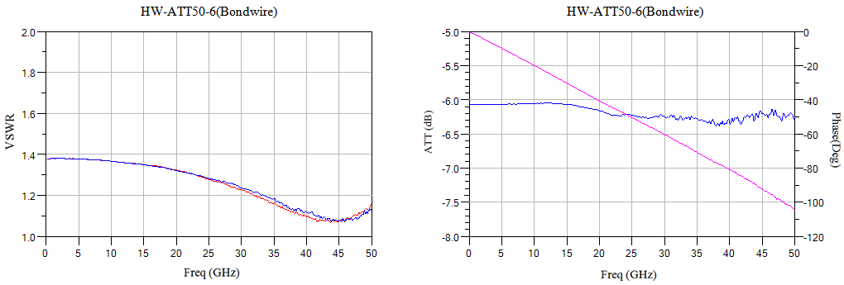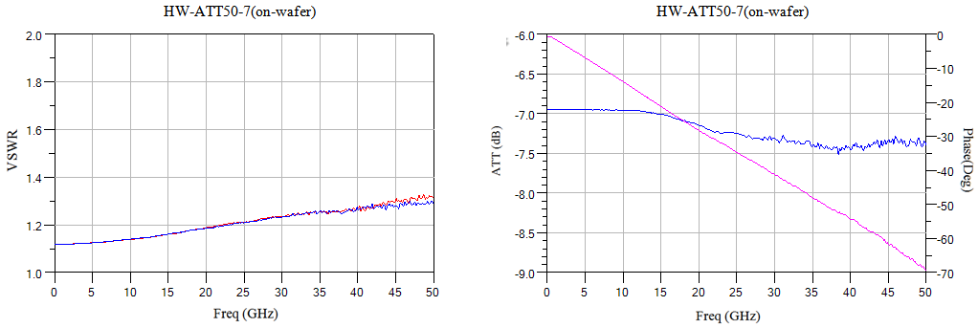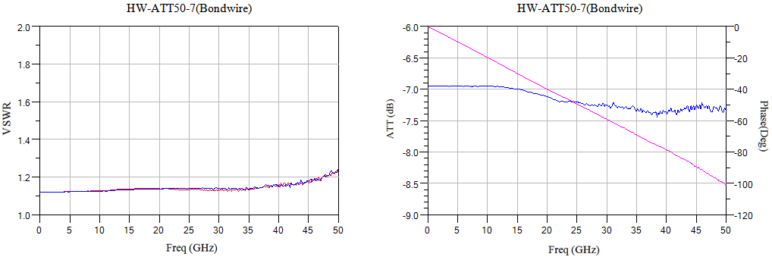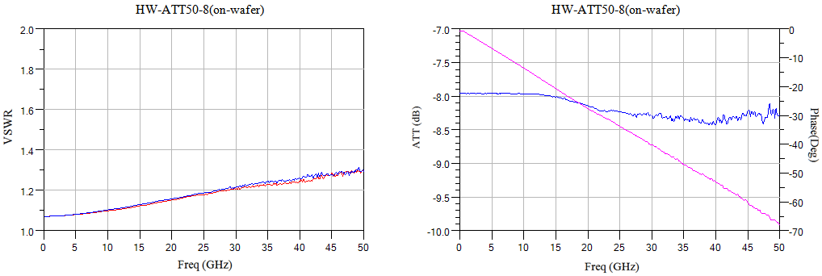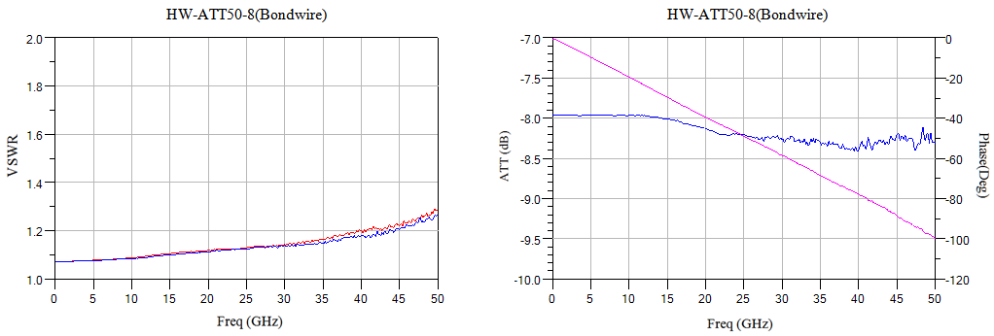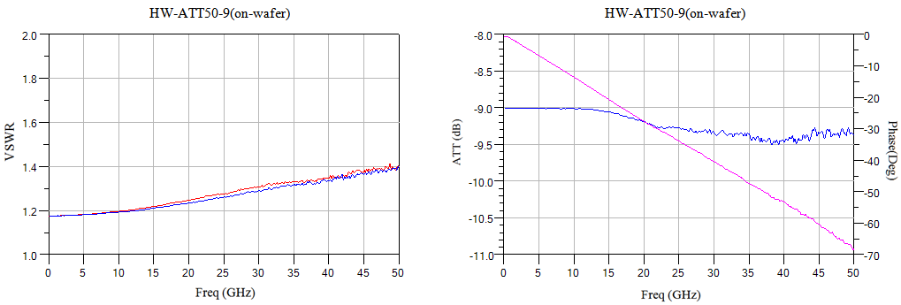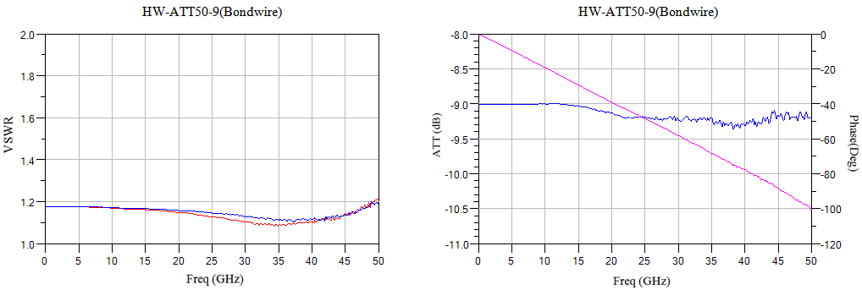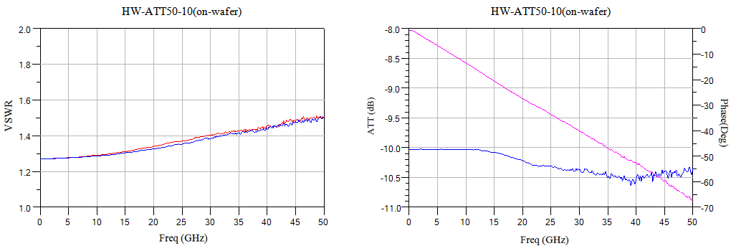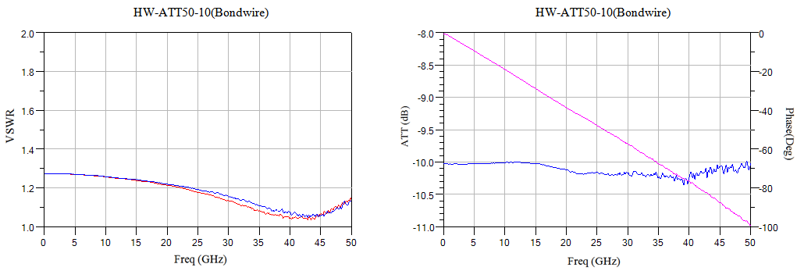
Size diagram：(unit mm)
Suggested assembly drawing：
Instructions:
Storage: The chip must be placed in a container with electrostatic protection and stored in a nitrogen environment.
Cleaning treatment: The bare chip must be operated and used in a purified environment. It is forbidden to use liquid cleaning agent to clean the chip.
Electrostatic protection: Strictly comply with the ESD protection requirements to avoid electrostatic damage to the components.
General operation: Use vacuum chuck or precision pointed tweezers to pick up the chip.Avoid touching the surface of the chip with tools or fingers during handling.
Mounting operation: The chip can be installed using AuSn solder eutectic welding or conductive adhesive bonding process.The mounting surface must be clean and flat.
Bonding operation: Input and output with 2 (recommended diameter of 25um gold wire) bonding wire, bonding wire length less than 250um is optimal.It is recommended to use the smallest possible ultrasonic energy.Bonding begins at the pressure point on the chip and ends at the package (or substrate).

Performance Characteristics：
- Frequency band: 2.4~8GHz
- Insertion loss: 3.4 dB
- Attenuation range: 0.5 to 31.5dB
- Input/output voltage standing wave ratio: 1.4/1.3
- Chip size: 1.5mm×0.85mm×0.1mm
Product Description：
CW-DAT425 is a GaAs MMIC 6-bit CNC attenuator chip with a frequency coverage range of 2.4 to 8GHz and less than 4dB of insertion loss. The GCW-DAT425 uses +5V/0V logic control with a switching speed of less than 20ns.
Electrical parameters：( T_{A}=25℃，Vc=+5V/0V)
Indicators |  | Minimum | Typical value | Maximum value | Units
Frequency range |  | 2.4~8 |  |  | GHz
Insertion loss |  | - | 3.4 | 4 | dB
Attenuation range |  | - | 31.5 | - | dB
Attenuation accuracy | 0.5dB | 0.3 | 0.5 | 0.7 | dB
Attenuation accuracy | 1dB | 0.7 | 1 | 1.2 | dB
Attenuation accuracy | 2dB | 1.7 | 2 | 2.3 | dB
Attenuation accuracy | 4dB | 3.7 | 4 | 4.3 | dB
Attenuation accuracy | 8dB | 7.6 | 8 | 8.3 | dB
Attenuation accuracy | 16dB | 15.4 | 16 | 16.3 | dB
Enter the standing wave ratio |  | - | 1.4 | - | dB
Output standing wave ratio |  | - | 1.3 | - | dB
Use limiting parameters：
Control voltage range | Vdd+0.5V
Storage temperature | -65℃~150℃
Service temperature | -55℃~125℃

Typical curve：
Insertion loss vs. frequency full attenuated state VS. Frequency
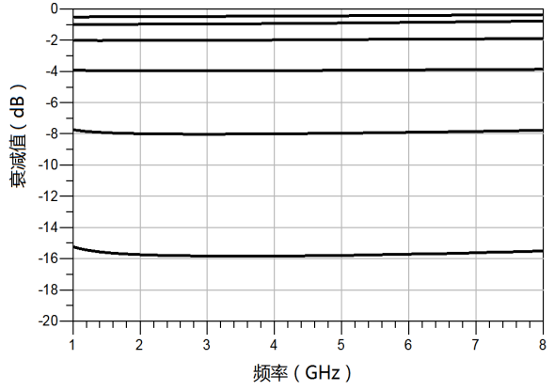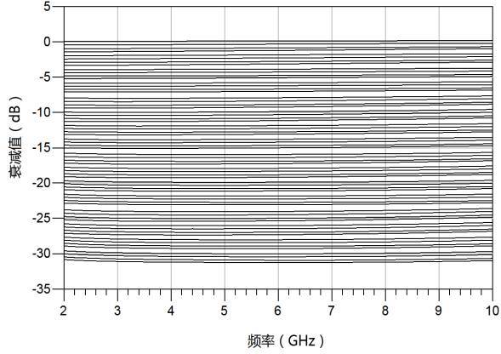
Input standing wave vs. Frequency Output standing wave VS. Frequency
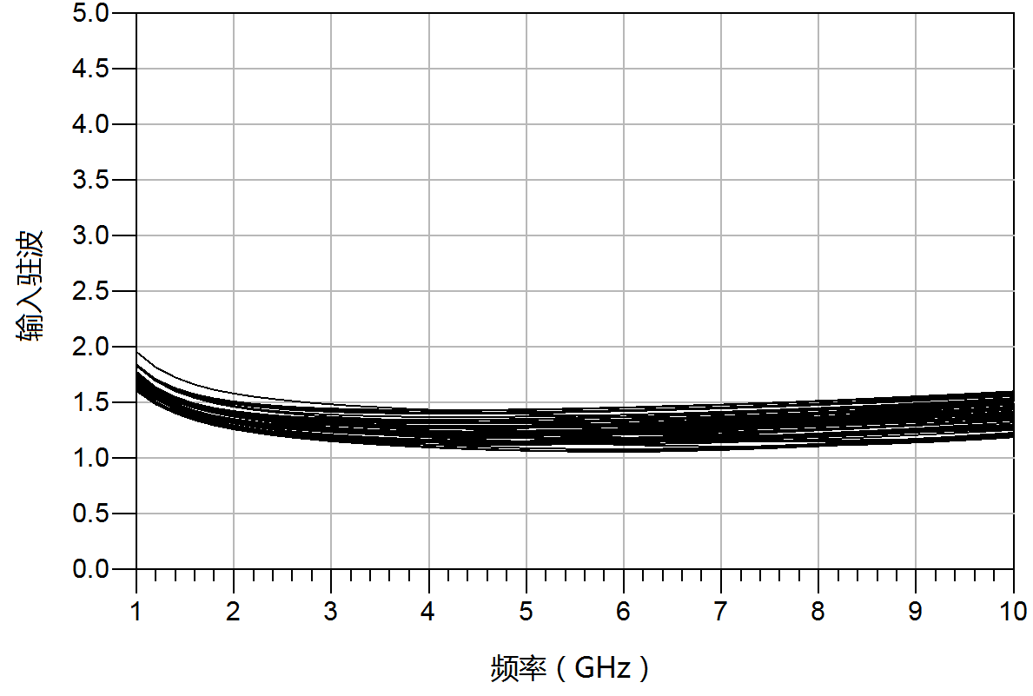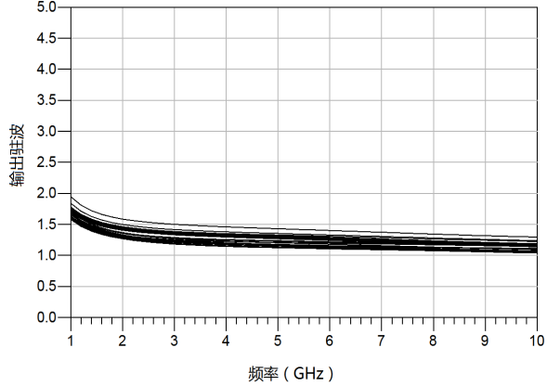
Insertion loss vs. frequency additional phase shift VS. Frequency 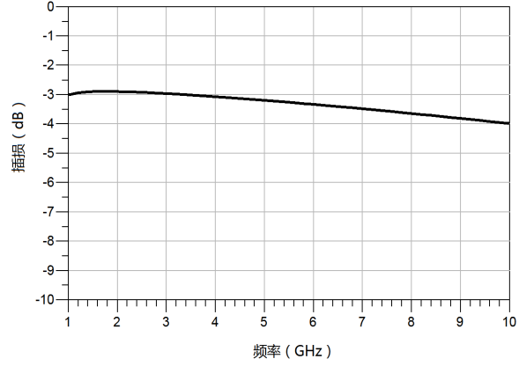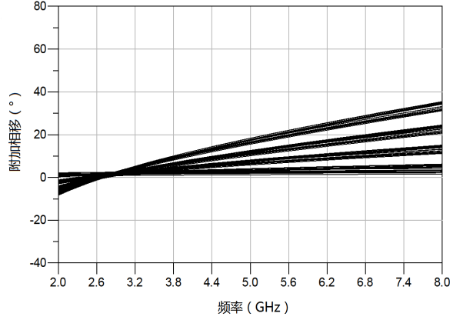

Truth table:
16dB | 8dB | 4dB | 2dB | 1dB | 0.5dB | Status
V1 | V2 | V3 | V4 | V5 | V6 | Status
High | High | High | High | High | High | Reference state
High | High | High | High | High | Low | 0.5dB
High | High | High | High | Low | High | 1dB
High | High | High | Low | High | High | 2dB
High | High | Low | High | High | High | 4dB
High | Low | High | High | High | High | 8dB
Low | High | High | High | High | High | 16dB
Low | Low | Low | Low | Low | Low | 31.5dB
Note：Low=0~0.2V；High=Vdd±0.2V（Vdd=+3.3V~+5V）
Size chart：（unit mm）

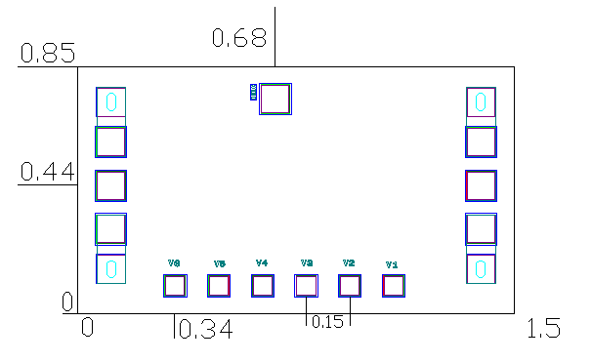

Suggested assembly drawing：
Instructions:
Storage: The chip must be placed in a container with electrostatic protection and stored in a nitrogen environment.
Cleaning treatment: The bare chip must be operated and used in a purified environment. It is forbidden to use liquid cleaning agent to clean the chip.
Electrostatic protection: Strictly comply with the ESD protection requirements to avoid electrostatic damage to the components.
General operation: Use vacuum chuck or precision pointed tweezers to pick up the chip.Avoid touching the surface of the chip with tools or fingers during handling.
Mounting operation: The chip can be installed using AuSn solder eutectic welding or conductive adhesive bonding process.The mounting surface must be clean and flat.
Bonding operation: Input and output with 2 (recommended diameter of 25um gold wire) bonding wire, bonding wire length less than 250um is optimal.It is recommended to use the smallest possible ultrasonic energy.Bonding begins at the pressure point on the chip and ends at the package (or substrate).

Performance Features：
4

4

- Attenuation: 5dB
- Flatness of attenuation: ± 0.15dB
- I/O return loss: 20 dB
- Maximum input power: +27 dBm
- Chip size: 0.6mm×0.51mm×0.1mm
Product Description：
CW-AT105S_1_2 is a GaAs MMIC fixed attenuator with excellent performance.The chip covers the DC-40GHz band range, attenuation range is optional, attenuation fluctuation is less than 0.4dB, input-output voltage standing wave ratio is less than 1.3.
Electrical parameters：( T_{A}=25℃)
Indicators | Minimum | Typical value | Maximum value | Units
Frequency range | DC-40 |  |  | GHz
Attenuation fluctuation | - | - | 0.4 | dB
Enter the standing wave ratio | - | 1.2 | 1.3 | -
Output standing wave ratio | - | 1.2 | 1.3 | -
Use limit parameters: (Exceeding any of the above maximum limits risks permanent damage.)
Maximum input power | 27 dBm
Storage temperature | -65℃-175℃
Service temperature | -55℃-125℃
Typical curve：（T_{A}=+25℃）
I/O return loss Insertion loss
frequency frequency

Size drawing：（unit mm）
Suggested assembly drawing:
Instructions:
Storage: The chip must be placed in a container with electrostatic protection and stored in a nitrogen environment.
Cleaning treatment: The bare chip must be operated and used in a purified environment. It is forbidden to use liquid cleaning agent to clean the chip.
Electrostatic protection: Strictly comply with the ESD protection requirements to avoid electrostatic damage to the components.
General operation: Use vacuum chuck or precision pointed tweezers to pick up the chip.Avoid touching the surface of the chip with tools or fingers during handling.
Mounting operation: The chip can be installed using AuSn solder eutectic welding or conductive adhesive bonding process.The mounting surface must be clean and flat.
Bonding operation: Input and output with 2 (recommended diameter of 25um gold wire) bonding wire, bonding wire length less than 250um is optimal.It is recommended to use the smallest possible ultrasonic energy.Bonding begins at the pressure point on the chip and ends at the package (or substrate).

Performance Characteristics：
- Frequency range: 0.5~18GHz
- Attenuation range: 0.5~15.5dB
- Insertion loss: 3.1dB
- Attenuation additional phase shift: ±4°
- Chip size: 2.7mm x 1.5mm x 0.1mm
- Product Description：
CW-DAT239NC is a GaAs MMIC wideband 5-bit CNC attenuator with operating frequency covering 0.5~18GHz and insertion loss less than 3.4dB. Its basic attenuator is 0.5dB, 1dB, 2dB, 4dB, 8dB, and total attenuator is 15.5dB.This numerical control attenuator uses 0/-5V logic control, no power consumption.With excellent attenuation characteristics and port standing over the whole operating frequency range, it is very suitable for microwave hybrid integrated circuits and multi-chip modules as well as low power systems.
Electrical parameters：( TA=25℃，0/-5V control)
Indicators | Minimum | Typical value | Maximum value | Units
Frequency range | 0.5~18 |  |  | GHz
Insertion loss | - | 3.1 | - | dB
Attenuation range | 0.5 | - | 15.5 | dB
Attenuator attached phase shift | - | ±4 | - | °
Return loss | - | 15 | - | dB
Enter P1dB | - | 24 | - | dBm
Switching time | - | 30 | - | Ns
Use limiting parameters：
Maximum power | 27 dBm
Storage temperature | -65℃-175℃
Service temperature | -55℃~125℃
Typical curve：
Insertion loss ground state attenuation amount

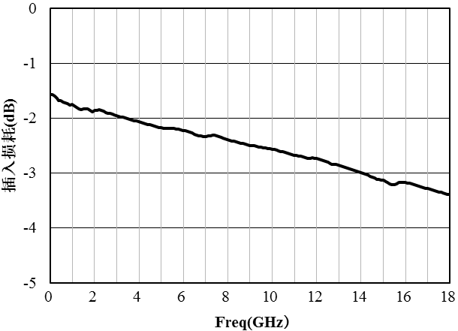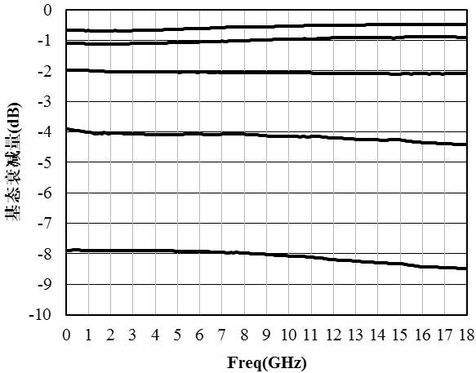
Attenuation additional phase shift input return loss
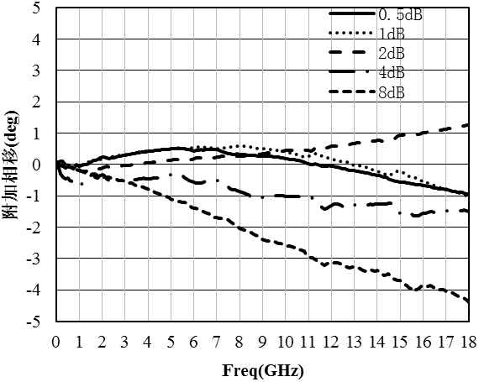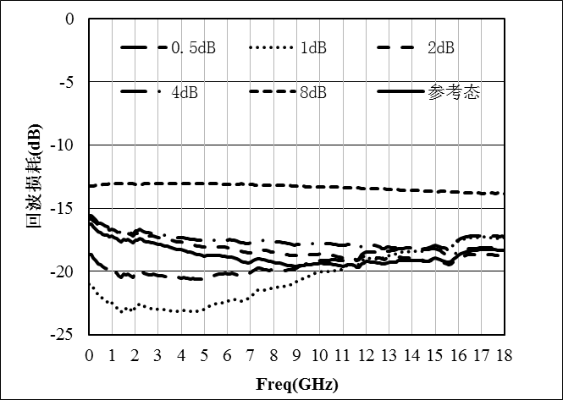
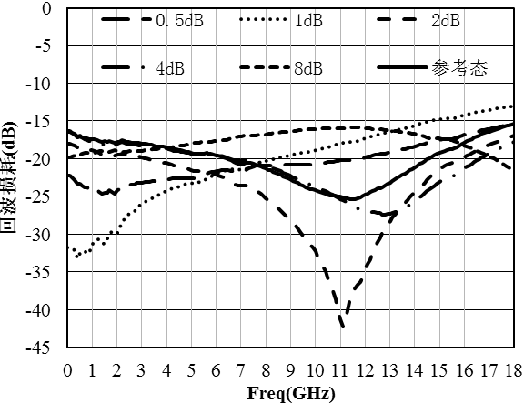
Output return loss

Truth table:
Decay state | 1A | 2A | 3A | 3B | 4A | 4B | 5A | 5B
Decay state | 0.5dB | 1dB | 2dB |  | 4dB |  | 8dB
Reference state | -5 | -5 | -5 | 0 | -5 | 0 | -5 | 0
0.5dB | 0 | -5 | 0 | -5 | 0 | -5 | 0 | -5
1dB | -5 | 0 | 0 | -5 | 0 | -5 | 0 | -5
2dB | -5 | -5 | 0 | -5 | 0 | -5 | 0 | -5
4dB | -5 | -5 | 0 | -5 | 0 | -5 | 0 | -5
8dB | -5 | -5 | 0 | -5 | 0 | -5 | 0 | -5

Physical size drawing：(unit µm)
Physical proposed assembly drawing：

Instructions:
- For use in a purified environment, do not touch the surface of the chip when using.
- Input and output with 2 (diameter of 25um gold wire) bonding wire, bonding wire length of about 300um is optimal.
- I/O has divider capacitors.
- This product belongs to electrostatic sensitive device, pay attention to anti-static during storage and use.
It is stored in dry and nitrogen environment.

Performance Characteristics：
- Band: DC-40GHz
- Attenuation: 15dB
- Flatness of attenuation: ±0.3dB
- Input/output return loss: 20dB
- Chip size: 0.79mm×0.57mm×0.1mm
Product Description：
CW-AT40A-15 is a GaAs MMIC 15dB fixed attenuator chip. The fixed attenuator chip covers the frequency range of DC~40GHz, the attenuation is 15dB, and the input and output echo is less than 20dB.
Electrical parameters：( TA=25℃,VD=+5V)
Index | Minimum | Typical value | Maximum value | Units
Frequency range | DC~40 |  |  | GHz
Amount of attenuation | - | 15 | - | dB
Decaying amount flatness | - | ±0.3 | - | dB
Input return loss | 20 | - | - | dB
Output return loss | 20 | - | - | dB
Use limit parameters：
Input power | +27dBm
Storage temperature | -65℃~150℃
Service temperature | -55℃~85℃
Typical curve：
Insertion loss return loss
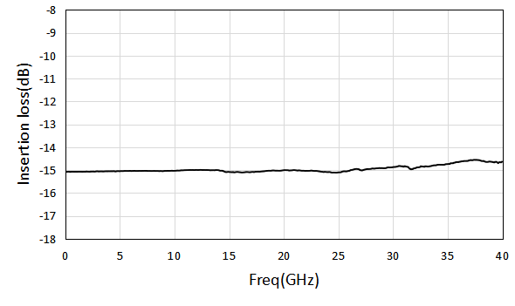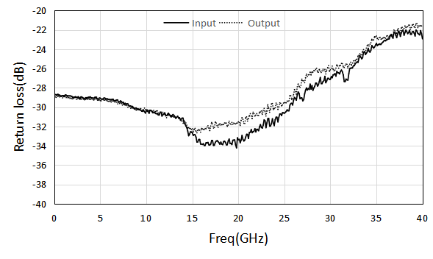

Size drawing：(unit mm)
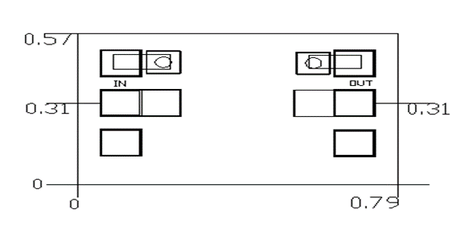
Suggested assembly drawing:
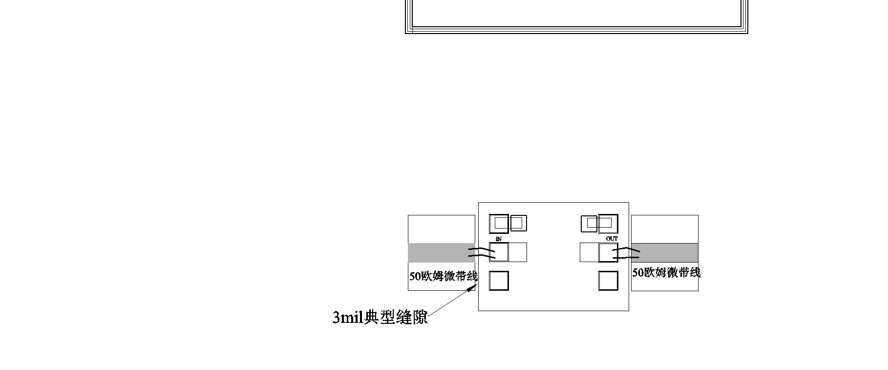
Instructions:
Storage: The chip must be placed in a container with electrostatic protection and stored in a nitrogen environment.
Cleaning treatment: The bare chip must be operated and used in a purified environment. It is forbidden to use liquid cleaning agent to clean the chip.
Electrostatic protection: Strictly comply with the ESD protection requirements to avoid electrostatic damage to the components.
General operation: Use vacuum chuck or precision pointed tweezers to pick up the chip.Avoid touching the surface of the chip with tools or fingers during handling.
Mounting operation: The chip can be installed using AuSn solder eutectic welding or conductive adhesive bonding process.The mounting surface must be clean and flat.
Bonding operation: Input and output with 2 (recommended diameter of 25um gold wire) bonding wire, bonding wire length less than 250um is optimal.It is recommended to use the smallest possible ultrasonic energy.Bonding begins at the pressure point on the chip and ends at the package (or substrate).

08 Power divider
Number | Frequency range  (GHz) | Insertion loss  (dB) | Flatness of insertion loss  (dB) | Standing wave | isolation  (dB) | Page number
CW-PD0204V | 2-4 | 0.5 | ±0.2 | 1.3/1.3 | 20
CW-PD0204VA | 2-4 | 0.7 | ±0.2 | 1.2/1.2 | 25
CW-PD0218 | 2.0-18 | 0.7 | ±0.3 | 1.3/1.3 | 14
CW-PD0218V | 2.0-18 | 1 | ±0.3 | 1.5/1.5 | 15
CW-PD0618 | 6-18 | 0.6 | ±0.15 | 1.5/1.3 | 17
CW-PD0618V | 6-18 | 0.8 | ±0.4 | 1.3/1.4 | 20
CW-PD0812 | 8-12 | 0.4 | ±0.05 | 1.3/1.1 | 18
CW-PD1218V | 12-18 | 0.5 | ±0.2 | 1.3/1.3 | 20
CW-PD1840 | 18-40 | 0.5 | ±0.1 | 1.4/1.4 | 11
CW-PD1840V | 18-40 | 0.8 | ±0.2 | 1.2/1.4 | 22
CW-PD20P502 | 0.5-2 | 1.2 | ±0.3 | - | 20
CW-PD0118 | 1-18 | 1.4 | ±0.2 | 1.5/1.5 | 20
CW-PD0208 | 2-8 | 1 | ±0.2 | - | 18
CW-PD0218S | 2-18 | 0.7 | ±0.3 | - | 20
CW-PD1218VA | 12-18 | 0.4 | - | 1.3/1.3 | 20
CW-PD3040V | 30-40 | 0.5 | - | 1.3/1.3 | 25
CW-PD30618 | 6-18 | 1.0 | ±0.3 | 2.0/1.4 | 16
CW-PD31018 | 10-18 | 0.6 | ±0.3 | 1.3/1.2 | 22
CW-PD31418 | 14-18 | 0.5 | - | 1.5/1.4 | 16
CW-PD32040 | 20-40 | 0.8 | - | 1.9/1.5 | 15
CW-PD43040 | 33-37 | 1.1 | - | 1.37/1.2 | 20

Performance Features：
- Frequency band: 2~4GHz
- Insertion loss: 0.5dB
- Fluctuation of insertion loss: ±0.2dB
- Isolation: 20dB
- Input/output return loss: 20dB/20dB
- Chip size: 1.3mm×1.1mm×0.1mm
Product Description：
CW-PD0204V is a GaAs MMIC0° two-way power splitter chip. The power splitter chip has the characteristics of small plug loss, high isolation, small size, easy integration and so on. It is widely used in power distribution and synthesis.Its frequency range covers 2~4GHz, and the insertion loss is less than 0.7dB in the whole frequency band.
Electrical parameters：( T_{A}=25℃）
Indicators | Minimum | Typical value | Maximum value | Units
Frequency range | 2~4 |  |  | GHz
Insertion loss | - | 0.5 | - | dB
Fluctuations in plug loss | - | - | ±0.2 | dB
isolation | 20 | 22 | - | dB
Input return loss | - | 20 | - | dB
Output return loss | - | 20 | - | dB
Use limiting parameters：
Input power | +27dBm
Storage temperature | -65℃~150℃
Service temperature | -55℃~85℃
Typical curve：
Insertion loss isolation

Return loss
Size drawing：（unit mm）
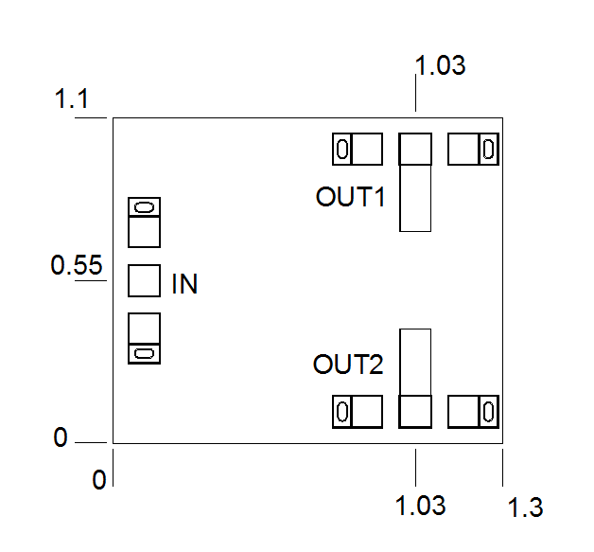
Suggested assembly drawing：
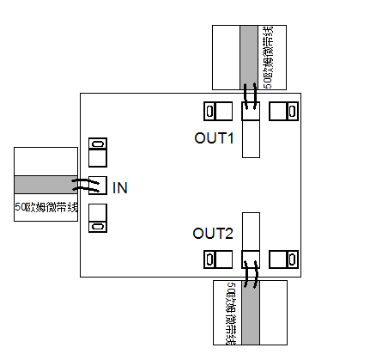
Instructions:
Storage: The chip must be placed in a container with electrostatic protection and stored in a nitrogen environment.
Cleaning treatment: The bare chip must be operated and used in a purified environment. It is forbidden to use liquid cleaning agent to clean the chip.
Electrostatic protection: Strictly comply with the ESD protection requirements to avoid electrostatic damage to the components.
General operation: Use vacuum chuck or precision pointed tweezers to pick up the chip.Avoid touching the surface of the chip with tools or fingers during handling.
Mounting operation: The chip can be installed using AuSn solder eutectic welding or conductive adhesive bonding process.The mounting surface must be clean and flat.
Bonding operation: Input and output with 2 (recommended diameter of 25um gold wire) bonding wire, bonding wire length less than 250um is optimal.It is recommended to use the smallest possible ultrasonic energy.Bonding begins at the pressure point on the chip and ends at the package (or substrate).

Performance Characteristics：
- Frequency band: 2~4GHz
- Insertion loss: 0.7dB
- Isolation: 25dB
- Input/output voltage standing wave ratio: 1.3/1.2
- Chip size: 1.2mm×0.9mm×0.1mm
Product description：
CW-PD0204VA is a GaAs MMIC0° two-way power splitter chip. The power splitter chip has the characteristics of small plug loss, high isolation, small size, easy integration and so on. It is widely used in power distribution and synthesis.Its frequency range covers 2~4GHz, and the in-band insertion loss is 0.7dB.
Electrical parameters：( T_{A}=25℃）
Indicators | Minimum | Typical value | Maximum value | Units
Frequency range | 2~4 |  |  | GHz
Insertion loss | - | 0.7 | - | dB
isolation | - | 25 | - | dB
Input voltage standing wave ratio | - | 1.3 | - | -
Output voltage standing wave ratio | - | 1.2 | - | -
Use limiting parameters：
Input power | +27dBm
Storage temperature | -65℃~150℃
Service temperature | -55℃~85℃
Typical curve：
Insertion loss isolation
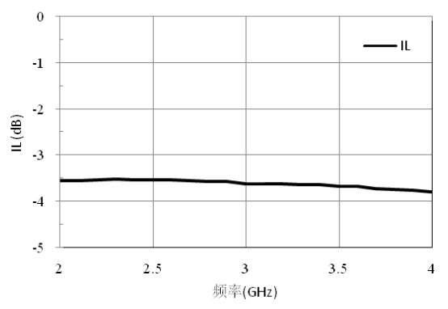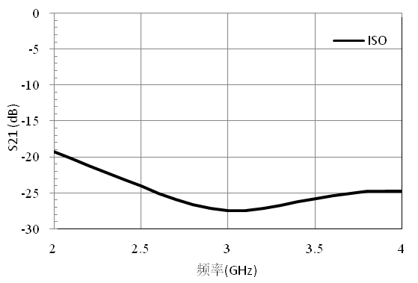

Input/output voltage standing wave ratio
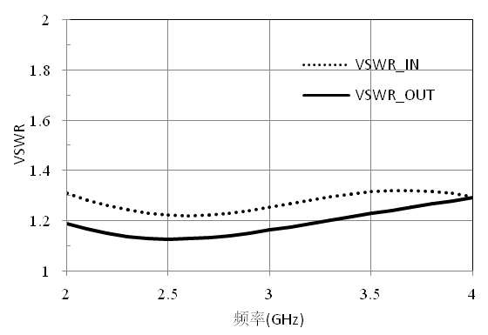
Size diagram：（unit mm）
Suggested assembly drawing：

Instructions:
Storage: The chip must be placed in a container with electrostatic protection and stored in a nitrogen environment.
Cleaning treatment: The bare chip must be operated and used in a purified environment. It is forbidden to use liquid cleaning agent to clean the chip.
Electrostatic protection: Strictly comply with the ESD protection requirements to avoid electrostatic damage to the components.
General operation: Use vacuum chuck or precision pointed tweezers to pick up the chip.Avoid touching the surface of the chip with tools or fingers during handling.
Mounting operation: The chip can be installed using AuSn solder eutectic welding or conductive adhesive bonding process.The mounting surface must be clean and flat.
Bonding operation: Input and output with 2 (recommended diameter of 25um gold wire) bonding wire, bonding wire length less than 250um is optimal.It is recommended to use the smallest possible ultrasonic energy.Bonding begins at the pressure point on the chip and ends at the package (or substrate).

Performance Characteristics：
- Frequency band: 2~18GHz
- Insertion loss: 0.7dB
- Insertion loss fluctuation: ±0.3dB
- Isolation: 14dB
- Input/output voltage standing wave ratio: 1.3/1.3
- Chip size: 1.5mm x 3.0mm x 0.1mm
Product Description：
CW-PD0218 is a GaAs MMIC 0° two-way power splitter chip, its frequency range covers 2~18GHz, and the insertion loss is less than 1.0dB in the entire band.
Electrical parameters：( T_{A}=25℃)
Indicators | Minimum | Typical value | Maximum value | Units
Frequency range | 2~18 |  |  | GHz
Insertion loss | 0.5 | 0.7 | 1.0 | dB
Fluctuations in plug loss | - | - | ±0.3 | dB
isolation | 14 | 17 | - | dB
Enter the standing wave ratio | - | 1.3 | - | -
Output standing wave ratio | - | 1.3 | - | -
Use limit parameters: (Exceeding any of the above maximum limits risks permanent damage.)
Input power | +37dBm
Storage temperature | -65℃~150℃
Service temperature | -55℃~125℃
Typical curve：
Insertion loss standing wave ratio
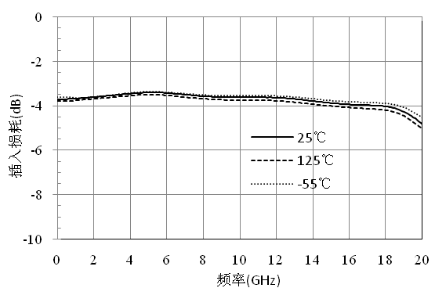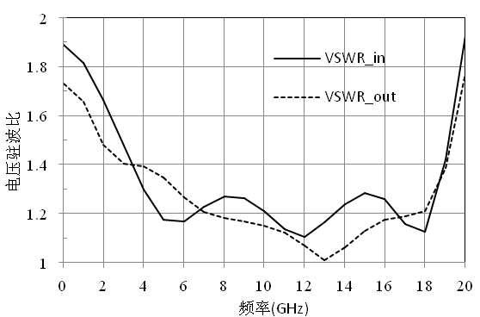

isolation
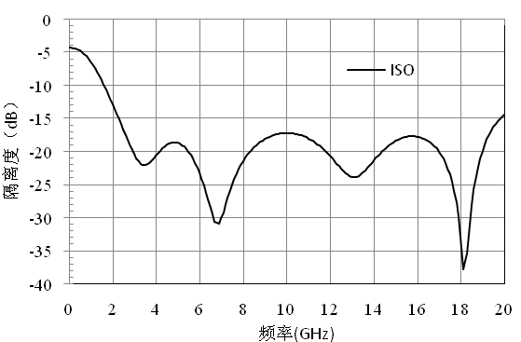
Size drawing：（unit mm）

Suggested assembly drawing：
Instructions:
Storage: The chip must be placed in a container with electrostatic protection and stored in a nitrogen environment.
Cleaning treatment: The bare chip must be operated and used in a purified environment. It is forbidden to use liquid cleaning agent to clean the chip.
Electrostatic protection: Strictly comply with the ESD protection requirements to avoid electrostatic damage to the components.
General operation: Use vacuum chuck or precision pointed tweezers to pick up the chip.Avoid touching the surface of the chip with tools or fingers during handling.
Mounting operation: The chip can be installed using AuSn solder eutectic welding or conductive adhesive bonding process.The mounting surface must be clean and flat.
Bonding operation: Input and output with 2 (recommended diameter of 25um gold wire) bonding wire, bonding wire length less than 250um is optimal.It is recommended to use the smallest possible ultrasonic energy.Bonding begins at the pressure point on the chip and ends at the package (or substrate).

Performance Characteristics：
- Frequency band: 2~18GHz
- Insertion loss: 1 dB
- Fluctuation in insertion loss: ±0.3dB
- Isolation: 15dB
- Input/output voltage standing wave ratio: 1.5/1.5
- Chip size: 2.0mm x 2.0mm x 0.075mm
Product Description：
CW-PD0218V is a GaAs MMIC 0° two-way power splitter chip. Its frequency range covers 2~18GHz and the insertion loss is less than 1.3dB in the entire band.
Electrical parameters：( T_{A}=25℃)
Indicators | Minimum | Typical value | Maximum value | Units
Indicators | 2~18 |  |  | GHz
Frequency range | 0.7 | 1 | 1.3 | dB
Insertion loss | - | - | ±0.3 | dB
Fluctuations in plug loss | 15 | - | - | dB
isolation | - | 1.5 | - | -
Enter the standing wave ratio | - | 1.5 | - | -
Use limit parameters：(Exceeding any of the above maximum limits risks permanent damage.)
Input power | +37dBm
Storage temperature | -65℃~150℃
Service temperature | -55℃~125℃
Typical curve:
Insertion loss isolation
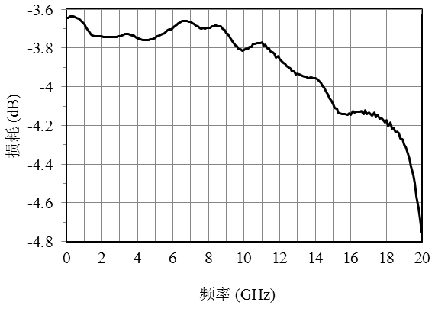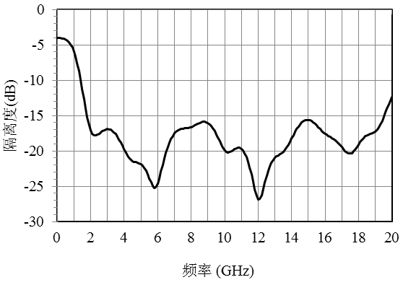

Standing wave ratio
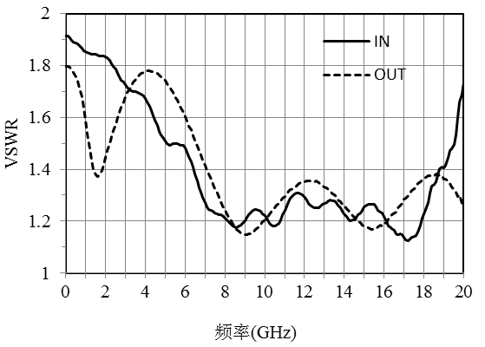

Dimensional drawing：（unit mm）

Suggested assembly drawing：
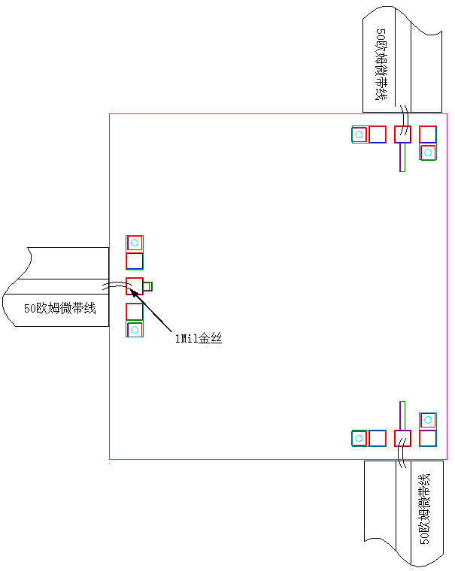
Instructions:
Storage: The chip must be placed in a container with electrostatic protection and stored in a nitrogen environment.
Cleaning treatment: The bare chip must be operated and used in a purified environment. It is forbidden to use liquid cleaning agent to clean the chip.
Electrostatic protection: Strictly comply with the ESD protection requirements to avoid electrostatic damage to the components.
General operation: Use vacuum chuck or precision pointed tweezers to pick up the chip.Avoid touching the surface of the chip with tools or fingers during handling.
Mounting operation: The chip can be installed using AuSn solder eutectic welding or conductive adhesive bonding process.The mounting surface must be clean and flat.
Bonding operation: Input and output with 2 (recommended diameter of 25um gold wire) bonding wire, bonding wire length less than 250um is optimal.It is recommended to use the smallest possible ultrasonic energy.Bonding begins at the pressure point on the chip and ends at the package (or substrate).

Performance Characteristics：
- Frequency range: 6-18GHz
- Insertion loss: 0.6dB
- Insertion loss fluctuation: ±0.15dB
- Isolation degree: 17dB
- Input/output voltage standing wave ratio: 1.5/1.3
- Chip size: 1.5mm x 1.5mm x 0.1mm
Product Description：
CW-PD0618 is a GaAs MMIC 0° two-way power splater with excellent performance. The chip is grounded through the back metal through the through hole. The chip frequency band covers 6-18GHz, the insertion loss is less than 0.6dB, and the input-output voltage standing wave ratio is less than 1.5.
Electrical parameters：( TA=25℃)
Indicators | Minimum | Typical value | Maximum value | Units
Frequency range | 6-18 |  |  | GHz
Insertion loss | 0.3 | - | 0.6 | dB
Fluctuations in plug loss | - | - | ±0.15 | dB
isolation | 17 | - | - | dB
Enter the standing wave ratio | - | - | 1.5 | -
Output standing wave ratio | - | - | 1.3 | -
Use limit parameters: (Exceeding any of the above maximum limits risks permanent damage.)
Maximum input power | 37dBm
Storage temperature | -65℃-150℃
Service temperature | -55℃-125℃
Typical curve：
Insertion loss isolation
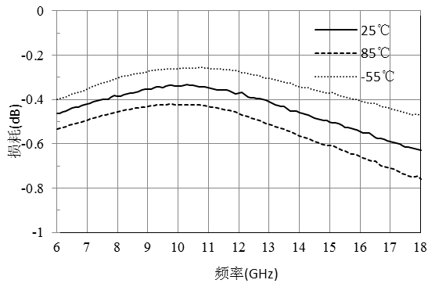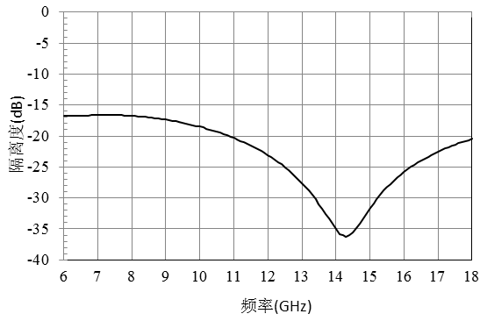
Standing wave ratio
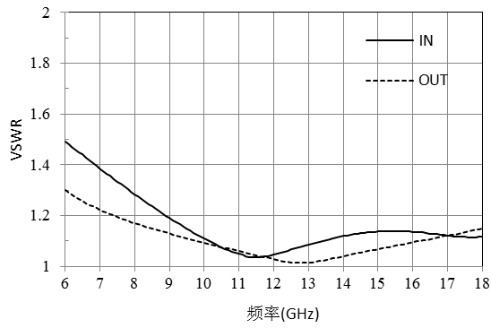
Dimensional drawing：(unit mm)
Suggested assembly drawing：

Instructions:
Storage: The chip must be placed in a container with electrostatic protection and stored in a nitrogen environment.
Cleaning treatment: The bare chip must be operated and used in a purified environment. It is forbidden to use liquid cleaning agent to clean the chip.
Electrostatic protection: Strictly comply with the ESD protection requirements to avoid electrostatic damage to the components.
General operation: Use vacuum chuck or precision pointed tweezers to pick up the chip.Avoid touching the surface of the chip with tools or fingers during handling.
Mounting operation: The chip can be installed using AuSn solder eutectic welding or conductive adhesive bonding process.The mounting surface must be clean and flat.
Bonding operation: Input and output with 2 (recommended diameter of 25um gold wire) bonding wire, bonding wire length less than 250um is optimal.It is recommended to use the smallest possible ultrasonic energy.Bonding begins at the pressure point on the chip and ends at the package (or substrate).
Performance Characteristics：
- Frequency band: 6~18GHz
- Insertion loss: 0.8dB
- Fluctuation of insertion loss: ±0.4dB
- Isolation: 20dB
- Input/output voltage standing wave ratio: 1.3/1.4
- Chip size: 1.5mm×1.5mm×0.075mm
Product Description：
CW-PD0618V is a GaAs MMIC 0° two-way power splitter chip. The power splitter chip has the characteristics of small plug loss, high isolation, small size, light weight and easy integration, and its frequency range covers 6~18GHz.
Electrical parameters：( T_{A}=25℃)
Indicators | Minimum | Typical value | Maximum value | Units
Frequency range | 6~18 |  |  | GHz
Insertion loss | 0.4 | 0.8 | 1.2 | dB
Fluctuations in plug loss | - | - | ±0.4 | dB
isolation | 17 | 20 | 57 | dB
Enter the standing wave ratio | 1.1 | 1.3 | 1.5 | -
Output standing wave ratio | 1.1 | 1.4 | 1.6 | -
Use limit parameters: (Exceeding any of the above maximum limits risks permanent damage.)
Input power | +37dBm
Storage temperature | -65℃~150℃
Service temperature | -55℃~125℃
Typical curve：
Insertion loss isolation
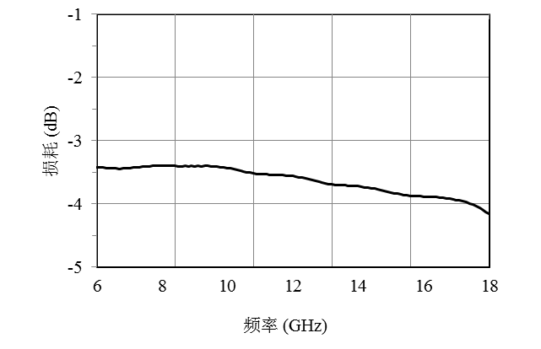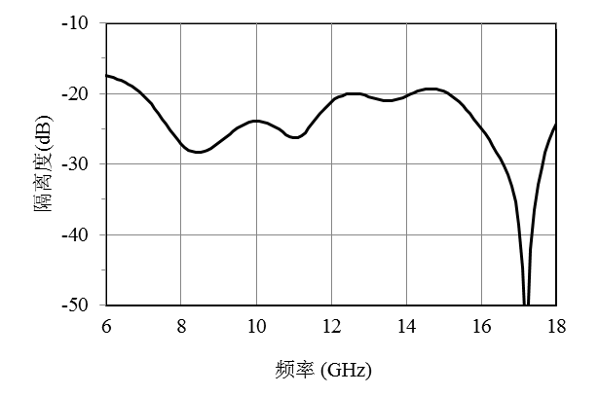
Standing wave ratio
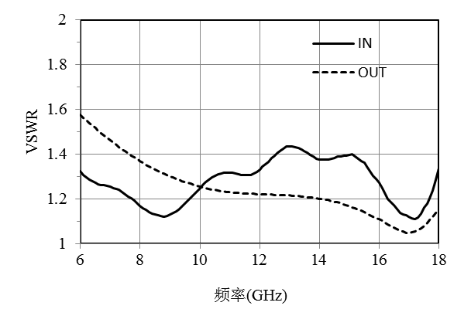
Dimensional drawing：（unit mm）
Suggested assembly drawing:

Instructions:
Storage: The chip must be placed in a container with electrostatic protection and stored in a nitrogen environment.
Cleaning treatment: The bare chip must be operated and used in a purified environment. It is forbidden to use liquid cleaning agent to clean the chip.
Electrostatic protection: Strictly comply with the ESD protection requirements to avoid electrostatic damage to the components.
General operation: Use vacuum chuck or precision pointed tweezers to pick up the chip.Avoid touching the surface of the chip with tools or fingers during handling.
Mounting operation: The chip can be installed using AuSn solder eutectic welding or conductive adhesive bonding process.The mounting surface must be clean and flat.
Bonding operation: Input and output with 2 (recommended diameter of 25um gold wire) bonding wire, bonding wire length less than 250um is optimal.It is recommended to use the smallest possible ultrasonic energy.Bonding begins at the pressure point on the chip and ends at the package (or substrate).

Performance Characteristics：
- Frequency range: 8-12GHz
- Insertion loss: 0.4dB
- Insertion loss fluctuation: ±0.05dB
- Isolation degree: 18dB
- Input/output voltage standing wave ratio: 1.3/1.1
- Chip size: 1.5mm×4.0mm×0.1mm
Product Description：
CW-PD0812 is a GaAs MMIC 0° two-way power divider with excellent performance.The chip covers a band range of 8-12GHz, has insertion loss of less than 0.4dB and input-output voltage standing wave ratio of less than 1.3.
Electrical parameters：( TA=25℃)
Indicators | Minimum | Typical value | Maximum value | Units
Frequency range | 8-12 |  |  | GHz
Insertion loss | 0.3 | - | 0.4 | dB
Fluctuations in plug loss | - | - | ±0.05 | dB
isolation | 18 | - | - | dB
Input standing wave | - | - | 1.3 | -
Output standing wave | - | - | 1.1 | -
Use limit parameters: (Exceeding any of the above maximum limits risks permanent damage.)
Maximum input power | 37dBm
Storage temperature | -65℃-150℃
Service temperature | -55℃-125℃
Typical curve：
Insertion loss isolation
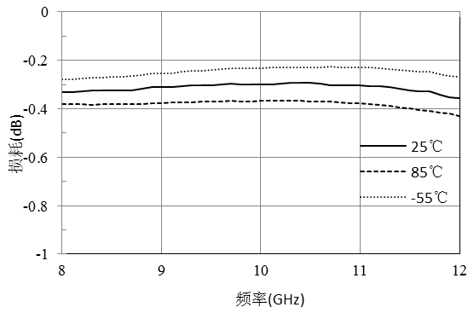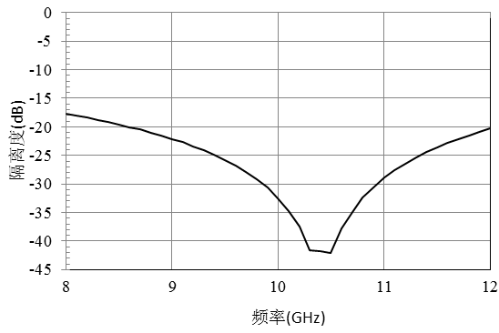
Standing wave ratio
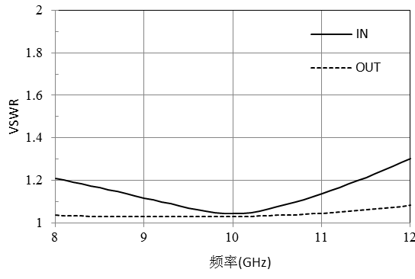
Dimensional drawing：(unit mm)

Suggested assembly drawing：
Instructions:
Storage: The chip must be placed in a container with electrostatic protection and stored in a nitrogen environment.
Cleaning treatment: The bare chip must be operated and used in a purified environment. It is forbidden to use liquid cleaning agent to clean the chip.
Electrostatic protection: Strictly comply with the ESD protection requirements to avoid electrostatic damage to the components.
General operation: Use vacuum chuck or precision pointed tweezers to pick up the chip.Avoid touching the surface of the chip with tools or fingers during handling.
Mounting operation: The chip can be installed using AuSn solder eutectic welding or conductive adhesive bonding process.The mounting surface must be clean and flat.
Bonding operation: Input and output with 2 (recommended diameter of 25um gold wire) bonding wire, bonding wire length less than 250um is optimal.It is recommended to use the smallest possible ultrasonic energy.Bonding begins at the pressure point on the chip and ends at the package (or substrate).

Performance Characteristics：
- Frequency band: 12~18GHz
- Insertion loss: 0.5dB
- Fluctuation of insertion loss: ±0.2dB
- Isolation: 20dB
- Input/output voltage standing wave ratio: 1.3/1.3
- Chip size: 1.5mm×1.5mm×0.075mm
Product Description：
CW-PD1218V is a gallium arsenide monolithic two-power splitter chip.The chip has the characteristics of small plug loss, high isolation, small size, light weight, easy integration, and so on. It is widely used in power distribution and synthesis.The chip adopts on-chip through hole metallization process to ensure good grounding.The back side is metallized, suitable for eutectic sintering and conductive adhesive bonding processes.
Electrical parameters：( T_{A}=25℃)
Indicators | Minimum | Typical value | Maximum value | Units
Frequency range | 12~18 |  |  | GHz
Insertion loss | 0.3 | 0.5 | 0.7 | dB
Fluctuations in plug loss | - | - | ±0.2 | dB
isolation | - | 20 | - | dB
Enter the standing wave ratio | - | 1.3 | - | -
Output standing wave ratio | - | 1.3 | - | -
Use limit parameters：(Exceeding any of the above maximum limits risks permanent damage.)
Input power | +30dBm
Storage temperature | -65℃~150℃
Service temperature | -55℃~125℃
Typical curve：
Insertion loss isolation
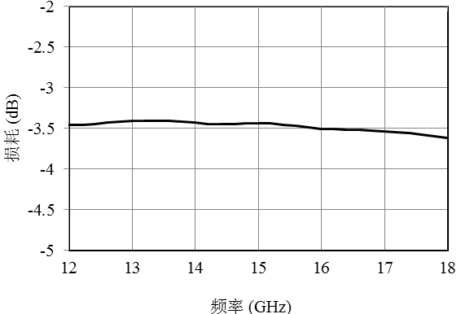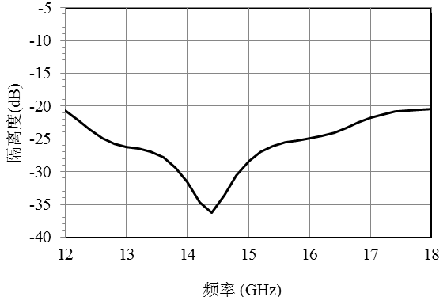
Standing wave ratio
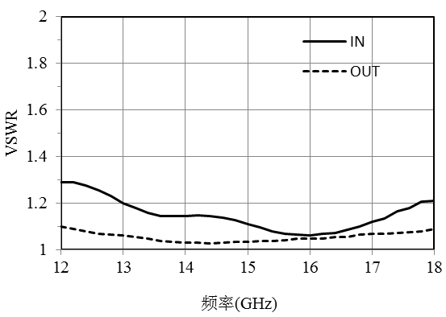
Dimensional drawing：（unit mm）

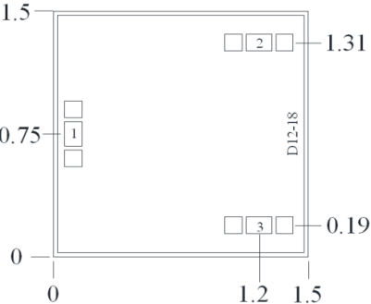

Suggested assembly drawing：
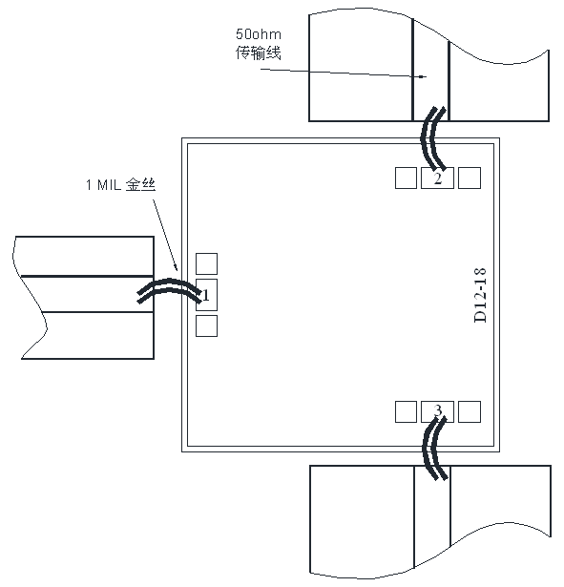
Instructions:
Storage: The chip must be placed in a container with electrostatic protection and stored in a nitrogen environment.
Cleaning treatment: The bare chip must be operated and used in a purified environment. It is forbidden to use liquid cleaning agent to clean the chip.
Electrostatic protection: Strictly comply with the ESD protection requirements to avoid electrostatic damage to the components.
General operation: Use vacuum chuck or precision pointed tweezers to pick up the chip.Avoid touching the surface of the chip with tools or fingers during handling.
Mounting operation: The chip can be installed using AuSn solder eutectic welding or conductive adhesive bonding process.The mounting surface must be clean and flat.
Bonding operation: Input and output with 2 (recommended diameter of 25um gold wire) bonding wire, bonding wire length less than 250um is optimal.It is recommended to use the smallest possible ultrasonic energy.Bonding begins at the pressure point on the chip and ends at the package (or substrate).

Performance Characteristics：
- Frequency range: 18-40GHz
- Insertion loss: 0.6dB
- Fluctuation of insertion loss: ±0.1dB
- Isolation degree: 11dB
- Input/output voltage standing wave ratio: 1.4/1.4
- Chip size: 1.5mm x 3.0mm x 0.1mm
Product Description：
The CW-PD1840 is a GaAs MMIC 0° two-way power divider with excellent performance.The chip covers a band range of 18-40GHz, has insertion loss of less than 0.6dB and input-output voltage standing wave ratio of less than 1.4
Electrical parameters：( T_{A}=25℃)
Indicators | Minimum | Typical value | Maximum value | Units
Frequency range | 18-40 |  |  | GHz
Insertion loss | 0.5 | - | 0.6 | dB
Fluctuations in plug loss | - | - | ±0.1 | dB
isolation | 11 | - | - | dB
Input standing wave | - | - | 1.4 | -
Output standing wave | - | - | 1.4 | -
Use limit parameters：(Exceeding any of the above maximum limits may cause permanent damage.)
Maximum input power | 37dBm
Storage temperature | -65℃-150℃
Service temperature | -55℃-125℃
Typical curve：
Insertion loss isolation
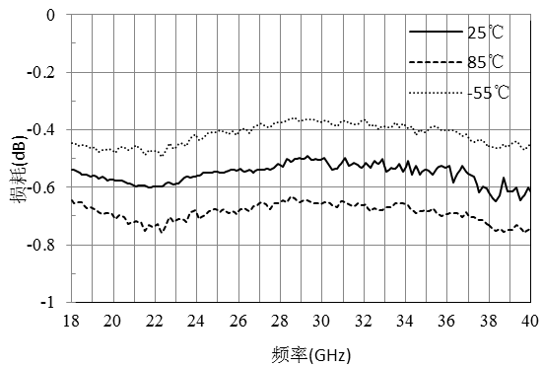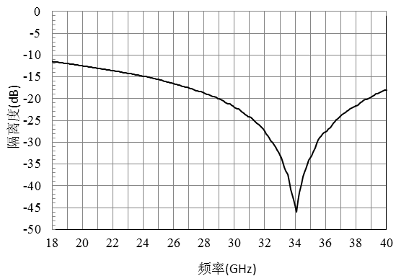
Standing wave ratio
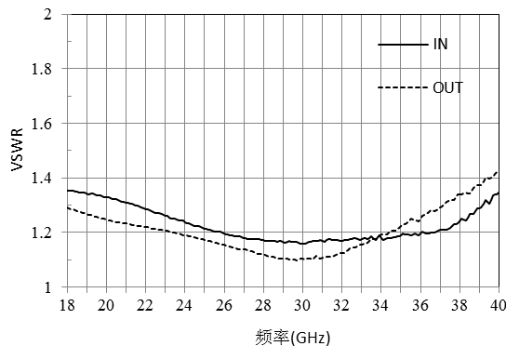
Dimensional drawing：(unit mm)
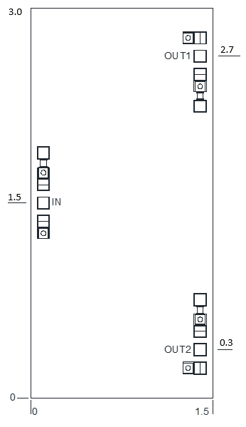

Suggested assembly drawing：
Instructions:
Storage: The chip must be placed in a container with electrostatic protection and stored in a nitrogen environment.
Cleaning treatment: The bare chip must be operated and used in a purified environment. It is forbidden to use liquid cleaning agent to clean the chip.
Electrostatic protection: Strictly comply with the ESD protection requirements to avoid electrostatic damage to the components.
General operation: Use vacuum chuck or precision pointed tweezers to pick up the chip.Avoid touching the surface of the chip with tools or fingers during handling.
Mounting operation: The chip can be installed using AuSn solder eutectic welding or conductive adhesive bonding process.The mounting surface must be clean and flat.
Bonding operation: Input and output with 2 (recommended diameter of 25um gold wire) bonding wire, bonding wire length less than 250um is optimal.It is recommended to use the smallest possible ultrasonic energy.Bonding begins at the pressure point on the chip and ends at the package (or substrate).

Performance Characteristics：
- Frequency band: 18~40GHz
- Insertion loss: 0.8dB
- Fluctuation of insertion loss: ±0.2dB
- Isolation: 25dB
- Input/output voltage standing wave ratio: 1.2/1.1
- Chip size: 1.67mm×1.4mm×0.075mm
Product Description：
CW-PD1840V is a GaAs MMIC 0° two-way power splitter chip. The power splitter chip has the characteristics of small plug loss, high isolation, small size, light weight, easy integration and so on. Its frequency range covers 18~40GHz.
Electrical parameters：( T_{A}=25℃)
Indicators | Minimum | Typical value | Maximum value | Units
Frequency range | 18~40 |  |  | GHz
Insertion loss | 0.6 | 0.8 | 1.0 | dB
Fluctuations in plug loss | - | - | ±0.2 | dB
isolation | 22 | 25 | - | dB
Enter the standing wave ratio | - | 1.2 | 1.4 | -
Output standing wave ratio | - | 1.1 | 1.3 | -
Use limit parameters: (Exceeding any of the above maximum limits risks permanent damage.)
Input power | +37dBm
Storage temperature | -65℃~150℃
Service temperature | -55℃~125℃
Typical curve：
Insertion loss input-output standing wave ratio
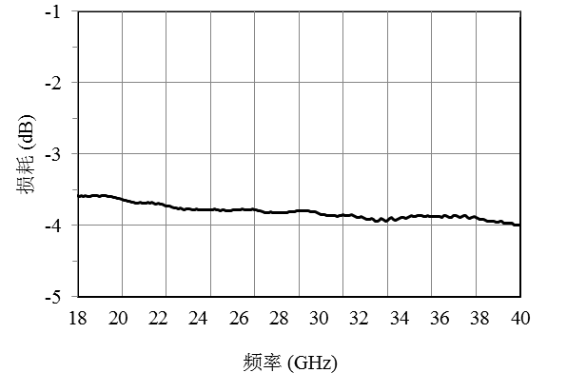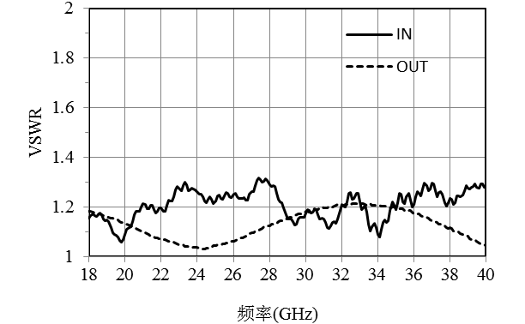
isolation

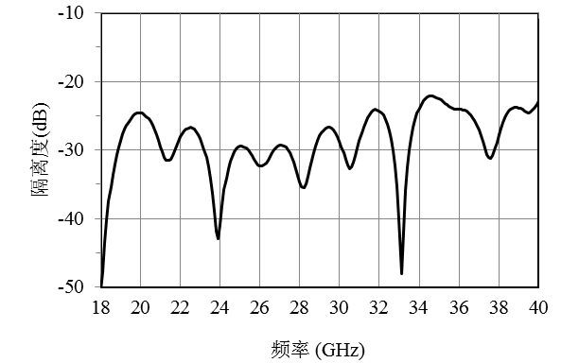
Size drawing：（unit mm）
Suggested assembly drawing：

Instructions:
Storage: The chip must be placed in a container with electrostatic protection and stored in a nitrogen environment.
Cleaning treatment: The bare chip must be operated and used in a purified environment. It is forbidden to use liquid cleaning agent to clean the chip.
Electrostatic protection: Strictly comply with the ESD protection requirements to avoid electrostatic damage to the components.
General operation: Use vacuum chuck or precision pointed tweezers to pick up the chip.Avoid touching the surface of the chip with tools or fingers during handling.
Mounting operation: The chip can be installed using AuSn solder eutectic welding or conductive adhesive bonding process.The mounting surface must be clean and flat.
Bonding operation: Input and output with 2 (recommended diameter of 25um gold wire) bonding wire, bonding wire length less than 250um is optimal.It is recommended to use the smallest possible ultrasonic energy.Bonding begins at the pressure point on the chip and ends at the package (or substrate).

Performance Characteristics：
- Band range: 0.5-2GHz
- Insertion loss: 1.2dB
- Input/output: 50 Ohm match
- Chip size: 1.5mm x 1.0mm x 0.1mm
Product Description：
The CW-PD20P502 is a GaAs MMIC two-way power divider with a frequency range covering 0.5-2GHz and a 1.6dB insertion loss.
Electrical parameters：( TA=25℃)
Indicators | Minimum | Typical value | Maximum value | Units
Frequency range | 0.5-2 |  |  | GHz
Insertion loss | - | 1.2 | - | dB
Flatness | - | ±0.3 | - | dB
isolation | - | 20 | - | dB
Return loss | - | 20 | - | dB
Use limit parameters：
Input power | +37dBm
Storage temperature | -65℃-150℃
Service temperature | -55℃-85℃
Typical curve：
Insertion loss I/O return loss
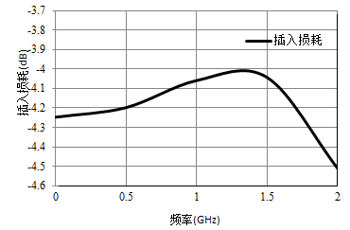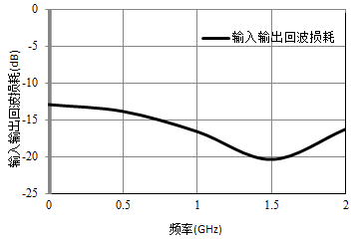

isolation
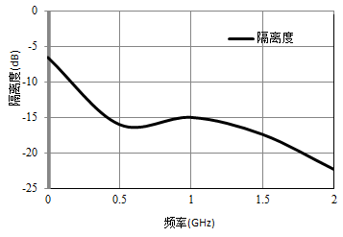
Size drawing：(unit mm)
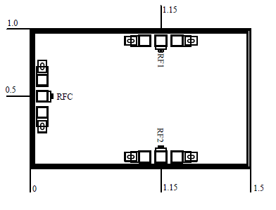

4

Suggested assembly drawing：
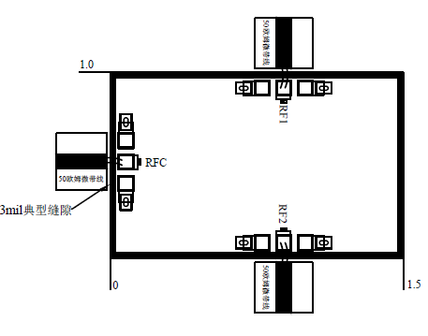

Instructions:
Storage: The chip must be placed in a container with electrostatic protection and stored in a nitrogen environment.
Cleaning treatment: The bare chip must be operated and used in a purified environment. It is forbidden to use liquid cleaning agent to clean the chip.
Electrostatic protection: Strictly comply with the ESD protection requirements to avoid electrostatic damage to the components.
General operation: Use vacuum chuck or precision pointed tweezers to pick up the chip.Avoid touching the surface of the chip with tools or fingers during handling.
Mounting operation: The chip can be installed using AuSn solder eutectic welding or conductive adhesive bonding process.The mounting surface must be clean and flat.
Bonding operation: Input and output with 2 (recommended diameter of 25um gold wire) bonding wire, bonding wire length less than 250um is optimal.It is recommended to use the smallest possible ultrasonic energy.Bonding begins at the pressure point on the chip and ends at the package (or substrate).
Performance Features：
4

4

- Frequency range: 1-18GHz
- Insertion loss: 1.4dB
- Input/output: 50 Ohm match
- Chip size: 2.60mm x 2.23mm x 0.1mm
Product Description：
The CW-PD0118 is a GaAs MMIC two-way 0 degree power divider with excellent performance.The chip covers the 1-18GHz band range.
Electrical parameters：( T_{A}=25℃)
Indicators |  | Minimum | Typical value | Maximum value | Units
Frequency range |  | 1-18 |  |  | GHz
Insertion loss |  | - | 1.4 | - | dB
Flatness |  | - | ±0.2 | - | dB
isolation | 1-2GHz | - | - | - | dB
isolation | 2-18GHz | - | - | - | dB
Return loss |  | - | 12 | - | dB
Use limit parameters: (Exceeding any of the above maximum limits risks permanent damage.)
Maximum input power | +37 dBm
Storage temperature | -65℃-175℃
Service temperature | -55℃-125℃
Typical curve：（T_{A}=+25℃）
I/O return loss Insertion loss
Frequency Frequency

Size drawing:(unit mm）
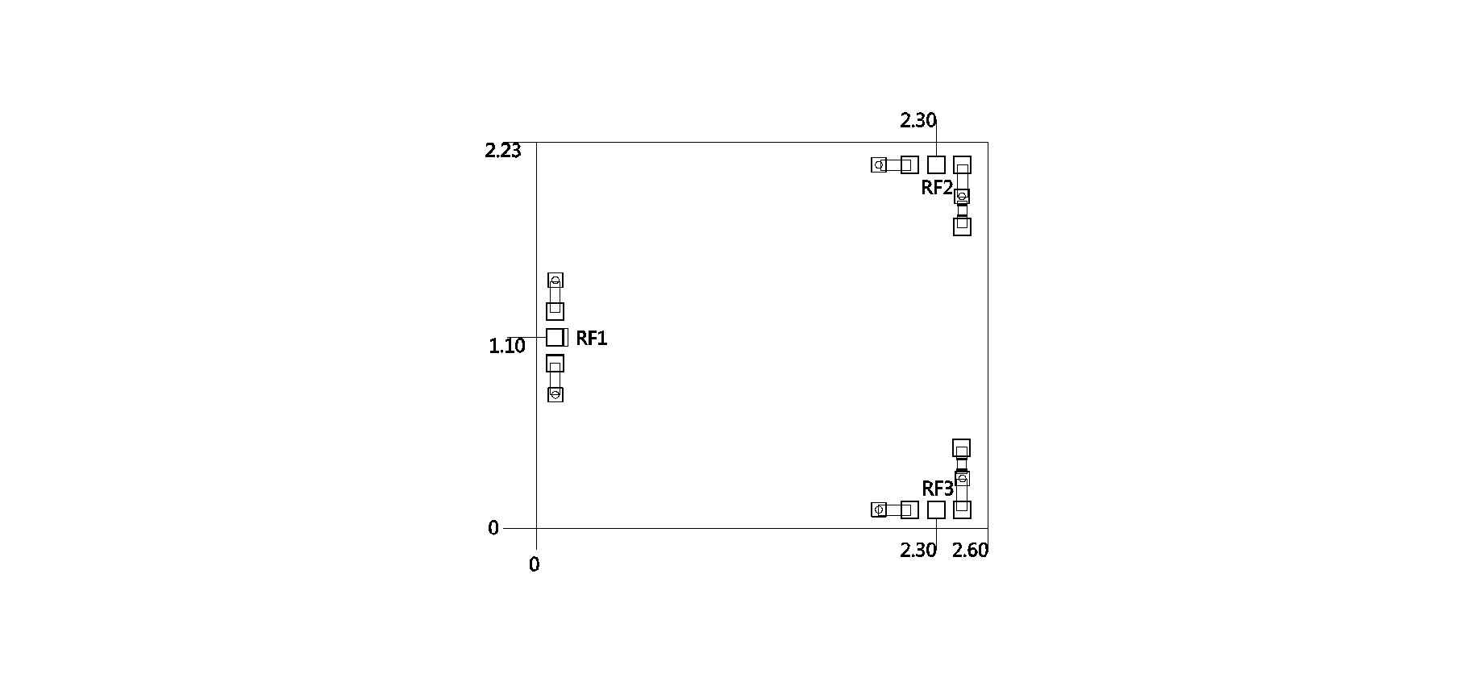
Suggested assembly drawing：
Instructions:
Storage: The chip must be placed in a container with electrostatic protection and stored in a nitrogen environment.
Cleaning treatment: The bare chip must be operated and used in a purified environment. It is forbidden to use liquid cleaning agent to clean the chip.
Electrostatic protection: Strictly comply with the ESD protection requirements to avoid electrostatic damage to the components.
General operation: Use vacuum chuck or precision pointed tweezers to pick up the chip.Avoid touching the surface of the chip with tools or fingers during handling.
Mounting operation: The chip can be installed using AuSn solder eutectic welding or conductive adhesive bonding process.The mounting surface must be clean and flat.
Bonding operation: Input and output with 2 (recommended diameter of 25um gold wire) bonding wire, bonding wire length less than 250um is optimal.It is recommended to use the smallest possible ultrasonic energy.Bonding begins at the pressure point on the chip and ends at the package (or substrate)
Performance Characteristics:
- Frequency band: 2~8GHz
- Insertion loss: 1dB
- Input/Output :50 Ohm match
- Chip size: 1.5mm x 1mm x 0.1mm
Product Description:
CW-PD0208 is a GaAs MMIC0° two-way power splitter chip. The power splitter chip has the characteristics of small plug loss, high isolation, small size, easy integration, etc., which is widely used in power distribution and synthesis.Its frequency range covers 2~8GHz, and the in-band insertion loss is 1dB.
Electrical parameters：( T_{A}=25℃）
Indicators | Minimum | Typical value | Maximum value | Units
Frequency range | 2~8 |  |  | GHz
Insertion loss | - | 1 | - | dB
Flatness | - | ±0.2 | - | dB
isolation | - | 18 | - | dB
Return loss | - | 15 | - | dB
Use limiting parameters：
Input power | +37dBm
Storage temperature | -65℃~175℃
Service temperature | -55℃~125℃
Typical curve：
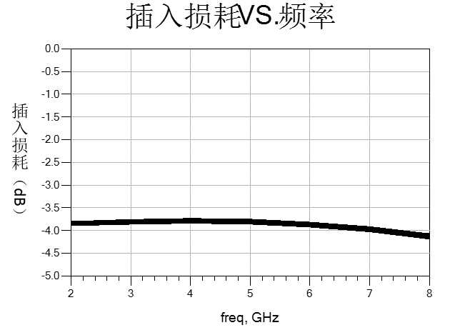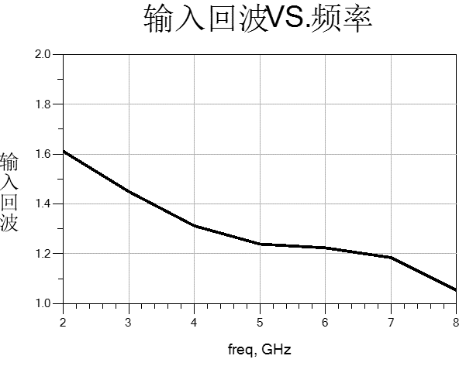

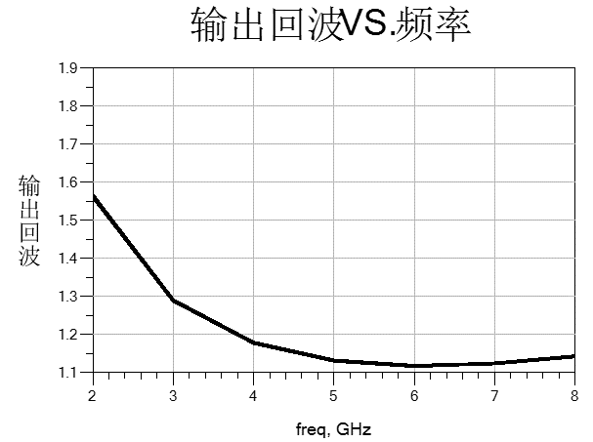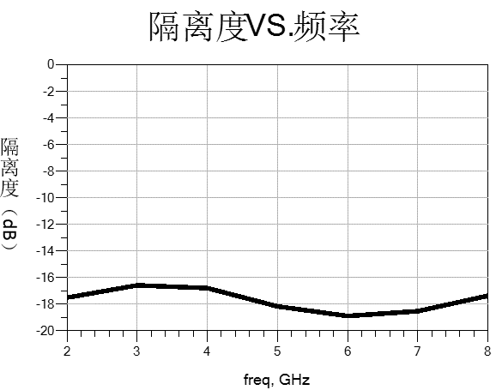
Dimensional drawing：（unit mm）
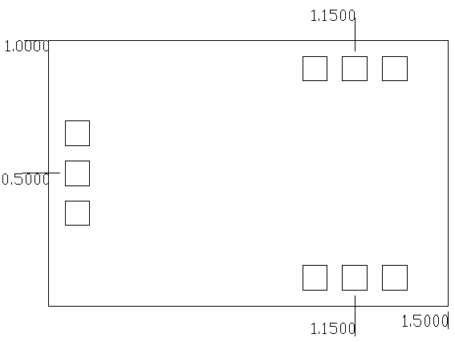
Suggested assembly drawing：
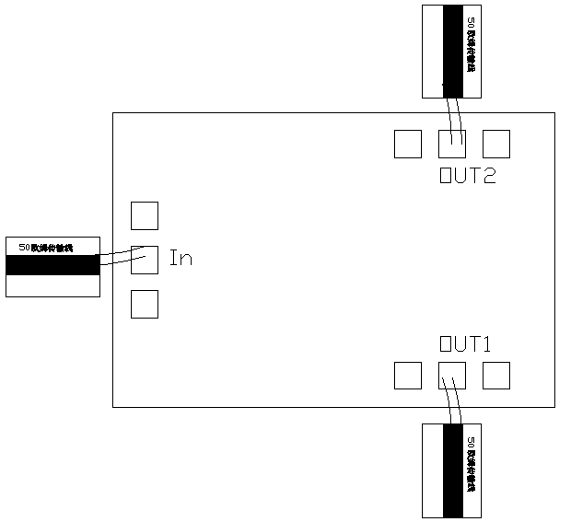
3mil assembly clearance

Instructions:
Storage: The chip must be placed in a container with electrostatic protection and stored in a nitrogen environment.
Cleaning treatment: The bare chip must be operated and used in a purified environment. It is forbidden to use liquid cleaning agent to clean the chip.
Electrostatic protection: Strictly comply with the ESD protection requirements to avoid electrostatic damage to the components.
General operation: Use vacuum chuck or precision pointed tweezers to pick up the chip.Avoid touching the surface of the chip with tools or fingers during handling.
Mounting operation: The chip can be installed using AuSn solder eutectic welding or conductive adhesive bonding process.The mounting surface must be clean and flat.
Bonding operation: Input and output with 2 (recommended diameter of 25um gold wire) bonding wire, bonding wire length less than 250um is optimal.It is recommended to use the smallest possible ultrasonic energy.Bonding begins at the pressure point on the chip and ends at the package (or substrate).
Performance Features：
4

4

- Frequency range: 2-18GHz
- Insertion loss: 0.7Db
- Isolation: 20dB
- Input/Output: 50 Ohm match
- Chip size: 2.00mm x 2.00mm x 0.1mm
Product Description:
CW-PD0218S is a GaAs MMIC 2-way 0 degree power divider with excellent performance.The chip covers the 2-18GHz band range.
Electrical parameters：( T_{A}=25℃)
Indicators | Minimum | Typical value | Maximum value | Units
Frequency range | 2-18 |  |  | GHz
Insertion loss | - | 0.7 | - | dB
Flatness | - | ±0.3 | - | dB
isolation | - | 20 | - | dB
Return loss | - | 15 | - | dB
Use limit parameters: (Exceeding any of the above maximum limits risks permanent damage.)
Maximum input power | 37 dBm
Storage temperature | -65℃-175℃
Service temperature | -55℃-125℃
Typical curve：（T_{A}=+25℃）
I/O return loss Insertion loss
Frequency Frequency

Size drawing：（unit mm）
Suggested assembly drawing：
Instructions:
Storage: The chip must be placed in a container with electrostatic protection and stored in a nitrogen environment.
Cleaning treatment: The bare chip must be operated and used in a purified environment. It is forbidden to use liquid cleaning agent to clean the chip.
Electrostatic protection: Strictly comply with the ESD protection requirements to avoid electrostatic damage to the components.
General operation: Use vacuum chuck or precision pointed tweezers to pick up the chip.Avoid touching the surface of the chip with tools or fingers during handling.
Mounting operation: The chip can be installed using AuSn solder eutectic welding or conductive adhesive bonding process.The mounting surface must be clean and flat.
Bonding operation: Input and output with 2 (recommended diameter of 25um gold wire) bonding wire, bonding wire length less than 250um is optimal.It is recommended to use the smallest possible ultrasonic energy.Bonding begins at the pressure point on the chip and ends at the package (or substrate).
Performance Characteristics:
- Frequency band: 12~18GHz
- Insertion loss: 0.4dB
- Isolation: 20dB
- Input/output voltage standing wave ratio: 1.3/1.3
- Chip size: 0.85mm×0.7mm×0.1mm
Product Description：
CW-PD1218VA is a GaAs MMIC0° two-way power splitter chip. The power splitter chip has the characteristics of small plug loss, high isolation, small size, easy integration and so on. It is widely used in power distribution and synthesis.
Electrical parameters：( T_{A}=25℃）
Indicators | Minimum | Typical value | Maximum value | Units
Frequency range | 12~18 |  |  | GHz
Insertion loss | - | 0.4 | - | dB
isolation | - | 20 | - | dB
Input voltage standing wave ratio | - | 1.3 | - | -
Output voltage standing wave ratio | - | 1.3 | - | -
Use limiting parameters：
Input power | +37dBm
Storage temperature | -65℃~150℃
Service temperature | -55℃~85℃
Typical curve：
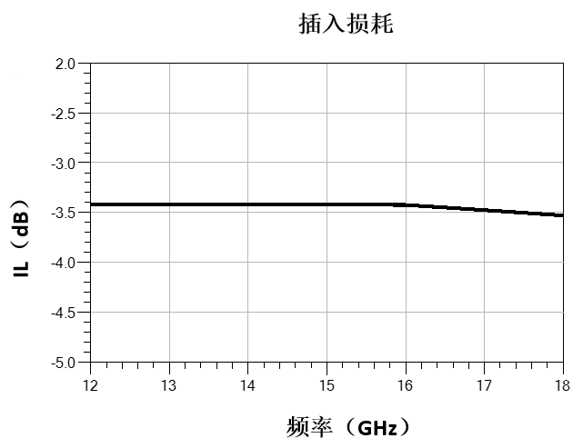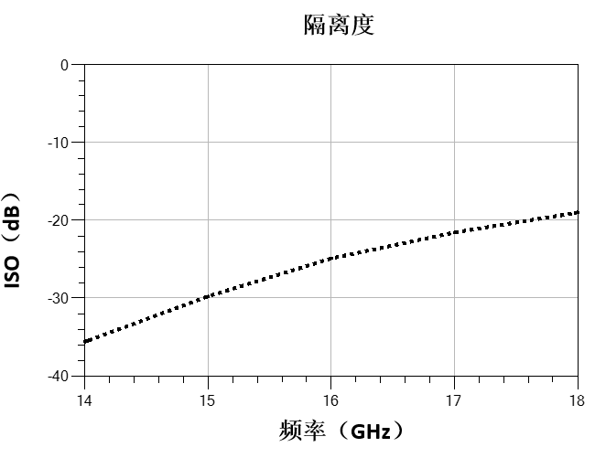

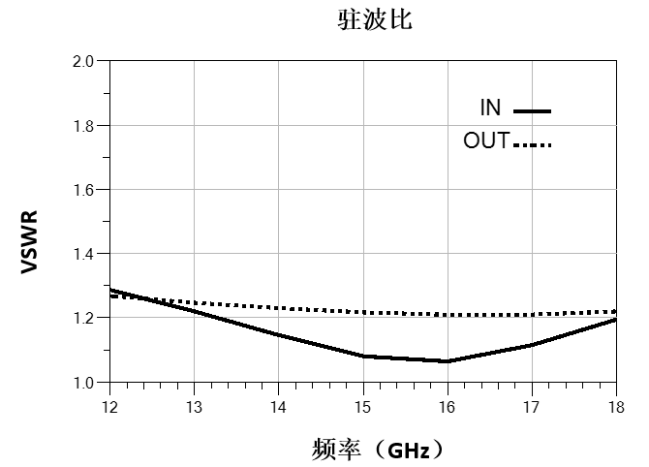
Dimensional drawing：（unit mm）
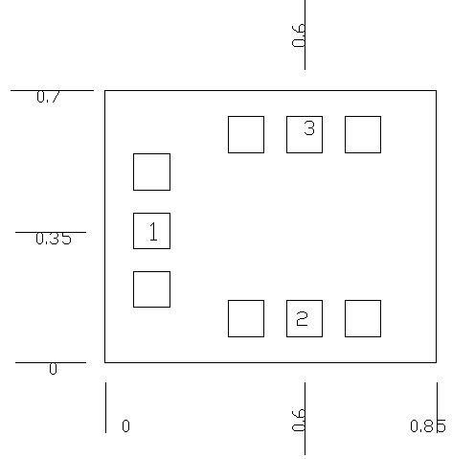
Suggested assembly drawing：
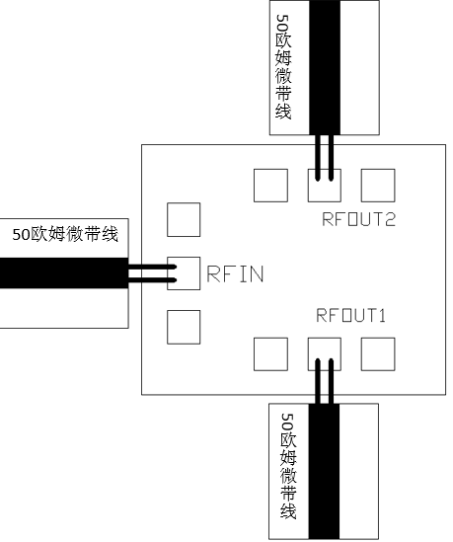
3mil assembly clearance

Instructions:
Storage: The chip must be placed in a container with electrostatic protection and stored in a nitrogen environment.
Cleaning treatment: The bare chip must be operated and used in a purified environment. It is forbidden to use liquid cleaning agent to clean the chip.
Electrostatic protection: Strictly comply with the ESD protection requirements to avoid electrostatic damage to the components.
General operation: Use vacuum chuck or precision pointed tweezers to pick up the chip.Avoid touching the surface of the chip with tools or fingers during handling.
Mounting operation: The chip can be installed using AuSn solder eutectic welding or conductive adhesive bonding process.The mounting surface must be clean and flat.
Bonding operation: Input and output with 2 (recommended diameter of 25um gold wire) bonding wire, bonding wire length less than 250um is optimal.It is recommended to use the smallest possible ultrasonic energy.Bonding begins at the pressure point on the chip and ends at the package (or substrate).
Performance Characteristics:
- Frequency band: 30~40GHz
- Insertion loss: 0.5dB
- Isolation: 25dB
- Input/output voltage standing wave ratio: 1.3/1.3
- Chip size: 0.7mm×0.62mm×0.1mm
Product Description：
CW-PD3040V is a GaAs MMIC0° two-way power splitter chip. The power splitter chip has the characteristics of small plug loss, high isolation, small size, easy integration and so on. It is widely used in power distribution and synthesis.
Electrical parameters：( T_{A}=25℃）
Indicators | Minimum | Typical value | Maximum value | Units
Frequency range | 30~40 |  |  | GHz
Insertion loss | - | 0.5 | - | dB
isolation | - | 25 | - | dB
Input voltage standing wave ratio | - | 1.3 | - | -
Output voltage standing wave ratio | - | 1.3 | - | -
Use limiting parameters：
Input power | +27dBm
Storage temperature | -65℃~150℃
Service temperature | -55℃~85℃

Typical curve：
Insertion loss isolation
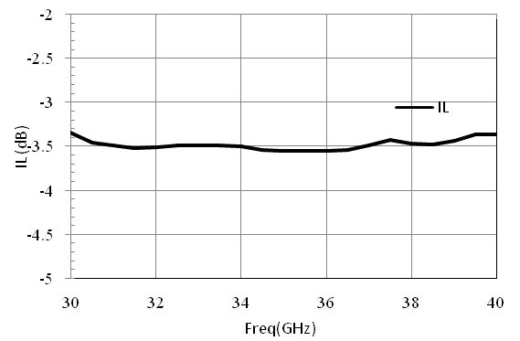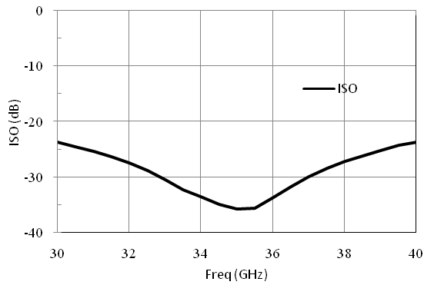

Input/output voltage standing wave ratio
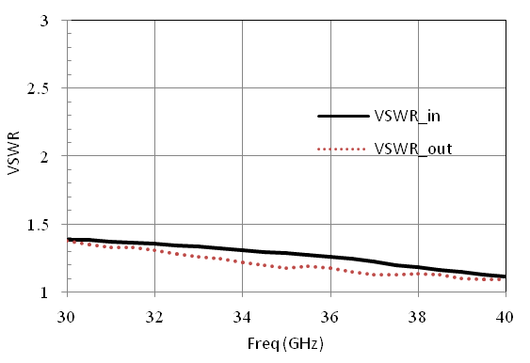
Size diagram：（unit mm）
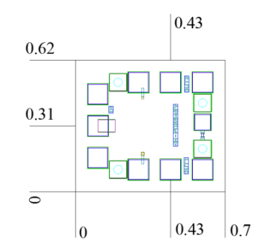
Suggested assembly drawing：
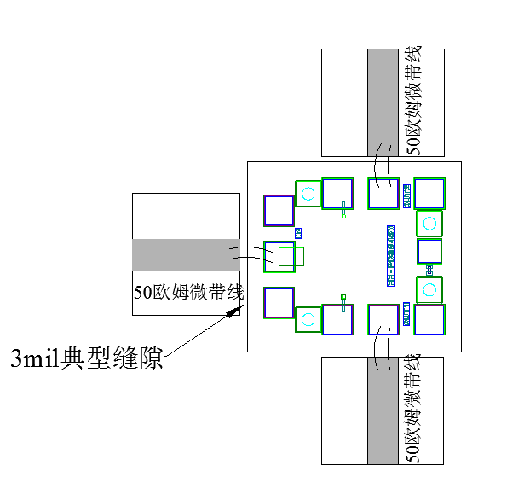
Instructions:
Storage: The chip must be placed in a container with electrostatic protection and stored in a nitrogen environment.
Cleaning treatment: The bare chip must be operated and used in a purified environment. It is forbidden to use liquid cleaning agent to clean the chip.
Electrostatic protection: Strictly comply with the ESD protection requirements to avoid electrostatic damage to the components.
General operation: Use vacuum chuck or precision pointed tweezers to pick up the chip.Avoid touching the surface of the chip with tools or fingers during handling.
Mounting operation: The chip can be installed using AuSn solder eutectic welding or conductive adhesive bonding process.The mounting surface must be clean and flat.
Bonding operation: Input and output with 2 (recommended diameter of 25um gold wire) bonding wire, bonding wire length less than 250um is optimal.It is recommended to use the smallest possible ultrasonic energy.Bonding begins at the pressure point on the chip and ends at the package (or substrate).
Performance Characteristics:
- Frequency band: 6-18GHz
- Insertion loss: 1.0dB
- Insertion loss fluctuation: ±0.3dB
- Isolation: 16dB
- Input return loss: 10dB
- Output return loss: 16dB
- Chip size: 2.2mm×1.3mm×0.1mm
Product Description：
CW-PD30618 is a GaAs MMIC 0° three-way power splitter chip. The power splitter chip has the characteristics of low plug loss, high isolation, small size and easy integration, and its frequency range covers 6~18GHz.
Electrical parameters：( T_{A}=25℃）
Indicators | Minimum | Typical value | Maximum value | Units
Frequency range | 6~18 |  |  | GHz
Insertion loss | - | 1.0 | 1.2 | dB
Fluctuations in plug loss | - | ±0.3 | - | dB
isolation | 16 | 20 | - | dB
Input return loss | 10 | 15 | - | dB
Output return loss | 16 | 20 | - | dB
Use limit parameters: (Exceeding any of the following maximum limits risks permanent damage)
Input power | +33dBm
Storage temperature | -65℃~+150℃
Service temperature | -55℃~+85℃
Typical curve：
2 port insertion loss 3 port insertion loss
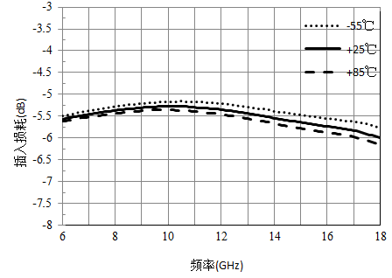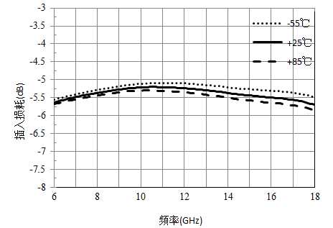
4-Port insertion loss isolation
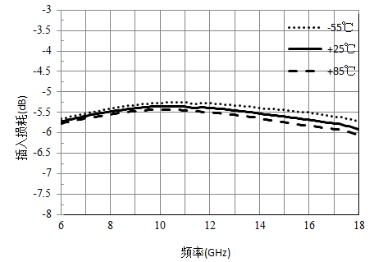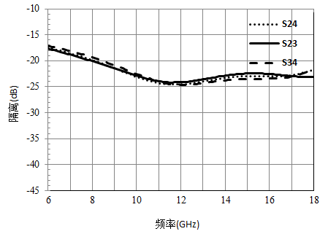
Input return loss output return loss
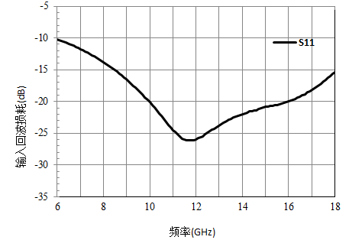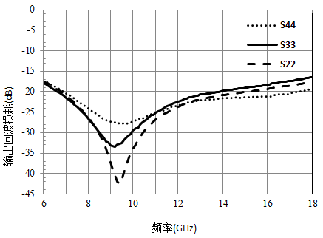
Size drawing：(unit mm)
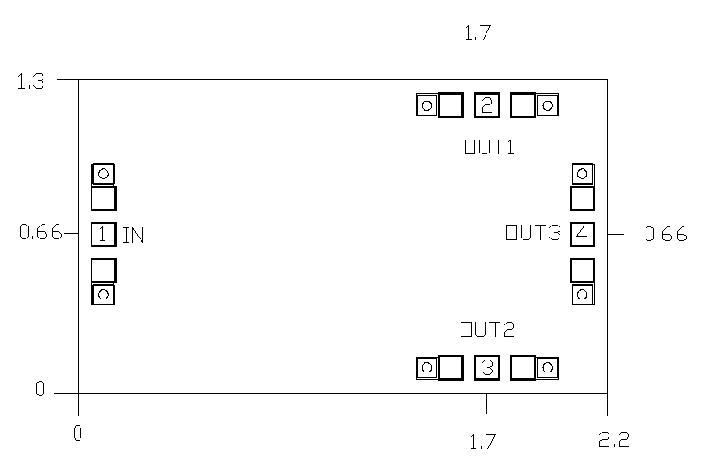

Suggested assembly drawing：
4

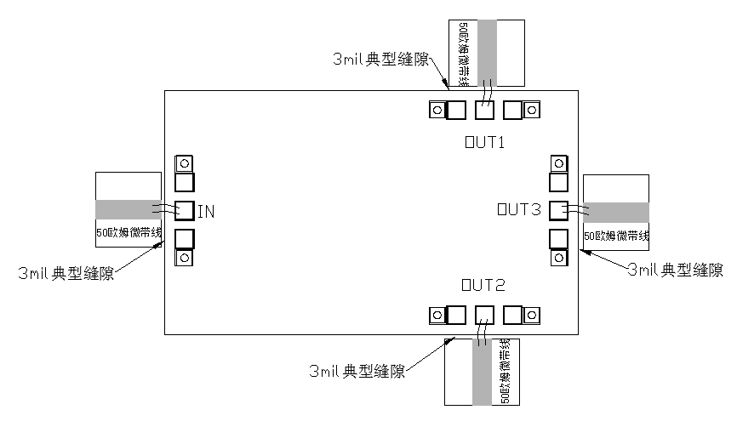
Instructions:
Storage: The chip must be placed in a container with electrostatic protection and stored in a nitrogen environment.
Cleaning treatment: The bare chip must be operated and used in a purified environment. It is forbidden to use liquid cleaning agent to clean the chip.
Electrostatic protection: Strictly comply with the ESD protection requirements to avoid electrostatic damage to the components.
General operation: Use vacuum chuck or precision pointed tweezers to pick up the chip.Avoid touching the surface of the chip with tools or fingers during handling.
Mounting operation: The chip can be installed using AuSn solder eutectic welding or conductive adhesive bonding process.The mounting surface must be clean and flat.
Bonding operation: Input and output with 2 (recommended diameter of 25um gold wire) bonding wire, bonding wire length less than 250um is optimal.It is recommended to use the smallest possible ultrasonic energy.Bonding begins at the pressure point on the chip and ends at the package (or substrate).
Performance Characteristics:
- Frequency band: 10-18GHz
- Insertion loss: 0.6dB
- Fluctuation of insertion loss: ±0.3dB
- Isolation: 22dB
- Input return loss: 18dB
- Output return loss: 22dB
- Chip size: 1.18mm×1.0mm×0.1mm
Product Description：
CW-PD31018 is a GaAs MMIC 0° three-way power splitter chip. The power splitter chip has the characteristics of small plug loss, high isolation, small size, easy integration and so on. Its frequency range covers 10~18GHz.
Electrical parameters：( T_{A}=25℃）
Indicators | Minimum | Typical value | Maximum value | Units
Frequency range | 10~18 |  |  | GHz
Insertion loss | - | 0.6 | 0.8 | dB
Fluctuations in plug loss | - | ±0.3 | - | dB
isolation | 22 | - | - | dB
Input return loss | 18 | - | - | dB
Output return loss | 22 | - | - | dB
Use limit parameters: (Exceeding any of the following maximum limits risks permanent damage)
Input power | +30dBm
Storage temperature | -65℃~+150℃
Service temperature | -55℃~+85℃
Typical curve：
2 port insertion loss 3 port insertion loss
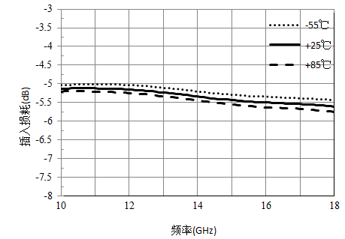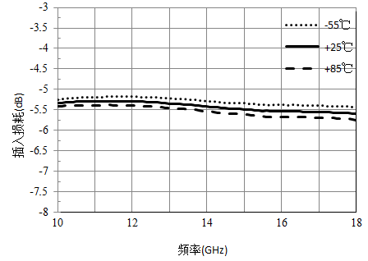
4-Port insertion loss isolation
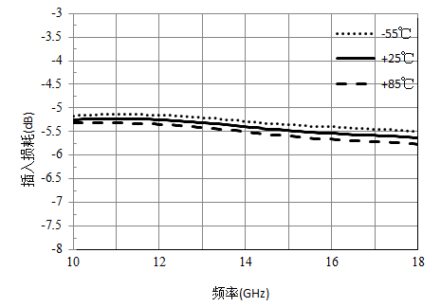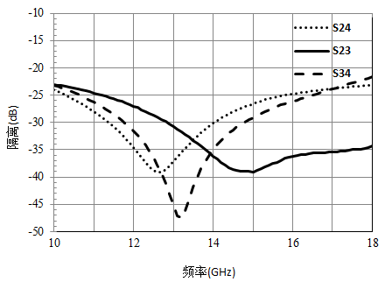
Input return loss output return loss
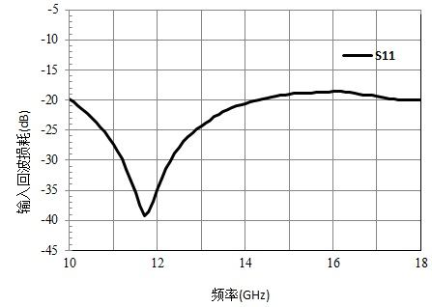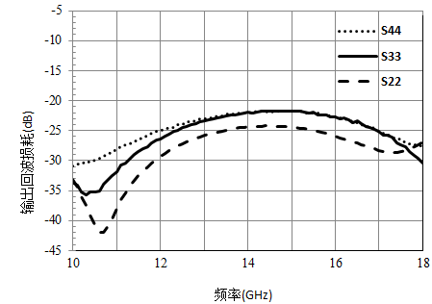
Size drawing：(unit mm)
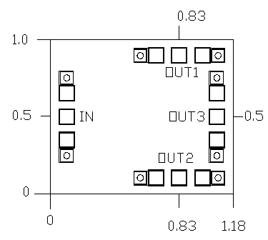

Suggested assembly drawing：

4

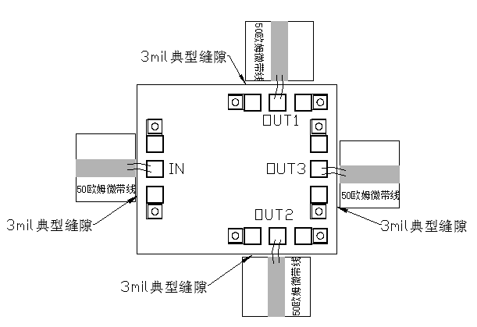
Instructions:
Storage: The chip must be placed in a container with electrostatic protection and stored in a nitrogen environment.
Cleaning treatment: The bare chip must be operated and used in a purified environment. It is forbidden to use liquid cleaning agent to clean the chip.
Electrostatic protection: Strictly comply with the ESD protection requirements to avoid electrostatic damage to the components.
General operation: Use vacuum chuck or precision pointed tweezers to pick up the chip.Avoid touching the surface of the chip with tools or fingers during handling.
Mounting operation: The chip can be installed using AuSn solder eutectic welding or conductive adhesive bonding process.The mounting surface must be clean and flat.
Bonding operation: Input and output with 2 (recommended diameter of 25um gold wire) bonding wire, bonding wire length less than 250um is optimal.It is recommended to use the smallest possible ultrasonic energy.Bonding begins at the pressure point on the chip and ends at the package (or substrate).
Performance Characteristics：
- Frequency band: 14~18GHz
- Insertion loss: 0.5dB
- Isolation: 16dB
- Input/output voltage standing wave ratio: 1.5/1.4
- Chip size: 0.87mm×1mm×0.1mm
Product Description：
CW-PD31418 is a GaAs MMIC0° three-way power splitter chip. The power splitter chip has the characteristics of small plug loss, high isolation, small size, easy integration and so on. It is widely used in power distribution and synthesis.Its frequency range covers 14~18GHz, with in-band insertion loss of 0.5dB.
Electrical parameters：( T_{A}=25℃）
Indicators | Minimum | Typical value | Maximum value | Units
Frequency range | 14~18 |  |  | GHz
Insertion loss | - | 0.5 | 0.6 | dB
isolation | - | 16 | - | dB
Input voltage standing wave ratio | - | 1.5 | - | -
Output voltage standing wave ratio | - | 1.4 | - | -
Use limiting parameters：
Input power | +33dBm
Storage temperature | -65℃~150℃
Service temperature | -55℃~85℃
Typical curve：

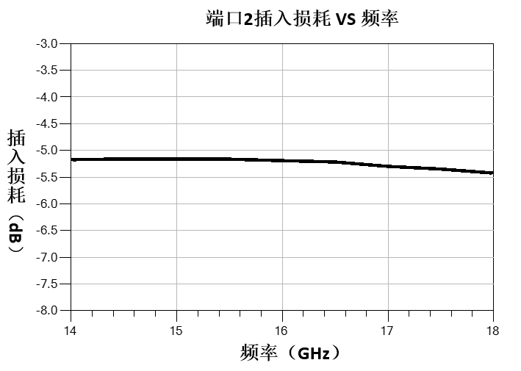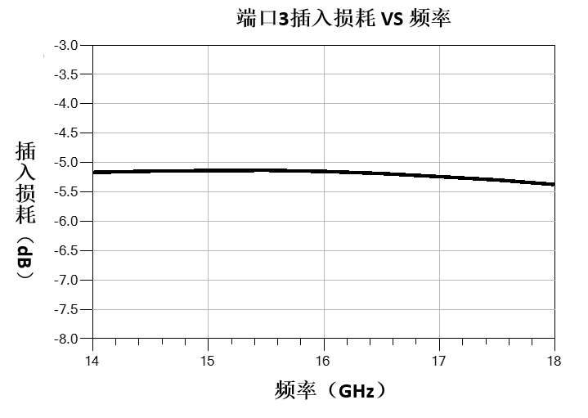

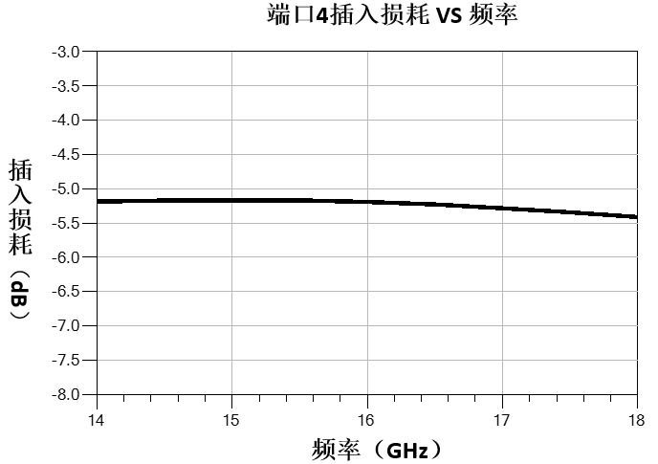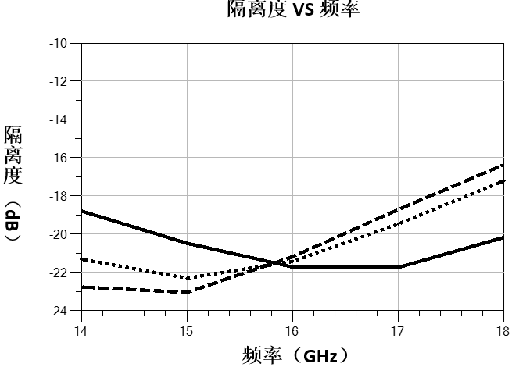
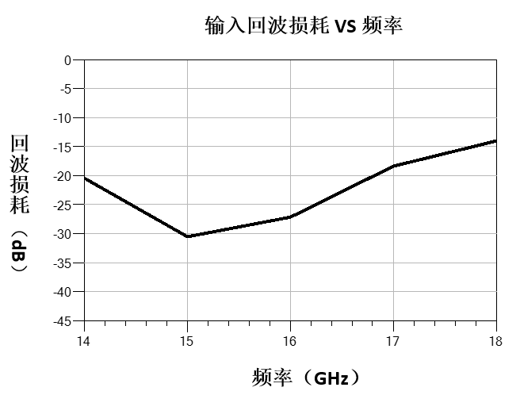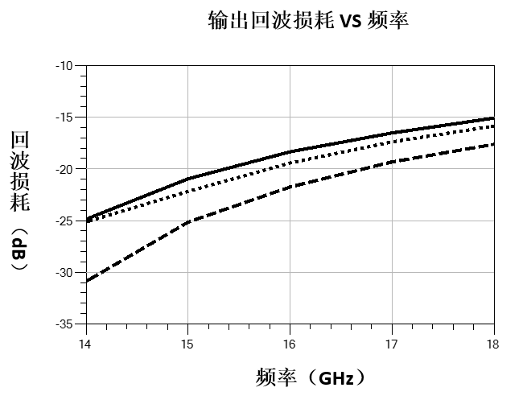
Dimensional drawing：（unit mm）
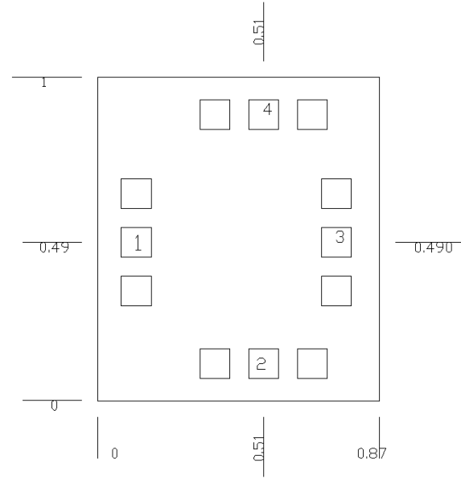

Suggested assembly drawing：

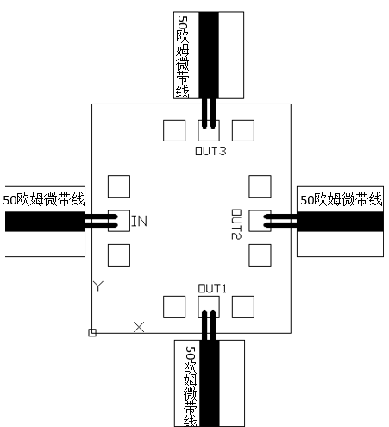
3mil Suggested assembly
Instructions:
Storage: The chip must be placed in a container with electrostatic protection and stored in a nitrogen environment.
Cleaning treatment: The bare chip must be operated and used in a purified environment. It is forbidden to use liquid cleaning agent to clean the chip.
Electrostatic protection: Strictly comply with the ESD protection requirements to avoid electrostatic damage to the components.
General operation: Use vacuum chuck or precision pointed tweezers to pick up the chip.Avoid touching the surface of the chip with tools or fingers during handling.
Mounting operation: The chip can be installed using AuSn solder eutectic welding or conductive adhesive bonding process.The mounting surface must be clean and flat.
Bonding operation: Input and output with 2 (recommended diameter of 25um gold wire) bonding wire, bonding wire length less than 250um is optimal.It is recommended to use the smallest possible ultrasonic energy.Bonding begins at the pressure point on the chip and ends at the package (or substrate).
Performance Characteristics:
- Frequency band: 20~40GHz
- Insertion loss: 0.8dB
- Isolation: 15dB
- Input/output voltage standing wave ratio: 1.9/1.5
- Chip size: 1.00mm×0.92mm×0.1mm
Product Description：
CW-PD32040 is a GaAs MMIC0° three-way power splitter chip. The power splitter chip has the characteristics of small plug loss, high isolation, small size, easy integration and so on. It is widely used in power distribution and synthesis.Its frequency range covers 20~40GHz, with in-band insertion loss of 0.8dB.
Electrical parameters：( T_{A}=25℃）
Indicators | Minimum | Typical value | Maximum value | Units
Frequency range | 20~40 |  |  | GHz
Insertion loss | - | 0.8 | 1 | dB
isolation | - | 15 | - | dB
Input voltage standing wave ratio | - | 1.9 | - | -
Output voltage standing wave ratio | - | 1.5 | - | -
Use limiting parameters：
Input power | +15dBm
Storage temperature | -65℃~150℃
Service temperature | -55℃~85℃
Typical curve：

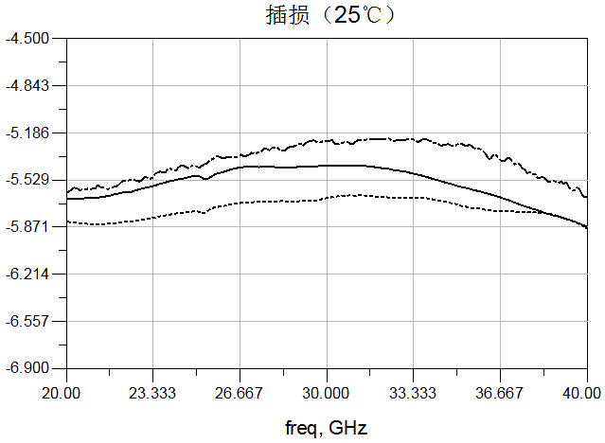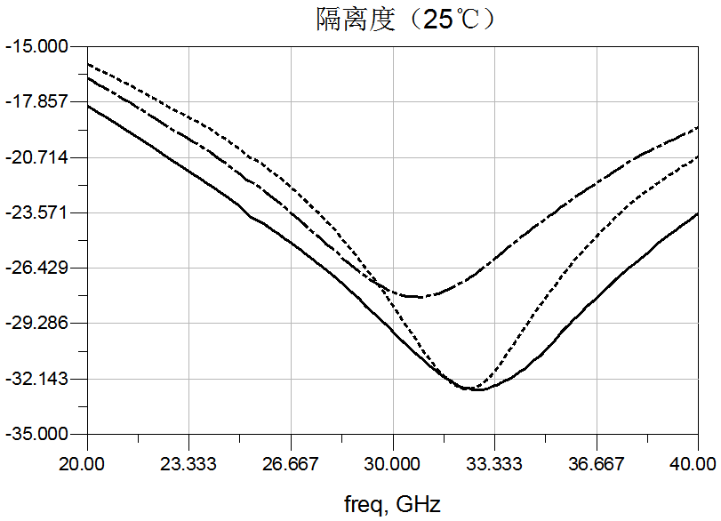

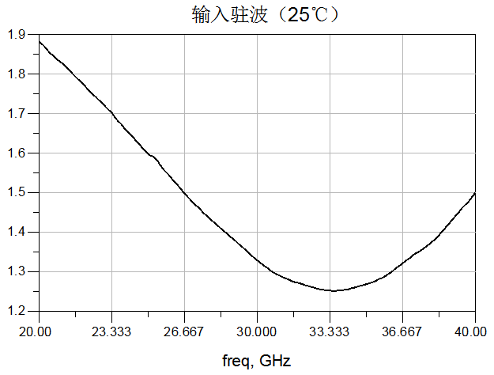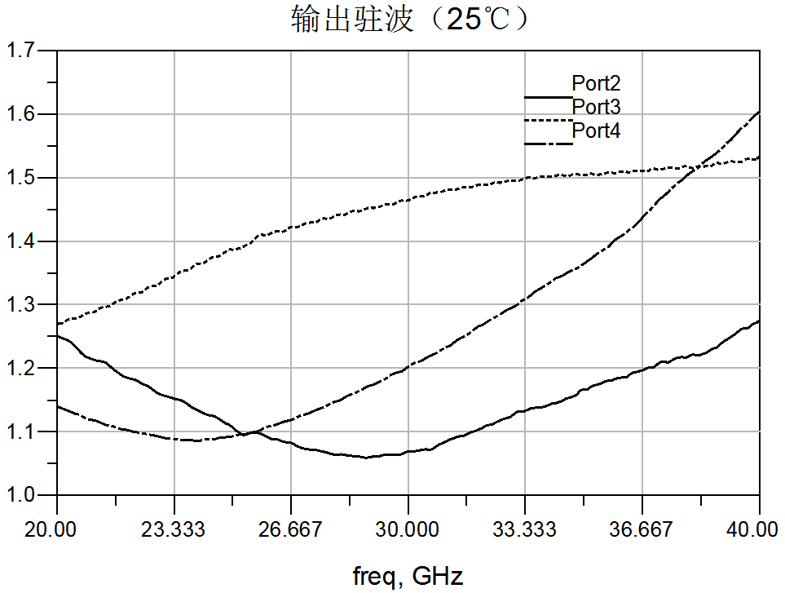
Dimensional drawing：（unit mm）
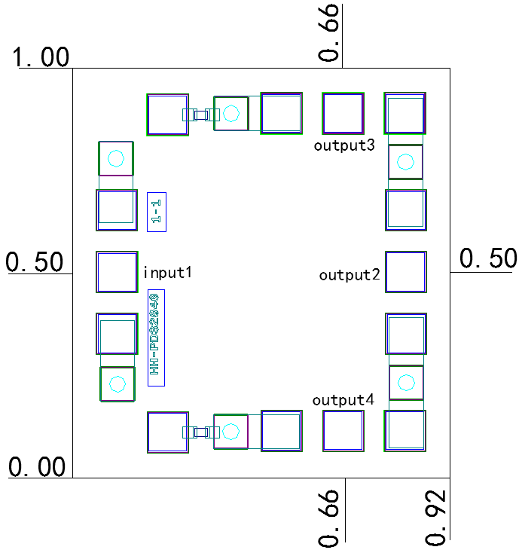
Suggested assembly drawing：
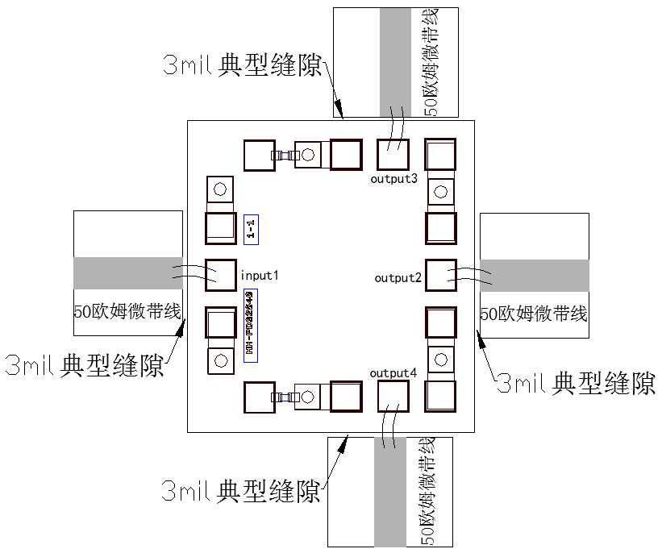

Instructions:
Storage: The chip must be placed in a container with electrostatic protection and stored in a nitrogen environment.
Cleaning treatment: The bare chip must be operated and used in a purified environment. It is forbidden to use liquid cleaning agent to clean the chip.
Electrostatic protection: Strictly comply with the ESD protection requirements to avoid electrostatic damage to the components.
General operation: Use vacuum chuck or precision pointed tweezers to pick up the chip.Avoid touching the surface of the chip with tools or fingers during handling.
Mounting operation: The chip can be installed using AuSn solder eutectic welding or conductive adhesive bonding process.The mounting surface must be clean and flat.
Bonding operation: Input and output with 2 (recommended diameter of 25um gold wire) bonding wire, bonding wire length less than 250um is optimal.It is recommended to use the smallest possible ultrasonic energy.Bonding begins at the pressure point on the chip and ends at the package (or substrate).
Performance Characteristics:
- Frequency band: 33~37GHz
- Insertion loss: 1.1dB
- Isolation: 20dB
- Input/output voltage standing wave ratio: 1.37/1.2
- Chip size: 2mm x 1.1mm x 0.1mm
Product description：
CW-PD43040 is a GaAs MMIC0° four-way power splitter chip. The power splitter chip has the characteristics of small plug loss, high isolation, small size, easy integration and so on. It is widely used in power distribution and synthesis.
Electrical parameters：( T_{A}=25℃）
Indicators | Minimum | Typical value | Maximum value | Units
Frequency range | 33~37 |  |  | GHz
Insertion loss | - | 1.1 | - | dB
isolation | - | 20 | - | dB
Input voltage standing wave ratio | - | 1.37 | - | -
Output voltage standing wave ratio | - | 1.2 | - | -
Use limiting parameters：
Input power | +27dBm
Storage temperature | -65℃~150℃
Service temperature | -55℃~85℃
Typical curve:
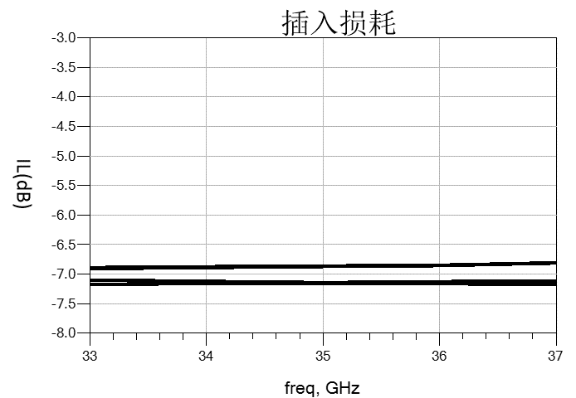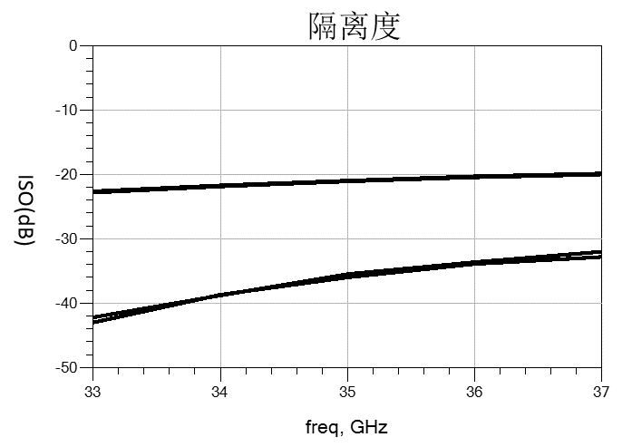

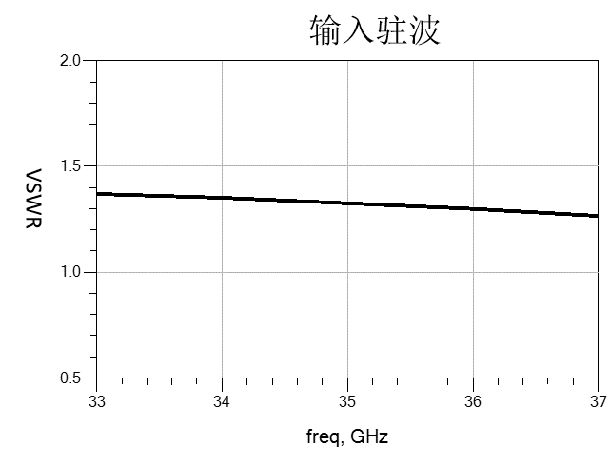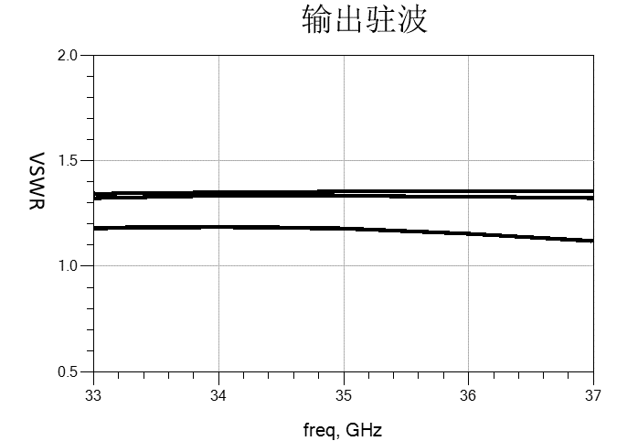
Dimensional drawing：（unit mm）
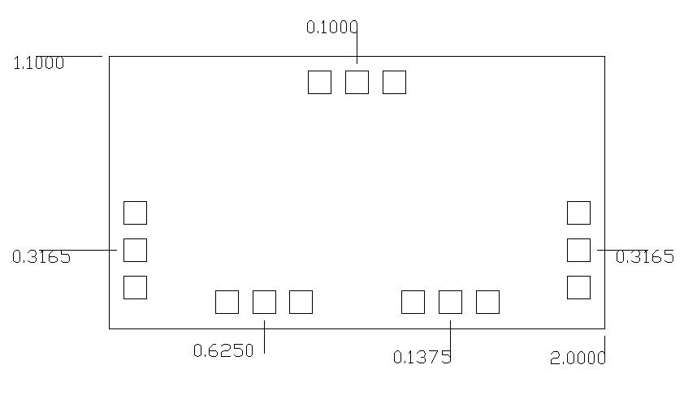
In
OUT4
OUT3
OUT2
OUT1
Suggested assembly drawing：
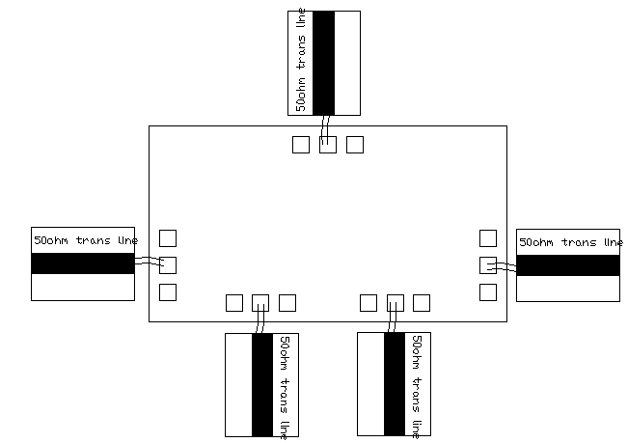
Instructions:
Storage: The chip must be placed in a container with electrostatic protection and stored in a nitrogen environment.
Cleaning treatment: The bare chip must be operated and used in a purified environment. It is forbidden to use liquid cleaning agent to clean the chip.
Electrostatic protection: Strictly comply with the ESD protection requirements to avoid electrostatic damage to the components.
General operation: Use vacuum chuck or precision pointed tweezers to pick up the chip.Avoid touching the surface of the chip with tools or fingers during handling.
Mounting operation: The chip can be installed using AuSn solder eutectic welding or conductive adhesive bonding process.The mounting surface must be clean and flat.
Bonding operation: Input and output with 2 (recommended diameter of 25um gold wire) bonding wire, bonding wire length less than 250um is optimal.It is recommended to use the smallest possible ultrasonic energy.Bonding starts at the pressure point on the chip and ends at the package (or substrate)

09 Equalizer
Number | Frequency range  (GHz) | Insertion loss  (dB) | Equal measure  (dB) | Standing wave | Page number
CW-AE00506 | 0.5-6.0 | 0.5/0.6/0.8/0.8/0.9/1.0 | 2/3/4/5/6/7 | 1.2/1.2
CW-AE0218 | 2.0-18 | 1.0/1.0/1.0/1.0/1.2/1.2 | 2/3/4/5/6/7 | 1.2/1.2
CW-AE0218-8 | 2.0-18 | 1.3 | 8 | 1.3/1.3
CW-AE0218-16 | 2.0-18 | 2.5 | 16 | 1.3/1.3
CW-AE0612 | 6.0-12 | 0.9 | 3 | 1.2/1.2
CW-AE0618 | 6.0-18 | 0.6/0.6/1.0/1.1/1.1/1.1 | 2/3/4/5/6/7 | 1.2/1.2
CW-AE1840 | 18-40 | 1.2/1.2/1.2/1.1/1.1/1.6 | 2/3/4/5/6/7 | 1.4/1.4
CW-AE0618-357 | 6.0-18 | 0.8 | 3/5/7 | 1.3/1.3
CW-AE0118-4 | 1.0-18 | 0.5 | 4 | -
CW-AE0118-6 | 1.0-18 | 0.6 | 6 | -

Performance Features:
- Frequency band: 0.5~6GHz
- Insertion loss: 0.5 dB/dB/dB / 0.8 0.6 0.8 0.9 dB/dB / 1 dB
- All measurements: 2dB/3dB/4dB/5dB/6dB/7dB
- Input/output voltage standing wave ratio: 1.2/1.2
- Chip size: 0.6mm×0.6mm×0.1mm
Product Description：
CW-AE00506-2, CW-AE00506-3, CW-AE00506-4, CW-AE00506-5, CW-AE00506-6, CW-AE00506-7 are GaAs MMIC series equalizer chips with frequency range covering 0.5GHz-6GHz.In the frequency range, the insertion loss is a positive slope, and the average measurement is 2dB, 3dB, 4dB, 5dB, 6dB and 7dB respectively.
Electrical parameters：( T_{A}=25℃)
Indicators |  | Minimum | Typical value | Maximum value | Units
Frequency range |  | 0.5 ~ 6 |  |  | GHz
Insertion loss | CW-AE00506-2 | 0.5 | - | 2.6 | dB
Insertion loss | CW-AE00506-3 | 0.6 | - | 3.7 | dB
Insertion loss | CW-AE00506-4 | 0.8 | - | 4.8 | dB
Insertion loss | CW-AE00506-5 | 0.8 | - | 5.8 | dB
Insertion loss | CW-AE00506-6 | 0.9 | - | 7 | dB
Insertion loss | CW-AE00506-7 | 1.0 | - | 8 | dB
Even measure | CW-AE00506-2 | - | 2 | - | dB
Even measure | CW-AE00506-3 | - | 3 | - | dB
Even measure | CW-AE00506-4 | - | 4 | - | dB
Even measure | CW-AE00506-5 | - | 5 | - | dB
Even measure | CW-AE00506-6 | - | 6 | - | dB
Even measure | CW-AE00506-7 | - | 7 | - | dB
Input voltage standing wave ratio |  | - | 1.2 | 1.3 | -
Output voltage standing wave ratio |  | - | 1.2 | 1.3 | -
Use limit parameters: (Exceeding any of the above maximum limits risks permanent damage.)
Input power | +30dBm
Storage temperature | -65℃~150℃
Service temperature | -55℃~125℃

Typical curve：
CW-AE00506-2（on wafer）
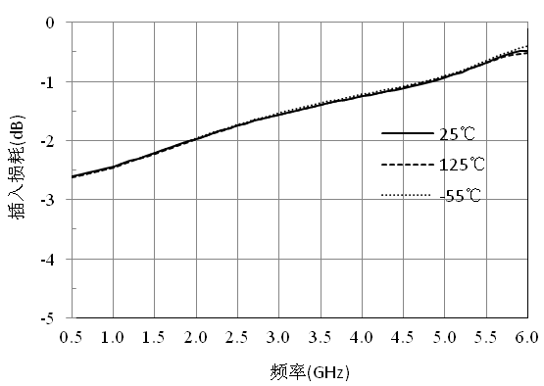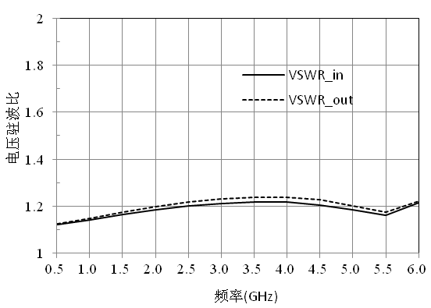

CW-AE00506-2（bondwire）
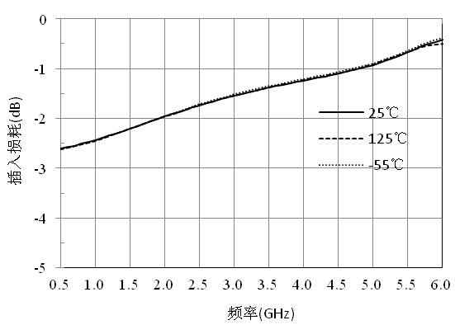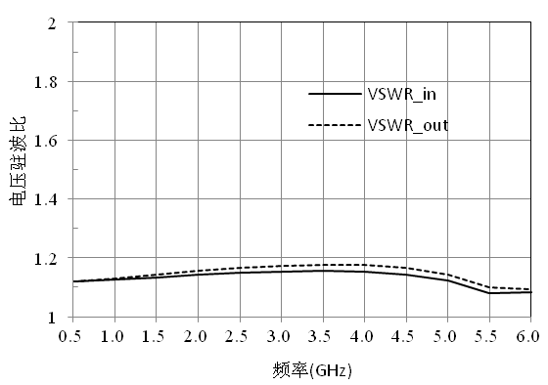

CW-AE00506-3（on wafer）
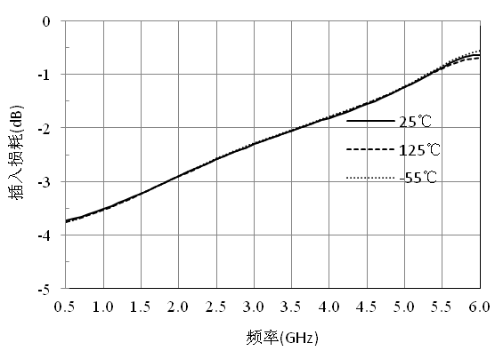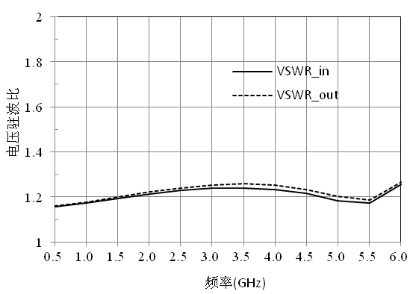

CW-AE00506-3（bondwire）
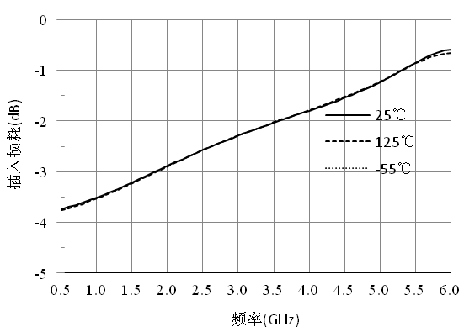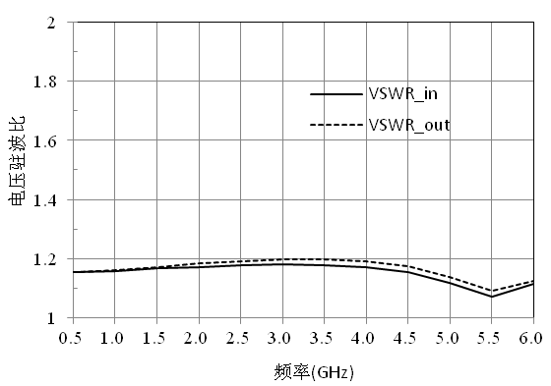

CW-AE00506-4（on wafer）
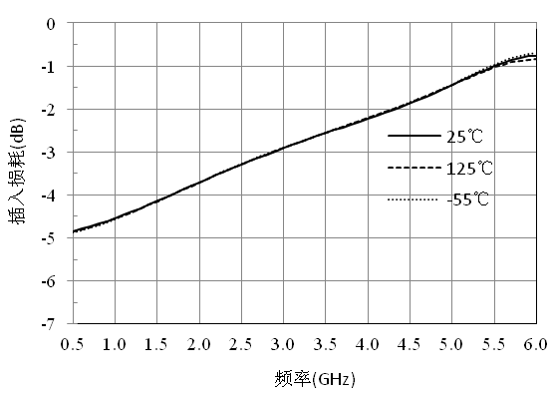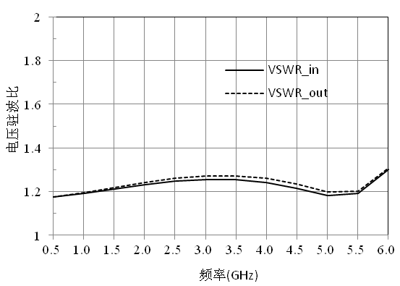

CW-AE00506-4（bondwire）
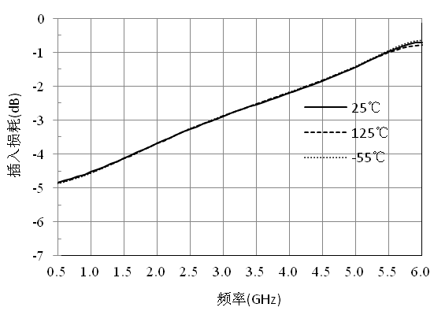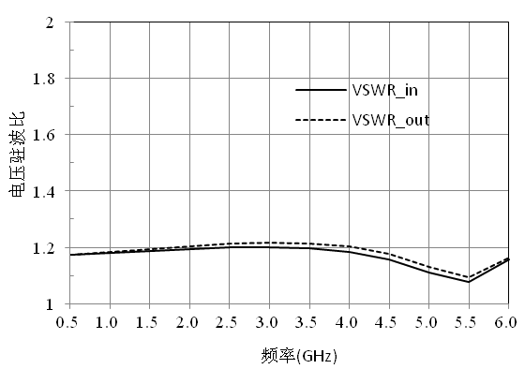

CW-AE00506-5（on wafer）
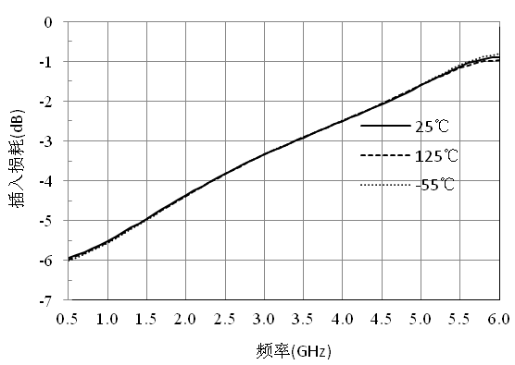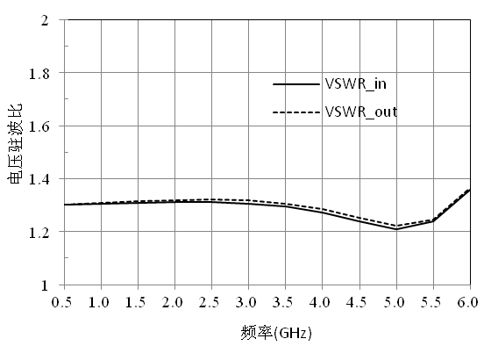

CW-AE00506-5（bondwire）
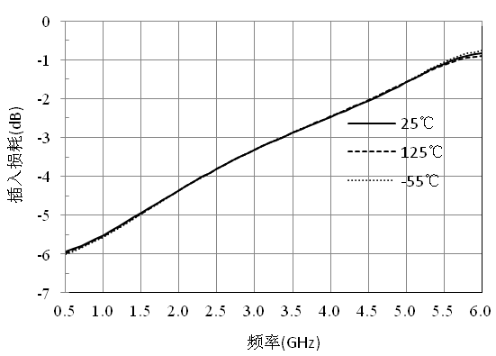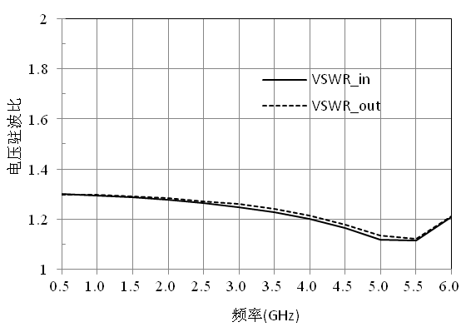

CW-AE00506-6（on wafer）

CW-AE00506-6（bondwire）
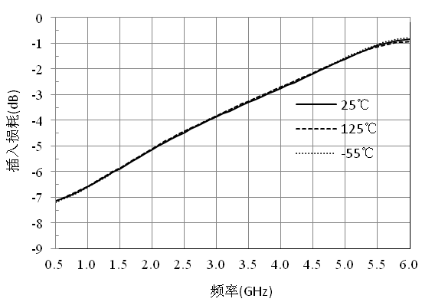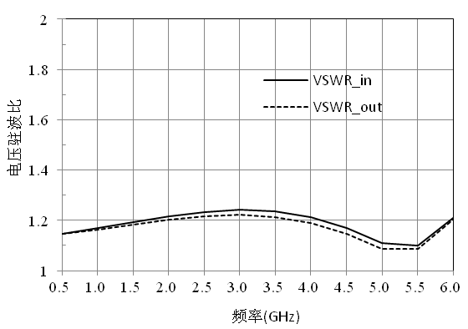

CW-AE00506-7（on wafer）
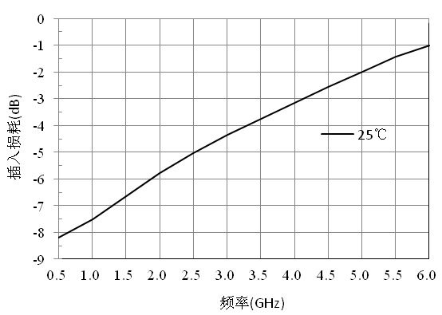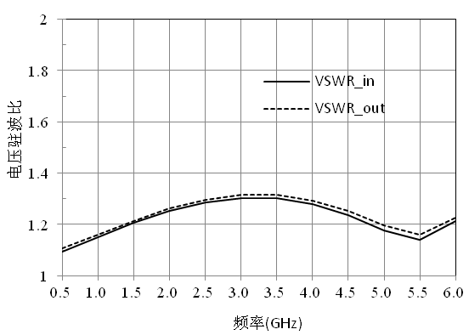

CW-AE00506-7（bondwire）
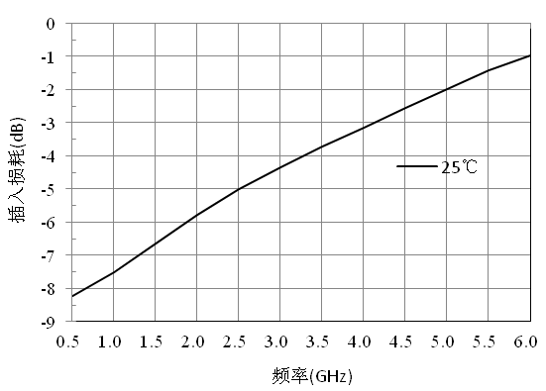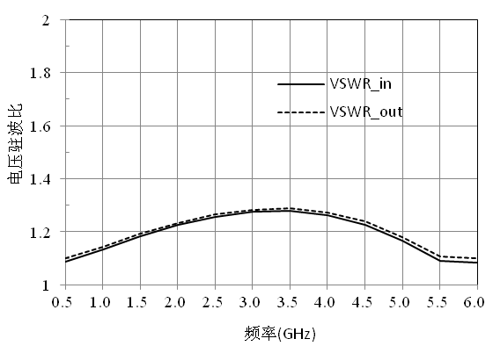

Size drawing：（unit mm）
Suggested assembly drawing：

Instructions:
Storage: The chip must be placed in a container with electrostatic protection and stored in a nitrogen environment.
Cleaning treatment: The bare chip must be operated and used in a purified environment. It is forbidden to use liquid cleaning agent to clean the chip.
Electrostatic protection: Strictly comply with the ESD protection requirements to avoid electrostatic damage to the components.
General operation: Use vacuum chuck or precision pointed tweezers to pick up the chip.Avoid touching the surface of the chip with tools or fingers during handling.
Mounting operation: The chip can be installed using AuSn solder eutectic welding or conductive adhesive bonding process.The mounting surface must be clean and flat.
Bonding operation: Input and output with 2 (recommended diameter of 25um gold wire) bonding wire, bonding wire length less than 250um is optimal.It is recommended to use the smallest possible ultrasonic energy.Bonding begins at the pressure point on the chip and ends at the package (or substrate).

Performance Characteristics:
- Frequency band: 2~18GHz
- Insertion loss: 1.0 dB/dB/dB / 1.0 1.0 1.0 1.2 dB/dB / 1.2 dB
- All measurements: 2dB/3dB/4dB/5dB/6dB/7dB
- Input/output voltage standing wave ratio: 1.2/1.2
- Chip size: 0.6mm×0.6mm×0.1mm
Product Description：
CW-AE0218-2, CW-AE0218-3, CW-AE0218-4, CW-AE218-5, CW-AE218-6, CW-AE0218-7 are GaAs MMIC series equalizer chips with frequency range covering 2GHz-18GHz.The insertion loss in the frequency range is a positive slope, and all measurements are 2dB, 3dB, 4dB, 5dB, 6dB and 7dB respectively.
Electrical parameters：( T_{A}=25℃)
Indicators |  | Minimum | Typical value | Maximum value | Units
Frequency range |  | 2 ~ 18 |  |  | GHz
Insertion loss | CW-AE0218-2 | 1 | - | 3 | dB
Insertion loss | CW-AE0218-3 | 1 | - | 4 | dB
Insertion loss | CW-AE0218-4 | 1 | - | 5 | dB
Insertion loss | CW-AE0218-5 | 1 | - | 6 | dB
Insertion loss | CW-AE0218-6 | 1.2 | - | 7.1 | dB
Insertion loss | CW-AE0218-7 | 1.2 | - | 8.1 | dB
Even measure | CW-AE0218-2 | - | 2 | - | dB
Even measure | CW-AE0218-3 | - | 3 | - | dB
Even measure | CW-AE0218-4 | - | 4 | - | dB
Even measure | CW-AE0218-5 | - | 5 | - | dB
Even measure | CW-AE0218-6 | - | 6 | - | dB
Even measure | CW-AE0218-7 | - | 7 | - | dB
Input voltage standing wave ratio |  | - | 1.2 | 1.3 | -
Output voltage standing wave ratio |  | - | 1.2 | 1.3 | -
Use limit parameters: (Exceeding any of the above maximum limits risks permanent damage.)
Input power | +30dBm
Storage temperature | -65℃~150℃
Service temperature | -55℃~125℃

Typical curve：
CW-AE0218-2（on wafer）
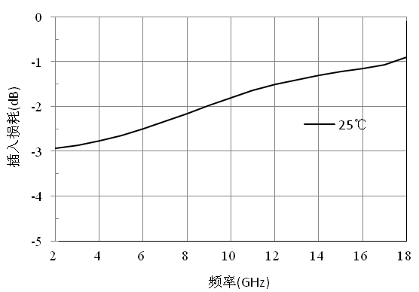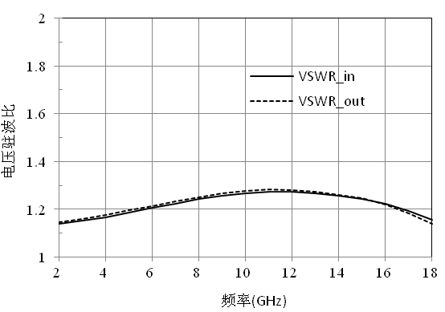

CW-AE0218-2（bondwire）
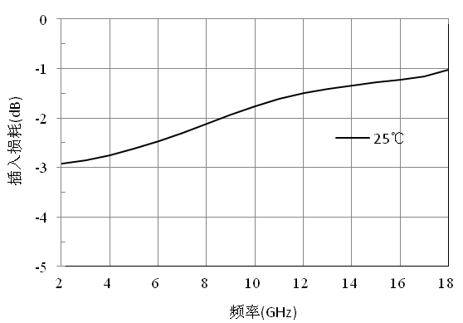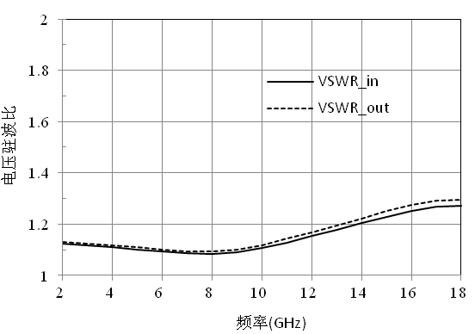

CW-AE0218-3（on wafer）
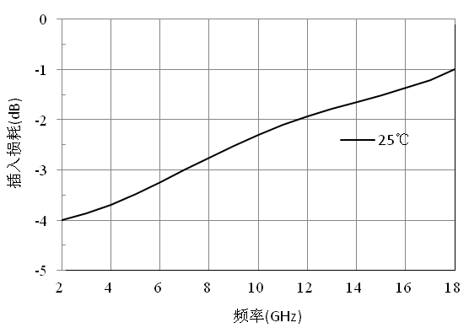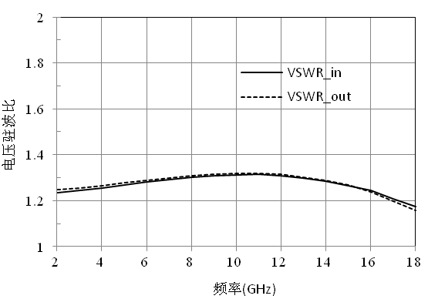

CW-AE0218-3（bondwire）
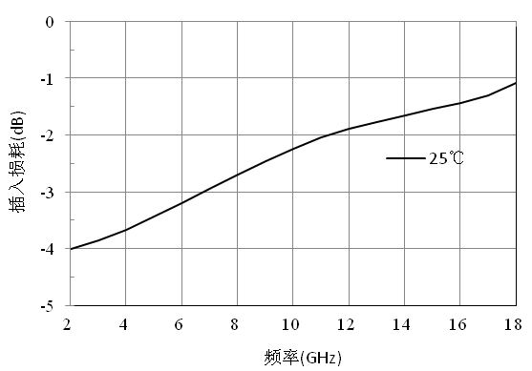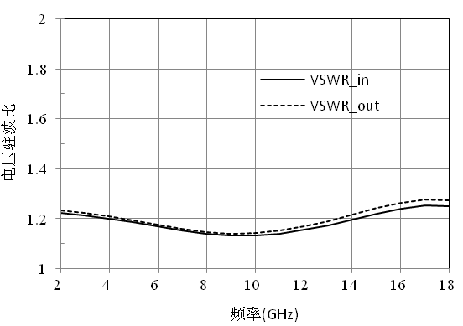

CW-AE0218-4（on wafer）
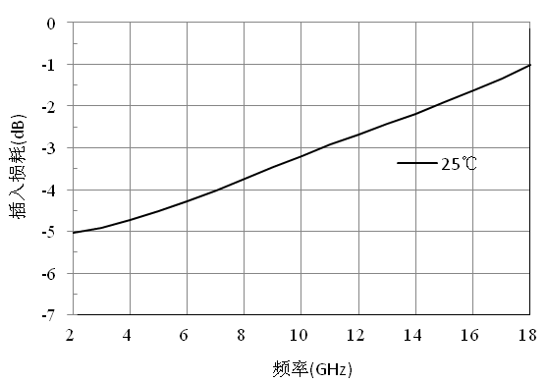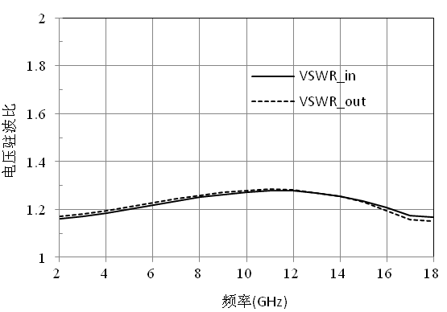

CW-AE0218-4（bondwire）
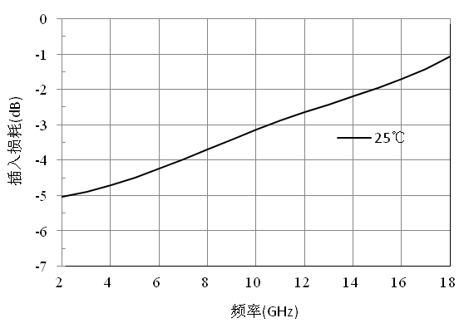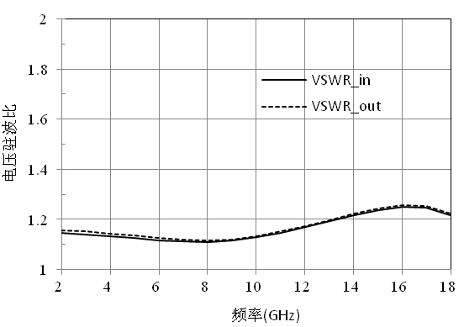

CW-AE0218-5（on wafer）
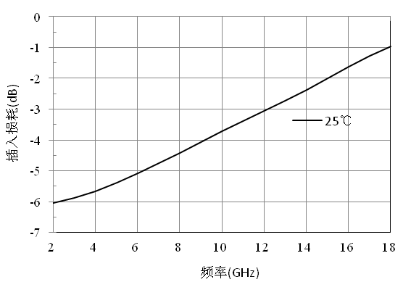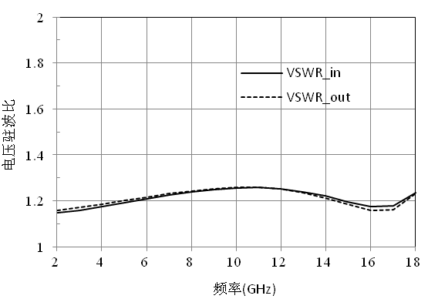

CW-AE0218-5（bondwire）
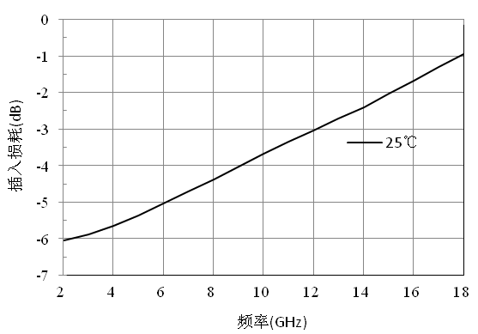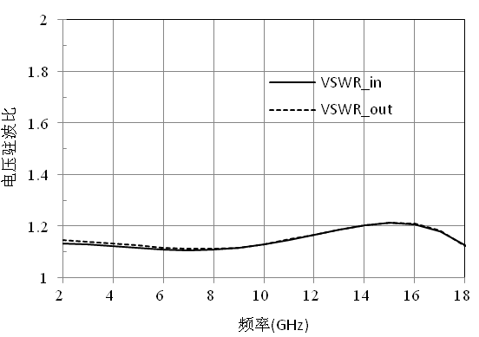

CW-AE0218-6（on wafer）
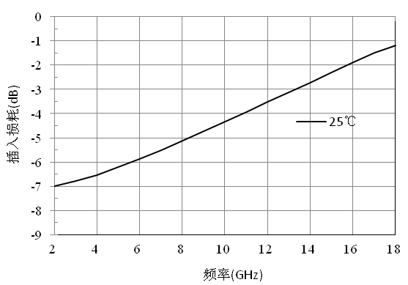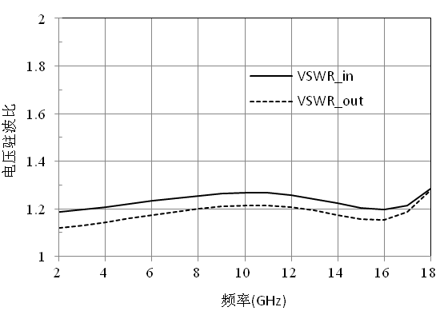

CW-AE0218-6（bondwire）
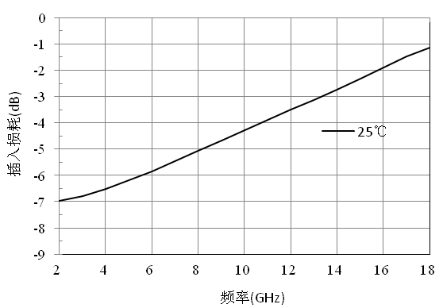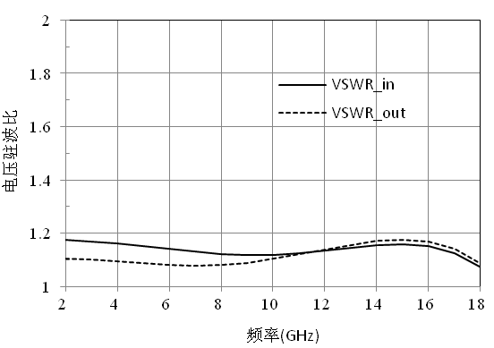

CW-AE0218-7（on wafer）
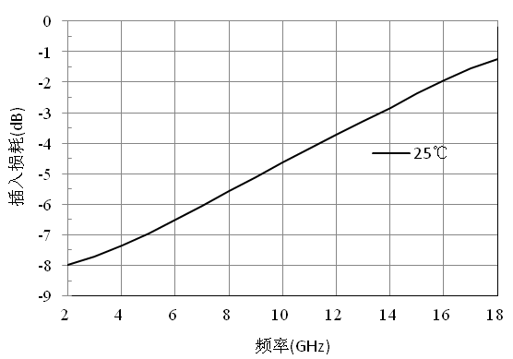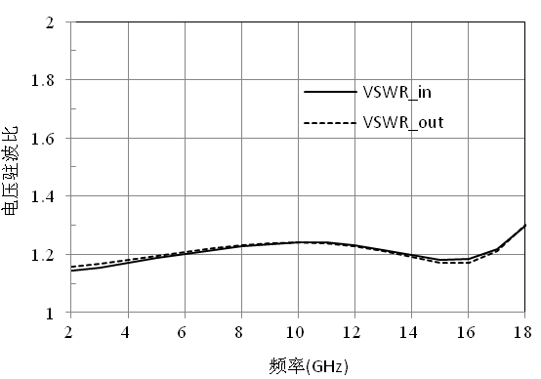

CW-AE0218-7（bondwire）
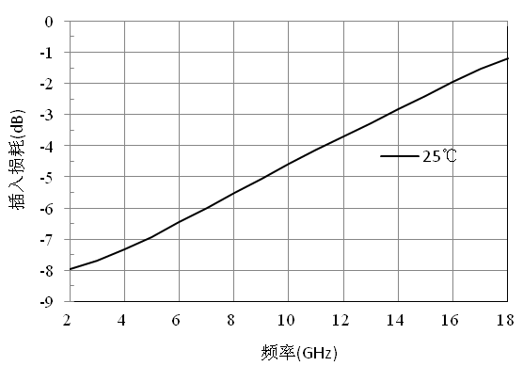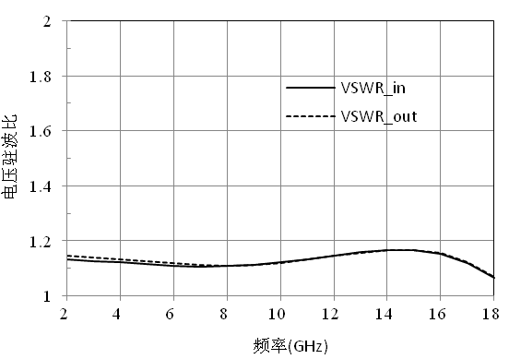

Size drawing：（unit mm）
Suggested assembly drawing：

Instructions:
Storage: The chip must be placed in a container with electrostatic protection and stored in a nitrogen environment.
Cleaning treatment: The bare chip must be operated and used in a purified environment. It is forbidden to use liquid cleaning agent to clean the chip.
Electrostatic protection: Strictly comply with the ESD protection requirements to avoid electrostatic damage to the components.
General operation: Use vacuum chuck or precision pointed tweezers to pick up the chip.Avoid touching the surface of the chip with tools or fingers during handling.
Mounting operation: The chip can be installed using AuSn solder eutectic welding or conductive adhesive bonding process.The mounting surface must be clean and flat.
Bonding operation: Input and output with 2 (recommended diameter of 25um gold wire) bonding wire, bonding wire length less than 250um is optimal.It is recommended to use the smallest possible ultrasonic energy.Bonding begins at the pressure point on the chip and ends at the package (or substrate).

Performance Characteristics:
- Frequency band: 2~18GHz
- Insertion loss: 1.3dB
- Average measurement: 8dB
- Input/output voltage standing wave ratio: 1.3/1.3
- Chip size: 0.6mm×0.6mm×0.1mm
Product Description：
CW-AE0218-8 is a GaAs MMIC equalizer chip with frequency range covering 2GHz-18GHz.In the frequency range, the plug loss is positive slope, 18GHz plug loss is 1.3dB, 2~18GHz is measured as 8dB, input and output voltage standing wave ratio 1.3.
Electrical parameters：( T_{A}=25℃)
Indicators |  | Minimum | Typical value | Maximum value | Units
Frequency range |  | 2 ~ 18 |  |  | GHz
Insertion loss | CW-AE0218-8 | 1.3 | - | 9.2 | dB
Even measure | CW-AE0218-8 | - | 8 | - | dB
Input voltage standing wave ratio |  | - | 1.3 | - | -
Output voltage standing wave ratio |  | - | 1.3 | - | -
Use limit parameters: (Exceeding any of the above maximum limits risks permanent damage.)
Input power | +30dBm
Storage temperature | -65℃~150℃
Service temperature | -55℃~125℃
Typical curve：
CW-AE0218-8（on wafer）

CW-AE0218-8（bondwire）
Size drawing：（unit mm）
Suggested assembly drawing：
Instructions:
Storage: The chip must be placed in a container with electrostatic protection and stored in a nitrogen environment.
Cleaning treatment: The bare chip must be operated and used in a purified environment. It is forbidden to use liquid cleaning agent to clean the chip.
Electrostatic protection: Strictly comply with the ESD protection requirements to avoid electrostatic damage to the components.
General operation: Use vacuum chuck or precision pointed tweezers to pick up the chip.Avoid touching the surface of the chip with tools or fingers during handling.
Mounting operation: The chip can be installed using AuSn solder eutectic welding or conductive adhesive bonding process.The mounting surface must be clean and flat.
Bonding operation: Input and output with 2 (recommended diameter of 25um gold wire) bonding wire, bonding wire length less than 250um is optimal.It is recommended to use the smallest possible ultrasonic energy.Bonding begins at the pressure point on the chip and ends at the package (or substrate).

Performance Characteristics:
- Frequency band: 2~18GHz
- Insertion loss: 2.5dB
- Average measurement: 16dB
- Input/output voltage standing wave ratio: 1.3/1.3
- Chip size: 0.85mm×0.6mm×0.1mm
Product Description：
CW-AE0218-16 is a GaAs MMIC equalizer chip with frequency range covering 2GHz to 18GHz.In the frequency range, the plug loss is a positive slope, 18GHz plug loss is 2.5dB, 2~18GHz is measured as 16dB, input and output voltage standing wave ratio 1.3.
Electrical parameters：( T_{A}=25℃)
Indicators |  | Minimum | Typical value | Maximum value | Units
Frequency range |  | 2~18 |  |  | GHz
Insertion loss | CW-AE0218-16 | 2.5 | - | 18.3 | dB
Even measure | CW-AE0218-16 | - | 16 | - | dB
Input voltage standing wave ratio |  | - | 1.3 | - | -
Output voltage standing wave ratio |  | - | 1.3 | - | -
Use limit parameters: (Exceeding any of the above maximum limits risks permanent damage.)
Input power | +30dBm
Storage temperature | -65℃~150℃
Service temperature | -55℃~125℃
Typical curve：
CW-AE0218-16（on wafer）

CW-AE0218-16（bondwire）
Size drawing：（unit mm）
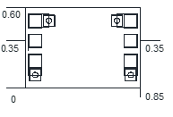
Suggested assembly drawing：
Instructions:
Storage: The chip must be placed in a container with electrostatic protection and stored in a nitrogen environment.
Cleaning treatment: The bare chip must be operated and used in a purified environment. It is forbidden to use liquid cleaning agent to clean the chip.
Electrostatic protection: Strictly comply with the ESD protection requirements to avoid electrostatic damage to the components.
General operation: Use vacuum chuck or precision pointed tweezers to pick up the chip.Avoid touching the surface of the chip with tools or fingers during handling.
Mounting operation: The chip can be installed using AuSn solder eutectic welding or conductive adhesive bonding process.The mounting surface must be clean and flat.
Bonding operation: Input and output with 2 (recommended diameter of 25um gold wire) bonding wire, bonding wire length less than 250um is optimal.It is recommended to use the smallest possible ultrasonic energy.Bonding begins at the pressure point on the chip and ends at the package (or substrate).

Performance Characteristics:
- Passband band: 6.0 ~ 12.0GHz
- Passband loss: 0.9 dB
- All measurements: 3.4dB
- Return loss: 20dB
- Chip size: 0.80mmx0.85mm x 0.1mm
Product Description：
CW-AE0612 is a gallium arsenide monolithic equalizer chip.The equalizer chip has the characteristics of small size, light weight, easy integration, high performance, etc., and is widely used in the improvement of channel amplitude flatness.The equalizer chip is realized by lumped unit, the performance is not affected by the external box body, and the use is simple and convenient.The chip size is 0.80mmx0.85mm x 0.1mm.
Electrical parameters：( T_{A}=25℃)
Indicators |  | Minimum | Typical value | Maximum value | Units
Frequency range |  | 2 ~ 18 |  |  | GHz
Insertion loss | CW-AE0612 | 0.9 | - | 4.3 | dB
Even measure | CW-AE0612 | - | 3.4 | - | dB
Input return loss |  | 20 | - | - | dB
Output return loss |  | 20 | - | - | dB
Use limit parameters: (Exceeding any of the above maximum limits risks permanent damage.)
Maximum input power | +30dBm
Storage temperature | -65℃～+150℃
Service temperature | -55℃～+125℃
Typical curve：（T_{A}=+25℃）
I/O return loss Insertion loss

Size drawing：（unit mm）
Suggested assembly drawing：
Instructions:
Storage: The chip must be placed in a container with electrostatic protection and stored in a nitrogen environment.
Cleaning treatment: The bare chip must be operated and used in a purified environment. It is forbidden to use liquid cleaning agent to clean the chip.
Electrostatic protection: Strictly comply with the ESD protection requirements to avoid electrostatic damage to the components.
General operation: Use vacuum chuck or precision pointed tweezers to pick up the chip.Avoid touching the surface of the chip with tools or fingers during handling.
Mounting operation: The chip can be installed using AuSn solder eutectic welding or conductive adhesive bonding process.The mounting surface must be clean and flat.
Bonding operation: Input and output with 2 (recommended diameter of 25um gold wire) bonding wire, bonding wire length less than 250um is optimal.It is recommended to use the smallest possible ultrasonic energy.Bonding begins at the pressure point on the chip and ends at the package (or substrate).

Performance Characteristics:
- Frequency band: 6~18GHz
- Insertion loss: 1 dB/dB/dB / 0.6 0.6 1.1 1.1 dB/dB / 1.1 dB
- All measurements: 2dB/3dB/4dB/5dB/6dB/7dB
- Input/output voltage standing wave ratio: 1.2/1.2
- Chip size: 0.6mm×0.6mm×0.1mm
Product Description：
CW-AE0618-2, CW-AE0618-3, CW-AE0618-4, CW-AE0618-5, CW-AE0618-6, CW-AE0618-7 are GaAs MMIC series equalizer chips with frequency range covering 6GHz-18GHz.The insertion loss in the frequency range is a positive slope, and all measurements are 2dB, 3dB, 4dB, 5dB, 6dB and 7dB respectively.
Electrical parameters：( T_{A}=25℃)
Indicators |  | Minimum | Typical value | Maximum value | Units
Frequency range |  | 6 ~ 18 |  |  | GHz
Insertion loss | CW-AE0618-2 | 0.6 | - | 2.6 | dB
Insertion loss | CW-AE0618-3 | 0.6 | - | 3.5 | dB
Insertion loss | CW-AE0618-4 | 1 | - | 5.0 | dB
Insertion loss | CW-AE0618-5 | 1.1 | - | 5.9 | dB
Insertion loss | CW-AE0618-6 | 1.1 | - | 7 | dB
Insertion loss | CW-AE0618-7 | 1.1 | - | 8 | dB
Even measure | CW-AE0618-2 | - | 2 | - | dB
Even measure | CW-AE0618-3 | - | 3 | - | dB
Even measure | CW-AE0618-4 | - | 4 | - | dB
Even measure | CW-AE0618-5 | - | 5 | - | dB
Even measure | CW-AE0618-6 | - | 6 | - | dB
Even measure | CW-AE0618-7 | - | 7 | - | dB
Input voltage standing wave ratio |  | - | 1.2 | 1.3 | -
Output voltage standing wave ratio |  | - | 1.2 | 1.3 | -
Use limit parameters: (Exceeding any of the above maximum limits risks permanent damage.)
Input power | +30dBm
Storage temperature | -65℃~150℃
Service temperature | -55℃~125℃

Typical curve：
CW-AE0618-2（on wafer）
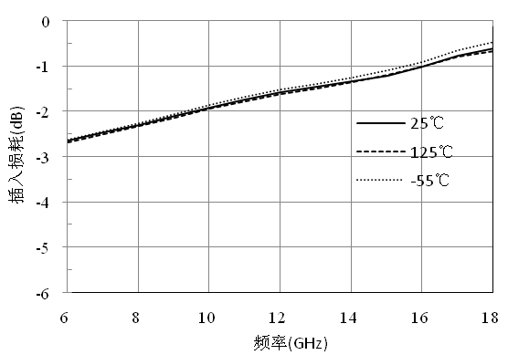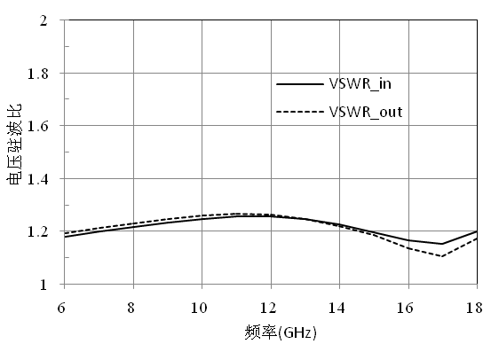

CW-AE0618-2（bondwire）
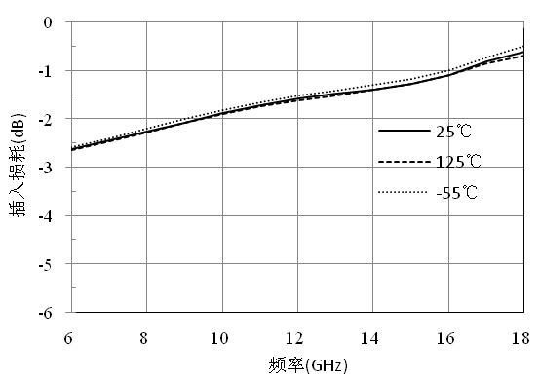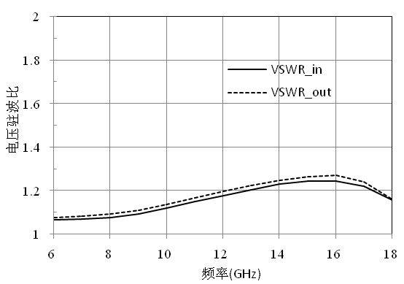

CW-AE0618-3（on wafer）
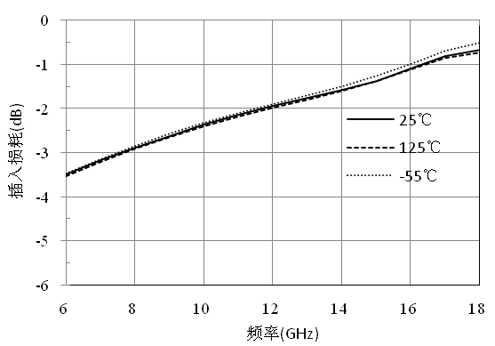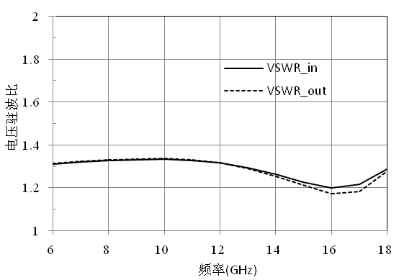

CW-AE0618-3（bondwire）
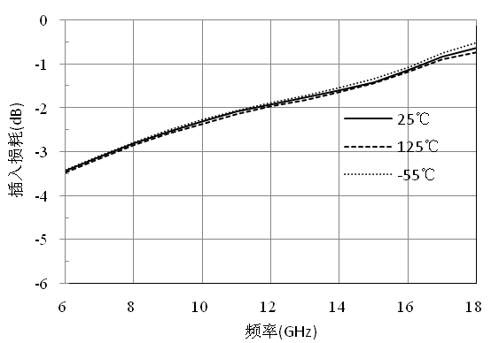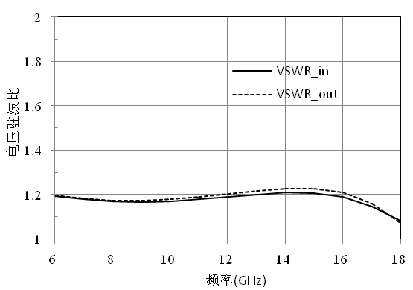

CW-AE0618-4（on wafer）
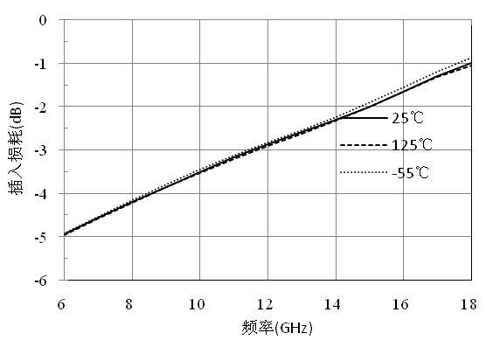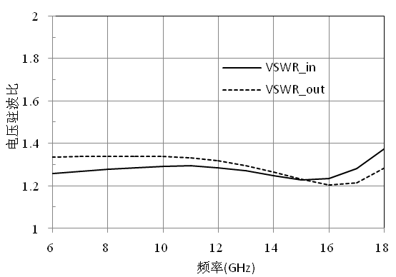

CW-AE0618-4（bondwire）
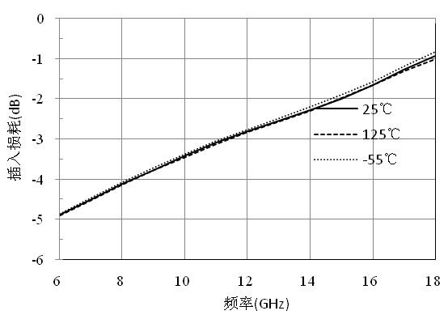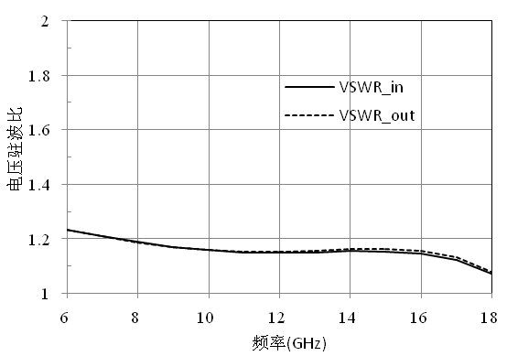

CW-AE0618-5（on wafer）
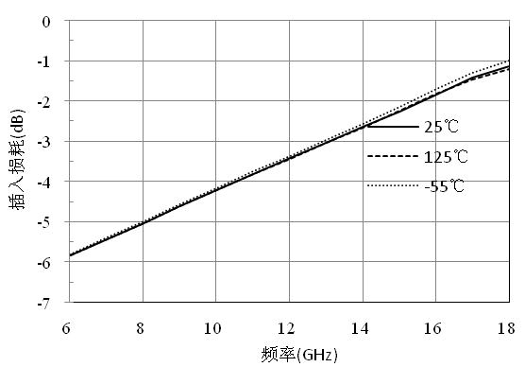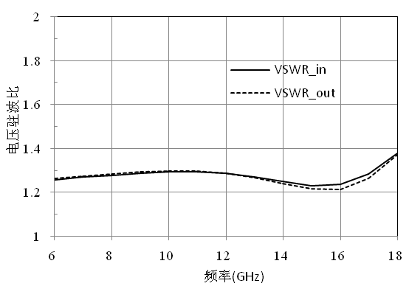

CW-AE0618-5（bondwire）
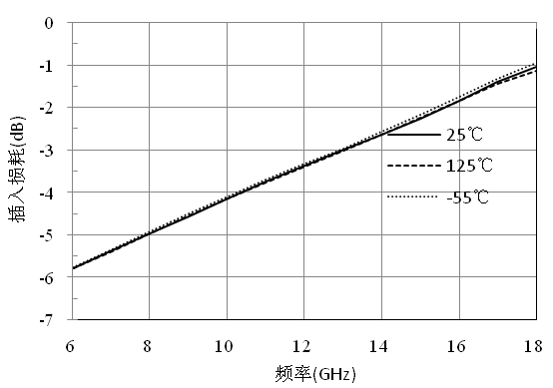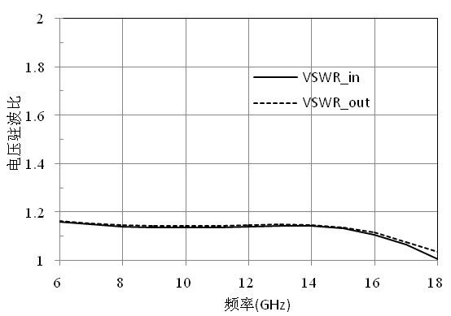

CW-AE0618-6（on wafer）
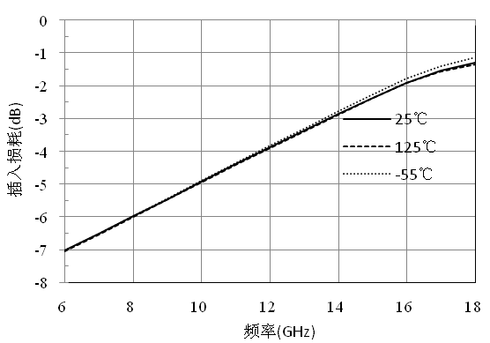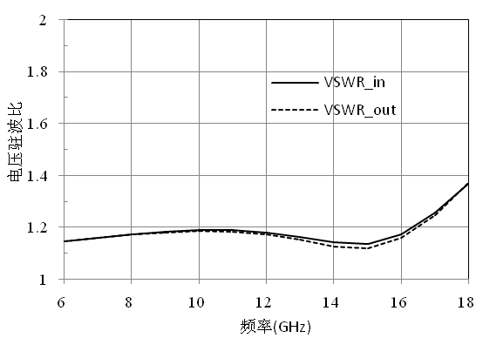

CW-AE0618-6（bondwire）
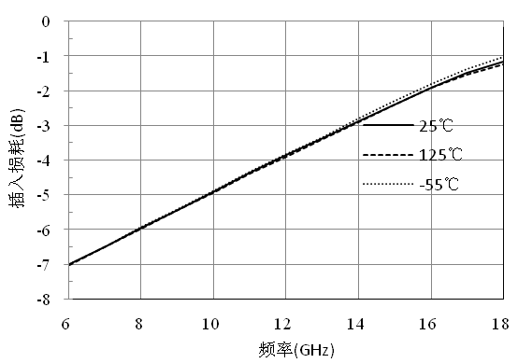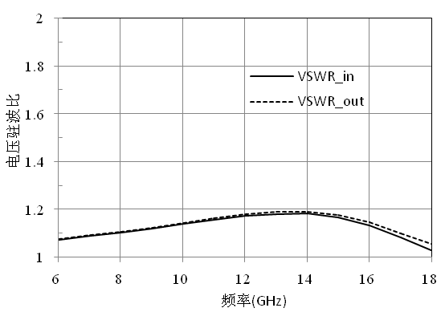

CW-AE0618-7（on wafer）
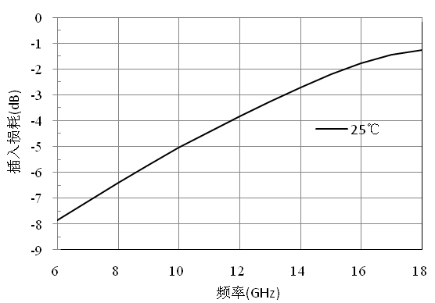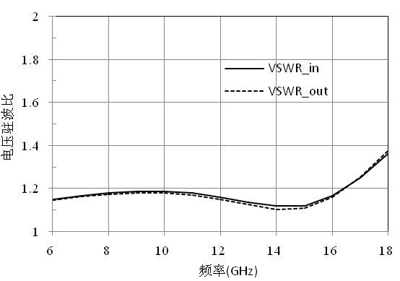

CW-AE0618-7（bondwire）
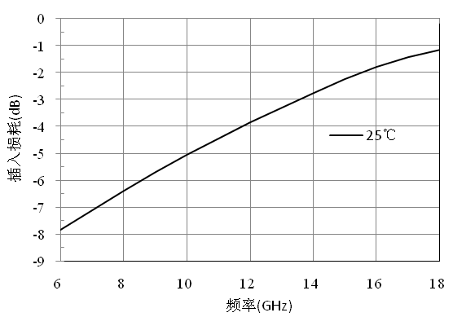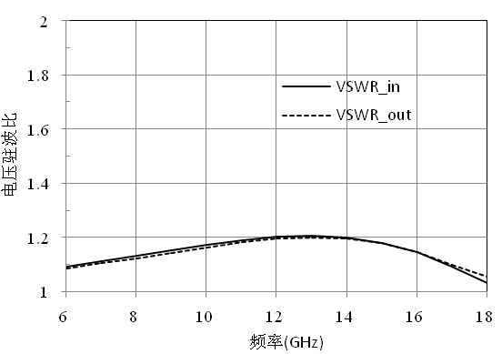

Size drawing：（unit mm）
Suggested assembly drawing：

Instructions:
Storage: The chip must be placed in a container with electrostatic protection and stored in a nitrogen environment.
Cleaning treatment: The bare chip must be operated and used in a purified environment. It is forbidden to use liquid cleaning agent to clean the chip.
Electrostatic protection: Strictly comply with the ESD protection requirements to avoid electrostatic damage to the components.
General operation: Use vacuum chuck or precision pointed tweezers to pick up the chip.Avoid touching the surface of the chip with tools or fingers during handling.
Mounting operation: The chip can be installed using AuSn solder eutectic welding or conductive adhesive bonding process.The mounting surface must be clean and flat.
Bonding operation: Input and output with 2 (recommended diameter of 25um gold wire) bonding wire, bonding wire length less than 250um is optimal.It is recommended to use the smallest possible ultrasonic energy.Bonding begins at the pressure point on the chip and ends at the package (or substrate).

Performance Characteristics:
- Frequency band: 18~40GHz
- Insertion loss: 1.2 dB/dB/dB / 1.2 1.2 1.1 1.1 dB/dB / 1.6 dB
- Both measured: 2/3/4/5/6/7dB
- Input/output voltage standing wave ratio: 1.4/1.4
- Chip size: 0.6mm×0.6mm×0.1mm
Product Description：
The CW-AE1840 is a GaAs MMIC series equalizer chip covering the frequency range from 18GHz to 40GHz.Plug loss is a positive slope across the frequency range, all measure optional range 2/3/4/5/6/7 dB.
Electrical parameters：( T_{A}=25℃)
Indicators |  | Minimum | Typical value | Maximum value | Units
Frequency range |  | 18 ~ 40 |  |  | GHz
Insertion loss | CW-AE1840-2 | 1.2 | - | 3.1 | dB
Insertion loss | CW-AE1840-3 | 1.2 | - | 3.9 | dB
Insertion loss | CW-AE1840-4 | 1.2 | - | 5.0 | dB
Insertion loss | CW-AE1840-5 | 1.1 | - | 5.7 | dB
Insertion loss | CW-AE1840-6 | 1.1 | - | 6.6 | dB
Insertion loss | CW-AE1840-7 | 1.6 | - | 7.8 | dB
Even measure | CW-AE1840-2 | - | 2 | - | dB
Even measure | CW-AE1840-3 | - | 3 | - | dB
Even measure | CW-AE1840-4 | - | 4 | - | dB
Even measure | CW-AE1840-5 | - | 5 | - | dB
Even measure | CW-AE1840-6 | - | 6 | - | dB
Even measure | CW-AE1840-7 | - | 7 | - | dB
Input voltage standing wave ratio |  | - | 1.4 | 1.5 | -
Output voltage standing wave ratio |  | - | 1.4 | 1.5 | -
Use limit parameters: (Exceeding any of the above maximum limits risks permanent damage.)
Input power | +30dBm
Storage temperature | -65℃~150℃
Service temperature | -55℃~125℃

Typical curve：
CW-AE1840-2
CW-AE1840-3

CW-AE1840-4

CW-AE1840-5

CW-AE1840-6

CW-AE1840-7

Size drawing：（unit mm）

Suggested assembly drawing：
Instructions:
Storage: The chip must be placed in a container with electrostatic protection and stored in a nitrogen environment.
Cleaning treatment: The bare chip must be operated and used in a purified environment. It is forbidden to use liquid cleaning agent to clean the chip.
Electrostatic protection: Strictly comply with the ESD protection requirements to avoid electrostatic damage to the components.
General operation: Use vacuum chuck or precision pointed tweezers to pick up the chip.Avoid touching the surface of the chip with tools or fingers during handling.
Mounting operation: The chip can be installed using AuSn solder eutectic welding or conductive adhesive bonding process.The mounting surface must be clean and flat.
Bonding operation: Input and output with 2 (recommended diameter of 25um gold wire) bonding wire, bonding wire length less than 250um is optimal.It is recommended to use the smallest possible ultrasonic energy.Bonding begins at the pressure point on the chip and ends at the package (or substrate).

Performance Characteristics:
- Frequency band: 6~18GHz
- Insertion loss: 0.8dB
- Both measurements: 3/5/7dB
- Input/output voltage standing wave ratio: 1.3/1.3
- Chip size: 0.6mm×1.5mm×0.1mm
Product Description：
CW-AE0618-357 is a GaAs MMIC equalizer chip covering the frequency range from 6GHz to 18GHz.The insertion loss in the frequency range is a positive slope, all measured as 3dB, 5dB, 7dB optional.
Electrical parameters：( T_{A}=25℃)
Indicators | Minimum | Typical value | Maximum value | Units
Frequency range | 6~18 |  |  | GHz
Insertion loss  CW-AE0218205 | 0.8 | - | - | dB
Even measure  CW-AE0218205 | - | 3/5/7（optional） | - | dB
Input voltage standing wave ratio | - | 1.2 | 1.3 | -
Output voltage standing wave ratio | - | 1.2 | 1.3 | -
Use limit parameters: (Exceeding any of the above maximum limits risks permanent damage.)
Input power | +30dBm
Storage temperature | -65℃~150℃
Service temperature | -55℃~125℃
Typical curve：
CW-AE0618-357（bondwire）
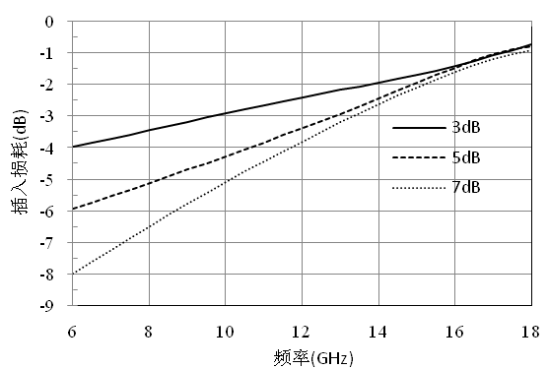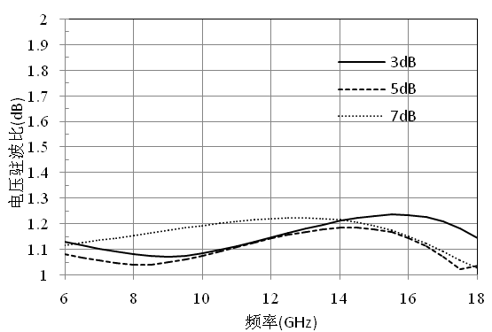

Size drawing：（unit mm）
Suggested assembly drawing：
Instructions:
Storage: The chip must be placed in a container with electrostatic protection and stored in a nitrogen environment.
Cleaning treatment: The bare chip must be operated and used in a purified environment. It is forbidden to use liquid cleaning agent to clean the chip.
Electrostatic protection: Strictly comply with the ESD protection requirements to avoid electrostatic damage to the components.
General operation: Use vacuum chuck or precision pointed tweezers to pick up the chip.Avoid touching the surface of the chip with tools or fingers during handling.
Mounting operation: The chip can be installed using AuSn solder eutectic welding or conductive adhesive bonding process.The mounting surface must be clean and flat.
Bonding operation: Input and output with 2 (recommended diameter of 25um gold wire) bonding wire, bonding wire length less than 250um is optimal.It is recommended to use the smallest possible ultrasonic energy.Bonding begins at the pressure point on the chip and ends at the package (or substrate).

Performance Characteristics:
- Frequency band: 1-18 GHz
- Passband loss: 0.5dB
- All measures: 4.0 dB
- Return loss: 25 dB
- Chip size: 0.95mm×1.0mm×0.1mm
Product Description：
CW-AE0118-4 is a GaAs MMIC 4dB equalizer chip.The equalizer chip has the characteristics of small size, light weight, easy integration, high performance, etc., and is widely used in improving the amplitude flatness of channels.The equalizer chip is realized by lumped unit, the performance is not affected by the external box body, and the use is simple and convenient.The chip size is 0.95mm×1.0mm×0.1mm.
Electrical parameters：( T_{A}=25℃）
Indicators | Minimum | Typical value | Maximum value | Units
Frequency range | 1-18 |  |  | GHz
Insertion loss @18GHz | - | 0.5 | - | dB
Even measure | - | 4 | - | dB
Return loss | - | 25 | - | dB
Use limit parameters: (Exceeding any of the following maximum limits risks permanent damage)
Input power | +30dBm
Storage temperature | -65℃~+175℃
Service temperature | -55℃~+85℃
Typical curve：( T_{A}=25℃）
Insertion loss return loss

Size drawing：(unit mm)
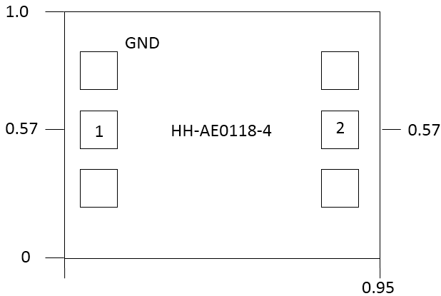

Suggested assembly drawing：
4

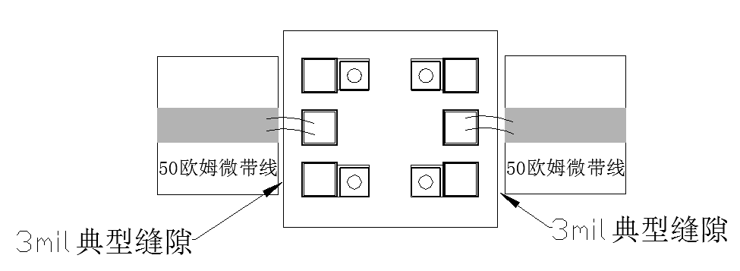
Instructions:
Storage: The chip must be placed in a container with electrostatic protection and stored in a nitrogen environment.
Cleaning treatment: The bare chip must be operated and used in a purified environment. It is forbidden to use liquid cleaning agent to clean the chip.
Electrostatic protection: Strictly comply with the ESD protection requirements to avoid electrostatic damage to the components.
General operation: Use vacuum chuck or precision pointed tweezers to pick up the chip.Avoid touching the surface of the chip with tools or fingers during handling.
Mounting operation: The chip can be installed using AuSn solder eutectic welding or conductive adhesive bonding process.The mounting surface must be clean and flat.
Bonding operation: Input and output with 2 (recommended diameter of 25um gold wire) bonding wire, bonding wire length less than 250um is optimal.It is recommended to use the smallest possible ultrasonic energy.Bonding begins at the pressure point on the chip and ends at the package (or substrate).

Performance Characteristics:
- Frequency band: 1~18GHz
- Insertion loss: 0.6dB@18GHz
- All measurements: 6dB
- Input/Output: 50 ohm match
- Chip size: 0.95 x 1 x 0.1mm³
Product Description：
CW-AE0118-6 is a GaAs MMIC equalizer chip, widely used to improve in-band fluctuation, equalizer amplitude characteristics, the chip through the back metal through the hole ground, input and output consider the influence of gold wire bonding, recommended to use 2 diameter 25um gold wire bonding, bonding line length about 300um is the best.
Electrical parameters：( T_{A}=25℃）
Indicators | Minimum | Typical value | Maximum value | Units
Frequency range | 1~18 |  |  | GHz
Insertion loss @18GHz | - | 0.6 | - | dB
Even measure | - | 6 | - | dB
Return loss | - | 22 | - | dB
Use limiting parameters：
Input power | +30dBm
Storage temperature | -65℃~175℃
Service temperature | -55℃~85℃
Typical curve：

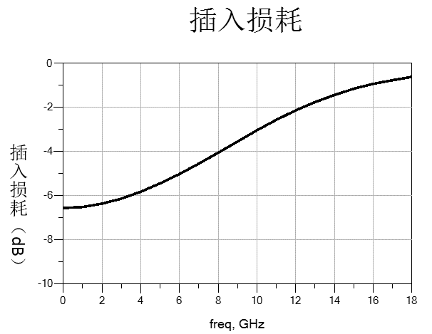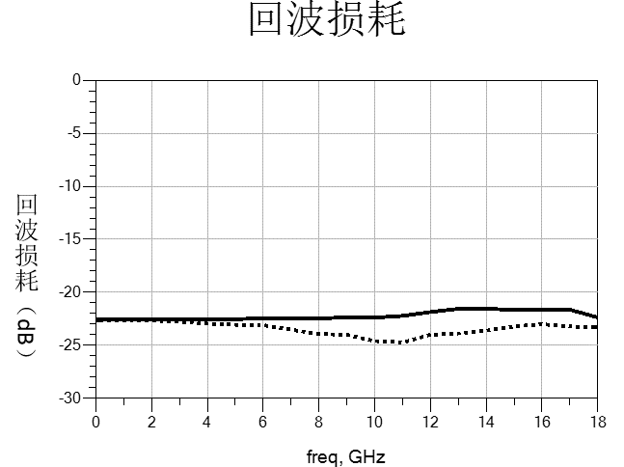
Dimensional drawing：（unit mm）

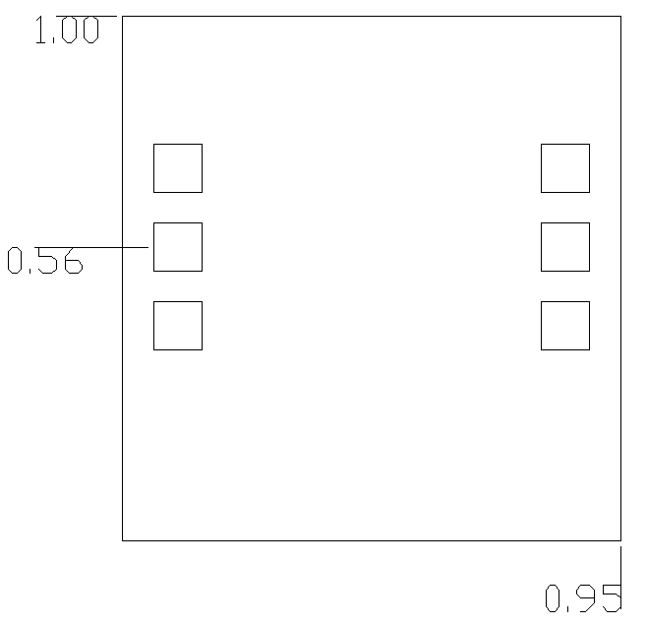
2
1
Suggested assembly drawing：
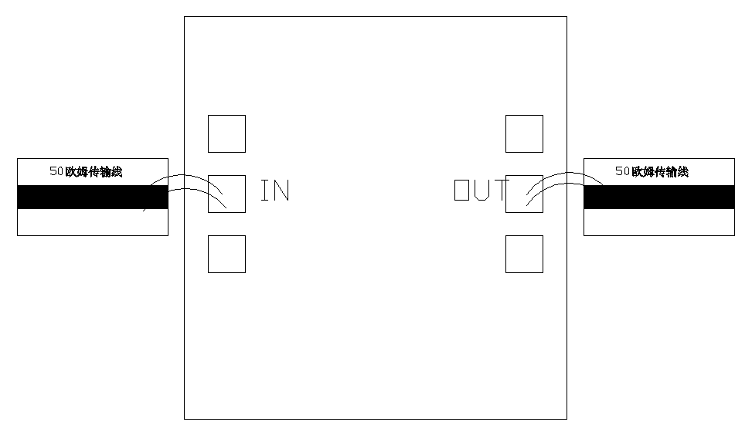
3mil assembly clearance
Pad number | Function | Description
1,2 | RF1，RF2 | Rf branch end of the series pad
Instructions for use:
Storage: The chip must be placed in a container with electrostatic protection and stored in a nitrogen environment.
Cleaning treatment: The bare chip must be operated and used in a purified environment. It is forbidden to use liquid cleaning agent to clean the chip.
Electrostatic protection: Strictly comply with the ESD protection requirements to avoid electrostatic damage to the components.
General operation: Use vacuum chuck or precision pointed tweezers to pick up the chip.Avoid touching the surface of the chip with tools or fingers during handling.
Mounting operation: The chip can be installed using AuSn solder eutectic welding or conductive adhesive bonding process.The mounting surface must be clean and flat.
Bonding operation: Input and output with 2 (recommended diameter of 25um gold wire) bonding wire, bonding wire length less than 250um is optimal.It is recommended to use the smallest possible ultrasonic energy.Bonding starts at the pressure point on the chip and ends at the package (or substrate)
10 Limiter
(The products in this catalog are customized multifunctional chips, welcome users to customize products according to their own needs)
Number | Frequency range  (GHz) | Insertion loss  (dB) | Limiting level  (dBm) | Input standing wave | Output standing wave | Page number
CW-LM0618 | 6-18 | 0.3 | 17 | 1.3 | 1.3
CW-LM1018 | 10-18 | 0.6 | 17 | 1.6 | 1.6

Performance Features:
- Frequency range: 6GHz~18GHz
- Insertion loss: 0.3dB
- Limiting level: 17dBm
- Input/output voltage standing wave ratio: 1.3/1.3
- Endurance power: 4W (CW)
- Chip size: 1.62mm×0.74mm×0.10mm
Product Description：
CW-LM0618 is a GaAs process broadband limiter chip.Its band range covers 6.0-18GHz, insertion loss is less than 0.5dB, and input-output voltage standing wave ratio is less than 1.3.
Electrical parameters：(TA=25℃)
Indicators | Minimum | Typical value | Maximum value | Units
Frequency range | 6-18 |  |  | GHz
Insertion loss | - | 0.3 | 0.5 | dB
Enter the standing wave ratio | - | - | 1.3 | -
Output standing wave ratio | - | - | 1.3 | -
Limiting level | - | 17 | - | dBm
Use limiting parameters:
Maximum input power | 37dBm
Storage temperature | -65℃-150℃
Service temperature | -55℃-125℃
Typical curve：
Insertion loss standing wave ratio

Limiting level
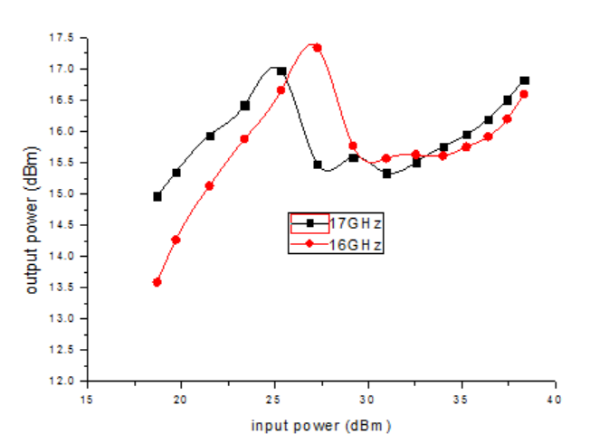
Size drawing：(unit µm)
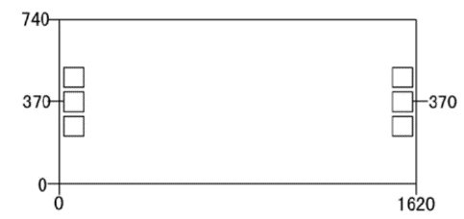
Note: All sizes are in (um) and the press-point size is 100×100um²
Suggested assembly drawing：
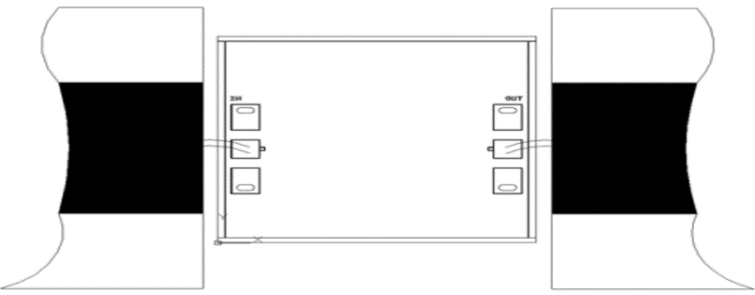

Instructions:
1. Assembly in a purified environment;
2. GaAs material is very brittle, chip surface is easy to be damaged, do not touch the surface, must be careful when using;
3. Input and output with two bonding lines (diameter of 25μm), the bonding line as short as possible, not more than 300μm;
4. The back of the chip must be grounded;
5 Sintered with 80/20 gold tin.The sintering temperature should not exceed 300℃, and the sintering time should not exceed 30 seconds as short as possible;
6. This product belongs to electrostatic sensitive device, pay attention to anti-static when storing and using;
7. Dry and nitrogen storage environment;
8. Do not try to clean the surface of the chip by dry or wet chemical methods;
9. Contact the supplier if you have any problems.

Performance Characteristics:
- Frequency range: 10GHz~18GHz
- Insertion loss: 0.6dB
- Limiting level: 17dBm
- Input/output voltage standing wave ratio: 1.6/1.6
- Resistant power: 20W+ (PW=2ms,DC=20%)
- Chip size: 1.4mm×1.25mm×0.10mm(can be made into 1.4×0.85)
Product Description：
CW-LM1018 is a GaAs process broadband limiter chip.Its band range covers 10GHz-18GHz, insertion loss is less than 0.6dB, and input-output voltage standing wave ratio is less than 1.6.
Electrical parameters：( TA=25℃)
Indicators | Minimum | Typical value | Maximum value | Units
Frequency range | 10-18 |  |  | GHz
Insertion loss | - | 0.5 | 0.6 | dB
Enter the standing wave ratio | - | - | 1.6 | -
Output standing wave ratio | - | - | 1.6 | -
Limiting level | - | 17 | - | dBm
Use limit parameters: (Exceeding any of the above maximum limits is likely to cause permanent damage.)
Maximum input power | 43.5dBm
Storage temperature | -65℃-150℃
Service temperature | -55℃-125℃
Typical curve：
Insertion loss standing wave ratio

Limiting level
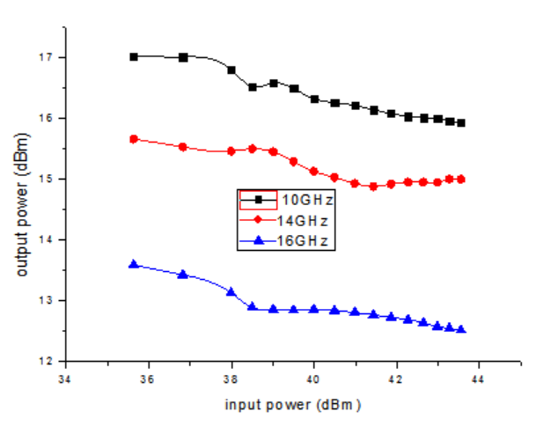
Chip size diagram：(unit µm)( two size options)

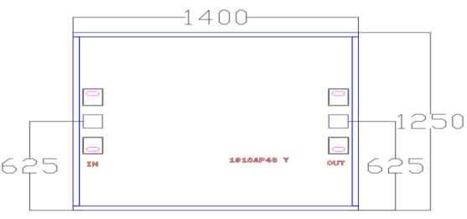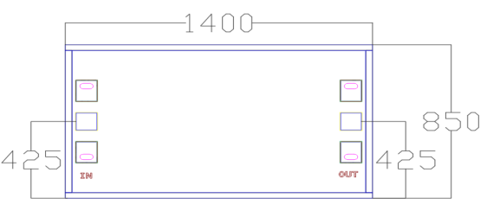
Note: All sizes are in (um) and the press-point size is 100×100um²
Proposed assembly drawing for the chip：
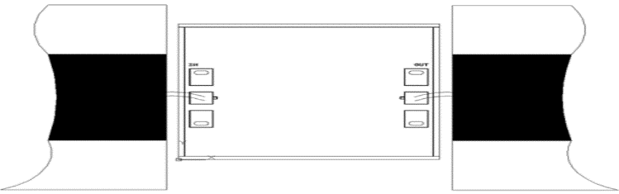
Instructions:
1. Assembly in a purified environment;
2. GaAs material is very brittle, chip surface is easy to be damaged, do not touch the surface, must be careful when using;
3. Input and output with two bonding lines (diameter of 25μm), the bonding line as short as possible, not more than 300μm;
4. The back of the chip must be grounded;
5 Sintered with 80/20 gold tin.The sintering temperature should not exceed 300℃, and the sintering time should not exceed 30 seconds as short as possible;
6. This product belongs to electrostatic sensitive device, pay attention to anti-static when storing and using;
7. Dry and nitrogen storage environment;
8. Do not try to clean the surface of the chip by dry or wet chemical methods;
9. Contact the supplier if you have any problems.

11 field effect transistor
(The products in this catalog are customized multifunctional chips, welcome users to customize products according to their own needs)
number | Frequency range  (GHz) | Saturation leakage current  (mA) | transconductance  (mS) | Gain  dB | Noise factor  dB | Page number
CW-FET13 | 2-18 | 30-50 | 72 | 12@12GHz | 0.46
CW-FET45 | 2-18 | 40-60 | 90 | 13 | 0.5

Performance Characteristics:
- Frequency band: 2~18 GHz
- Saturation leakage current: 38mA
- Turn-off voltage: -0.5V
- Gain @12GHz: 12dB
- Noise factor @12GHz: 0.46dB
- Lg ≤ 0.15μm, Wg = 200μm
- Chip size: Length 0.45mm x width 0.36mm x thickness 0.1mm
Product Description：
CW-FET13 is an ultra-high electron mobility transistor (GaAs field-effect transistor /HEMT chip) with frequency coverage of 2 to 18GHz, a typical 12GHz noise factor of 0.46dB, powered by +2V.It is suitable for telecommunication, satellite communication network and other low noise applications.
Electrical parameters：（$T_{a}=25℃$）
Item | Conditions | Minimum | Typical value | Maximum value | Units
Saturation current | Vds=2V，Vgs=0V | 30 | 38 | 50 | mA
transconductance | Vds=2V，Ids=10mA | 45 | 72 | - | mS
Turn-off voltage | Vds=2V，Ids=1mA | -0.4 | -0.5 | -0.6 | V
Gate source breakdown | Igs=-10uA | -3.0 | -8 | - | V
Noise factor | Vds=2V Ids=10mA@12GHz | - | 0.46 | 0.55 | dB
Gain | Vds=2V Ids=10mA@12GHz | 9.0 | 12 | - | dB
Typical curve：（$T_{a}=25℃$）
Noise factor Vs drain current Drain current & transconductance Vs grid voltage
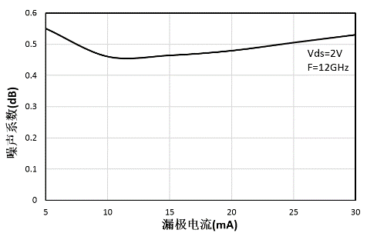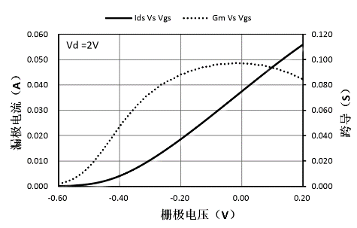

Noise factor Vs frequency drain current Vs drain voltage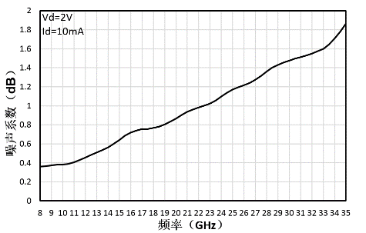 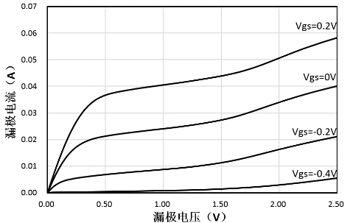
Size diagram：（unit µm）
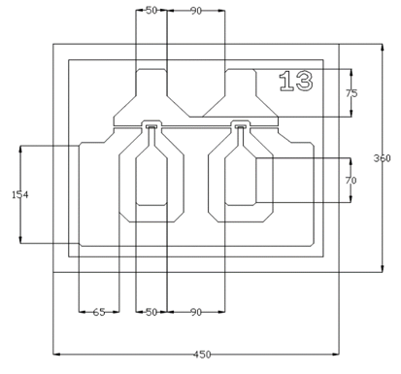
Instructions:
1) For use in a purified environment, do not touch the surface of the chip when using.
2) Store in a dry and nitrogen environment.
Performance characteristics:
- Frequency band: 2~18 GHz
- Saturation leakage current: 50mA
- Turn-off voltage: -0.5V
- Gain @12GHz: 13dB
- Noise factor @12GHz: 0.5dB
- Lg ≤ 0.15μm, Wg = 280μm
- Chip size: Length 0.45mm x width 0.36mm x thickness 0.1mm
Product Description：
CW-FET45 is an ultra-high electron mobility transistor (GaAs field-effect transistor /HEMT chip) with a frequency coverage of 2 to 18GHz, a typical noise factor of 0.5dB for 12GHz, powered by +2V.It is suitable for telecommunication, satellite communication network and other low noise applications.
Electrical parameters：（$T_{a}=25℃$）
Item | Conditions | Minimum | Typical value | Maximum value | Units
Saturation current | Vds=2V，Vgs=0V | 40 | 50 | 60 | mA
transconductance | Vds=2V，Ids=10mA | 45 | 90 | - | mS
Turn-off voltage | Vds=2V，Ids=1mA | -0.4 | -0.5 | -0.6 | V
Gate source breakdown | Igs=-10uA | -3.0 | -7.5 | - | V
Noise factor | Vds=2V Ids=10mA@12GHz | - | 0.5 | 0.65 | dB
Gain | Vds=2V Ids=10mA@12GHz | 9.0 | 13 | - | dB
Typical curve：（$T_{a}=25℃$）
Noise factor Vs drain current Drain current & transconductance Vs grid voltage
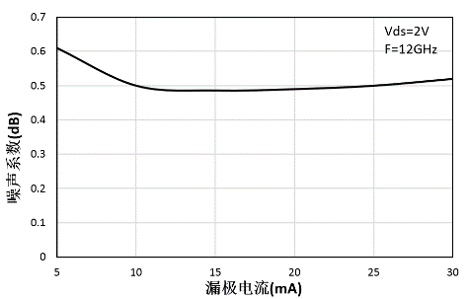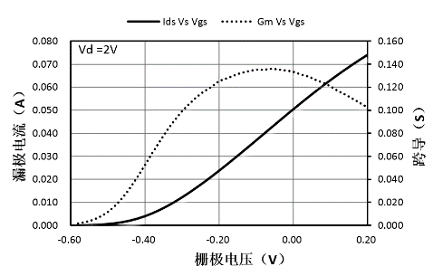

Noise factor Vs frequency drain current Vs drain voltage
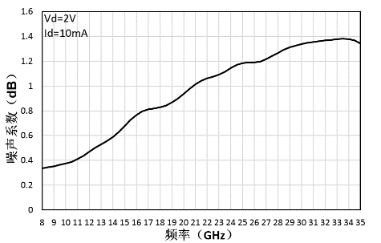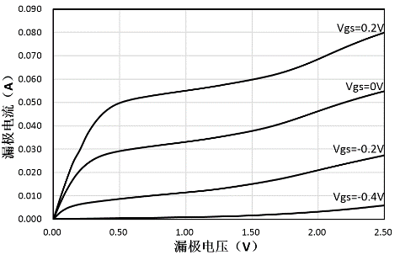
Size diagram：（unit µm）
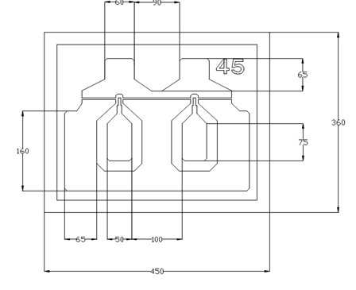
Instructions:
1) For use in a purified environment, do not touch the surface of the chip when using.
2) Store in a dry and nitrogen environment.

